EDITORIALS AND COMMENTARIES
Reflections on Dr J Michael Lane, a giant of public health (1936-2020)
C Raina MacIntyre¹
¹ Biosecurity Program, The Kirby Institute for Infection and Immunity, UNSW Sydney

Abstract
Reflections on Dr J Michael Lane (1936-2020) a global leader in smallpox eradication and the Director of Smallpox Eradication at the US CDC. Dr Lane was an alumnus of the US CDC's Epidemic Intelligence Service and had worked in global health on control of outbreaks in many countries. He was a pivotal figure in smallpox eradication, especially in identifying the risk of continuing smallpox vaccination in the US when disease incidence was low. This article is a reflection on his global contributions to infectious diseases control.
Key words: Smallpox, epidemics, infectious diseases

I first met Dr Mike Lane in 1992 as a student of field epidemiology at the Australian National University. Mike arrived in 1991 to set up the Australian field epidemiology training program (FETP), based on the US Centers for Disease Control and Prevention’s (CDC) Epidemic Intelligence service of which he was an alumnus. He had been director of the Center for Prevention Services at the US CDC, where he had a long and distinguished career. He instilled in me a love of infectious diseases field epidemiology, the "disease detective" work, which is one of the most important contributions of the United States to global public health, resulting in a network of 75 FETPs around the world. He left an enormous legacy in Australia and at the Australian National University, which has graduated over 200 field epidemiologists. These graduates have been at the forefront of the COVID-19 response in Australia and globally. At the time, I knew him as an outstanding teacher and an expert in field epidemiology – the science of outbreak investigation. There are many pretenders out there, even among those experts providing advice to governments who do not have the basic knowledge of field epidemiology, which is essential for epidemic control, especially when there is no drug or vaccine available. This has seen many mistakes in basic public health approaches around the world and subsequent loss of epidemic control. But Mike was the real deal, with extensive and global field experience of controlling outbreaks. Like many great people, Mike was a humble man who never boasted about his achievements. Yet it was only years later when working on smallpox research, after coming across his seminal publications on smallpox, that I came to know Mike was a global leader in smallpox eradication and the Director of Smallpox Eradication at the US CDC.
There are many lessons to be learned about smallpox and it's eradication, in which Dr Mike Lane played a pivotal role. It was Mike who realised that by the 1970s, the risks of smallpox vaccine, which has significant adverse effects, were greater than the benefits during a period where there was no smallpox in the country, which led to cessation of mass vaccination in the US. We are now talking about mass vaccination against COVID-19 of the whole population, but the last time any country attempted vaccination at such a scale was for smallpox, over 40 years ago. There is no experience of this scale of vaccination among people currently working in public health. Mike was a repository of vast knowledge about epidemic control, and specifically smallpox and the field operational aspects of eradication. Now he along with Frank Fenner and DA Henderson have passed away, and their collective knowledge is no longer available to us.
When I started doing research on smallpox in 2006, long after Mike taught me field epidemiology in the early 1990s, I reached out to him again and we published a paper together in 2007. After talking to him at length in 2017, and knowing he had cancer, I realised he had a wealth of knowledge about smallpox control, applicable to any other respiratory virus, which was not in any textbook or journal article. I therefore interviewed him so that some of this knowledge could be made available to others after he passed away. He led the CDC team which responded to the last European outbreak of smallpox in the former Yugoslavia in 1972, which presents a lesson for re-emergence of long-forgotten diseases. One of the important lessons of smallpox eradication was that of ring vaccination (also called "surveillance and containment") when vaccines are in short supply or mass vaccination is too challenging. Many vaccines are effective as post-exposure prophylaxis in contacts of a case - smallpox, measles, hepatitis A for example. In the end, smallpox was eradicated using ring vaccination, not mass vaccination, bringing success in the last hot spots such as India, where mass vaccination
had been a challenge. Mike discussed all of this in his 2017 interview. I have not seen any clinical trials of COVID-19 vaccine looking at efficacy in close contacts - but we should be running those trials, as this is an important strategy that requires far less doses than mass vaccination.
I last saw Mike on 9 December 2019, the 40th anniversary of the eradication of smallpox. Mike was a speaker at a smallpox pandemic exercise we organised on 9 December 2019 in Washington DC, Pacific Eclipse. As the COVID-19 pandemic was beginning in China (unknown to the world), we exercised a pandemic of smallpox with over 200 experts and operational stakeholders. We looked at many critical issues such as travel bans, infected ships and mass transport vehicles, contact tracing, testing, vaccination, law and order, and critical infrastructure. We even looked at the political impact of the 2020 election in the US on pandemic control. To have Mike's expertise in the room was a privilege and one which enabled his vast knowledge to be shared with people involved in the COVID-19 response today. His input from the last European outbreak of smallpox was incorporated into the fictional scenario in Pacific Eclipse, including failure of diagnosis, importance of contact tracing and case isolation, use of vaccines, and mobilising resources to manage a large outbreak. We were able to tell participants after the exercise that the scenario was based on facts from Yugoslavia, which in 1972 had not seen smallpox for over 30 years. So clinicians were not familiar with it when a return traveller brought it back into Kosovo, and a delay in diagnosis set off an epidemic which infected 175 people. This grounded our fictional exercise in a reality informed by Mike. Many have since contacted me to let me know how Pacific Eclipse and Mike’s expertise informed their response to the current COVID-19 pandemic.
The COVID-19 pandemic has exposed the loss of corporate knowledge in countries around the world of basic principles of non-pharmaceutical epidemic control measures such as contact tracing and case isolation. People have had to learn on the job and adapt as COVID-19 spiralled out of control. The UK SAGE committee, early in the pandemic, even suggested abandoning contact tracing, one of the two most influential predictors of epidemic control, and other countries began repeating the same thoughts. Many countries and expert advisors around the world have promoted misinformed theories of herd immunity through natural infection, displaying a complete lack of knowledge of herd immunity itself and of the pre-vaccine epidemiology of infectious diseases such as smallpox, measles, rubella and mumps. Mike could have set them straight and told them that smallpox did not eradicate itself through “herd immunity”, but that we needed a vaccine, and that prior to the vaccine it caused massive, cycling epidemics that never went away. He was the real deal with vast knowledge of epidemic infections. He was also a man of integrity and values, who would not stand
by idle if an injustice was done. He told me he left CDC after the HIV epidemic, unhappy with the politicisation of HIV and some of the political decisions that impacted public health at the time. He was truly a good man, who never wavered from his mission in public health to do good and improve health for others. He remained actively involved on smallpox committees in the US and the WHO, and I am grateful for the chance to have seen him again, and that he could share his knowledge with others one last time.
I heard from a friend of Mike in September that he was not well, and sent him an email. Stoically, he replied saying he was feeling a bit better. Then, his daughter Cindy sent me a message on 21 October to call her, and I knew it was not good news. It is a great loss to the world and to public health. Mike leaves behind his wife Lila, daughter Cynthia Edwards and her family including his grandchildren Chase and Sage, his ex-wife Carolina, and many colleagues and friends. One of his other students at the Australian National University, Dr Tony Stewart said “We knew from day one that Mike was an exceptional teacher and brilliant field epidemiologist. However, it wasn’t until some years later on my first trip to US CDC that I realised just how fortunate we’d been. I was telling a group of CDC colleagues about the (Australian FETP) and mentioned that Mike was my supervisor. They were as a group disbelieving and incredulous; one suggested I was mistaken, or that I must be referring to a different Mike Lane, not the Mike Lane. He was truly legendary among the public health pantheon.”

Dr Michael Lane (foreground), as a panellist at the smallpox simulation, Pacific Eclipse, in the United States in December 2019.

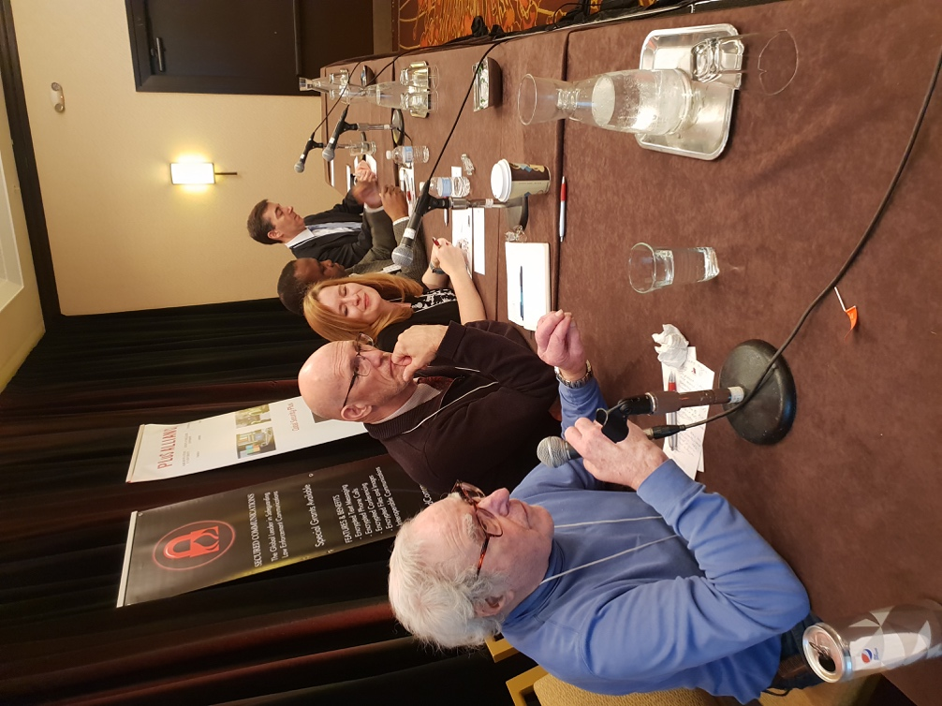

How to cite this article: MacIntyre CR. Reflections on DR J Michael Lane, a giant of public health (1936-2020). Global Biosecurity, 2020; 1(4).
Published: November 2020
Copyright: Copyright © 2020 The Author(s). This is an open-access article distributed under the terms of the Creative Commons Attribution 4.0 International License (CC-BY 4.0), which permits unrestricted use, distribution, and reproduction in any medium, provided the original author and source are credited. See http://creativecommons.org/licenses/by/4.0/ .
Global Biosecurity is a peer-reviewed open access journal published by University of New South Wales.

