RESEARCH ARTICLES
Early Signs of COVID-19 in Pakistan
Taimur Mahmood¹, Moiz Javed², Raina MacIntyre¹ & Aye Moa¹
¹ University of New South Wales, Australia
² Lahore Medical and Dental College, Pakistan

Abstract
Background: The outbreak of novel coronavirus (COVID-19) has turned into a public health emergency of international concern. With no antiviral drugs nor vaccine, presence of carriers without obvious symptoms and varied clinical characteristics, the traditional public health measures are certainly less effective. The early signs of COVID-19 and epidemiological data are essential to strengthen the overwhelmed healthcare systems.
Aim: To detect, assess and analyse the early signs of COVID-19 in Pakistan before the official reporting of cases in the country.
Methods: The study uses the EpiWATCH observatory to extract data from 1 November 2019 to 1 April 2020. The trend of pneumonia of unknown origin cases in Pakistan was observed to assess if cases of COVID-19 could have been detected before the first official case was reported. A descriptive analysis of the obtained data was achieved on the basis of geographic and demographic features.
Results: A total of 151 entries were included in the study. Before the identification of the first official case of COVID-19 in Pakistan, 54 reports of cases of pneumonia of unknown origin were recorded. After the first case of COVID-19 was reported, 97 reports of cases of COVID-19 were recorded. The study findings suggest that there were early signs of COVID-19 in Pakistan since the second week of January 2020, a month and a half prior to the first case being reported in the country.
Key words: COVID-19, pneumonia of unknown origin, early signs, Pakistan, EpiWATCH

Introduction
Pneumonia of unknown origin was reported through a number of cases by a surveillance mechanism in the city of Wuhan, Hubei Province, China in late December 2019 (CDC Weekly, 2020). On 31 December 31 2019, a response team was sent by the Chinese Center for Disease Control and Prevention to Wuhan, which excluded the possible disease causes including influenza, avian influenza, Severe Acute Respiratory Syndrome Coronavirus (SARS-CoV) and Middle East Respiratory Syndrome Coronavirus (MERS-CoV) (Yanping & Lan, 2020). The initial cases were epidemiologically linked to a seafood market of South China in Wuhan, and the local authorities shut and disinfected the affected area on 1 January 2020. The epidemiological connection of COVID-19 with Huanan wholesale seafood market also suggests the possibility of animal associated transmission including snakes, bats, marmots and birds (Zhu, Zhang & Wang, 2020). By 7 January 2020, the Chinese researches detected a novel virus through virus nucleic acid detection kits and the reverse-transcriptase polymerase chain reaction (RT-PCR) diagnostic tests from the bronchoalveolar lavage specimens of the infected cases (Wang, Horby, Hayden and Gao, 2020). Through isolation of the virus and further analysis based on molecular studies, it was verified that the infective

organism was a new Coronavirus (CoV), named 2019-nCoV. The virus was eventually retitled by the World Health Organization (WHO) as SARS-CoV-2 and the associated disease was termed as COVID-19 (Sun et al., 2020).
To implement effective outbreak management, it is essential to comprehend the pathogenesis and transmission routes of the causative pathogen, and understand the natural course and history of the disease in the initial stages of a communicable disease outbreak. (Sarwar et al., 2020; Zhang et al., 2020). The COVID-19 outbreak was declared by the World Health Organization (WHO) as the sixth public health emergency of international concern on 30 January 2020 and was characterized as a pandemic by the WHO on 11 March 2020 (WHO, 2020). As of 1 April 2020, this pandemic has affected over 209 countries across the globe, resulting in 823,604 confirmed cases with 41,863 deaths worldwide (WHO, 2020). At present, there is no cure or vaccine available for the disease and the only strategy is to reduce its spread. Along with being a major global health crisis, with limited knowledge about its dynamics, this disease is also a serious threat to the global socio-economic status (Sherin, 2020). The SARS-CoV-2 pandemic has overwhelmed public health authorities and healthcare centers, especially in developing countries. Social and local media surveillance can provide many opportunities for strengthening healthcare systems and to overcome potential delays in screening, diagnosis and infection control in the current public health emergency (Mahmood et al., 2020).
The study is aimed at detection and analysis of the early epidemiological signs of COVID-19 using the trend of cases of pneumonia of unknown origin in Pakistan before the notification of the index case of COVID-19, and comparing the trend with the cases of COVID-19 from 1 November 2019 to 1 April 2020, using EpiWATCH data. As the typical surveillance mechanisms for diseases are based on notifications from healthcare systems and laboratories, a delay by weeks or even months in identification of outbreaks can occur. This study uses the open-source data from EpiWATCH such as press releases, social media reports and news articles to obtain a real-time image and analyze the early signs of the on-going disease outbreak. By summarizing this data, a trajectory of early signs of COVID-19 in Pakistan can be obtained, which can provide assistance to governing bodies and researchers to collate the epidemiology of COVID-19 in the country to that in other nations of the world.

Methods
In this study, EpiWATCH was used, an open source outbreak data collection and epidemic observatory of the world founded by the Australian National Health and Medical Research Council (NHMRC). It uses data sources such as social-media, press articles and releases for enhanced outbreak surveillance, scanning and analysis (EpiWATCH, 2020).
Corresponding data dated 1 November 2019 to 1 April 2020 on cases of pneumonia of unknown origin in Pakistan (before the diagnosis of first COVID-19 case in Pakistan) and COVID- 19 cases were obtained from the EpiWATCH database via keyword based search - ‘pneumonia, pneumonia of unknown origin, respiratory infection, lung inflammation, respiratory disease, severe acute respiratory infection (SARI), severe acute respiratory syndrome (SARS), cough, fever, cough AND fever, COVID-19 and SARS-CoV-2’ to identify early signals of COVID-19 in Pakistan. The keywords were also translated from various local languages of Pakistan such as Urdu, Punjabi and Pushto to obtain local news reports and determine the trend of pneumonia of unknown origin. Entries from 1 November 2019 to 1 April 2020 that reported cases of pneumonia of unknown origin and confirmed cases of COVID-19 were included in the selection criteria. The exclusion criteria consisted of news reports that were not reporting cases from Pakistan, pneumonia with a known cause (bacterial or viral), non-pneumonia respiratory illnesses, and news duplicates.
The news reports of various outbreak clusters were grouped according to time, place and person for a thorough analysis. The trend of pneumonia of unknown origin cases was observed to identify the early signs of COVID-19 in Pakistan. A descriptive analysis of obtained data was achieved using Microsoft Excel, and the outbreak clusters were grouped on the basis of geographic and demographic features.

Results
A total of 291 entries dated between 1 November 2019 and 1 April 2020, were obtained from the EpiWATCH database using the above-mentioned keywords. After excluding the duplicates and reports of cases not matching the selection criteria, 151 entries were included in the study.
Figure 1 represents the count of daily entries of reports of cases of pneumonia of unknown origin before the index case of SARS-CoV-2 was diagnosed in Pakistan, and thereafter, the following COVID-19 cases, extracted through EpiWATCH. Between 1 November 2019 and 25 February 2020, 54 reports of cases of pneumonia of unknown origin were recorded, and 97 reports of cases of COVID-19 were recorded from 26 February to 1 April 2020. An increase in reports of cases of pneumonia of unknown origin can be seen from mid-January 2020 until mid-February 2020, with a subsequent rise in the entries after the diagnosis of the index case of COVID-19 in Pakistan on 26 February 2020.

Pneumonia of unknown origin and COVID-19 in Pakistan – Epidemiology
Between 1 November 2020 and 1 April 2020, we obtained 3,364 cases of pneumonia of unknown origin and confirmed cases of COVID-19 in Pakistan. There were 1,075 cases (31.9%) reported between 1 November 2019 and 25 February 2020, prior to the identification of the first case of COVID-19 in Pakistan. Outbreak clusters can be seen in the months of November and December 2019, with a gradual increase in cases of pneumonia of unknown origin from mid-January 2020 until 25 February 2020.
From 1 November 2019 to 31 December 2019, 993 cases of pneumonia of unknown origin were reported countrywide. Majority (40.2%) of the cases were reported in Islamabad Capital Territory with comparatively fewer cases in Punjab (30.2%) and Khyber Pakhtunkhwa (29.5%). Since early January 2020 until 25 February 2020, EpiWATCH detected 82 cases of pneumonia of unknown origin. Majority (43.9%) of the cases were reported from the province Sindh, followed by cases from Punjab (30.4%) and Khyber Pakhtunkhwa (25.6%). The gradual increase in cases of pneumonia of unknown origin is seen from almost one and a half months before the first confirmed case of COVID-19 was reported by the government of Pakistan.
Between 26 February and 1 April 2020, 2,289 confirmed cases of COVID-19 were declared nationwide. In Figure 2, a notable rise of COVID-19 cases can be seen after the first diagnosis of the first case on 26 February 2020.

Figure 1. Number of entries reporting cases of pneumonia of unknown origin and COVID-19 in Pakistan from 1 November 2019 to 1 April 2020.

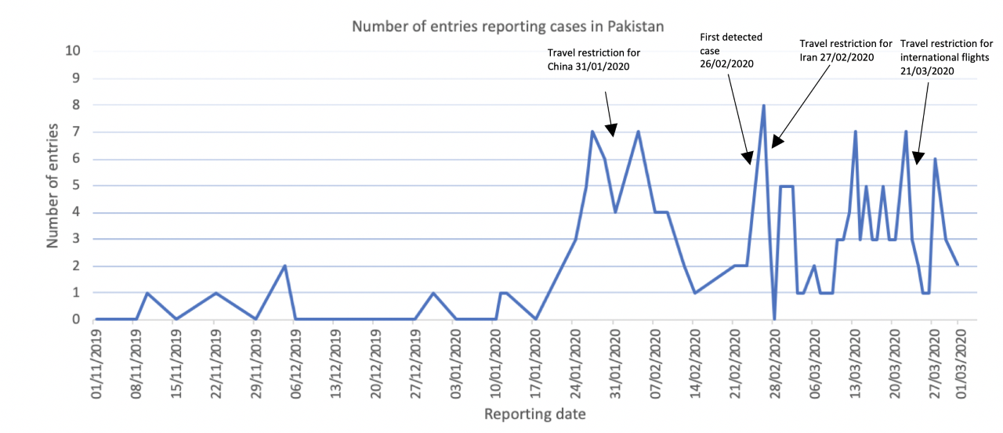

Figure 2. Number of cases of pneumonia of unknown origin and COVID-19 in Pakistan between 1 November 2019 and 1 April 2020.
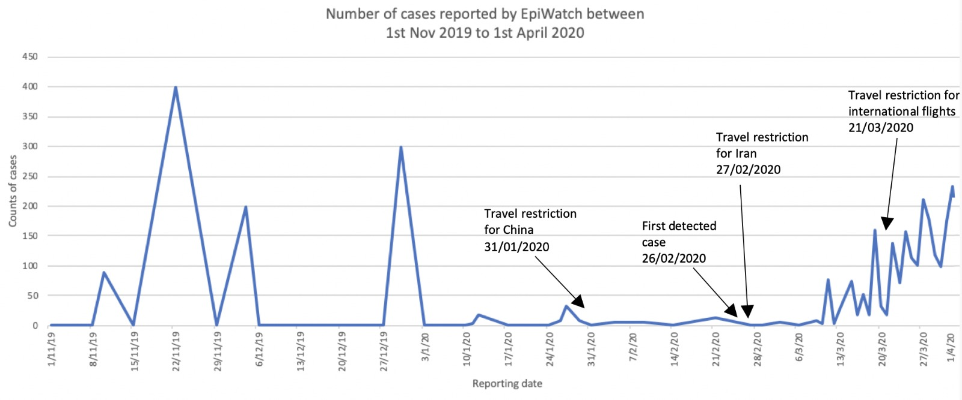

The majority of cases of pneumonia of unknown origin in the year 2019 were discovered in Islamabad, followed by different cities of the provinces Punjab and Khyber Pakhtunkhwa. The majority of cases of pneumonia of unknown origin in the year 2020 were identified in the province Punjab, followed by cases from the Sindh province. Initially, the majority of cases of COVID-19 were seen in the province of Sindh but as of 1 April 2020, Punjab has the greatest number of COVID-19 positive cases.
As seen in Figure 3, the male population has higher proportion of total cases of pneumonia of unknown origin than females throughout all the age groups. In terms of age distribution, the greatest number of cases are reported among individuals aged 20-29 years, while the age bracket of 80+ years has the lowest number of cases for both males and females. The age and gender information of the remaining 38% of the cases was not available in the entries.

COVID-19 Timeline in Pakistan
Since the outbreak of COVID-19 in China, the government of Pakistan has applied several precautionary measures to prevent the outbreak occurring in the country. Travel restrictions to and from China were implemented from 31 January 2020, and travel restrictions to and from Iran from 27 February 2020. Moreover, since international visitors and pilgrims from Iran were a significant threat for the outbreak to occur in Pakistan, quarantine centers were set up in many cities, especially the ones close to neighboring countries. Furthermore, all educational institutes were closed from 13 March 2020 to 31 March to avoid the spread and transmission of the disease (Nafees & Khan, 2020). A complete travel restriction for all the international flights, inter-city transport and trains network was implemented on 21 March 2020 and simultaneously, a nationwide lockdown was enforced on 24 March 2020 (Farooq, Khan & Khan, 2020).
However, the preventive measures were insufficient in stopping the COVID-19 outbreak from occurring in Pakistan. Almost one and a half months after the detection of early signs of pneumonia in the country, Pakistan reported its first two confirmed cases (pilgrim travelers from Iran) of COVID-19 on 26 February 2020 and the first death associated to COVID-19 on 18 March 2020. Figure 4 portrays the daily new and cumulative cases of COVID-19 in Pakistan. An increase in confirmed cases can be seen from early March, which is in line with our research results. As of 1 April 2020, Pakistan has 2,289 confirmed cases, 31 deaths, 2,151 active cases and 107 recoveries (Government of Pakistan, 2020).
Table 1 represents the provincial distribution of COVID-19 cases and associated deaths in Pakistan as per 1 April 2020. Figure 5 also shows a geographical distribution of COVID-19 cases by province in Pakistan, from 26 February 2020 to 1 April 2020.
As seen in Figure 5, males constitute a higher percentage of total cases of COVID-19 than females throughout all the age groups. In terms of age distribution, the greatest number of cases are reported among individuals aged 20-29 years, while the age bracket of 80+ years has the lowest number of cases for both males and females.

Figure 3. Distribution of reported cases by Age and Sex in Pakistan between 1 November 2019 - 1 April 2020 (Source: EpiWATCH data).
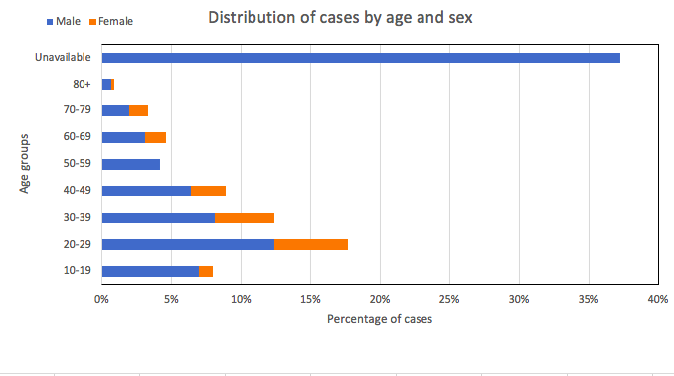

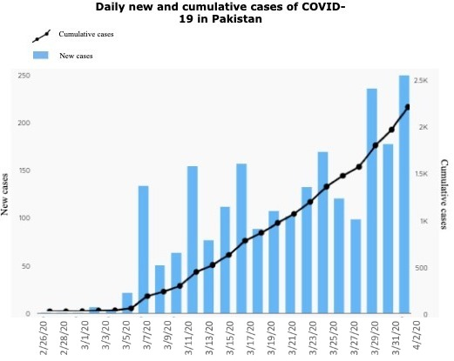
Figure 4. New cases and cumulative cases of COVID-19 in Pakistan from 26 February 2020 until 1 April 2020 (Government of Pakistan, 2020).

Table 1. Distribution of COVID-19 cases and deaths by province in Pakistan (26 February 2020 – 1 April 2020) (Government of Pakistan, 2020).

Province | Cases | Deaths
Sindh | 743 | 9
Punjab | 845 | 11
Khyber Pakhtunkhwa (KPK) | 274 | 8
Balochistan | 169 | 1
Islamabad Capital Territory (ICT) | 62 | 0
Gilgit-Baltistan (GB) | 187 | 2
Azad Jammu & Kashmir (AJK) | 9 | 0
Total | 2,289 | 31

Figure 5. Distribution of reported cases by Age and Sex in Pakistan between 26 February 2020 – 1 April 2020 (Government of Pakistan, 2020).

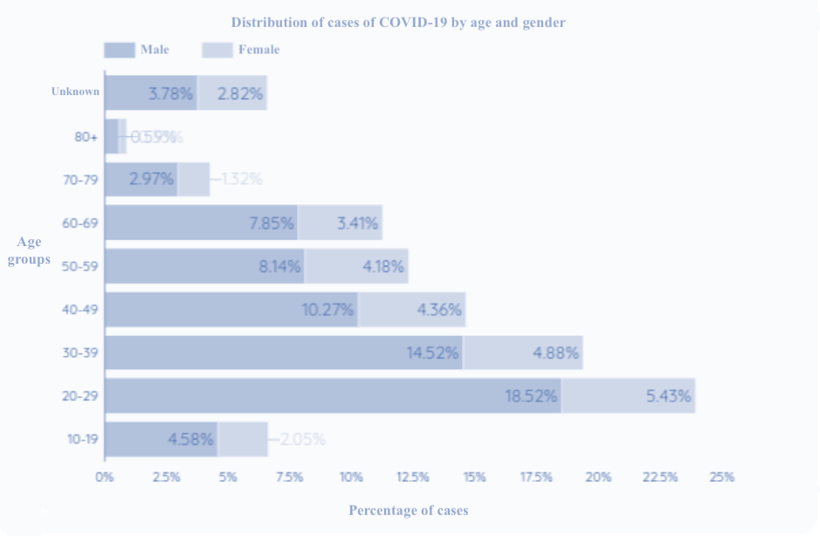

Discussion
Community disease surveillance is of utmost value in the prevention and monitoring of public health emergencies. The World Health Organization defines public health surveillance as, “the continuous, systematic collection, analysis and interpretation of health-related data needed for the planning, implementation and evaluation of public health practice.” (WHO, 2020). Information and data extracted through social media, press releases and news articles are an extremely useful component of surveillance as the traditional pre-existing laboratory-based, hospital and outpatient systems rely on tracking individuals seeking healthcare facilities, hence underestimating the total disease burden (Aiello, Renson & Zivich, 2020). Research studies have shown that open-source intelligence, online news and social-media surveillance shall be used to improve the efficiency of public health professionals to identify such disease outbreaks earlier and enhance the response to emergency situations (Charles-Smith et al., 2015).
Pakistan shares a border with China, which is the epicenter of the pandemic, and Iran, which has a high COVID-19 related mortality rate. Due to this reason, the risk of the outbreak occurring in Pakistan was significantly high, which led the government to initiate the ‘National Action Plan for Preparedness and Response to Corona Virus Disease (COVID-19) in Pakistan’ on 12 February 2020. The plan aimed to control the spread of the infectious disease and strengthen the emergency preparedness of the nation against the anticipated events

(NIH, 2020). Pakistan’s first line of response was to impose a travel ban on China on 31 January 2020, which led to significant delay of almost 4 weeks in the importation of cases. Pakistan reported its first two cases of COVID-19 on 26 February 2020. The Ministry of health reported the first case in the city of Karachi and the other was diagnosed in Islamabad, Capital Territory (Waris et al., 2020). Both of these cases shared a common travel record to Iran and subsequently, a travel ban on Iran was imposed on 27 February 2020 and schools were shut down in several areas on the same day to control the outbreak (Reuters, 2020). Within the next two weeks, 20 out of 471 suspected cases were confirmed for COVID-19 and eventually travel restrictions were imposed on all international and domestic flights, train services and inter-city transport on 21 March 2020 (Sherin, 2020). The local authorities, with support of the central government, engaged in rigorous actions to ensure public safety, such as increased testing laboratories and kits to facilitate early identification of infected individuals. Other measures such as contact tracing, risk communication, social distancing, quarantine and isolation centers, increased public awareness and identification of COVID-19 hotspots were also initiated (Waris et al., 2020). As of 1 April 2020, the outbreak has resulted in 2,289 confirmed cases and 31 deaths with 17,324 tests conducted across the country (Government of Pakistan, 2020).
The study analyses and identifies the early signs of COVID-19 in Pakistan through data extracted from EpiWATCH using the search word ‘pneumonia of unknown cause’ to compare the disease trends before and after the notification of first official case of COVID-19 in Pakistan. A significant rise in reports of cases of pneumonia of unknown origin was observed by early January 2020, a month and a half before the first 2 cases of COVID-19 were notified in Pakistan on 26 February 2020. Moreover, from the beginning of March 2020, an increase in number of reports of cases was captured by EpiWATCH, which is consistent with the growing number of cases of COVID-19 in Pakistan. Pneumonia is the second-leading cause of death among children under 5 years in Pakistan, and the majority of the news reports for cases of pneumonia in 2019 were of children (Bashir et al., 2016). Suspected individuals with a recent travel history to and from China were immediately quarantined and tested but were later declared as cases of pneumonia. Interestingly, Pakistan acquired their initial testing kits for COVID-19 from China in early February 2020 which could be a possible reason for the delay in early diagnosis of suspected cases (Nafees & Khan, 2020). Furthermore, there was a gradual increase in reporting of cases after the first two cases were diagnosed on 26 February 2020. However, the cases started to increase sharply after 6 March 2020 until 1 April 2020.
The study’s findings are consistent with most of the cases belonging to the 20-29 years age group. However, other studies have found that the age groups (50-59 years and 60+ years) are more prone to the COVID-19 infection. The study also found that the male population was more prone to the COVID-19 infection in Pakistan, which is consistent with the findings from studies conducted in different countries (Arentz et al., 2020; Shi et al., 2020; Tian et al., 2020).
Geographically, a spatial distribution of cases of pneumonia of unknown origin was observed in Pakistan. The distribution of cases (for the year 2020) from our study is comparable to the initial trend of COVID-19 cases in Pakistan, with Sindh constituting the greatest frequency of initial cases of COVID-19. A possible reason for this can be the travelling of religious pilgrims from Iran to Karachi (Sindh), since the Taftan border lacks the essential resources for control and preventive measures (Nafees & Khan, 2020). An influx of cases before the diagnosis of the index case of COVID-19 in Pakistan can be assumed as a cause for the early signs of COVID-19 in Pakistan. However, the gradual rise in frequency of cases in Punjab can be attributed to the fact that it is the most populated region of the country (Pakistan Bureau of Statistics, 2020). Furthermore, healthcare facilities and laboratories play a critical role in outbreak situations, from diagnosis to surveillance. Since Punjab and Sindh are the most developed provinces of Pakistan, the higher frequency of cases can also be correlated to a higher number of testing facilities and healthcare resources (Ahmed et al., 2020). Figure 6 represents the provincial distribution of total number of cases of COVID-19 in the country. With the geographical distribution, we can evaluate the disease burden being the highest in Punjab and lowest in the Azad Jammu and Kashmir province. As of 1 April 2020, the data obtained from Ministry of Health, Pakistan shows that Punjab (36.9%) has the highest number of cases, followed by Sindh (32.4%), Khyber Pakhtunkhwa (11.9%), Gilgit Baltistan (8.1%), Balochistan (7.3%), Islamabad Capital Territory (2.7%) and Azad Jammu and Kashmir (0.3%) (Government of Pakistan, 2020). Figure 6 represents the provincial distribution of total number of cases of COVID-19 in the country.
The exponential spread of COVID-19 has forced all the countries worldwide to take necessary preventive measures. The government of Pakistan has also taken measures within their limited capabilities to ensure the population’s safeness of life against COVID-19. With the implementation of travel restrictions, quarantine centers and a nationwide lockdown, the government also facilitated by building new hospitals and specifying designated hospitals for the admission of patients affected by COVID-19. Standard Operating Procedures (SOPs) were established and disseminated across the healthcare systems regarding hand hygiene, waste disposal, compliance to personal protective equipment (PPE), and appropriate training to healthcare workers to fight the outbreak (Waris et al., 2020). Moreover, misdiagnosis and under-reporting are important factors that can interfere with public health reporting. Due to financial ramifications of the COVID-19 crisis and social distancing campaigns, a significant decline in testing volumes was observed initially, which suggests that Pakistan may have misdiagnosed or under-reported the actual total number of cases of COVID-19 in the country (Ahmed et al., 2020). However, to cover this gap, Pakistan’s government inaugurated 15 new laboratories (Khyber Pakhtunkhwa – 1, Gilgit Baltistan – 1, Islamabad Capital Territory – 1, Balochistan – 1, Azad Jammu and Kashmir – 1, Punjab – 5 and Sindh – 5) providing free of cost PCR testing for COVID-19 to the general public in various regions countrywide, increasing the testing capacity from 30,000 to 280,000 tests (Waris et al., 2020).

Figure 6. Geographical distribution of COVID-19 cases by provinces in Pakistan between 26 February – 1 April 2020 (Data Source - (Government of Pakistan, 2020)).
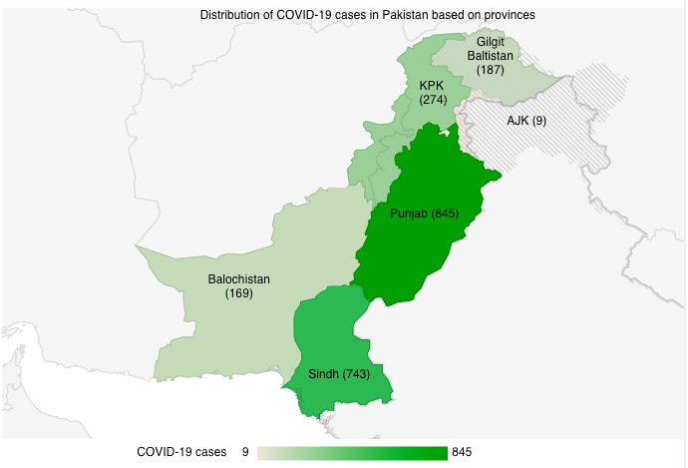

There are a few limitations of this study. Since the study uses data extracted from open source observatory, social media and news reports, there can be an overestimation of the frequency of cases of pneumonia of unknown origin. Most of the reports included do not provide clear information regarding the laboratory diagnosis of the cases of pneumonia and were based on the symptoms or initial suspicion of the disease. Secondly, mathematical modelling to evaluate the preventive measures and strategies applied by the government of Pakistan was not included in the study. Lastly, most of the conventional public health surveillance system are based on confirmation through case ascertainment, which is not achievable with surveillance through media reports and press releases. This research suggests that a further study is required to gauge the strength of public health measures and disease prevention and control strategies of Pakistan. This will provide assistance to the governing bodies to analyze the efficacy of existing strategies against COVID-19 in Pakistan and suggest possible recommendations as needed. Since the data used for this research study is publicly available and does not involve human participants, ethical approval is not needed.

Conclusion
The research findings suggest that the early signs of COVID-19 in Pakistan are detected by cases of pneumonia of unknown origin. The study found that since the second week of January 2020, there was a gradual rise in the number of reported cases of pneumonia of unknown origin until the diagnosis of the first official case of COVID-19 in Pakistan. The surveillance data obtained through EpiWATCH enabled early identification of the suspected cases of COVID-19 and provided data to draw a comparison of disease trends before and after the outbreak occurred in the country. The research also found that the trend of reporting of cases of pneumonia in Pakistan significantly increases during an outbreak/epidemic, leading to a potential reporting bias in time periods before the outbreak. The research was successful in detecting and analyzing early signs of COVID-19 in Pakistan, a month and a half prior to the first case being reported in the country.

References
Aiello, A., Renson, A., & Zivich, P. (2020). Social Media– and Internet-Based Disease Surveillance for Public Health. Annual Review Of Public Health, 41(1), 101-118. https://doi.org/10.1146/annurev-publhealth-040119-094402

Arentz, M., Yim, E., Klaff, L., Lokhandwala, S., Riedo, F., Chong, M., & Lee, M. (2020). Characteristics and Outcomes of 21 Critically Ill Patients With COVID-19 in Washington State. JAMA, 323(16), 1612. https://doi.org/10.1001/jama.2020.4326

CDC. (2020). Coronavirus Disease 2019 (COVID-19). Retrieved 15 July 2020, from https://www.cdc.gov/coronavirus/2019-ncov/hcp/clinical-guidance-management-patients.html.

CDC Weekly, C., 2020. The Epidemiological Characteristics of an Outbreak of 2019 Novel Coronavirus Diseases (COVID-19) — China, 2020. China CDC Weekly, 2(8), pp.113-122.

Charles-Smith, L., Reynolds, T., Cameron, M., Conway, M., Lau, E., & Olsen, J. et al. (2015). Using Social Media for Actionable Disease Surveillance and Outbreak Management: A Systematic Literature Review. PLOS ONE, 10(10), e0139701. https://doi.org/10.1371/journal.pone.0139701

EpiWatch. (2020). NHMRC Centre for Research Excellence, Integrated Systems for Epidemic Response. Iser.med.unsw.edu.au. Retrieved 27 June 2020, from https://iser.med.unsw.edu.au/epiwatch.

Farooq, F., Khan, J., & Khan, M. (2020). Effect of Lockdown on the spread of COVID-19 in Pakistan. arXiv preprint arXiv:2005.09422.

Government of Pakistan. (2020). COVID-19 Health Advisory Platform by Ministry of National Health Services Regulations and Coordination. Retrieved 18 July 2020, from http://covid.gov.pk/stats/pakistan.

Mahmood, S., Hasan, K., Colder Carras, M., & Labrique, A. (2020). Global preparedness against COVID-19: we must leverage the power of digital health (Preprint). JMIR Public Health And Surveillance. https://doi.org/10.2196/18980

Nafees, M., & Khan, F. (2020). Pakistan’s Response to COVID-19 Pandemic and Efficacy of Quarantine and Partial Lockdown: A Review. Electronic Journal Of General Medicine, 17(6), em240. https://doi.org/10.29333/ejgm/7951

NIH. (2020). National action plan for preparedness & response to Corona virus disease (Covid-19) Pakistan
Retrieved 22 July 2020, from https://www.nih.org.pk/wp-content/uploads/2020/02/NAP-covid-19_AL@version-3-date-12-2-2020-with-annexures.pdf.

Ong, S. W. X., Tan, Y. K., Chia, P. Y., Lee, T. H., Ng, O. T., Wong, M. S. Y., & Marimuthu, K. (2020). Air, surface environmental, and personal protective equipment contamination by severe acute respiratory syndrome coronavirus 2 (SARS-CoV-2) from a symptomatic patient. Jama, 323(16), 1610-1612.

Pakistan Bureau of Statistics. (2020). Population Census | Pakistan Bureau of Statistics. Retrieved 1 August 2020, from http://www.pbs.gov.pk/content/population-census.

Reuters. (2020). Pakistan shuts schools, suspends Iran flights to curb coronavirus spread. Retrieved from https://www.reuters.com/article/us-china-health-pakistan/pakistan-shuts-schools-suspends-iran-flights-to-curb-coronavirus-spread-idUSKCN20L179

Sarwar, S., Waheed, R., Sarwar, S., & Khan, A. (2020). COVID-19 challenges to Pakistan: Is GIS analysis useful to draw solutions?. Science Of The Total Environment, 730, 139089. https://doi.org/10.1016/j.scitotenv.2020.139089

Sherin, A. (2020). PREPAREDNESS AND RESPONSE OF PAKISTAN FOR CORONAVIRUS DISEASE 2019: GAPS AND CHALLENGES. KHYBER MEDICAL UNIVERSITY JOURNAL, 12(2), 79-80. https://doi.org/10.35845/kmuj.2020.20450

Shi, H., Han, X., Jiang, N., Cao, Y., Alwalid, O., & Gu, J. et al. (2020). Radiological findings from 81 patients with COVID-19 pneumonia in Wuhan, China: a descriptive study. The Lancet Infectious Diseases, 20(4), 425-434. https://doi.org/10.1016/s1473-3099(20)30086-4

Sun, J., He, W., Wang, L., Lai, A., Ji, X., Zhai, X., Li, G., Suchard, M., Tian, J., Zhou, J., Veit, M. and Su, S., 2020. COVID-19: Epidemiology, Evolution, and Cross-Disciplinary Perspectives. Trends in Molecular Medicine, 26(5), pp.483-495.

Tian, S., Hu, N., Lou, J., Chen, K., Kang, X., & Xiang, Z. et al. (2020). Characteristics of COVID-19 infection in Beijing. Journal Of Infection, 80(4), 401-406. https://doi.org/10.1016/j.jinf.2020.02.018

Wang, C., Horby, P., Hayden, F. and Gao, G., 2020. A novel coronavirus outbreak of global health concern. The Lancet, 395(10223), pp.470-473.

Waris, A., Atta, U., Ali, M., Asmat, A., & Baset, A. (2020). COVID-19 outbreak: current scenario of Pakistan. New Microbes And New Infections, 35, 100681. https://doi.org/10.1016/j.nmni.2020.100681

WHO. (2020). WHO Coronavirus Disease (COVID-19) Dashboard. Covid19.who.int. Retrieved 1 August 2020, from https://covid19.who.int/?gclid=CjwKCAjw4MP5BRBtEiwASfwALzOQh3wXFZbta9Wx3b-Ln-Aeoi7L2ZMqH6e9im2695jJaxygJj49AxoCLpMQAvD_BwE.

WHO. (2020). Coronavirus Disease (COVID-19) - events as they happen. Retrieved 24 July 2020, from https://www.who.int/emergencies/diseases/novel-coronavirus-2019/events-as-they-happen.

WHO. (2020). WHO | Public health surveillance. Who.int. Retrieved 6 August 2020, from https://www.who.int/immunization/monitoring_surveillance/burden/vpd/en/.

Yanping, Z., & Lan, W. (2020). Analysis of epidemiological characteristics of new coronavirus pneumonia. Chinese Journal Or Epidemiology, 41(10.3760/cma.j.issn.0254-6450.2020.02.003). http://rs.yiigle.com/yufabiao/1181998.htm

Zhang, J., Litvinova, M., Wang, W., Wang, Y., Deng, X., & Chen, X. et al. (2020). Evolving epidemiology and transmission dynamics of coronavirus disease 2019 outside Hubei province, China: a descriptive and modelling study. The Lancet Infectious Diseases, 20(7), 793-802. https://doi.org/10.1016/s1473-3099(20)30230-9

Zhu, N., Zhang, D., & Wang, W. China Novel Coronavirus Investigating and Research Team. A novel coronavirus from patients with pneumonia in China, 2019 [published January 24, 2020]. N Engl J Med.

How to cite this article: Mahmood T, Javed M, MacIntyre R & Moa A. Early Signs of COVID-19 in Pakistan. Global Biosecurity, 2021; 3(1).
Published: May 2021
Copyright: Copyright © 2021 The Author(s). This is an open-access article distributed under the terms of the Creative Commons Attribution 4.0 International License (CC-BY 4.0), which permits unrestricted use, distribution, and reproduction in any medium, provided the original author and source are credited. See http://creativecommons.org/licenses/by/4.0/ .
Global Biosecurity is a peer-reviewed open access journal published by University of New South Wales.

