RESEARCH ARTICLES
Global outbreaks of zika infection by epidemic observatory (EpiWATCH), 2016-2019
Babitha Suseelan Bhargavi¹ & Aye Moa¹
¹ Biosecurity program, Kirby Institute, UNSW Sydney

Abstract
Background: Emerging zika virus outbreaks have caused devastating impacts around the globe with severe sequelae in the general population. Although zika is a self-limiting infection, it can be potentially associated with devastating medical complications like microcephaly and Guillain-Barre Syndrome. This study aims to analyse outbreaks of zika infection globally from 2016 through to 2019 using data from the epidemic observatory, EpiWATCH.
Methods: EpiWATCH filtered and retrieved information on outbreaks of diseases or emerging infections reported daily by online news media. In this report, we used keywords such as “zika”, “zika virus”, “microcephaly” and “Guillain-Barre Syndrome”, and searched reports of zika outbreaks dated between March 2016 and March 2019. Descriptive epidemiologic analysis was conducted in relation to geolocation and time.
Results: Using an open-source data, a total of 120 media reports of zika outbreaks globally from 2016-2019 were analysed. The total numbers of zika cases retrieved from EpiWATCH by year were 81,852 (2016), 609 (2017), 1,800 (2018) and 15 cases (2019) respectively. By geographical distribution, zika infections were seen across 19 countries, through various transmission modes in the study. The number of zika-related microcephaly cases were 15 in 2016 and 68 cases in 2017, and no other cases were reported thereafter. Seven cases of Guillain-Barre Syndrome were also reported in 2016.
Conclusion: The epidemic intelligence, EpiWATCH, represents relevant sources of information for reporting of rare or severe diseases or emerging infections globally. Using information from digital data streams could help in early identification of outbreaks or diseases and generate effective public health interventions in mitigating emerging health threats ahead of time than traditional surveillance systems.
Key words: Zika virus, Microcephaly, Guillain-Barre Syndrome, EpiWATCH, Outbreaks, Surveillance

Introduction
Infectious diseases are caused by biological agents such as viruses, bacteria, fungi or prions and are transmitted either directly or indirectly from one individual to another (1). The emerging infectious diseases (EIDs) have appeared from time to time and contributed to a crucial global burden impacting both the public health and economy in many countries around the world. The global trends explicitly indicate an upsurge and inflation in the total number of outbreaks, disease richness (number of unique diseases), disease diversity (richness and outbreak evenness), and per capita cases (2). EIDs are gaining momentous global attention as it is principally attributable to pathogens infiltrating the human population for the first time or due to the reintroduction of historically existing pathogens in humans, which recently came into light or increased in incidence (3, 4).
In recent years, more than 84 countries have reported and experienced unprecedented resurfacing of zika virus outbreaks globally. The disease has spread vastly throughout the continents of Africa, from Asia to a Pacific island, South America, regions of Europe, and North America (5). Zika virus is an enveloped single-stranded, positive-polarity RNA virus classified under the Flaviviridae family of viruses, genus Flavivirus, and was first isolated from the Zika Forest of Uganda (6, 7). Zika virus is icosahedral and has a non-segmented, single-stranded, 10-kilobase, positive-sense RNA genome (8). The genetic analysis indicated two main lineages, reportedly the African lineage and the Asian lineage (9).
Zika virus was first isolated in the year 1947 from the blood sample of a sentinel Rhesus monkey No. 766 (7). Zika was originally identified in humans in the year 1954, with strains evident in Nigeria in cases reported with mild febrile illness (10). The first massive outbreak was recorded in the island of Yap (Federated States of Micronesia) in 2007, and in 2013–2014 epidemic outbursts were observed in New Caledonia, French Polynesia, the Cook Islands, Easter Island, Vanuatu, and Samoa. Recent outbreaks were seen during 2015 in Brazil and 31 countries in the Americas in 2016 (11). The transmission cycle of zika virus embraces the coexistence of two cycles, sylvatic cycles and urban cycles, with one another and mixing with the zone of emergence (12). Zika follows an enzootic-transmission from mosquito to non-human primate/monkey and then to humans following the bite of an infected mosquitos (13).
Zika virus infection maybe asymptomatic and the clinical manifestations of the infection ranges from a mild to severe form of illness and complications. Although the symptoms are moderate and comprise of fairly mild-infection with pyrexia, asthenia, headaches, or myalgia, it may occasionally include a maculopapular rash and/or conjunctivitis (14). Zika is suspected to cause abortions, congenital anomalies such as microcephaly, Guillain-Barré Syndrome (GBS) and neurological defects that are collectively termed congenital zika syndrome (CZS) (15). Unanswered questions and queries remain in this area of research on CZS in recent years. Quantitative estimates from 2013-15, coupled with case scenarios reported in 2015 (fetal autopsy, fetal imaging, pathological and virologic analyses), underscore a potential correlation between zika viral infection in pregnancy and fetal malformations. Microcephaly is a cephalic disorder with cerebral atrophy and ventriculomegaly, extensive intracranial calcifications, simplified gyral patterns, dysgenesis of the corpus callosum, and cerebellar hypoplasia (16). GBS is an autoimmune disorder characterized by damage to peripheral nerves resulting in life-threatening muscle weakness in the extremities and upper body, and as the disease progresses it fatally affects the respiratory muscles (17).
The diagnosis of zika virus is by a blood test (reverse transcriptase-polymerase chain reaction RT-PCR) (18). For a pregnant woman, the zika virus Nucleic acid amplification technology assays (ZIKV NAT test), careful evaluation by serial ultrasound examinations and nomograms for fetal head circumference have been introduced (19). There is no specific antiviral medication, treatment or vaccine available to date, apart from supportive care to relieve the symptoms (20). Prevention of zika virus includes vector-control by using mosquito repellent, wearing long-sleeved clothing, removal of household waste and stagnant water, air-conditioning, and usage of door nets and screens, which would prevent from mosquito bites as well as removal of breeding sources (21).
The past years have shown that zika epidemics have affected various parts of the world with a significant public health concern. There were series of unexpected outbreaks, with claims directed towards the sequence of events of microcephaly and Guillain Barre Syndrome associated with zika infection. This research aimed to analyse media reports of zika virus outbreaks globally using data from EpiWATCH outbreaks observatory.

Methods
EpiWATCH was developed by the NHMRC Centre for Research Excellence’s Integrated Systems for Epidemic Response (ISER) (22). EpiWATCH is a “semi-automated epidemic observatory” which collects data on disease outbreak or infection at a global level. This platform was designed specifically to explore outbreak analysis, conduct active and rapid surveillance of epidemics, and identify rare/serious emerging and re-emerging infections of public health significance through open-source data such as news reports, social media and other public reports. EpiWATCH employs pre-defined, semi-automated web-queries, the results of which are fine-tuned by researchers who report the relevant information on the outbreaks of the diseases in a timely manner. It also provides watching briefs and outbreak alerts to the broader audience (22).
For this report, outbreak alerts were retrieved using the keywords “zika”, “zika virus”, “microcephaly” and “Guillain-Barre Syndrome”, dated between 1/3/2016 and 5/3/2019. The hypertext documents found in the EpiWATCH database were reviewed and analysed. The non-English reports were translated using Google translate and analysed. In addition, public domain data from the World Health Organization’s (WHO) reports were also examined and validated for the number of reported zika events for the same time period in the study.
Data were collated and analysed by using Microsoft excel 2019. Descriptive epidemiology was conducted to describe the disease trend, complications and geographical distribution of outbreaks of zika infections. Mapchart.net software and Microsoft excel 2019 were applied for geolocation tags and geographic heat map in the study. This study used publicly available de-identified data, and thus ethical application was not necessary.

Results
The EpiWATCH database included a total of 120 media reported zika outbreaks, which comprised of 15 duplicate reports, thus forming a final count of 105 reports globally from 2016-2019. This included reports of zika infection from news articles and social media globally. There were 37 reports in 2016, 40 reports in 2017, 24 and 3 reports from 2018 and 2019 respectively. Figure 1 below presents the total number of zika outbreaks reports retrieved from EpiWATCH by month and year, 2016-2019. Additionally, the number of media reports and zika cases by country were presented in the appendix, Table A1.

Figure 1. The total number of zika outbreak reports by month and year, 2016-2019 (EpiWATCH).

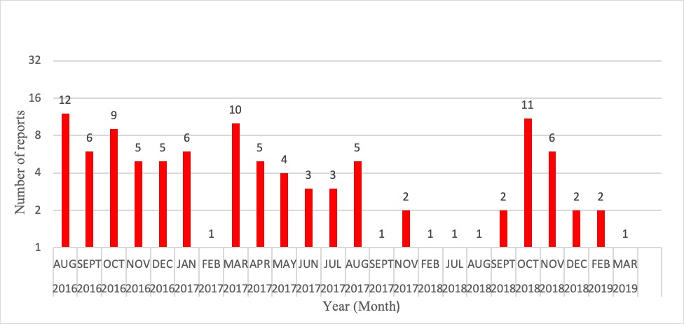

EpiWATCH included a total of 120 reports with the highest number of reports available during the months of August and October in 2016, March 2017, and October 2018. There were relatively less number of reports available in other months (Figure 1).
For confirmed zika infections in total, the numbers of reported zika cases were 81,852, 609, 1,800 and 15 from 2016 through to March 2019, respectively. Figure 2 presents the total number of reported zika cases by country from EpiWATCH globally. The geographical distribution of zika infection shows that the infection transmitted across 19 countries during the study period. The geographical distribution has steadily widened. The largest number of reported cases were found in the United States (81,115). A substantially high number of zika cases were also reported from countries such as Thailand (1,044), Mexico (996) and India (671) during that period.

Figure 2. The total number of reported zika cases by country, 2016-2019 (EpiWATCH).
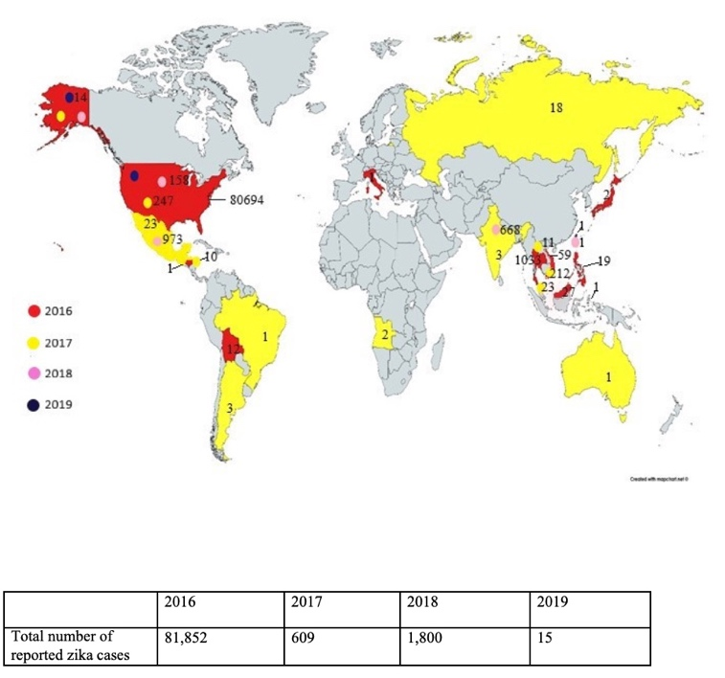

Note: The number of zika cases are mentioned with respect to relevant years.

Figure 3. The total number of pregnant women with possible zika infection, 2016-2019* (from EpiWATCH).

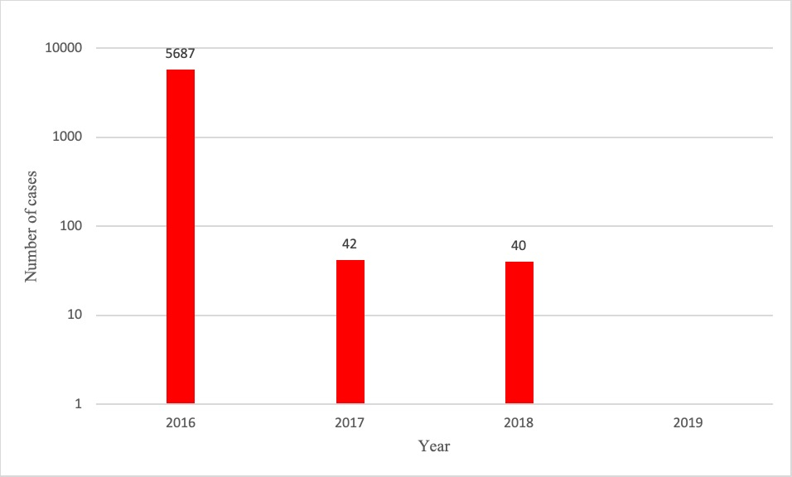

* None reported in 2019.

Figure 3 shows the number of pregnant women with zika infection reported by EpiWATCH by year. EpiWATCH database reported microcephaly cases during 2016 and 2017. The highest number of cases reported in the outbreak was seen during 2017, with 67 microcephaly cases. The reported cases from EpiWATCH also included a study of children with microcephaly in Mato Grosso, Brazil, with a total of 351 cases selected through “surveillance protocol”, of which 52 were confirmed (23). Among the 52 confirmed cases, 25 resulted in death during pregnancy or delivery due to microcephaly. There were no reports of zika-related microcephaly in 2018 and 2019 (until March 2019). In 2016, seven cases were reported with Guillain-Barre Syndrome, rare neurological disorder or potential

complications by zika virus infection, however, no reported cases were observed to have these symptoms during 2017, 2018 and 2019.
Using the available data from EpiWATCH, Table 1 shows the reported number of cases by transmission mode: travel-associated cases, locally- and sexually- transmitted cases, as well as zika-associated deaths. Zika-associated deaths comprised of deaths due to microcephaly and Guillain Barre Syndrome. Reported deaths were the highest in 2017, which included 25 infant deaths due to abortions during pregnancy or stillbirth during delivery. It was shown that the potential causes of deaths reported during 2016 were also related to Guillain Barre Syndrome.

Table 1. Number of reported zika cases globally by mode of transmission and year, 2016-2019 (EpiWATCH).

Zika cases | 2016 | 2017 | 2018 | 2019
Travel-associated cases | 1,470 | 207 | 3 | 15
Locally-transmitted cases | 267 | 10 | 0 | 0
Sexually-transmitted cases | 14 | 1 | 0 | 0
Reported zika-associated deaths | 6 | 25 | 4 | 0

Figure 4. The total number of zika cases by country, 2016-2019, World Health Organization

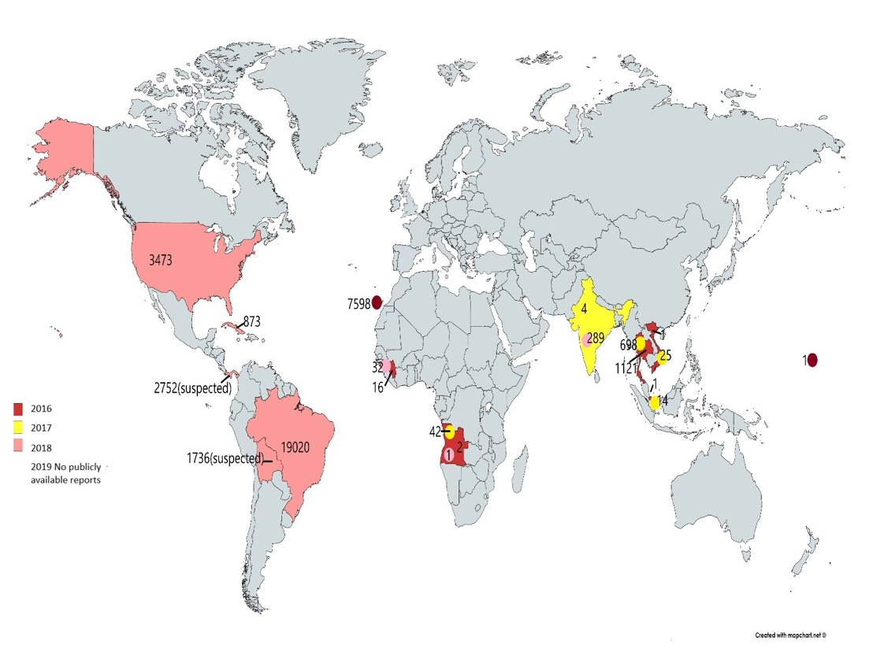

Figure 4 shows the incidence of zika by countries from 2016-2019, derived from the situation summary of 2019 – a global overview by the WHO. The WHO reported both confirmed and suspected cases of zika infection during this period. A total of 37,699 cases were reported during the year 2016-2018, with Bolivia and Panama having 1,736 and 2,752 suspected cases of zika infection. The WHO reported the highest incidence of microcephaly in 2017, with 44 cases in total. However, there were no reports available during 2019 (24).

Discussion
This research explores and analyses the zika virus outbreaks globally using the EpiWATCH outbreak data. The total number of zika cases extracted from 2016-2019 were 84,276. Our findings from EpiWATCH showed that the number of zika cases peaked in 2016 and declined substantially from 2017 to 2019, affecting nineteen countries over the period. Most of the zika cases reported by EpiWATCH were from the United States of America, with 81,115 cases in total. Studies have shown that zika virus affects populations across all ages including adults, pregnant women, infants and seniors, with mild to moderate symptoms consisting of fever, muscle cramps, conjunctivitis, birth defects, and muscle paralysis (10, 25). Also, pregnant women are at a high-risk of zika infection and its complications, such as microcephaly (25).
Although zika is recorded as a vector-borne disease, other routes of transmission such as sexual route, perinatal, blood-borne transmission, locally acquired and travel-related cases were also noted and reported by EpiWATCH (26). Our results showed two major routes of transmission, i.e. travel and local-transmission, and indicated that there were higher numbers of travel-related cases throughout 2016 and 2017. This report is suggestive of the importance of diverse control measures, guidelines and the need for developing strategies to protect individuals against zika infection. Some studies have focussed on various transmission routes to mitigate virus circulation in the population (27). A study showed that most of the zika cases were acquired by travel-transmission route in USA. In that study, about 110 individuals affected (96%) were cases of zika infection who had history of travelling to zika prone areas (28). A systematic review also reported a rapid spread of zika infection from travellers (29). It was found that there were a higher number of zika infections in travellers returning to their homelands from zika infected countries.
From the EpiWATCH database, the highest number of reported zika cases were reported in travellers in 2016, followed by locally transmitted cases. This also highlighted the importance of travel advisories, by informing proper precautionary approaches for pregnant women and sexual partners accordingly relevant to their travel destinations. Determining the contribution of travel-associated zika cases emphasises the geographical high-risk regions, along with insights into the existence and level/degree of the risk of transmission in geographical regions. Also, our study highlights the importance of imported cases as it could potentially result in local-transmission of the virus in some regions. From the study’s findings, there is an increasing trend of zika infections observed during the main tourism season (data not shown). Other studies and the Center for Disease Control and Prevention (CDC) also reported similar cases due to travelling and tourism during peak seasons, and travel warnings were being issued to zika virus affected countries in conjunction with other preventive measures (28, 29). The previous geo-sentinel analysis also presented situational similarity to efforts followed during former zika outbreaks (30).
Zika-related deaths were reported in severe cases of Guillain Barre syndrome in adults and older individuals, and some microcephaly in infants. There were cases of fetal deaths and miscarriage/still births, along with severe neurological sequelae causing a deadly paralysis observed in the study (31). On the basis of available evidence from research studies, there is causal association between zika virus and microcephaly and serious neurological anomalies (31, 32). It was explained in the study that the zika virus could breach the placental barrier and transmit the infection, with the indication of virus and its persistence in the placenta (33). Studies also suggest that zika is a classic TORCH (toxoplasma, other, rubella, cytomegalovirus, and herpes) pathogen and that it enters the fetal brain during pregnancy by crossing the placental barrier (34). Another study also demonstrated lucidity towards the plausible suggestion of virus crossing through the maternal placental barrier and developing infection leading to long-term neurological manifestations (35). Additionally, the re-emergence of two major lineages of zika virus, the Asian and African lineages, might contribute to the transmission and the spread of disease in diverse countries (36). Similar findings were reported by the CDC (28, 37).
EpiWATCH documented cases show a quantitative, seasonal surge of zika infection with an increasing number of cases in the United States, India, Mexico, Singapore, Thailand and Vietnam during the wet and rainy seasons, suggesting that the climate setting favours the abundance of vectors for the transmission of zika infections (data not shown). Studies also documented that the epidemic waves lengthened and the upsurge of infection was found during temperate and rainy seasons in tropical and subtropical regions (38, 39). As evident from the results, the epidemiologic inferences from the descriptive data were broadly in line with most other recent studies showing similar outbreaks in the island and coastal regions, in addition to the seasons favouring the breeding of mosquitoes (40, 41).
A comparison of EpiWATCH and the WHO’s database reveals that the WHO covered a broader outreach of areas in collection of zika information. The WHO provided a global overview of zika outbreaks across four of the six WHO regions: African Region, Region of the Americas, South-East Asia Region, and Western Pacific Region. In contrast to EpiWATCH’s chronological report, the WHO provided a comprehensive and cumulative situation summary report in public domain. Thus, it is difficult to analyse year-by-year cases between the two systems. A summary finding from the WHO global overview showed that the highest number of cases were seen in Brazil, followed by the African region, with cases of microcephaly reported in African, West pacific, South-east Asian regions. A comparison by countries reported under the WHO and EpiWATCH shows wider regions and countries covered by the WHO in the year 2016. Correspondingly, EpiWATCH also provided information on zika outbreaks from various countries by gathering a rich database around zika virus infection. The WHO reported the documented zika cases from 2007 through to 2016 across 44 countries, with the highest laboratory-confirmed zika infections from Brazil in 2015. Although significantly high numbers of zika cases were reported in Brazil during 2015/2016 (42, 43), EpiWATCH data did not capture such information, especially from Brazil as anticipated. These could be due to reporting bias in English-language data, as well as the maturity of the EpiWATCH surveillance system, which was developed and piloted in early 2016.
EpiWATCH systematically collects information that is available in public domain and are readily accessible and easy to use with a quick search. The other advantage is that EpiWATCH scans and captures outbreak reports daily and provides a rapid analysis of global disease outbreaks, which assists in early detection and surveillance of emerging and re-emerging infection in a timely manner. Consequently, these data serve as a source of information with regard to disease data, which can then form a valuable basis towards effective use of risk-reduction and management in public health services, thus strengthening public health security. Furthermore, the EpiWATCH database has global news reports and social media feeds from diverse languages, thereby eliminating language barriers in identifying outbreaks and biases through the inclusion of non-English language reports. However, there are some limitations in EpiWATCH, such as biases due to omissions of information leading to data gaps, media bias in selection and coverage of reporting which resulted in either over- or under-reporting of cases, and social desirability bias (with regards to the WHO) due to unwillingness by certain countries in reporting data to the WHO as it may affect the tourism industry and trade (44). However, in this study, data extracted were in an aggregated format, and thus we cannot identify cases by age groups. Moreover, the EpiWATCH system is not automated and is a labour intensive procedure as manual intervention is required in collecting, storing and analysing the data. Thus, techniques such as web crawling, text mining, etc. can be used to overcome those limitations. As a benefit, EpiWATCH could consider effective collaboration with search engine giants like Google to enable various activities through the usage of data miners and web crawlers to extract outbreaks of many diseases and to provide real-time updates globally.

Conclusion
Zika outbreaks significantly changed the world economy with the explosive spread and declaration of a global health emergency for a defined period. Thus, these outbreaks underline the need for continued vigilance of disease detection at a global level. This study provided a global analysis of zika outbreak trends over time in relation to geolocation and epidemiology. Study findings showed that the use of an open-source surveillance system, such as EpiWATCH, could provide information about outbreaks of emerging and re-emerging infection globally in a timely manner. Countries with low healthcare resource settings may have some benefits in adopting such a system in addition to traditional public health surveillance, for early detection and diagnosis of emerging infections to respond to appropriate intervention both locally and internationally.

References
- Ewald PW. Evolution of infectious disease: Oxford University Press on Demand; 1994.
- Smith KF, Goldberg M, Rosenthal S, Carlson L, Chen J, Chen C, et al. Global rise in human infectious disease outbreaks. Journal of the Royal Society Interface. 2014;11(101):20140950.
- Focosi D, Maggi F, Pistello M. Zika virus: implications for public health. Clinical Infectious Diseases. 2016;63(2):227-33.
- MacDonald PD, Holden EW. Zika and public health: Understanding the epidemiology and information environment. Pediatrics. 2018;141(Supplement 2):S137-S45.
- Petersen LR, Jamieson DJ, Powers AM, Honein MA. Zika virus. New England Journal of Medicine. 2016;374(16):1552-63.
- Quereshi A. zika virus disease: From origin to outbreak: Academic Press; 2017.
- Faye O, Freire CC, Iamarino A, Faye O, de Oliveira JVC, Diallo M, et al. Molecular evolution of Zika virus during its emergence in the 20th century. PLoS neglected tropical diseases. 2014;8(1):e2636.
- Kuno G, Chang G-J. Full-length sequencing and genomic characterization of Bagaza, Kedougou, and Zika viruses. Archives of virology. 2007;152(4):687-96.
- Haddow AD, Schuh AJ, Yasuda CY, Kasper MR, Heang V, Huy R, et al. Genetic characterization of Zika virus strains: geographic expansion of the Asian lineage. PLoS neglected tropical diseases. 2012;6(2):e1477.
- Weaver SC, Costa F, Garcia-Blanco MA, Ko AI, Ribeiro GS, Saade G, et al. Zika virus: History, emergence, biology, and prospects for control. Antiviral research. 2016;130:69-80.
- Waddell LA, Greig JD. Scoping review of the Zika virus literature. PloS one. 2016;11(5):e0156376.
- Rossi SL, Ebel GD, Shan C, Shi P-Y, Vasilakis N. Did Zika virus mutate to cause severe outbreaks? Trends in microbiology. 2018;26(10):877-85.
- Musso D, Gubler DJ. Zika virus. Clinical microbiology reviews. 2016;29(3):487-524.
- Heymann DL, Hodgson A, Freedman DO, Staples JE, Althabe F, Baruah K, et al. Zika virus and microcephaly: why is this situation a PHEIC? The Lancet. 2016;387(10020):719-21.
- Moore CA, Staples JE, Dobyns WB, Pessoa A, Ventura CV, Da Fonseca EB, et al. Characterizing the pattern of anomalies in congenital Zika syndrome for pediatric clinicians. JAMA pediatrics. 2017;171(3):288-95.
- Costa F, Sarno M, Khouri R, de Paula Freitas B, Siqueira I, Ribeiro GS, et al. Emergence of congenital Zika syndrome: viewpoint from the front lines. Annals of internal medicine. 2016;164(10):689-91.
- Hughes RA, Cornblath DR. Guillain-barre syndrome. The Lancet. 2005;366(9497):1653-66.
- Waggoner JJ, Pinsky BA. Zika virus: diagnostics for an emerging pandemic threat. Journal of clinical microbiology. 2016;54(4):860-7.
- Chakhtoura N, Hazra R, Spong CY. Zika virus: a public health perspective. Current opinion in obstetrics & gynecology. 2018;30(2):116-22.
- Chen LH, Hamer DH. Zika virus: rapid spread in the western hemisphere. American College of Physicians; 2016.
- Plourde AR, Bloch EM. A literature review of Zika virus. Emerging infectious diseases. 2016;22(7):1185.
- Hii A, Chughtai A, Housen T, Saketa S, Kunasekaran M, Sulaiman F, et al. Epidemic intelligence needs of stakeholders in the Asia-Pacific Region, 2017. International Journal of Infectious Diseases. 2019;79:113.
- Possas C, Brasil P, Marzochi MC, Tanuri A, Martins RM, Marques ET, et al. Zika puzzle in Brazil: peculiar conditions of viral introduction and dissemination-A Review. Memórias do Instituto Oswaldo Cruz. 2017;112(5):319-27.
- Laengin T, Augenstein S, Stadlbauer E, Girgnhuber H, Gloeck M, Riedel A. Performance of an Automated Zika IgG Immunoassay in the Detection of Zika IgG Specific Antibodies—A Validation Approach in Samples from Prevalence Areas and Non-Endemic Countries. Tropical Medicine and Infectious Disease. 2020;5(2):97.
- Johansson MA, Mier-y-Teran-Romero L, Reefhuis J, Gilboa SM, Hills SL. Zika and the risk of microcephaly. New England Journal of Medicine. 2016;375(1):1-4.
- Gregory CJ, Oduyebo T, Brault AC, Brooks JT, Chung K-W, Hills S, et al. Modes of transmission of Zika virus. The Journal of infectious diseases. 2017;216(suppl_10):S875-S83.
- Clapham H. Determinants of Zika transmission and control. Journal of Infectious Diseases. 2018.
- Armstrong P. Travel-associated Zika virus disease cases among US residents—United States, January 2015–February 2016. MMWR Morbidity and mortality weekly report. 2016;65.
- Wilder-Smith A, Chang CR, Leong WY. Zika in travellers 1947–2017: a systematic review. Journal of travel medicine. 2018;25(1):tay044.
- Leder K, Grobusch MP, Gautret P, Chen LH, Kuhn S, Lim PL, et al. Zika beyond the Americas: Travelers as sentinels of Zika virus transmission. A GeoSentinel analysis, 2012 to 2016. Plos one. 2017;12(10):e0185689.
- Ladhani SN, O'Connor C, Kirkbride H, Brooks T, Morgan D. Outbreak of Zika virus disease in the Americas and the association with microcephaly, congenital malformations and Guillain–Barré syndrome. Archives of disease in childhood. 2016;101(7):600-2.
- Coelho AVC, Crovella S. Microcephaly prevalence in infants born to Zika virus-infected women: a systematic review and meta-analysis. International journal of molecular sciences. 2017;18(8):1714.
- Mysorekar IU, Diamond MS. Modeling Zika virus infection in pregnancy. New England Journal of Medicine. 2016;375(5):481-4.
- Wen Z, Song H, Ming G-l. How does Zika virus cause microcephaly? Genes & development. 2017;31(9):849-61.
- Quicke KM, Bowen JR, Johnson EL, McDonald CE, Ma H, O’Neal JT, et al. Zika virus infects human placental macrophages. Cell host & microbe. 2016;20(1):83-90.
- Lanciotti RS, Lambert AJ, Holodniy M, Saavedra S, Signor LdCC. Phylogeny of Zika virus in western hemisphere, 2015. Emerging infectious diseases. 2016;22(5):933.
- Thomas DL. Local transmission of Zika virus—Puerto Rico, November 23, 2015–January 28, 2016. MMWR Morbidity and mortality weekly report. 2016;65.
- Shapshak P, Somboonwit C, Foley BT, Alrabaa SF, Wills T, Sinnott JT. Zika virus. Global Virology I-Identifying and Investigating Viral Diseases: Springer; 2015. p. 477-500.
- Shragai T, Tesla B, Murdock C, Harrington LC. Zika and chikungunya: mosquito-borne viruses in a changing world: Global change and vectors of chikungunya and Zika. Annals of the New York Academy of Sciences. 2017.
- Ibrahim NK. Zika virus: Epidemiology, current phobia and preparedness for upcoming mass gatherings, with examples from World Olympics and Pilgrimage. Pakistan journal of medical sciences. 2016;32(4):1038.
- Monaghan AJ, Morin CW, Steinhoff DF, Wilhelmi O, Hayden M, Quattrochi DA, et al. On the seasonal occurrence and abundance of the Zika virus vector mosquito Aedes aegypti in the contiguous United States. PLoS currents. 2016;8.
- Lowe R, Barcellos C, Brasil P, Cruz OG, Honório NA, Kuper H, et al. The Zika virus epidemic in Brazil: from discovery to future implications. International journal of environmental research and public health. 2018;15(1):96.
- Hills SL, Fischer M, Petersen LR. Epidemiology of Zika virus infection. The Journal of Infectious Diseases. 2017;216(suppl_10):S868-S74.
- Schwartz B. WHO issues new Zika updates. Contemporary OB/GYN. 2019;64(8):7-8.

Appendix

Table A1. The number of zika outbreak reports and cases by country, month and year, 2016-2019 (EpiWATCH).

Year | Month | Country | Total-Number of Cases | Number of Reports
2016 | August | USA | 11308 | 9
2016 | August | Taiwan | 1 | 1
2016 | August | Italy | 1 | 1
2016 | August | Singapore | 1 | 1
2016 | September | USA | 0 | 2
2016 | September | Singapore | 1 | 1
2016 | September | Malaysia | 12 | 1
2016 | September | Thailand | 353 | 1
2016 | September | Japan | 2 | 1
2016 | October | Honduras | 1 | 1
2016 | October | Malaysia | 7 | 1
2016 | October | USA | 31502 | 3
2016 | October | Vietnam | 12 | 2
2016 | October | UK | 0 | 1
2016 | October | Philippines | 19 | 1
2016 | November | Palau | 1 | 1
2016 | November | Vietnam | 47 | 2
2016 | November | Bolivia | 12 | 1
2016 | November | Thailand | 680 | 1
2016 | December | USA | 37884 | 4
2016 | December | Malaysia | 8 | 1
2017 | January | Africa | 2 | 2
2017 | January | Australia | 1 | 1
2017 | January | Vietnam | 212 | 1
2017 | January | Honduras | 10 | 1
2017 | January | USA | 3 | 1
2017 | February | Mexico | 23 | 1
2017 | March | Brazil | 1 | 1
2017 | March | Argentina | 3 | 2
2017 | March | USA | 90 | 2
2017 | March | Russia | 18 | 1
2017 | March | Singapore | 6 | 4
2017 | April | Singapore | 12 | 4
2017 | April | USA | 10 | 1
2017 | May | Singapore | 2 | 2
2017 | May | India | 3 | 2
2017 | June | Singapore | 2 | 1
2017 | June | USA | 140 | 2
2017 | July | Thailand | 11 | 1
2017 | July | USA | 1 | 1
2017 | July | Singapore | 1 | 1
2017 | August | USA | 3 | 4
2017 | August | Italy | 1 | 1
2017 | September | Italy | 1 | 1
2017 | November | USA | 2 | 2
2018 | February | USA | 0 | 1
2018 | July | Taiwan | 1 | 1
2018 | August | Brazil | 0 | 1
2018 | September | India | 1 | 2
2018 | October | India | 135 | 8
2018 | October | USA | 158 | 3
2018 | November | India | 252 | 4
2018 | November | Mexico | 723 | 2
2018 | December | Mexico | 250 | 1
2018 | December | India | 280 | 1
2019 | February | French Polynesia | 0 | 1
2019 | February | Taiwan | 1 | 1
2019 | March | USA | 14 | 1

How to cite this article: Bhargavi BS & Moa A. Global outbreaks of zika infection by epidemic observatory (EpiWATCH), 2016-2019. Global Biosecurity, 2020; 1(4).
Published: October 2020
Copyright: Copyright © 2020 The Author(s). This is an open-access article distributed under the terms of the Creative Commons Attribution 4.0 International License (CC-BY 4.0), which permits unrestricted use, distribution, and reproduction in any medium, provided the original author and source are credited. See http://creativecommons.org/licenses/by/4.0/ .
Global Biosecurity is a peer-reviewed open access journal published by University of New South Wales.

