RAPID REPORTS AND PERSPECTIVES FROM THE FIELD
Rise in pneumonia cases of unknown aetiology in Kazakhstan in June 2020: A rapid analysis
Phi-Yen Nguyen¹, Xin Jessie Chen² & Mohana Kunasekaran²
¹ University of New South Wales
² Biosecurity Program, Kirby Institute, University of New South Wales
Abstract
On 9 July 2020, the Chinese Embassy in Kazakhstan issued a warning of a “local pneumonia of unknown cause” in Kazakhstan, which purportedly had a much higher fatality rate than COVID-19. The Ministry of Health of Kazakhstan refuted the claim, stating that these pneumonia cases were diagnosed clinically without laboratory confirmation, and might include non-laboratory confirmed COVID-19 cases. This article aims to provide a rapid epidemiological analysis of pneumonia and COVID-19 in Kazakhstan from January to June 2020 and examine past trends in respiratory disease outbreaks in Kazakhstan since September 2019. Descriptive statistics were presented using COVID-19 statistics from the World Health Organisation (WHO) and pneumonia statistics from media briefings by Kazakhstan’s Ministry of Health. Case fatality rates (CFR) of pneumonia cases for the first 6 months of 2019 and 2020 were 2.67% and 1.42%, respectively. CFR of pneumonia cases for June 2019 and June 2020 were 3.44% and 1.92%, respectively. The numbers of pneumonia cases and deaths have increased in 2020, but with lower CFR, as compared to the same period in 2019. From 16 September 2019 to 10 July 2020, a total of 80 reports of disease outbreaks in Kazakhstan were detected, including 15 reports of respiratory diseases of unknown aetiology. A cluster of 6 reports were detected over 2 days about the surge in pneumonia cases in June 2020, a strong signal that prompted the investigation underlying this study.

Discussion: Epidemic curves of COVID-19 cases and deaths are consistent with the hypothesis that the spike of pneumonia cases in June 2020 is attributed to COVID-19 cases diagnosed clinically but not confirmed with laboratory testing. This event illustrates that EpiWatch was capable of detecting early signs of a suspicious epidemic activity through event-based surveillance of informal, non-English information channels. It also provides sources for disease statistics, in this case pneumonia incidence, which are not published on official websites but are important data for preliminary analysis of emerging infections.
Key words: Kazakhstan, pneumonia, unknown aetiology, surveillance, COVID-19, infectious diseases

Background
On 9 July 2020, the Chinese Embassy in Kazakhstan issued a warning of a “local pneumonia of unknown case” in Kazakhstan, which purportedly had a much higher fatality rate than COVID-19 (1). The statement cited local reports that out of 1,772 deaths caused by pneumonia in the first 6 months of 2020, 628 deaths (35.4%) occurred in June alone (1). On 10 July 2020, the Ministry of Health of Kazakhstan refuted the claim, asserting that pneumonia cases were collected routinely and categorised based on the World Health Organisation (WHO) International Classification of Diseases 10 (ICD-10). In Kazakhstan, COVID-19 infections diagnosed clinically and epidemiologically, but confirmed through laboratory testings, are classified under the ICD-10 criteria of “Viral pneumonia of unspecified aetiology” (2). After subsequent WHO consultations, Kazakhstan announced that starting from 1 August 2020, it will integrate viral pneumonia of unknown aetiology to COVID-19 cases and deaths, which will now include laboratory-confirmed COVID-19 and non-laboratory confirmed pneumonia cases with COVID-19 clinical symptoms (3). This decision is consistent with WHO’s earlier assessment that inadequate national testing capacity in Kazakhstan may result in COVID-19 cases being misdiagnosed as pneumonia (4).
This article aims to provide a rapid epidemiological analysis of pneumonia and COVID-19 in Kazakhstan from January to June 2020. Moreover, the recent surge in pneumonia cases was examined in the context of all notifications of respiratory infectious disease outbreaks in Kazakhstan since September 2019 in EpiWatch.

Methods
COVID-19 statistics were retrieved from the WHO official dashboard (5). Pneumonia statistics were gathered from media reports and media briefings by Kazakhstan’s Ministry of Health. Epidemic curves were constructed based on COVID-19 cases and deaths as of 18 July 2020. Case fatality rates (CFR) of confirmed COVID-19 cases and pneumonia cases were calculated based on their respective death statistics; and a combined CFR was calculated on the assumption that all viral pneumonia cases with unknown aetiology are non-laboratory confirmed COVID-19 cases.
A strengthened surveillance protocol was implemented on 16 September 2019 to monitor disease trends around the focus of Kolstsovo (Novosibirsky, Russia). Reports of infectious outbreaks in Kazakhstan were retrieved from the EpiWatch database for the period of 16 September 2019 to 10 July 2020 (date of Kazakhstan’s official statement on pneumonia of unknown aetiology). These reports were reviewed for aetiology, locations and distance from the Vector building based on Google Maps. Aetiology was classified into known and unknown; and further stratified into bacterial, viral or others. Trends in notifications of infectious outbreaks in Kazakhstan were plotted over time. A scatter plot showing these reports based on aetiology, distance from the focus of surveillance and days from the start date (16 September 2019) was generated. Reports that do not specify a provincial-level location within Kazakhstan are excluded from the scatter plot.

Results
COVID-19 Situation in Kazakhstan
As of 10 July 2020, Kazakhstan registered a total of 54,747 confirmed COVID-19 cases, with 296 deaths (CFR of 0.54%) (5). The first signals of cases were reported on 13 March 2020, when four Kazakh citizens in Almaty and Nur-Sultan contracted COVID-19 after returning from Germany and Italy.
Due to its proximity with China, Kazakhstan implemented pre-emptive response measures even before the first case was detected. On 26 January 2020, airport and border control was strengthened. Passenger trains and flights from China were suspended on 1 February and 3 February 2020, respectively. On 20 February 2020, all other overseas countries were stratified based on risk levels and returning travellers were placed under quarantine according to where they returned from. Just 2 days after the first case was detected, the country swiftly entered a state of emergency on 16 March 2020, with strict quarantine regime nationwide and controlled entrance/exit through major cities. The state of emergency was originally planned to end on 15 April, and was extended to 11 May 2020. This decree enforced several measures to curb the spread of COVID-19, most notably suspending activities at places of mass gathering such as shopping and recreation centres, cinemas, and exhibitions among others; prohibiting mass gatherings; and restricting entrances and exits at the borders for all forms of transport. (6)
Following the lifting of the restrictions on 11 May 2020, Kazakhstan’s major cities experienced a resurgence of COVID-19 cases, with hospitals in Nur-Sultan warning of reaching 90% capacity limits. Nur-Sultan’s Department of Public Health revealed that as of 17 June 2020, a total of 1,711 patients were receiving treatment at Nur-Sultan Infectious Disease Hospital, the capital’s designated COVID-19 treatment facility, among whom 10% were critically ill patients in ICU and the remaining with moderate severity (7). On 5 July 2020, Kazakhstan introduced another 14-day restriction period, becoming the first country to re-enter a second full lockdown (8).
Figure 1 summarises the trend in COVID-19 cases and deaths in Kazakhstan in the studied period, with a timeline of significant events. Following the lifting of restriction, daily case numbers started rising gradually since 17 May 2020 (6 days after re-opening) and surging since 20 June 2020 (40 days after re-opening, or approximately 3 incubation periods). Daily death counts started rising since 1 June 2020 (15 days after re-opening, or approximately 2 incubation periods).

Pneumonia reports in Kazakhstan
According to media briefings by the Ministry of Health, 234,187 cases of pneumonia and 3,327 pneumonia deaths were registered between 1 January 2020 and 15 July 2020. Compared with the same period last year (70,926 cases and 1,896 deaths), the number of pneumonia cases has increased by 230.2% and pneumonia deaths by 75.5% (9). CFR for the first 6 months of 2019 and 2020 were 2.67% and 1.42%, respectively.
Specifically, 32,724 pneumonia cases and 628 pneumonia deaths were registered in June 2020. Compared with June 2019 (7,964 cases and 274 deaths), the number of pneumonia cases has increased by 310.1% and pneumonia deaths by 129.2% (9,10). CFR for June 2019 and June 2020 were 3.44% and 1.92%, respectively.
Overall, based on preliminary statistics, the numbers of pneumonia cases and deaths have increased in 2020, but with lower CFR, as compared to the same period in 2019. This is consistent with a government report that shows a decline in pneumonia incidence and mortality in East Kazakhstan region for 2016 to 2019 (11).

Infectious disease outbreaks in Kazakhstan
From 16 September 2019 to 10 July 2020, a total of 80 reports of disease outbreaks in Kazakhstan were detected. Out of 80 reports, 62 were outbreaks with identified pathogens (77.5%), including 43 viral (69.4%), 15 bacterial (24.2%) and 3 of other causes (6.5%). Of the 18 reports with unidentified pathogens, 3 were suspected viral infections (16.7%). Among 46 reports about outbreaks of viral aetiology, 33 (71.7%) were on COVID-19.
Among 80 reports, there are 18 (23%) written in English, 41 (51%) in Kazakh, 14 (18%) in Mandarin Chinese, 6 (8%) in Russian and 1 (1%) in Hindi.
Figures 2 & 3 show the trends in notifications of all disease outbreaks in Kazakhstan for the studied period, classified by class of pathogens.
Figure 3 shows the spatial-temporal spread of disease outbreak notifications in Kazakhstan for the studied period. Within 100 days from the start of the strengthened surveillance system, the system had reported 40 events in Kazakhstan, with a balanced mix of identified diseases and diseases with unknown aetiology. Since 14 March 2020, the system received another 40 notifications, of which 28 were excluded from the scatter plot as they were nationwide COVID-19 statistics updates and thus without a specific location. Although the excluded reports did not inform new outbreaks, they collected to assist observatory members in monitoring trends and policy updates for COVID-19 response in Kazakhstan. The clusters of reports about the surge in pneumonia cases on 9-10 July 2020 prompted the investigation underlying this study.

Figure 1. Epidemic curve of daily cases and deaths in Kazakhstan from 14 March 2020 to 10 July 2020. Date of reporting to the WHO is used as proxy for onset date.
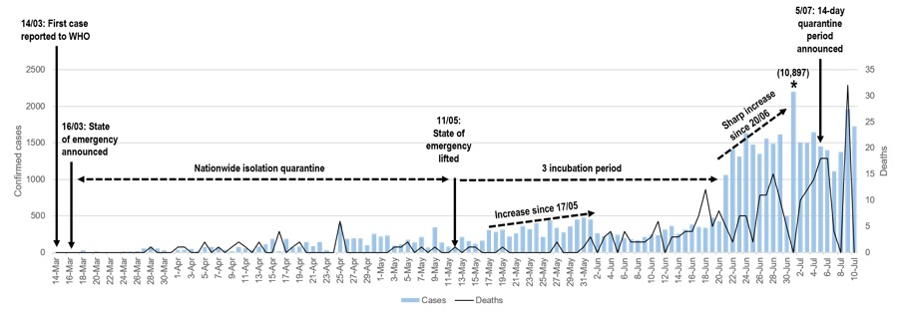
* Note: The number of confirmed cases on 1 July 2020 is 10,837 cases, following a new reporting protocol that includes asymptomatic COVID-19 cases. The case count for 1 July 2020 was cut off at 2,500 to maintain high resolution in this bar chart

Figure 2. Number of daily reports of disease outbreaks in Kazakhstan from 16 September 2019 to 31 December 2019 (a), and 14 March 2020 to 10 July 2020 (b). The period of 1 January 2020 to 13 March 2020 was omitted due to absence of reports. A disease is classified as "unknown" if no specific detail was given in source materials to identify aetiology.
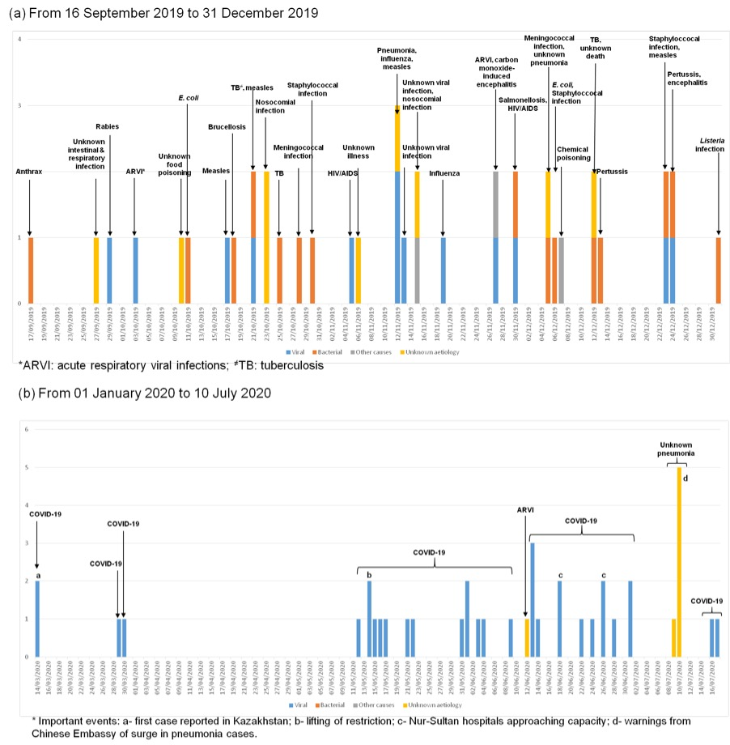

Figure 3. Spatial-temporal trend in daily reports of disease outbreaks in Kazakhstan from 16 September 2019 to 10 July 2020, by aetiology. 34 reports were excluded because they provide nationwide statistics and do not identify a local outbreak (28 were daily COVID-19 statistics update).
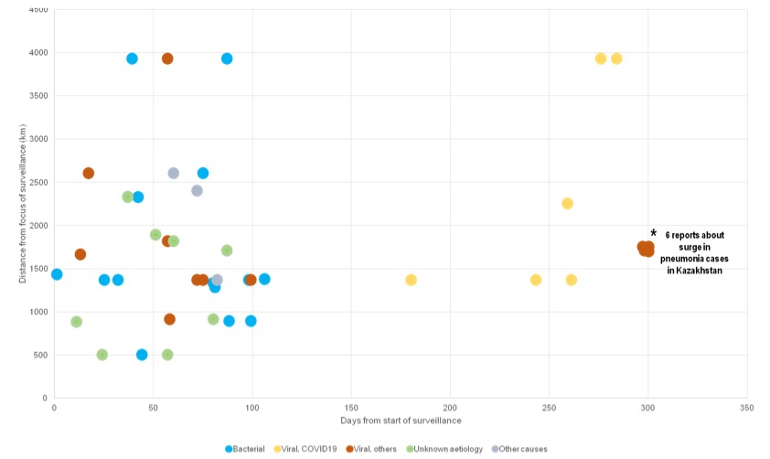

Table 1. More details on reports of respiratory diseases of unknown aetiology in the studied period.

Date of notification | Event | Location | Source
27/09/2019 | An 11-year-old child died of bilateral pneumonia, cerebral oedema and other concomitant diseases. She was first admitted on 1/08/2019 with diarrhoea and vomiting. | Karaganda | (12)
3/10/2019 | A 4-year-old child died after being treated for suspected acute respiratory viral infections (ARVI). He was first admitted on 28/09/2019 with fever, lethargy, headache and vomiting. | Aktau | (13)
6/11/2019 | Residents reported 7 deaths over the past 1.5 years, with an average age of 71 (range 50-97). Official inquiry found an increase in overall mortality, but ruled out mortality due to malignant neoplasms and radiation activity from a local gold mine. | Bulak | (14)
12/11/2019 | A 53-year-old man died of bilateral pneumonia (no further information). | Pavlodar | (15)
15/11/2019 | A 5-year-old child died of severe viral infection, complicated by damage to the bronchopulmonary system and brain. She first visited a local polyclinic with complaints of fever, and was subsequently admitted to hospital. Meningitis was ruled out after lumbar puncture. | Aktobe | (16)
27/11/2019 | Since the beginning of 2019, Almaty reported 9,000 cases of ARVI, lower than the same time last year but with more than 50% cases among children. 648 cases of measles were reported, mainly amongst the unvaccinated and children under one years of age. | Almaty | (17)
5/12/2019 | A 3-year-old child was hospitalised and placed in the intensive care unit after being diagnosed with pneumonia. He developed gangrene after an antibiotic IV injection, which led to amputation. | Kokshetau | (18)
12/12/2019 | An 11-year-old child died after complaining of severe headache and vomiting. Meningitis was suspected as the cause of death. | Shymkent | (19)
12/06/2020 | Respiratory diseases accounted for 11.7% of deaths from January-March 2020, including 1008 from influenza, acute respiratory infections, and pneumonia. | Kazakhstan | (20)
9/07/2020 | The Chinese Embassy warned its citizens living in Kazakhstan of a local pneumonia that was allegedly deadlier than the corona virus infection. It cited local reports that "1,772 people died of unknown pneumonia in the first six months of this year, with 628 dying in June alone." | Shymkent, Atyrau and Aktobe | (21)
10/07/2020 |  |  | (22–26)

Discussion
Several signs support the hypothesis that the rise in pneumonia cases in Kazakhstan was related to resurgence of COVID-19 cases after the lifting of quarantine restrictions. Kazakhstan’s epidemic curve shows clear signs of a second-wave, as cases started to rise after 2-3 periods of incubation from the end of restriction. The sharp increase in cases occurred from 20 June 2020, which coincides with reports of hospitals reaching full capacity in major cities at the end of June (7). The rise in pneumonia cases of unknown aetiology was also reported within this period (1). Moreover, the locations where the purported pneumonia outbreaks occurred (Shymkent city, Atyrau province and Aktobe province) are also COVID-19 hot spots (27).
In addition, despite the initial sharp increase, daily new cases have been stabilising at approximately 1,500 cases per day since 1 July 2020, which is inconsistent with the exponential increase of COVID-19 as observed in other countries with second waves (28,29). At the same time, daily new deaths continue to rise, with an observed 100% daily increase on 9 July and 11 July 2020 (5). These patterns suggest that the testing capacity of the country has reached its full limit, putting a cap on the number of newly diagnosed daily.
The release of aggregated data on COVID-19 and viral pneumonia of unknown aetiology on 1 August 2020 will allow us to calculate the combined CFR and examine retrospectively whether the surge in undiagnosed pneumonia in June 2020 was indeed undiagnosed COVID-19, or some other causes.
This event illustrates that EpiWatch was capable of detecting early signs of a potential emerging infection through event-based surveillance of informal, non-English information channels. The scatter plot illustrates how the spatial-temporal pattern of EpiWatch notifications can alert the observatory to suspicious epidemic activity. The first signal of this event was an article on 9 July 2020, followed by 5 other articles on 10 July 2020, forming a cluster around the same date-distance coordinate. Data on pneumonia incidence in Kazakhstan was not publicly shared on official sources, so statistics from media channels (who had access to official figures through media briefings by the Minister of Health) are an important source for preliminary analysis of CFR and incidence.

Conclusion
Preliminary statistics show that although pneumonia cases and deaths have increased in 2020, the CFR is lower compared to the same period in 2019. The high CFR among pneumonia cases of unknown aetiology in Kazakhstan in June 2020 is possibly due to non-laboratory confirmed COVID-19 cases, which points to the need for national testing capacity to keep up with the surge of COVID-19 cases following the lifting of quarantine restrictions. More data analysis is needed after the new reporting protocol is implemented on 1 August 2020.
This event demonstrates the capacity of EpiWatch in rapid detection of unusual epidemic signals around the world, especially from non-English and non-governmental sources.

Reference
- Global Times. Chinese Embassy in Kazakhstan urges caution following reports of “unknown pneumonia.” 2020 Jul 9 [cited 2020 Jul 15]; Available from: https://www.globaltimes.cn/content/1194082.shtml
- Government of Kazakhstan. Кейбір Қытай БАҚ-тарының Қазақстандағы жаңа пневмония туралы ақпараты шындыққа сәйкес келмейді [The information of some Chinese media about the new pneumonia in Kazakhstan is not true] [Internet]. Available from: https://www.gov.kz/memleket/entities/dsm/press/news/details/informaciya-nekotoryh-kitayskih-smi-o-novoy-pnevmonii-v-kazahstane-ne-sootvetstvuet-deystvitelnosti
- KAZ Inform. Kazakhstan to release aggregate data on coronavirus, pneumonia cases [Internet]. 2020 [cited 2020 Jul 18]. Available from: https://www.inform.kz/en/kazakhstan-to-release-aggregate-data-on-coronavirus-pneumonia-cases_a3673855
- World Health Organisation. Media briefing on COVID-19, 10 July 2020 [Internet]. 2020 [cited 2020 Jul 18]. Available from: https://www.youtube.com/watch?v=B9hNbOPKQbk
- World Health Organisation. Kazakhstan: WHO Coronavirus Disease (COVID-19) Dashboard | WHO Coronavirus Disease (COVID-19) Dashboard [Internet]. [cited 2020 Jul 18]. Available from: https://covid19.who.int/region/euro/country/kz
- Kazakhstan Council on International Relations. COVID-19 Strategy: Chronology, Measures, Results [Internet]. 2020. Available from: http://kazcouncil.kz/storage/app/media/covideng.pdf
- China News Network. 哈萨克斯坦首都疫情恶化 逼近抗疫医疗资源负荷上限 [Kazakhstan’s capital epidemic worsens and approaches the upper limit of anti-epidemic medical resource load_Nur Sultan] [Internet]. 2020 [cited 2020 Jul 18]. Available from: https://www.sohu.com/a/402549138_123753
- Government of Kazakhstan. State Commission approves measures to stabilize epidemiological situation in Kazakhstan - Official Information Source of the Prime Minister of the Republic of Kazakhstan [Internet]. [cited 2020 Jul 18]. Available from: https://primeminister.kz/en/news/goskomissiya-utverdila-mery-po-stabilizacii-epidemiologicheskoy-situacii-v-rk-26422
- KAZ Inform. Kazakhstan reports 3,327 pneumonia deaths since beginning of 2020 [Internet]. 2020 [cited 2020 Jul 18]. Available from: https://www.inform.kz/en/kazakhstan-reports-3-327-pneumonia-deaths-since-beginning-of-2020_a3673894
- CTGN. What you need to know about the “unspecified” pneumonia in Kazakhstan - CGTN [Internet]. 2020 [cited 2020 Jul 18]. Available from: https://news.cgtn.com/news/2020-07-12/What-you-need-to-know-about-the-unspecified-pneumonia-in-Kazakhstan-S46oGg79n2/index.html
- Altay News. The number of patients with pneumonia in the East Kazakhstan region has decreased over the past 4 years [Internet]. 2020 [cited 2020 Jul 19]. Available from: https://altaynews.kz/kz/shko-da-pnevmoniyamen-auyirgan-naukastar-sanyi-songyi-4-zhyilda-azajdyi-51468.html
- Tengri News. “Простите, у нас молодой врач”. 11-месячная девочка умерла после кишечной инфекции и ангины ["Sorry, we have a young doctor." 11-month-old girl dies after intestinal infection and sore throat] [Internet]. 2019 [cited 2020 Jul 19]. Available from: https://tengrinews.kz/kazakhstan_news/prostite-nas-molodoy-vrach-11-mesyachnaya-devochka-umerla-380242/
- LADA News. Жительница Актау пожаловалась на врачей детской инфекционной больницы [Aktau resident complained about the doctors of the children’s infectious diseases hospital] [Internet]. 2019 [cited 2020 Jul 19]. Available from: https://www.lada.kz/aktau_news/society/73833-zhitelnica-aktau-pozhalovalas-na-vrachey-detskoy-infekcionnoy-bolnicy.html
- Zakon News. “Загадочные смерти” в селе СКО. Представлены реальные данные ["Mysterious deaths" in the village of SKO. Real data presented] [Internet]. 2019 [cited 2020 Jul 19]. Available from: https://www.zakon.kz/4993700-zagadochnye-smerti-v-sele-sko.html
- Tengri News. Мужчина умер от пневмонии в Павлодаре: родные обвинили врачей скорой помощи [A man died of pneumonia in Pavlodar: relatives accused ambulance doctors] [Internet]. 2019 [cited 2020 Jul 19]. Available from: https://tengrinews.kz/kazakhstan_news/mujchina-umer-pnevmonii-pavlodare-rodnyie-obvinili-vrachey-383760/
- Today News. Девочка умерла от тяжелой вирусной инфекции в Актобе: родители винят врачей - портал [The girl died from a severe viral infection in Aktobe: parents blame doctors] [Internet]. 2019 [cited 2020 Jul 19]. Available from: http://today.kz/news/kazahstan/2019-11-15/786924-devochka-umerla-ot-tyazheloj-virusnoj-infektsii-v-aktobe-roditeli-vinyat-vrachej/
- New Times. Порядка 9 тыс человек заболели ОРВИ в Алматы [About 9 thousand people fell ill with ARVI in Almaty] [Internet]. 2019 [cited 2020 Jul 19]. Available from: https://newtimes.kz/obshchestvo/101123-poryadka-9-tys-patsientov-zaboleli-orvi-v-almaty
- Zakon News. Пневмония у ребенка привела к ампутации руки [Child’s pneumonia led to arm amputation] [Internet]. 2019 [cited 2020 Jul 19]. Available from: https://www.zakon.kz/4997457-pnevmoniya-u-rebenka-privela-k.html
- Zakon News. “Винит мать в смерти”. Стали известны подробности смерти школьницы из Шымкента ["Mother blames death." Details of the death of a schoolgirl from Shymkent became known] [Internet]. 2019 [cited 2020 Jul 19]. Available from: https://www.zakon.kz/4998631-vinit-mat-v-smerti-stali-izvestny.html
- Azattyq. Около тысячи смертей от ОРЗ, гриппа и пневмонии зарегистрировали в Казахстане в первом квартале [About a thousand deaths from acute respiratory infections, influenza and pneumonia were registered in Kazakhstan in the first quarter] [Internet]. 2019 [cited 2020 Jul 19]. Available from: https://rus.azattyq.org/a/30666768.html
- Dongguan Daily. 哈萨克斯坦不明肺炎致千余人死亡，致死率远高新冠！[Unidentified pneumonia in Kazakhstan has caused more than a thousand deaths, and the fatality rate is much higher!] [Internet]. 2020 [cited 2020 Jul 19]. Available from: http://news.timedg.com/2020-07/09/21135016.shtml
- Navbharat Times. इस देश में कोरोना से अधिक जानलेवा बना निमोनिया, 1772 लोगों की मौत [Kazakhstan unknown pneumonia China issue warning after death rate increase] [Internet]. 2020 [cited 2020 Jul 19]. Available from: https://navbharattimes.indiatimes.com/world/asian-countries/kazakhstan-pneumonia-unknown-china-issue-warning-after-death-rate-increase/articleshow/76896145.cms
- Beijing News. 哈萨克斯坦现不明肺炎 在哈留学生：很多人外出不戴口罩 [Kazakhstan is now unidentified pneumonia students in Kazakhstan: many people go out without wearing masks] [Internet]. 2020 [cited 2020 Jul 19]. Available from: https://www.sohu.com/a/406736733_114988
- 7NEWS. Chinese embassy in Kazakhstan issues alert over new “unknown” penumonia infection “much deadlier than coronavirus” [Internet]. 2020 [cited 2020 Jul 19]. Available from: https://7news.com.au/news/public-health/chinese-embassy-in-kazakhstan-issues-alert-over-new-unknown-infection-much-deadlier-than-covid-c-1158992
- Okezone News. Deadly Pneumonia outbreak spreads in Kazakhstan, China warns citizens [Internet]. 2020 [cited 2020 Jul 19]. Available from: https://news.okezone.com/read/2020/07/10/18/2244300/wabah-pneumonia-mematikan-menyebar-di-kazakhstan-china-peringatkan-warganya
- WION News. Now, China claims Kazakhstan’s “unknown pneumonia” deadlier than COVID-19, World News [Internet]. 2020 [cited 2020 Jul 19]. Available from: https://www.wionews.com/world/now-china-claims-kazakhstans-unknown-pneumonia-deadlier-than-covid-19-312369
- Ministry of Health of Kazakhstan. Ситуация с коронавирусом официально [Official situation of Coronavirus] [Internet]. [cited 2020 Jul 19]. Available from: https://www.coronavirus2020.kz/ru
- World Health Organisation. Republic of Korea: WHO Coronavirus Disease (COVID-19) Dashboard | WHO Coronavirus Disease (COVID-19) Dashboard [Internet]. [cited 2020 Jul 19]. Available from: https://covid19.who.int/region/wpro/country/kr
- World Health Organisation. Japan: WHO Coronavirus Disease (COVID-19) Dashboard | WHO Coronavirus Disease (COVID-19) Dashboard [Internet]. [cited 2020 Jul 19]. Available from: https://covid19.who.int/region/wpro/country/jp

How to cite this article: Nguyen PY, Chen XJ & Kunasekaran M. Rise in pneumonia cases of unknown aetiology in Kazakhstan in June 2020: A rapid analysis. Global Biosecurity, 2020; 1(4).
Published: August 2020
Copyright: Copyright © 2020 The Author(s). This is an open-access article distributed under the terms of the Creative Commons Attribution 4.0 International License (CC-BY 4.0), which permits unrestricted use, distribution, and reproduction in any medium, provided the original author and source are credited. See http://creativecommons.org/licenses/by/4.0/ .
Global Biosecurity is a peer-reviewed open access journal published by University of New South Wales.

