**RESEARCH ARTICLES**

**Trend analysis of exponential increase of COVID-19 cases in Pakistan: An interpretation**

Nadia Noreen1,2,3, Irum Naveed4, Saima Dil2,5, Saeed Ullah Khan Niazi3, Shabana Saleem3, Nasser Mohiuddin3, Naveed Ullah Khan6, Beenish Noor3, Mumtaz Ali Khan7 & Farida Khudaid Khan2,8

1  Directorate of Central Health Establishment

2 FELTP Pakistan

3 Ministry of National Health Services, Regulation and Coordination

4 PIMS Islamabad

5 Livestock & Dairy Development Department, Punjab

6 FGPC Islamabad

7 Federal Disease Surveillance Division. NIH. Islamabad

8 Bolan Medical University, Quetta

**Abstract**

***Background*:** The 2019 novel coronavirus (SARS-CoV-2) originated in the central Chinese city, Wuhan, at the end of December 2019. Pakistan reported its first 2 confirmed cases on 26February 2020,linked to a travel history of Iran. This study was conducted to see the trends of COVID-19 infection growth and doubling time in Pakistan, from an early containment state to a much belated exponential rise pattern.

***Method****:* This study is based on the analysis of the publicly available data on COVID-19 from the Ministry of National Health Services Regulations and Coordination’s COVID-19 dashboard and the publicly available National command and operation centre daily situation reports from 26February - 27July 2020 to show the trends and patterns of COVID-19 among the Pakistani population.

***Results****:* A total of275,225 COVID-19 patients have been reported, with 5,865 deaths, 1,229 critically ill, and 242,436 recovered. Sindh has the highest number of confirmed cases (92,279). The majority of affected patients are male (72%). Local transmission cases stand at 97%. The percentage positivity has now declined to 4.8%, reaching a peak value of 25.7% in May. An average of 6.4 daily tests were conducted for each confirmed case, which makes 0.11 daily tests per thousand people. Daily cases surge had a 5.8% increase per day, with a 5-fold increase in infection until mid-June, which has now decreased to 80%. On 13 June 2020, the highest number of cases were reported (6,825 new highest daily deaths were reported on 19 June 2020). The case doubling time was 3 days initially and now stands at 28 days. The current CFR is 2.1%, with 5,865 deaths.

***Conclusion****:* The lack of effective quarantine facilities and limited testing capacities at the Taftan border crossing resulted in the importation of the virus in the country. Risk mitigation measures that were implemented, such as lockdown by provinces and the Federal government, were eased in mid-May due to the economic impact but was followed by a spike in cases. The cumulative confirmed case count, after showing an exponential growth pattern within two months of the start of the outbreak, is now on the decline. Careful and responsible behaviors from people, preparedness, and planning, including sentinel surveillance at the district level, are required for the sustainability of COVID-19 control.

**Keywords:** Exponential growth, Case doubling rate, COVID-19, Percentage Positivity, Testing Capacity.

**Introduction**

The novel coronavirus, renamed as Severe Acute Respiratory Syndrome Corona Virus-2 (SARS-CoV-2), the causative agent of the COVID-19 respiratory illness (1), originated in the central Chinese city, Wuhan, by the end of December 2019. With the first case outside China reported on 7 January in Thailand, and now a pandemic as declared by the WHO, it continues to devastate several countries across the world, with spread to almost 216 countries in a couple of months (2). Seven months into the pandemic, so far it has infected more than 16.03 million people across the globe with almost 649,218 deaths and 960,47 recoveries to date (3). Though the outbreak has been contained by the Chinese government in Wuhan, the first epicenter, it is now widespread, especially in the United States of America (USA), Brazil, Russia, and India, with USA declared as the third Epicenter after China and Europe. The USA is the worst affected country, with 4,437,009 cases and 151,053 deaths (4). Globally the situation has worsened, with a single-day record of 283,888 cases on 26 July 2020 and nearly 75% of these cases were from 10 countries in the Americas and South Asia. Infection is on a decline in some parts of the world, as Europe with many countries is showing positive signs. However, on the whole, the global situation is quite grimed and alarming (5). The complex situation has put a strain on health systems, with overwhelmed ICU beds in many countries.

Data from several countries, as revealed by the WHO, depicts that older people above 50 are hit the hardest, but younger people are not even spared, making up a significant proportion of patients requiring hospitalization. The world witnessed that it took 67 days to reach the first 100,000 cases, 11 days for the second 100,000, 17 days to reach 1 million cases, and 87 days to reach the grim landmark of 10 million cases (4).

Pakistan, despite its proximity with China, remained unscathed for a couple of weeks after the declaration of the outbreak and reported its first confirmed case on 26February – a 22-year old man linked to a travel history of Iran, one of the worst-hit countries (6). Subsequent cases also had a history of travel from Iran, the Kingdom of Saudi Arabia, the United Kingdom and, Italy (7).After a brief pause following the first case, Pakistan witnessed a sharp surge, as many pilgrims who returned from Iran and were placed in quarantine at different designated places tested positive (7). Since 10 March 2020, the steady rise in cases converted to a sub-exponential number of cases in Pakistan until mid-May (8). The Government of Pakistan gave a National Preparedness & Response Plan for COVID-19, as a blueprint for Pandemic Preparedness for Pakistan under the Global Health Security Agenda (GHSA) in March 2020, to cope with the Coronavirus outbreak in the country (9). A National Core Committee (NCC) was established as a government lead agency for COVID-19 control activities, under the direct supervision of the Prime Minister, with representation from all four provinces, Gilgit Baltistan (GB) and Azad Jammu and Kashmir (AJ&K) (10). Later on, the National command and Operation Centre, a joint civilian-military body, was formed to act as an implementation arm of NCC for coordinated national COVID-19 response, with the key function of ensuring effective coordination between the federal and provincial government to deal with the pandemic (11).

Pakistan’s Health Ministry took several steps to limit the spread of the virus among its population, by syndromic thermal screening at point of entries, quarantining travelers at borders linked to Iran and Afghanistan, travel restrictions including instituting border control by the suspension of all international flights and imposition of a stringent country-wide lockdown as a risk mitigation measure (12),(13). These preventive measures delayed the spread of infection among the population. However, being surrounded by two epicenters of the pandemic and having a population of 212.8 million, the transmission remained relatively low for quite some time and not even a single case has been reported from China (14). After initial lagging infection rates in Western nations, Pakistan experienced a surge in cases in early June. Pakistan reached the second-highest number of confirmed cases in the East Mediterranean Region (EMRO) after Iran (15) (16). Pakistan, being the world’s fifth-most populous country, with high population density in megacities Lahore and Karachi each teeming with more than 10 million people, were at the verge of a corona growth trajectory with a deepening economic meltdown caused by the virus, rickety health infrastructure and potential overwhelming of health facilities faltering under the pressure of a surge (17) (18). Pakistan was raised to the second hardest-hit country in South Asia, with the third-highest cases in the WHO categorized EMRO region after Iran and the fourteenth highest case count globally (15). Effective public health measures and comprehensive strategies have dramatically improved the situation in Pakistan.

This study provides an insight into the situation and trend in Pakistan from an early containment state to a much belated exponential rise pattern, first at a steady pace, then at a fast pace and now on the decline.

**Methods**

This study is based on a descriptive trend analysis of publicly available data. These include COVID-19 total and active cases, deaths, recoveries, daily testing from the Ministry of National Health Services Regulations and Coordination COVID-19 dashboard, European Centre for Disease Prevention and Control (ECDC) website, and publicly available National command and Operation Centre daily situation reports on the geographic distribution of cases and deaths from 26 February to 27 July 2020. These show the trends and patterns of COVID-19 among the Pakistani population.

The data related to the number of cases, deaths and recoveries were extracted from reports and websites, and recorded on spreadsheets for analysis. Data analysis was done via descriptive statistics as percentages, frequencies, and using Epi info version 7 and Microsoft Excel 10. Case doubling time and death doubling time, in days, were calculated by taking the first 500 cases and first 5 deaths as reference (0 point) on Microsoft Excel 10.

The case fatality rate (CFR), the recovery rate of cases, and positive rate of tests were calculated using the following equations:

a) Case fatality rate = (total number of deaths from disease / total number of cases diagnosed with the disease) x 100

b) Recovery rate = (total number of patients recovered from disease / total number of patients diagnosed with the disease) x 100

c) Positive Rate = (total number of positive cases per day/ total number of tests done per day ) x 100

**Results**

Starting from 23 January 2020, as on 27 July 2020, a total of 7,418 flights and 1,410,111 passengers were thermally screened at points of entry, with 305 suspects identified and 1,811,226 suspected cases in hospitals nationwide. So far 1,890,236 cumulative tests have been performed for COVID-19 at 134 designated testing points across Pakistan. The nationwide tally of COVID-19 patients has soared 275,225, which includes 6,531 healthcare workers and 5,865 causalities, including 75 healthcare workers, 1,229 critical patients admitted in ICU, and 242,436 recoveries, with a CFR of 2.1 % and a recovery rate of 88.1%. More than 115 districts in Punjab and Sindh are involved. Local transmission accounts for 97% of confirmed cases, while imported cases stand at 3%. The daily case count is on a decline.

Pakistan witnessed the highest number of daily new cases in the world, with 6,825 on 13 June 2020. The daily new coronavirus cases in Pakistan have now shown a receding trend from 20 June 2020, with the lowest daily count of 2,775 cases recorded on 25 June 2020, which is the lowest count for the month of June, and 1,013 on 20 July 2020. The figure marked a fall of almost 4,000 from the record highest tally of 6,825 reached on 13 June 2020. The epicurve below (Figure 1) shows daily new COVID-19 cases in Pakistan, with clear visualization of case count before the imposition of lockdown, during the lockdown, and post lockdown phase-Eid ul Adha, the holy festival.

**Figure 1.** Daily new COVID-19 cases in Pakistan.

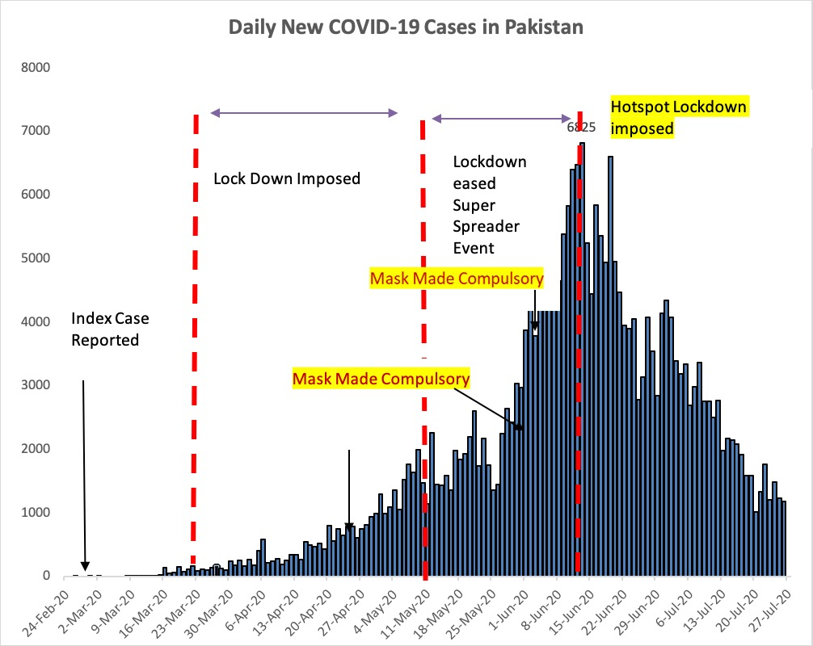

*Daily reported COVID-19 cases in Pakistan since the outbreak on 26 February 2020. The graph shows a sub-exponential growth pattern, then an exponential growth pattern, and then a decline phase - flattening the curve for the 153-day data extracted from the COVID.gov database. On day 1 of the epidemic, the number of cases was 2 and on day 153 the number of daily reported cases was 936. These numbers may represent the gap in the unreported or asymptomatic cases in Pakistan. The x-axis corresponds to the days, whereas the y-axis corresponds to the number of cases.*

Testing

Daily Testing and positive rate among those tested is an important tool to monitor outbreak in any country. Up until 9 July 2020, the percentage of positive results among all tested was 11.8%, with 23,255 tests done. Pakistan has so far conducted 1,909,846 tests / 6.9 tests per thousand people at 134 designated points including both public sector and private facilities.

The daily average of percentage positive climbed from an average of 11% in the weeks before the lockdown was lifted, i.e. the second week of May 2020, to a progressive average of 15.4% in the subsequent three weeks, with the highest percentage of 25.2 % in the last week of May. The

percentage positivity is now on a decline within the WHO desired value of 4.8% on 27 July 2020. The testing capacity of Pakistan was about 20,000 tests per day, with an average of 12,000 tests conducted and a maximum of 15,000 tests per day in May 2020. The daily testing capacity was ramped up from almost 15,000 daily tests to an average of 32,000 daily tests in the first half of June 2020, with an average of 21% of percentage positive among those tested. Testing capacity has increased to 71,780 tests per day with 40% utilization. Table 1 below gives the breakdown of testing facilities and daily testing capacity province-wise.

**Table 1.** Province-wide breakdown of testing facilities and daily testing capacity (19).

|  |  |  |
| --- | --- | --- |
| **Provinces** | **Labs** | **Testing Capacity per day (24hrs)** |
| **ICT** | 16 | 14,800 |
| **Punjab** | 34 | 21,950 |
| **Sindh** | 26 | 17,700 |
| **Baluchistan** | 3 | 2,200 |
| **Gilgit Baltistan** | 3 | 500 |
| **KPK** | 17 | 6,000 |
| **AJK** | 3 | 700 |
| **Armed Forces+ NDMA** | 33 | 8330 + 3000 |
| **TOTAL** | **134** | **71,780** |

An average of 6.4 daily tests were conducted for each confirmed case, which makes 0.11 daily tests per thousand population. Pakistan is performing 106 tests per million of the population, with 14.9 cases per million of the population, depicting the extent of testing relative to the scale of the outbreak across the country. The percentage positivity has shown a decline nationally and, in all provinces, with 4.7 % in ICT, 8.4% in Punjab, 15.6% in Sindh, 15% in KPK, 11.3% in Baluchistan, 1.9% in Gilgit Baltistan, and 6.3% in Azad Jammu and Kashmir up until 27 July 2020. The graphs below show the positivity trends of the national average.

**Figure 2.** Positive rate of COVID-19 cases.

*Trends of daily tests and daily new cases versus percentage positive from 11 March to 27 July 2020. There were approximately 12,000 to 15,000 daily tests in a day, which was increased to 20,000 to 31,000 tests in June. The average percentage positive was 12-15% in May 2020, which reached a maximum of 25.7 % on 2June 2020. The x-axis corresponds to days, whereas the y-axis corresponds to the number of cases and the number of tests performed. The black line on the secondary axis represents the percent positive rate.*

**Figure 3.** Number of tests done per each positive case.

*This was calculated by dividing the daily tests by daily positive cases, yielding the number of tests done per each positive case****.*** *The x-axis corresponds to days, whereas the y-axis corresponds to the number of tests performed.*

Cases

Sindh has become the hardest-hit province by the pandemic in terms of cases, followed by Punjab, Khyber Pakhtunkhwa, and Islamabad. The month of June has proven to be disastrous, with an enormous increase in case count till mid-June. Province wise breakup showed the highest number of confirmed cases in Sindh (118,824), followed by Punjab (92,279), Khyber Pakhtunkhwa (33,510), Islamabad Capital Territory (14,938), Baluchistan (11,624), Gilgit Baltistan (2,010), and Azad Jammu Kashmir (2,040). The figure below shows the distribution of cases across Pakistan.

**Figure 4.** Geographical distribution of COVID-19 Cases across Pakistan. (source: COVID.gov.pk).

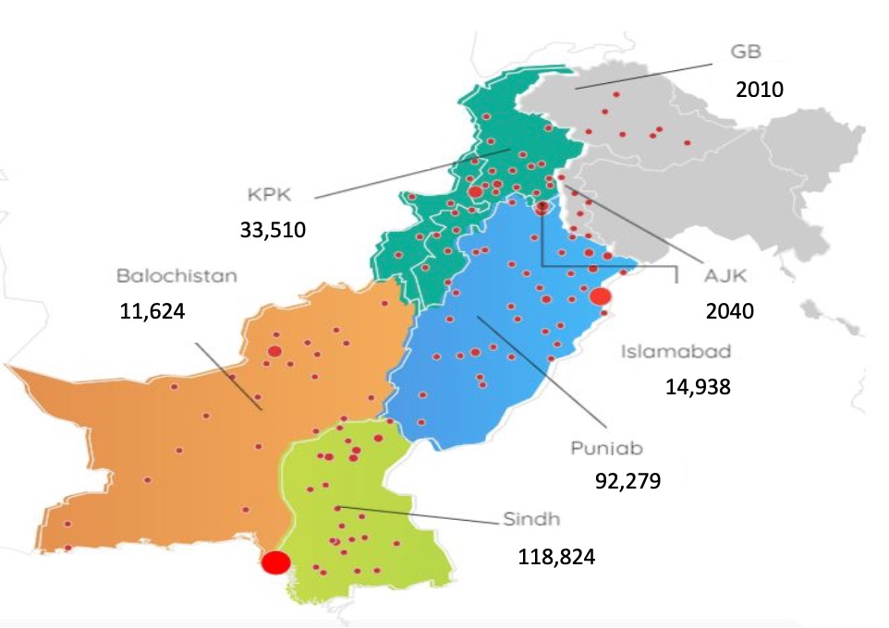

The cumulative case count has reached 275,225 confirmed cases. The graph below (figure 5) is the graphical presentation of confirmed COVID-19 cases in Pakistan.

**Figure 5.** The cumulative COVID-19 cases in Pakistan. (source: COVID.gov.pk).

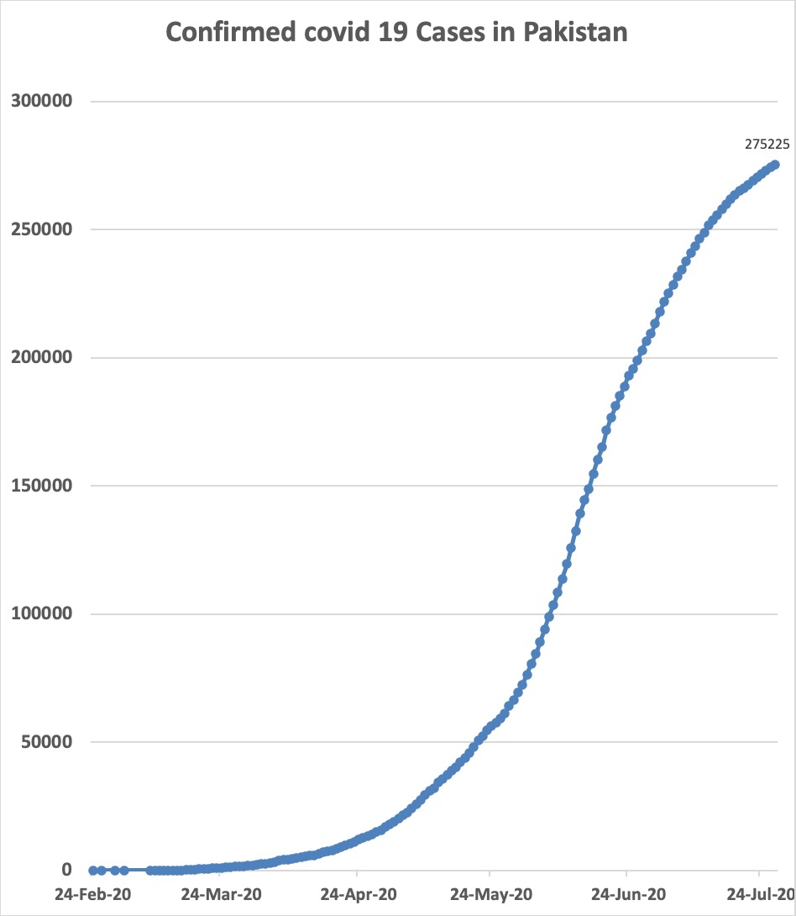

*These are the cumulative COVID-19 cases in Pakistan since the outbreak began on 26 February 2020. The graph shows an exponential growth pattern for the 153-days, with data extracted from the COVID.gov Pakistan database. The outbreak started at 2 cases and on day 153 of the epidemic, the number of cases stood at 275,225. The x-axis corresponds to days, whereas the y-axis corresponds to the number of cases.*

The cumulative confirmed case count in Pakistan showed an exponential growth pattern from May up until mid-June. Pakistan reached its first 100 confirmed cases on 16 March 2020, twenty days after reporting the first case, and the count reached 1,000 cases on 24 March 2020, within 28 days of the first confirmed case. The number of COVID-19 cases reached the 10,000 mark on 22 April 2020, 57 days after the first confirmed case. Pakistan’s first 50,000 cases count was reached 86 days after the outbreak, the second 50,000 16 days after the first 50 thousand, the third 50,000 10 days after, the fourth 50,000 11 days after the previous, and the last 50,000 15 days later than the previous.

Pakistan, with 6,505 cases in week 7 of the outbreak, had 29 cases per million of the population. This figure accelerated to 971 cases per million of the population, with the national tally reaching 217,809 cases in the first week of July 2020. Islamabad with 6,541 cases per million population has the highest cases per million population. The following table (Table 2) gives the case count per million population province wise:

**Table 2.** Cases per million population across all provinces.

|  |  |
| --- | --- |
| **PROVINCE** | **Cases per million Population** |
| Islamabad(ICT) | 6,541 |
| Sindh | 1,718 |
| Punjab | 674 |
| KPK | 712 |
| Baluchistan | 797 |
| Gilgit Baltistan | 1,210 |
| Azad Jammu & Kashmir | 281 |

After the identification of high-risk areas and hotspots, and the imposition of a smart lockdown strategy from 15 June 2020, there has been a 35% decline in the biweekly growth rate of cases.

The recovery rate of COVID-19 cases is 88.1%. The total recoveries stand at 242,436 (88.1%) and have overtaken the active cases 26,924 (9.8%). Among provinces, Sindh has the highest number and percentage of recoveries 108,480 (91.3 %) against total active cases 8,182 (7%), followed by Punjab 88.1%, Baluchistan 86.2%, and KPK has 81.3 % recovered patients.

On the other hand, the ICT Islamabad region has 12,377 recoveries (82.9%) with 16% of active cases, followed by the Gilgit Baltistan Region with 1,613 recoveries (80.3%) and 17.4% of active cases, and AJK has a 72.6% recovery rate.

Fixed-rate exponential growth refers to the number of cases doubled within a defined period. In Pakistan, after the reporting of the first two cases on 26 February 2020, it took 20 days to reach the first hundred cases. The case doubling time was 3 days initially after the first case, then it was reported as seven days up until 7 April 2020. The doubling rate remained 11 days for 5 weeks until 11 May 2020. The doubling time stands at 36 days, with a slowing down of average-case doubling time. The doubling time is dynamic and gives information regarding the impact or lack of impact of interventions on epidemic growth. The graph below (Figure 4) is the graphical presentation of the doubling rate of COVID-19 cases in days.

**Figure 6.** Doubling rates of reported COVID-19 cases in Pakistan.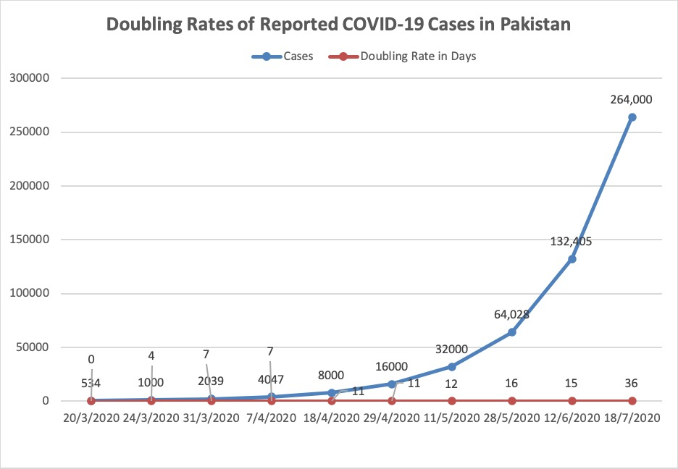

*Taking the first 500 cases as a reference point, the doubling time of cases is calculated by plotting cases on the Y-axis, days on the X-axis, and the number of cases doubled on the secondary axis.*

Keeping the value of R0 (the basic reproduction rate) as 2.28 data was generated which was quite close to the actual reported cases in Pakistan up until mid-April, the trends of the expected infectivity and the reported number of infections coincided significantly until mid-April. Later, the infections followed an exponential pattern, however still quite low as it was predicted and assumed if left unchecked, as the disease can spread at an

unprecedented rate in Pakistan, especially in closely-knit communities and densely populated areas. A peak was attained on 13 June 2020, with the highest single-day cases of COVID -19. Implementation of effective measures such as locality-based lockdown of hot-spots with clusters of cases and the Trace Test and Quarantine (TTQ) strategy to curb the rise in COVID-19 infections in Pakistan resulted in a decrease in the R0 of the virus.

**Figure 7.** Actual versus expected infectivity (R0) patterns of COVID-19 in Pakistan until 27 July 2020.

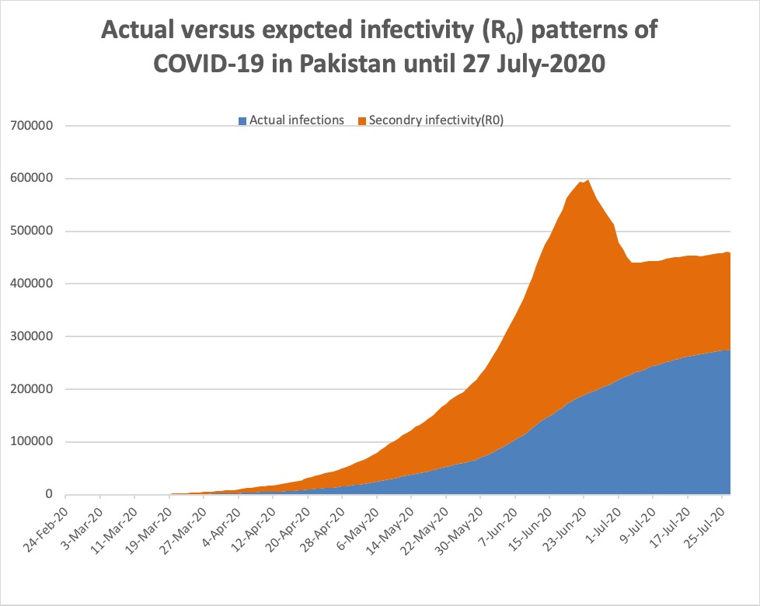

*The expected data for infected cases (R0) seems to follow the trajectory of the reported data from the COVID.gov Pakistan database until mid-April. This suggests a strong correlation between the trends of the expected data (I) based on the value of R0 and the reported data.*

Amongst the confirmed cases, 24.4% were from the younger age group (21-30 years of age) (20). The below 50 age group had 75.9% of the confirmed cases. Regarding gender, 72% of confirmed COVID-19 cases were males and 28% were females.

**Figure 8.** Age and gender distribution of COVID-19 cases.

Deaths

Limited testing and challenges in the attribution of the cause of death show that the number of confirmed deaths may not be an accurate count of the true number of deaths from COVID-19. The total confirmed deaths stood at 5,865 on 27 July 2020 and 23 daily confirmed deaths along with 75 deaths among health care workers including, 52 doctors, one medical student, 2 nurses, and 19 paramedics. The lowest number of daily deaths, i.e. 20 deaths reported on 26July 2020, was the lowest in the last three months since the start of the outbreak, as compared to the peak of 153 single day deaths on 20 June 2020. Total confirmed deaths are 23 deaths per million people with daily 0.34 deaths per million population. Weekly confirmed deaths refer to the cumulative number of confirmed deaths over the previous week. Fatalities have also decreased significantly over recent days.

**Figure 9.** Cumulative and daily deaths of COVID-19.

Pakistan reported its first two deaths on 18 March 2020, with a CFR of 0.6%, which doubled to 1.3% on 30 March in twelve days. The current CFR is 2.1% and is almost consistent with CFRs since week 7 of reported cases (1.9-2%). The death doubling rate of COVID-19 deaths is now 31 days. The graph below (figure 10) describes the death doubling rate since the country reported its first five deaths on 5 March 2020.

**Figure 10.** COVID-19 death doubling rate in Pakistan (days).

KPK reported the highest CFR of 5.6% in May 2020, which dropped to 3.5% in 2 months (27 July 2020). In Punjab, the CFR increased from 1.4% in the third week

of April to 2.3% on 27 July 2020, in two months period. The CFR trends of all provinces, GB and AJK are depicted in the graph (figure 11) below:

**Figure 11.** Trends of Case Fatality Rates (CFR) in provinces April 2020-27 July 2020.

The highest number of deaths were reported in the age group of 51-60 years. Of the deaths, 76.4% occurred in the 51-70 years age group. Among the deceased, the majority were males (71.1%) and 28.8% were females. Of the deceased, 71% have associated co-morbidities and 91% were hospitalized with an average stay of 5.9 days. Among those hospitalized, 57% of patients remained on the ventilator (average stay 3.1 days). The graph below (Figure 11) shows the age and gender distribution of COVID-19 deaths:

**Figure 12.** Age and gender distribution of COVID-19 deaths.

The case fatality rate (CFR) among various age groups varies, being the highest in the age group of 81 years and above.

The figure below is a graphical representation of the CFR among the deceased due to COVID-19 by age group.

**Figure 13.** Case fatality rate by age group.

**Discussion**

As of 27July 2020, Pakistan had 275,225 confirmed cases of COVID-19. Pakistan witnessed a phase of an exponential increase in cases with an average of 5.8% daily case growth trajectory until mid-June (21). Sindh and Punjab were the worst-hit provinces, with more than 115 districts involved (21). Pakistanis returning from the Middle East, Iran, Syria, and Saudi Arabia were the source of virus importation (7). At Taftan, most of the pilgrims were not tested or quarantined as the government initially did not have enough facilities available due to ill-planning and unavailability of PCR testing at Taftan to effectively resist the outbreak (22),(23). Secondly, in Pakistan, the two socio-demographic factors of low literacy rate and poverty were major hurdles in the observance of social distancing and might have contributed to the spread of disease. The low literacy rate of 59% and people with limited awareness, the non-seriousness of people regarding disease and its prevention, or being afraid of ostracism or hospitalization caused people to hide in their houses and not report their illness (24).

The data on the progression of the disease, available from a few studies in Wuhan, China, reveals that the time from symptom onset to death ranges from 2 to 8 weeks for COVID-19 (25). It means that people who are infected now may suffer from critical illnesses and will die after some time. By knowing the mortality risk of COVID-19, we will be able to respond adequately. The term mortality risk means the likelihood of being infected with COVID-19 and dying from it. For understanding mortality risk, we need to have the number of cases and the final number of deaths in a group of people. The CFR is strongly influenced by population demographics. A high CFR is seen in countries with high numbers of population groups with old people and people with associated co-morbidities (26). Pakistan reported its first 2 deaths on 18 March with 0.6% CFR (27). With 5,865 deaths to date, the current CFR is 2.1% against a CFR of 4% globally (21). The current mortality risk/CFR is 2.1% in Pakistan and is still low in comparison to other countries that have reported a higher CFR. France has the highest CFR of 16.7%, followed by the United Kingdom 15.2%, Italy 14.3%, Spain 10.2%, and Iran 5.4% (28).

The reason behind a low CFR maybe that Pakistan’s population is mainly comprised of young people (65%) with a strong immune system, which is why most of the confirmed cases are not critical (14). Only 4% of Pakistan’s population is over 65 years of age, in comparison to 16% in the U.S. and 23% in Italy, as per United Nations data. Unlike other populations, 24.4% of the confirmed cases in Pakistan are young people between 21 to 30 years of age (29). Life expectancy in Pakistan is 67 years, in comparison to Italy with a life expectancy of 83.5 years (30),(31). The average age in Pakistan is 22, which is more than a decade younger than Brazil’s average age (33 years), 16.5 years younger than US’s and 23.4 years younger than that of Italy. The average Italian is 45.4 years old (32) (33). These demographic factors are possible reasons for Pakistan’s low CFR and contained COVID-19 infections. The majority of COVID-19 cases are males (72%) and 28% are females (21). The reason may be that in Pakistani culture, men are mostly responsible for household financial needs and are the sole income earner, making them more vulnerable to exposure and infection (29), (34).

The recovery ratio of COVID-19 cases in Pakistan is 88.1%, in comparison to the global 63.8% and the USA which has a 94% recovery rate according to John Hopkins data. The recovery rate has dramatically improved in Pakistan after the third week of June 2020 (4).

In Pakistan, a month after the reporting of the first case, the number of people dying doubled in 3 days. This is higher in comparison to other countries, for example, the death growth rate due to COVID-19 was 5 days for Italy and Iran at the beginning of the outbreak (35). The doubling time increased from 3 days in April 2020 to 18 days in June 2020. The current doubling time is 31 days, in comparison to India which is 28 days, Brazil 43 days, Iran 47 days, USA at 81 days, and Italy with 109 days (36). The CFR has gone more than double from 0.6% to 1.3% in a matter of 14 days, and from 1.3% to 2.1% in 22 days, which was an alarming sign for the implementation of strict interventions. The current CFR is 2.1% against the global figure of 4% and has been almost consistent since week 7 of the reported cases. India has reported a similar CFR of 2.3%, while Brazil and the USA, which are some of the hardest-hit countries, have a CFR of 3.5% (37).

Another important factor is the exponential growth potential of SARS-COV-2 that is based on R0, which indicates the number of people that are to become infected by interaction with one infected person. The R0 value for COVID-19 in China was calculated as 2·28 in the early phase (38). Without any intervention by this R0, a virus with this exponential growth potential could have infected 60% of Pakistan’s population of 212.82 million. A large number of COVID-19 cases are asymptomatic and major sources of virus spread go undetected (39). The exponential rate of infections was prevented with the implementation of proper measures to reduce community transmission. This was through safe practices such as social distancing, hand-washing, and large-scale testing of suspected cases in high-risk areas reporting clusters of cases. The current R0 for Pakistanis is 0.64, reflecting the effectiveness of interventions as a locality-based lockdown of hotspots.

Testing for COVID-19 is a window into the pandemic and its spread, and vital in its control. Without testing, it is impossible to have an insight into pandemic trends and progression. It is the most important tool to slow and reduce the spread and impact of the virus by identifying infected individuals and enabling the health system to isolate those who are infected by tracing and quarantine of contacts (40). It also helps in identifying new hot spots of infections, thus helping authorities to limit the scope of the outbreak. Pakistan, with a testing capacity of 71,780 tests per day with 40% of utilization*,* is still categorized in the category of testing symptomatic as far testing policy is concerned. This is along with limited contact tracing in contrast to countries like Australia, USA, Canada, and Taiwan that having open public testing, including for those who are asymptomatic (41). The USA has a capacity of 500,000 tests per day and India has a testing capacity of 200,000 tests daily. The positive rate reflects that countries are testing sufficiently (41). A positive rate of 3-12% is a suggested benchmark of adequate testing according to the WHO (42). The current daily positive rate of Pakistan is 4.8%, which is within the desired limit of the WHO. Pakistan witnessed the highest positive rate in the last week of May 2020, with 25.7% on 27 May 2020. The positive rate started to recede in the last week of June. There is a gross difference in positive rates across countries. Some countries like Australia, South Korea, United Kingdom, Germany, and Canada have a positive rate of less than 1%, taking hundreds or thousands of tests to find one positive case in these countries. While countries like Nigeria, Ghana, Bolivia, Oman, and Mexico have a positive rate between 20-50% or even more, with a positive case as per a few tests conducted. Countries with high positive rates are conducting limited testing and are unlikely enough to find all cases (41).

The WHO has suggested approximately 10-30 tests per each confirmed case as a benchmark of adequate testing (43). Pakistan is currently doing 18.4 tests per each positive case, however, this rate declined to 4.5 tests per each case in the first week of June, which was the period of peak infectivity Pakistan has witnessed yet (21). Countries with very few tests per each confirmed case are likely to not be testing widely, e.g. Bolivia and Argentina doing 1.8 and 21.9 tests respectively per each confirmed case in contrast to New Zealand doing 6,580 tests, Australia doing 174 tests, Canada 96.5 tests, and Uruguay 103.7 tests per each confirmed case. Pakistan has done 9.32 tests per 1,000 population, which is quite low keeping the huge population in mind. On the other hand, the USA has done 178 tests per 1,000 people and Russia, which is hard hit by the virus, is conducting 203.63 per 1,000 people (41).

Initially, at the start of the outbreak in late February 2020, the testing by Polymerase Chain Reaction (PCR) for SARS COV-2 was very limited and only symptomatic with travel history of high-risk countries were tested. Pakistan witnessed a constantly increasing trend in the daily confirmed cases from mid-March 2020, owing to a modest increase in daily testing capacity and the start of community spread. An increase in the number of reported cases in March was probably due to the clusters of confirmed cases among members of a large religious congregation conducted in Raiwind, Punjab, and due to a modest increase in daily testing capacity (44). Strict nationwide lockdown, along with border closure and suspension of international flight operations, was imposed with effect from 23 March 2020, which resulted in a slow steady spread of infection (45). Despite the surging numbers of COVID-19 cases, the government announced gradual ease of lockdown from 9 May 2020 across the country, almost after one and a half months of imposition, citing a flailing economy and high poverty rates with strict implementation and following of social distancing guidelines (45). The relaxation resulted in an abrupt increase in daily cases, with a 5-fold increase in infection counts. Lockdown was lifted and eased in phases, about two weeks before the Eid al-Fitr festival, marking the end of the holy month of Ramadan with the resumption of transport and most businesses (46). Pakistan resorted the international flight operations with strict implementations of health protocols from 20 June 2020. The lifting of the weeks-long lockdown at the end of May roiled the situation in the country.

Flouting of Standard Operating Procedures (SOPs) during Ramadan and ahead of the Eid festival by the end of May changed the trend of cases across Pakistan**.** The effects of relaxing the lockdown restrictions gradually became visible as infection skyrocketed and cases started to increase after 25 May 2020 (21). The number of cases reported in the past four months since the start of the outbreak are equal to the number of cases reported in the last week of May and the first two weeks of June. Pakistan emerged as one of the countries with the fastest rate of coronavirus infections, as per the WHO in June 2020 (47). The government of Pakistan identified 500 coronavirus hotspot high-risk areas having clusters of COVID-19 cases in 20 big cities across the country and targeted them for limited locality-based targeted lockdown strategies, termed as "smart lockdown", with a comprehensive strategy of tracking and sealing the high-risk areas, contact tracing, and isolation and quarantine of contacts as a measure to curb the spread of the coronavirus (48).

Countries like South Korea, Taiwan, Japan, and Hong Kong, with key focus on simple non-pharmaceutical interventions and day to day habits of social distancing, mandatory use of face masks, frequent hand washing, and sanitization of surfaces, along with adequate and sufficient testing programs, have been successful in the containment of virus (49).

The number of reported cases underestimates true cases. Reported cases are the tip of the submerged iceberg because people do not show symptoms for several days and not everybody gets tested. Pakistan under-tested for COVID-19, keeping in view the large population, due to limited testing capacity, despite the fact that the WHO stresses aggressive testing for the interruption of community transmission. The success story of South Korea and Taiwan with three T approach of tract, test and treat is an example for the rest of the World (50). Singapore managed to contain COVID-19 without lockdown or major social disruption by maximizing all efforts to interrupt new transmission chains and keeping clusters under control through extreme testing regimes (51),(52).

The fixed-rate exponential growth refers to the number of cases doubled within a defined period. The estimated doubling period of the early coronavirus outbreak in China was almost 5 days, meaning 100 cases on day 0, then on day 6 there will be approximately 200 cases, and so on. The exponential growth with a longer doubling period represents slower growth compared to a shorter doubling period. The number of confirmed cases was doubled in Pakistan in 11 days for 5 weeks until 11 May 2020, which was relatively close to that of which was observed in the UAE (12 days) and Saudi Arabia (8 days), while Iran (25 days) and Iraq (21 days) had longer confirmed case doubling times. Longer confirmed case doubling times indicate a comparatively low spread of infection. Better understanding and implementation of social distancing and early detection of disease by testing and contact tracing can limit the transmission of disease among the population. Pakistan reached its first 100 confirmed cases on 16 March 2020. Government interventions played an important role to reverse the case growth trajectory. Interventions and responses were different province wise, as opposed to a coordinated nationwide effort. Sindh took the lead as it was the worst-hit province initially. Sindh was the first to implement lockdown and risk mitigation measures like school and office closures, and cancellation of public events like PSL (53). Punjab and KPK were sluggish in the beginning but tried to implement and reinforce interventional measures like social distancing and lockdown after a surge in confirmed cases. The Sindh government has been the most proactive in the reinforcement of lockdown and limited religious congregations in the ongoing COVID-19 crisis. Economic recession due to the corona outbreak led the federal government to ease the lockdown and switch to smart lockdown with the implementation of targeted tracking, tracing, and test strategy (54). Countries with extreme intervention measures, such as China and South Korea, have a steep negative slope on the curve, indicating the effective infection containment (52).

The report of the economic survey 2019 clearly shows that Pakistan has 1,279 public sector hospitals, with 220,829 registered doctors and 108,474 registered nurses. Under normal circumstance, only one doctor is available for 963 patients and there are 1,608 people for one hospital bed (55). COVID-19 had left a devastating impact on the much stronger health care systems of the United States and the United Kingdom. Pakistan’s rickety health infrastructure faltered under the pressure of a surge in cases after lock-down restrictions were eased on public gatherings and businesses at the end of May and the Eid festival. The intensive care units of megacities were overwhelmed, but the situation got better in July 2020 despite the prediction regarding the health system’s inability to encounter such a big epidemic. Pakistan has dramatically reversed the course, recording a sharp decline in coronavirus cases and deaths, which are both down more than 80% from their peaks. The progress in Pakistan was evident after the government opposed the WHO’s advice of strict lockdown, due to the poor vulnerable class and frail economy (56). The smart lockdown strategy and strict implementation of SOP’s by authorities was a balancing trick between core economic and public health activities, to reopen the economy with caution and prevent the spread of the virus.

The COVID-19 response in Pakistan, the world's fifth-most populous country, was difficult: a continued lockdown risked economic ruin, mass impoverishment, and even unrest among the vulnerable class. To mitigate the economic hardships experienced by the vulnerable class, the government launched a cash payment program with an allocation of Rs 144 billion to deliver one-time financial assistance to 12 million families. This program is administered through the social safety net Ehsaas programme, which is the federal government’s new poverty alleviation program, in partnership with all the federating units of Pakistan, to provide financial support to over 80 million people. This program played an instrumental role in mitigating the adverse impact of the pandemic on the economy (57).

**Conclusion**

Pakistan remained unaffected for a couple of weeks after the declaration of the outbreak and reported its first confirmed case on 26February 2020 from Iran. The mishandling of pilgrims including the lack of effective quarantine facilities and testing capacities at the Taftan border crossing resulted in the importation of the virus in the country. Pakistan started to feel the impact of the outbreak in Mid-March with a sudden spike in cases crossing the first hundred confirmed cases. Initially, the Sindh province was the worst affected province, with cases of local transmission reported in Karachi and a large number of positive COVID-19 cases among pilgrims quarantined at the Sukkhur facility. So far, Punjab and Sindh have the highest number of reported confirmed cases. Currently, 88.1 % of the reported cases have fully recovered and have been discharged from the hospital, while the Ministry of Health Services confirmed 5,865 deaths. Initially the cases were imported, with travelers from various affected countries such as Iran, Syria, United Kingdom, Saudi Arabia, and the USA, out of which 13% were pilgrims from Iran and the rest 08% were from other countries. Local transmission continuously spiked from Mid-March reaching 97%. The male population of the country is mostly infected, in comparison to females. The absolute lockdown resulted in slowing down of infection rate but due to the frail economy and the vulnerable class, the lockdown restrictions were eased in phases since Mid-May, resulting in a burst of infections at the end of May. Effective measures such as lockdown, media awareness campaigns regarding isolation and social distancing, and risk mitigation measures being implemented have resulted in a slow rate of infection growth, with reduced infection doubling rate in days. All provinces have moved towards partial lockdown with military deployment in aid of civil authorities. Keeping in view the WHO’s recommendation of aggressive testing, Pakistan’s limited testing capacity of 20,000-32,000 tests per day, which is regarded as under testing, has raised concern on the number of unreported cases in the community. Countries with successful containment strategies such as South Korea and Germany are examples for Pakistan. Early interventions have changed the scenario and examples are Italy and Germany, with their first reported cases a few days apart but they used different approaches to deal with exponential numbers, and this led Italy towards one of the worst medical emergencies.

**Recommendation**

Both government and individual responses based on increased aggressive testing and heightened social distancing are needed to curb the rate of infection growth. The health education of the public on the seriousness of COVID-19 and their role in preventing its spread by practicing social distancing, and isolation along with sustainable health facilities is the need of the day. An extremely comprehensive testing regime is required to test, trace the contacts, and treat and isolate to break the community transmission chain. Mass testing, quarantine of suspects and isolation of positives cases through the TTQ approach adopted by the government, resulted in the slowing of the spread of the disease and effectively suppressed it in only a few short weeks. Social distancing is an effective way to lower the R0, and stringent containment and mitigation strategies, quarantine measures, and greater testing capacity were implemented to reduce the R0 but requires sustainability.

The sustainability of health care facilities is directly linked to the health budget. Pakistan’s health care system receives the smallest share, i.e. 0.75% of the GDP, which is the lowest in the world. A higher allocation of the funds for health care would enhance the capacity of the system in terms of manpower and equipment. There is a need to leverage and sustain deep expertise in disaster management and infectious disease control.

The upcoming weeks and months are crucial as another Holy festival of Eid ul Azha and Moharram are approaching, along with the decision of reopening educational institutions from Mid-September, requiring a humble introspection, preparedness, and planning in a coherent way, including vigilant sentinel surveillance at the district level.

**Author’s Contribution**

NN involved in the conception and design of the study, literature review data collection, analysis, and wrote the manuscript, and SD is involved in the manuscript editing. SUKN supervised the study. IN and NM are involved in the editing of the manuscript. All authors read and approved the final manuscript.

**Competing Interests**

The authors declare that they have no competing interests.

**Funding**

None.

**Abbreviations**

|  |  |
| --- | --- |
| **ICT** | Islamabad Capital Territory |
| **ECDC** | European Centre for Disease Prevention and Control |
| **KPK** | Khyber Pakhtunkhwa |
| **AJK** | Azad Jammu & Kashmir |
| **KSA** | Kingdom of Saudi Arabia |
| **NIH** | National Institute of Health |
| **NHS** | National Health System |
| **UK** | United Kingdom |
| **BHU** | Basic Health Unit |
| **RHC** | Rural Health Centre |
| **GDP** | Gross Domestic Product |
| **ICU** | Intensive Care Unit |
| **COVID-19** | Coronavirus Disease-19 |
| **NCOC** | National Command and Operation Centre |
| **NCC** | National Coordination Committee |
| **SARS-COV-2** | Severe Acute Respiratory Syndrome Corona Virus-2 |
| **WHO** | World Health Organization |
| **EMRO** | East Mediterranean Region |
| **GB** | Gilgit Baltistan |
| **USA** | United States of America |
| **CFR** | Case Fatality Rate |
| **SOP’s** | Standard Operating Procedures |
| **TTQ** | Trace Test and Quarantine |

**References**

1. Wu Y, Ho W, Huang Y, Jin D-Y, Li S, Liu S-L, et al. SARS-CoV-2 is an appropriate name for the new coronavirus. Lancet [Internet]. 2020 Mar 21;395(10228):949–50. Available from: https://doi.org/10.1016/S0140-6736(20)30557-2
2. WHO. How the World Health Organization works [Internet]. 2020. p. 1–120. Available from: https://www.who.int/emergencies/diseases/novel-coronavirus-2019/events-as-they-happen
3. Dennison Himmelfarb CR, Baptiste D. Coronavirus Disease (COVID-19) [Internet]. Vol. Publish Ah, Journal of Cardiovascular Nursing. 2020. Available from: https://www.who.int/emergencies/diseases/novel-coronavirus-2019
4. Johns Hopkins Coronavirus Resource Center. COVID-19 Map - Johns Hopkins Coronavirus Resource Center [Internet]. Johns Hopkins Coronavirus Resource Center. 2020. Available from: https://coronavirus.jhu.edu/map.html
5. DW.com. Coronavirus latest_ WHO logs new daily record in global virus cases _ News _ DW _ 10 [Internet]. Available from: https://www.dw.com/en/coronavirus-latest-who-logs-new-daily-record-in-global-virus-cases/a-54118866
6. Abed Alah M, Abdeen S, Kehyayan V. The first few cases and fatalities of Corona Virus Disease 2019 (COVID-19) in the Eastern Mediterranean Region of the World Health Organization: A rapid review. J Infect Public Health [Internet]. 2020;2019:4–9. Available from: https://doi.org/10.1016/j.jiph.2020.06.009
7. Ashfaq Ahmed. Pakistan records 11 new coronavirus cases bringing the total tally to 18. Gulf news [Internet]. 2020;1–13. Available from: https://gulfnews.com/world/asia/pakistan/pakistan-records-11-new-coronavirus-cases-bringing-the-total-tally-to-18-1.70279643
8. Raza SI, Junaidi I. Pakistan opens markets amid steep rise in cases. Dawn.com [Internet]. 2020;8–11. Available from: https://www.dawn.com/news/1556213.
9. Services NH. National Action Plan for Preparedness & Response to Corona Virus Disease ( COVID-19 ) [Internet]. 2020. Available from: https://www.nih.org.pk/wp-content/uploads/2020/03/COVID-19-NAP-V2-13-March-2020.pdf?__cf_chl_jschl_tk__=535ed22d156920f0e5d1576202ab7d39c58f9931-1584691712-0-Ad71buzyy0gJON34CqWZ3N61NZWsZbEH8hrONScnOohYHv8IdRKnEGcKCi4b1GIX8Yc3kksn_CxtifA4vQv2iqlR0EEZHrccP
10. web desk. High-level NCC constituted to help curb coronavirus. The Nation [Internet]. Available from: https://nation.com.pk/14-Mar-2020/high-level-ncc-constitutes-to-help-curb-coronavirus
11. National Command Operation Center [Internet]. Available from: https://ncoc.gov.pk/sitrep.php
12. Waris A, Atta UK, Ali M, Asmat A, Baset A. COVID-19 outbreak: current scenario of Pakistan. New Microbes New Infect [Internet]. 2020;35(20):100681. Available from: https://doi.org/10.1016/j.nmni.2020.100681
13. Shaikh H. COVID-19 : Pakistan ’ s preparations and response The government of Pakistan has taken. International Growth Centre [Internet]. 2020;6–11. Available from: https://www.theigc.org/blog/COVID-19-pakistans-preparations-and-response/
14. Bench C. Population , Labour Force and Employment [Internet]. 2020. Available from: http://www.finance.gov.pk/survey/chapters_15/12_Population.pdf .
15. Culp Jr WC. Coronavirus Disease 2019: In-Home Isolation Room Construction. A&A Pract [Internet]. 2020 Apr;14(6):e01218–e01218. Available from: https://pubmed.ncbi.nlm.nih.gov/32784318
16. Dil S, Dil N, Maken ZH. COVID-19 Trends and Forecast in the Eastern Mediterranean Region With a Particular Focus on Pakistan. Cureus. 2020;12(6):6–13 e8582. doi:10.7759/cureus.8582
17. Nations U. Pakistan becomes world ’ s 5th most populous country. 2020;8–9. Available from: https://www.jasarat.com/en/2020/07/12/145753/
18. Shaikh H, Ijaz N. The six biggest challenges facing Pakistan’s urban future. International Growth Center [Internet]. 2017;https://www.theigc.org/blog/the-six-biggest-challe. Available from: https://www.theigc.org/blog/the-six-biggest-challenges-facing-pakistans-urban-future/
19. NCOC. NATIONAL COMMAND AND OPERATIONS CENTRE SITUATION REPORT PART – I [Internet]. 2020. Available from: https://ncoc.gov.pk/Sitrep/Jul/118.Sitrep - 28 Jul (Updated).pdf
20. COVID.gov.pk. COVID-19 Health Advisory Platform by Ministry of National Health Services Regulations and Coordination Dial 1166 health helpline CHAT BOT GUIDELINES PREVENTION FACILITIES PUBLIC SERVICE MESSAGE HOME / PAKISTAN CASES DETAILS PUNJAB COVID-19 Health Advisory [Internet]. 2020. p. 1–4. Available from: http://COVID.gov.pk/stats/pakistan
21. Ministry of Health G of P. COVID-19 Health Advisory Platform by Ministry of National Health Services Regulations and Coordination [Internet]. COVID.Gov. 2020. p. 30–2. Available from: http://COVID.gov.pk/
22. Tribune E, The S, E-paper U, E-paper E, Live E, Paper T, et al. Taftan quarantine centre devoid of facilities Pilgri ms kept at Taftan compla in about shorta ge of masks , handwa sh. 2020;1–2. Available from: https://tribune.com.pk/story/2177540/1-quarantine-centre-devoid-facilities/
23. Badshah SL, Ullah A, Badshah SH, Ahmad I. Spread of Novel coronavirus by returning pilgrims from Iran to Pakistan. J Travel Med [Internet]. 2020 Apr 9;27(3). Available from: https://doi.org/10.1093/jtm/taaa044
24. Targets NP, Baseline N. Economic Survey of Pakistan 2018-19,Education Chapter 10 [Internet]. Available from: http://www.finance.gov.pk/survey/chapters_19/10-Education.pdf
25. WHO. Report of the WHO-China Joint Mission on Coronavirus Disease 2019 ( COVID-19 ) [Internet]. Vol. 2019. 2020. Available from: https://www.who.int/docs/default-source/coronaviruse/who-china-joint-mission-on-covid-19-final-report.pdf
26. Dowd JB, Andriano L, Brazel DM, Rotondi V, Block P, Ding X, et al. Demographic science aids in understanding the spread and fatality rates of COVID-19. Proc Natl Acad Sci U S A [Internet]. 2020 May 5 [cited 2020 Aug 11];117(18):9696–8. Available from: http://www.ncbi.nlm.nih.gov/pubmed/32300018
27. AL. Pakistan confirms two deaths from coronavirus. aa.com.tr/en/asia-pacific/pakistan [Internet]. 2020;1–12. Available from: <https://www.aa.com.tr/en/asia-pacific/pakistan-confirms-2-deaths-from-coronavirus/1771081>
28. Max Roser, Hannah Ritchie, Esteban Ortiz-Ospina, Joe Hasell. Coronavirus Disease (COVID-19) – Statistics and Research - Our World in Data [Internet]. Vol. 2020, University of Oxford. 2020. p. 1–42. Available from: https://ourworldindata.org/coronavirus
29. Ahmad A. Coronavirus: Most COVID-19 patients in Pakistan are young adults as the total tally crosses 1100 cases. 2020; Available from: https://gulfnews.com/world/asia/pakistan/coronavirus-most-COVID-19-patients-in-pakistan-are-young-adults-as-the-total-tally-crosses-1100-cases
30. Statistics, Who T, Mahipala R. English pdf [Internet]. 2020. p. 3–4. Available from: https://www.who.int/countries/pak/en/
31. Metrics G, Projections UN. Italy Life Expectancy 1950-2020 [Internet]. 2020. p. 1–6. Available from: https://www.macrotrends.net/countries/ITA/italy/life-expectancy
32. H. Plecher. Pakistan - average age of the population 1950-2050 | Statista [Internet]. Statista. Available from: https://www.statista.com/statistics/319168/average-age-of-the-population-in-indonesia/
33. Brazil Population - 2020 [Internet]. Worldometer. 2020. p. 2020. Available from: https://worldpopulationreview.com/countries/brazil- population
34. Abid K, Bari YA, Younas M, Tahir Javaid S, Imran A. Progress of COVID-19 Epidemic in Pakistan. Asia-Pacific J public Heal [Internet]. 2020/05/19. 2020 May;32(4):154–6. Available from: https://pubmed.ncbi.nlm.nih.gov/32429679
35. Max Roser HR and EO-O. “Coronavirus Disease (COVID-19) – Statistics and Research”. Published online at OurWorldInData.org. [Internet]. Available from: https://ourworldindata.org/coronavirus
36. Our World in Data. Coronavirus (COVID-19) deaths - Statistics and Research - Our World in Data [Internet]. 2020. Available from: https://ourworldindata.org/coronavirus-testing
37. Roser M, Ritchie H, Ortiz-Ospina E, Hansell J. Mortality Risk of COVID-19 - Statistics and Research - Our World in Data [Internet]. Mortality Risk of COVID-19. 2020. p. 1. Available from: https://ourworldindata.org/mortality-risk-COVID?country=DOM
38. Liu Y, Gayle AA, Wilder-Smith A, Rocklöv J. The reproductive number of COVID-19 is higher compared to SARS coronavirus. J Travel Med [Internet]. 2020 Feb 13;27(2). Available from: https://doi.org/10.1093/jtm/taaa021
39. ELLEN CRANLEY. 40% of People With COVID-19 Show No Symptoms, The CDC Estimates. Science alert [Internet]. 2020;1–3. Available from: https://www.sciencealert.com/40-of-people-with-COVID-19-don-t-have-symptoms-latest-cdc-estimate-says
40. OECD. Testing for COVID-19: A way to lift confinement restrictions [Internet]. OCED. 2020. p. 1–21. Available from: https://www.oecd.org/coronavirus/policy-responses/testing-for-covid-19-a-way-to-lift-confinement-restrictions-89756248/
41. Our World in Data. Coronavirus (COVID-19) Testing - Statistics and Research - Our World in Data [Internet]. 2020. Available from: https://ourworldindata.org/coronavirus-testing
42. WHO. Public health criteria to adjust public health and social measures in the context of COVID-19. Annex to Considerations in adjusting public health and social measures in the context of COVID-19 [Internet]. Who. 2020. Available from: https://www.who.int/publications/i/item/public-health-criteria-to-adjust-public-health-and-social-measures-in-the-context-of-COVID-19
43. Momeni M. WHO media briefing 30th March 2020 [Internet]. Vol. 21, WHO. 2020. p. 1–9. Available from: https://www.who.int/docs/default-source/coronaviruse/transcripts/who-audio-emergencies-coronavirus-press-conference-full-30mar2020.pdf?sfvrsn=6b68bc4a_2
44. Assistant S. Corona cases in Pakistan witness sharp increase. The News [Internet]. 2020;2–5. Available from: https://www.thenews.com.pk/print/646072-corona-cases-in-pakistan-witness-sharp-increase
45. Rizwan Shehzad. Countrywide lockdown stretched till May 9. The ExpressTribune [Internet]. 2020;2020. Available from: www.exppress.com.pk
46. Newspaper T. Cabinet approves easing lockdown after May 9. Dawn [Internet]. 2020;9–11. Available from: https://www.dawn.com/news/1554927
47. Gul A. Spike in Pakistan COVID-19 Infections Prompts WHO to Call for More Lockdowns. VOA [Internet]. 2020;8–11. Available from: https://www.voanews.com/COVID-19-pandemic/spike-pakistan-COVID-19-infections-prompts-who-call-more-lockdowns
48. Hashim A. ’ Smart lockdown ’ in Pakistan to target 500 coronavirus hotspots Lack of healthcare facilities. Aljazeera [Internet]. 2020;6–9. Available from: https://www.aljazeera.com/news/2020/6/23/smart-lockdown-in-pakistan-to-target-500-coronavirus-hotspots
49. Jiji A. Hong Kong, Taiwan and South Korea buck global lockdown trend. The Japan Times [Internet]. 2020; Available from: https:www.japanesetimes.co.jp
50. C. Jason Wang, MD, PhD1,2; Chun Y. Ng, MBA, MPH2; Robert H. Brook, MD, ScD3 4. Response to COVID 19 in Taiwan Big Data Analytics, New Technology, and Proactive Testing. JAMA [Internet]. 2020;1–12. Available from: https://jamanetwork.com/journals/jama/fullarticle/2762689
51. Lee VJ, Chiew CJ, Khong WX. Interrupting transmission of COVID-19: lessons from containment efforts in Singapore. J Travel Med [Internet]. 2020 May;27(3). Available from: https://pubmed.ncbi.nlm.nih.gov/32167146/
52. Resp C-19 NE. Contact Transmission of COVID-19 in South Korea: Novel Investigation Techniques for Tracing Contacts. Osong Public Heal Res Perspect [Internet]. 2020 Feb 28;11(1):60–3. Available from: https://doi.org/10.24171/j.phrp.2020.11.1.09
53. Desk W. Schools to remain closed in Sindh till March 13. nation [Internet]. 2020; Available from: https://nation.com.pk/01-Mar-2020/schools-to-remain-closed-in-si
54. News. India and Pakistan ease coronavirus lockdown restrictions _ News _ Al Jazeera. Available from: https://www.aljazeera.com/news/2020/04/india-pakistan-ease-coronavirus-lockdown-restrictions-200425072609484.html
55. 2019 ES. Health and Nutrition [Internet]. 2018. Available from: http://www.finance.gov.pk/survey/chapters_19/11-Health and Nutrition.pdf
56. Rueters. WHO calls for intermittent lockdowns in Pakistan as COVID-19 cases rise sharply. Thehindu.com [Internet]. 2020;9–12. Available from: https://www.thehindu.com/news/international/who-calls-for-intermittent-lockdowns-in-pakistan-as-COVID-19-cases-rise-sharply/article31792311.ece
57. Nishtar S, Protection S, Minister P. COVID-19 : Using cash payments to protect the poor in Pakistan. World economic forum [Internet]. 2020;1–5. Available from: https://www.weforum.org/agenda/2020/05/using-cash-payments-protect-poor-pakistan/

**How to cite this article**: Noreen N, Naveed I, Dil S, Niazi SUK, Saleem S, Mohiuddin N, Khan NU, Noor B, Khan MA & Khan FK. Trend analysis of exponential increase of COVID-19 cases in Pakistan: An interpretation. *Global Biosecurity, 2020; 1(4).*

**Published**: October 2020

**Copyright:** Copyright © 2020 The Author(s). This is an open-access article distributed under the terms of the Creative Commons Attribution 4.0 International License (CC-BY 4.0), which permits unrestricted use, distribution, and reproduction in any medium, provided the original author and source are credited. See <http://creativecommons.org/licenses/by/4.0/> .

*Global Biosecurity* is a peer-reviewed open access journal published by University of New South Wales.