EDITORIALS AND COMMENTARIES
Global COVID-19 vaccine equity and the booster dose in low-resource countries: A decolonizing global health perspective
M. A. Rifat¹, Md. Nazmul Huda^{2,6}, Ateeb Ahmad Parray³, Uday Narayan Yadav⁴, Rashidul Alam Mahmud⁵, ARM Mehrab Ali⁶ & Sabuj Kanti Mistry^{3,6,7,8} *
¹ Karolinska Institutet, Sweden
² Western Sydney University, Australia
³ BRAC University, Bangladesh
⁴ Australian National University, Australia
⁵ University of Sydney, Australia
⁶ ARCED Foundation, Bangladesh
⁷ University of New South Wales, Australia
⁸ Daffodil International University, Bangladesh
* Corresponding author:
Sabuj Kanti Mistry
Email: smitra411@gmail.com

Abstract
On July 30, 2021, the administration of a third (booster) dose of the COVID-19 vaccine was introduced to enhance immunity among vaccinated people. Many developed countries have introduced vaccine booster doses as additional protection for their population to mitigate the severity of the ongoing COVID-19 pandemic. However, this idea is currently being replicated by low- and lower-middle-income countries (LMICs), where full vaccination coverage is, as of now, still below 45%, which is considerably lower than that of high-income countries (73%). This commentary focuses on the critiques of introducing booster dose strategy in low-income countries. We highlight different decolonizing global health perspectives, including vaccine equity, effective resource utilization, and priority setup, in this commentary.
Keywords: COVID-19 pandemic; Booster dose; Lower middle-income countries; Vaccine equity; decolonizing global health

Introduction
The ongoing COVID-19 pandemic has become the most serious and pressing public health issue of the 21st century. Decades of progress in reducing the inequality between wealthier and poorer nations has been undone (1). The more the world does not come to terms with COVID-19 in a way that benefits both the global north and the global south, the more the world will suffer losses (2). An “every country for itself” approach is detrimental from every country’s point of view (3). On the contrary, experts have suggested that ensuring global COVID-19 vaccine equity will economically benefit high-income countries (HICs) up to four times more if they extend support to the low- and lower-middle-income countries (LMICs) to effectively handle the severity of the COVID-19 pandemic (1, 4). To control the spread of infection and reduce the severity of morbidity and mortality, universal COVID-19 vaccination continues to be the most effective against severe illness, hospitalization and death caused by the various variants of concern such as Delta and Omicron (5, 6). As of February 10, 2022, 62% of the global population has received at least one dose of the COVID-19 vaccine (7). Reportedly, due to improved healthcare systems and high affordability, the vaccination coverage is high among upper-middle-income countries (UMICs, 75%) and HICs (72%), above the global target of 70% total population coverage by mid-2022 (7). On the contrary, limited resources and fragile healthcare systems in the low-income countries (LICs) and the LMICs have low coverage of COVID-19 vaccination, respectively 6% and 43%, compared to UMICs and HICs (7). It turns out that the coverage of global COVID-19 vaccination is unequally and disproportionately distributed across the countries, indicating power asymmetries in global health practice and global vaccine inequity. In addition, in the LICs and LMICs, vaccination coverage varies among different population groups depending on their socio-economic status (8-10). For instance, in Bangladesh, vaccination coverage is low among disadvantaged populations such as low socioeconomic groups, high-risk populations, slum dwellers and those living in rural areas/remote locations (11).
COVID-19 cases caused by the recent highly transmissible Omicron variant have exacerbated the worldwide public health crisis and led to consideration of the potential need for booster doses for increasing vaccine protection. Booster doses can be provided to vaccinated individuals from 4 months or longer after they receive their first dose. After completing the second dose and even third dose, vaccinated people may have waning immunity against severe illness and deaths. As such, many countries have initiated the fourth dose of COVID-19 vaccine even after the third dose to maintain the protection against COVID-19 (12, 13). An Israeli study shows a strong effect of waning immunity after six months of vaccination among all age groups (14). However, any decision to do so should be evidence-based, feasible, and consider the benefits and risks for individuals and society, including how many individuals have already received primary vaccinations. Many HICs (e.g., Israel, UK, Japan, USA, Switzerland, Australia) have already administered two booster doses of vaccine to counter waning immunity (15).
Renowned scientists refer to a colonial approach to COVID-19 vaccines and public health (16) and attribute the phenomenon to power imbalances across the globe (17). Evidence indicates that the HICs have received more vaccines than needed (18). Ironically, many low-income countries (e.g., countries in Asia and Africa) are rich in resources (18), however, the resources are unequally distributed with a large gap between the rich and poor (19), resulting in unequal access to COVID-19 vaccines as well. For example, the socio-economic structure and inequitable health system in Bangladesh benefit the wealthy individuals and disadvantage the poor (20) by not ensuring equitable distribution of vaccines for the latter (21). The unjust socio-economic structure and inequitable health systems in various countries and regions have exacerbated the unequal distribution of COVID-19 vaccines globally (18).
In his latest offline, Richard Horton criticized global leaders for being too “complacent” about booster doses while ignoring the shadow pandemic of “inequitable distribution of COVID-19 vaccination” (22). In addition to this, the booster has also led to debates regarding its efficacy, rationality, and vaccine equity, which extend in both positive and negative directions (23, 24). The mRNA booster vaccines could be administered considering two significant issues (25, 26). One is its importance in maintaining protection against emerging variants, and the other is its potential to increase vaccine effectiveness, especially among immunocompromised and/or immunodeficient vulnerable population groups such as people living with comorbidities. In contrast, several questions have emerged regarding the rationale behind introducing a booster dose against COVID-19 when the vaccination coverage is low compared to the global figures. Firstly, if a booster dose is warranted for the most socioeconomically and medically vulnerable individuals, it is rather unclear as to how the target groups would be efficiently identified, mainly in the LICs and LMICs. Secondly, uncertainty still exists regarding when and for whom a booster dose would be the most effective. This is reinforced by the lack of certainty that it will significantly fulfill its purpose (27). Thirdly, there is a potential gradient towards vaccine inequity, which is inequitable access to vaccines across the countries, because a high proportion of the population in the LICs and LMICs are still unvaccinated (23, 28). Few countries have domestic vaccine manufacturing capacity, and those that do not are dependent on those that do (21). Fourthly, equitable vaccination coverage across all countries is a high priority. One of the reasons for emerging variants of concern is high transmission, worsened by inequitable vaccine coverage rates across the world, and if it remains unaddressed, it poses a higher risk of emergence of dangerous variants of concern future (29). Finally, the emergence of new variants such as Omicron has re-intensified the issue of the introduction of booster doses (30). These arguments are crucial in decision making whether a booster dose should be administered if a high proportion of the population is unvaccinated, for example, in the LICs and LMICs.

Booster dose in the low-resource settings
Amid the ongoing debate and uncertainty about the booster doses, some LICs and LMICs have already administered booster doses even though their full vaccination coverage, the proportion of the populations receiving complete vaccine doses, was far lower than that of UMICs and HICs (7, 31-34). Administering booster doses to reduce morbidity and mortality is commendable; however, there are several questions about the introduction of booster doses in the low-resource settings. Firstly, the current vaccination scenario indicates that less than 11% of the population in the LICs, 56% of the population in the LMICs, and 17% in Africa have received at least one dose of vaccination (7). In this circumstance, administering a booster dose in those countries would further increase the domestic vaccine inequity, which was a major issue raised by researchers and policymakers even when high-income countries introduced it (1, 35). It resulted in a situation in which the LICs and LMICs have a poor vaccination coverage, and a privileged proportion of the population are receiving a booster dose, as if it could be termed as “inequity within inequity”, which also occurs within the HICs where domestic inequity is present. Noteworthy that considering the equity issue, the World Health Organization (WHO) initially suggested the high-income countries to wait until September 2021 to introduce booster doses (36). Secondly, it is challenging and costly for the LICs and LMICs to purchase the vaccines as well as to implement vaccination programs. For example, maintaining a cold chain, especially in some areas of Africa where lack of resources (e.g., uninterrupted power supply) is an issue, has been mentioned as a crucial problem for vaccine programs (1). In addition, fragile healthcare infrastructure, inadequate management, people’s lack of confidence in the healthcare system, and the crisis of refugees have been reported as extra burdens for maximizing the implementation of vaccination programs in LMICs like Bangladesh (11, 37). So, considering the bottlenecks, it is critical to resolve the problems for increasing the overall vaccination coverage or administering the booster dose for the privileged segment of the population. Finally, the more delay there is in achieving equitable global vaccination coverage, the more prolonged the COVID-19 pandemic would likely be. In LICs and LMICs with low primary vaccination coverage, achieving high first and second dose coverage should be a priority. While the primary coverage is low in LICs and LMICs, the booster dose administration may prolong the control of COVID-19 (38). Therefore, access to healthcare coverage and health promotion could be catalyzed to achieve primary vaccination coverage at the population level as early as possible. A prolonged pandemic can also lead to increased poverty and economic problems in those countries (39-41).

Recommendations
Considering the scarcity of resources and fragile healthcare structure in LICs and LMICs, there is a need to take multiple factors into account before introducing booster doses (28). Our recommendations focus on achieving high and equitable complete vaccination coverage at the earliest possible period in the LICs and LMICs. This could be done through effective resource mobilization and priority setup. Figure-1 shows the recommended areas of concern, including capacity building of the healthcare system for implementing vaccination programs, accessing adequate vaccine supply, consideration of clear strategies, stakeholders to be considered for effective decision making, improving public perception, and identifying the target groups. Considering the overall situation, prioritizing a high primary vaccination coverage, which could be similar to that of UMICs and HICs (≥80%), before administering a booster dose in the LMICs is highly recommended (42). Evidence shows that vaccinations have substantial health and economic benefits compared to cost and could potentially resist a population level, massive outbreak. From the immunological evidence perspective, a third dose is necessary, and two doses are not enough to maintain protection against the outbreak. Therefore, the priority should be first to achieve high first and second dose coverage, followed by high third dose coverage. That will achieve the best protection of populations (43). Alongside the booster doses of COVID-19 vaccines, every country should aspire to the highest efficacy vaccines, and the best vaccines should be available to all (44). Thus, it is important to achieve vaccine equity, both internationally and within a country (45). The strategy, such as Universal Vaccine Access Strategy (UVAS), could be followed by the rapid supply of vaccines to low coverage countries (3). The COVAX initiative has significantly catalyzed the vaccine production process which benefited the LICs and LMICs for getting access to the vaccines. However, the benefits of COVAX initiatives should be maximized through ensuring equitable distribution and minimizing the influence of vaccine nationalism (46). Vaccines should be made accessible to the populations at need in the most convenient way. In this regard, the COVAX may play a critical role in enhancing its manufacturing and distribution of COVID-19 vaccines for the people in LMICs, thus contributing to fair and equitable access for all (47). Thus, the modality of an expanded program on immunization (EPI), which has an evident success, could be a consideration for achieving the rapid coverage of COVID-19 vaccination program (48). Vaccine hesitancy is also reported as an obstacle to make the COVID-19 vaccination program effective in LMICs (49). Thus, focus could be given on improving the level of public perception on COVID-19 vaccines through identifying the target groups and conducting effective behavioral change communication.

Figure 1. Recommendations for achieving high and equitable vaccination coverage in the LICs and LMICs.

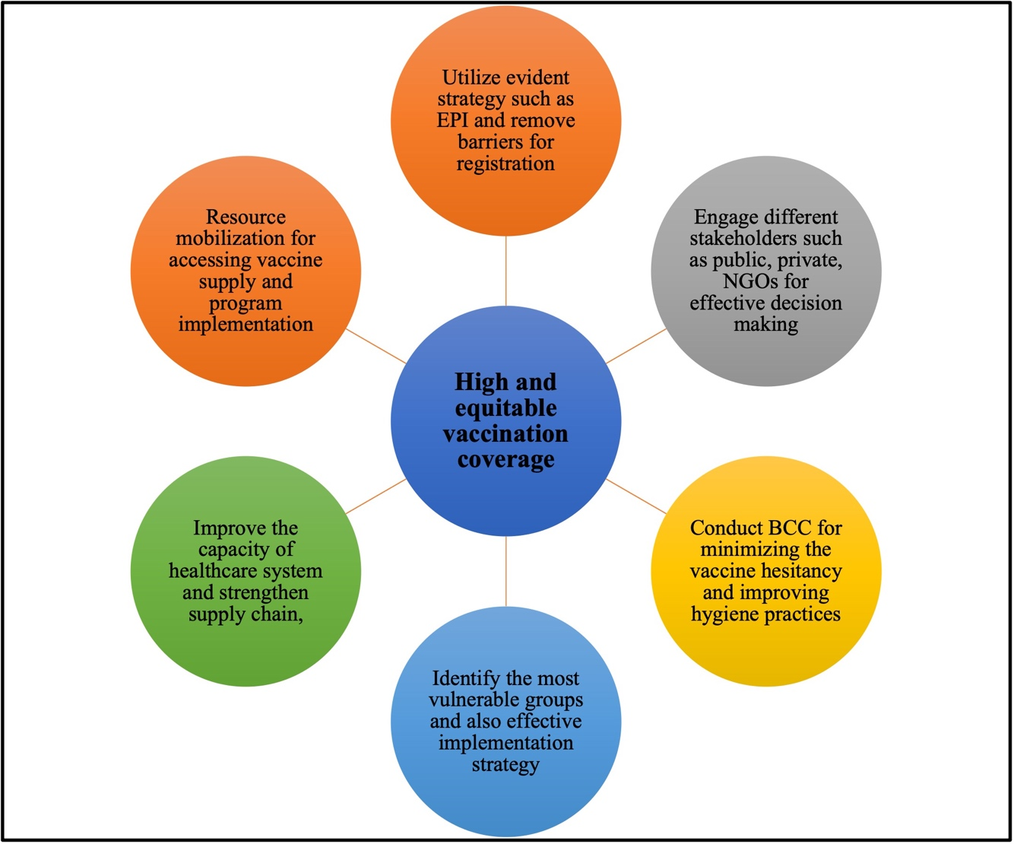

Conclusion
In the progress against COVID-19, the philosophy of vaccination is utilitarian, aiming to provide equitable protection for everybody. Considering the utilitarian perspective of vaccination, it is suggested to first achieve high primary vaccination coverage, followed by the introduction of a booster in the low-resource settings. Effective resource mobilization for achieving high primary vaccination coverage among the people in the LICs and the LMICs should be achieved, followed by the same for booster doses. Formulating and implementing an effective action plan along these lines is recommended to achieve vaccine equity within these countries.

Funding
This research was not funded

Conflict of interest
No conflict of interest is declared.

References

- The Lancet Infectious Diseases. COVID-19 vaccine equity and booster doses. The Lancet Infectious Diseases. 2021;21(9):1193.
- Bandara S, Bhaumik S, Sriram V, Saha S, Zia N, Hasan MZ, et al. Stronger together: a new pandemic agenda for South Asia. BMJ Specialist Journals; 2021. p. e006776.
- Parray AA, Yadav UN, Das A, Ali ARMM, Mollick S, Saha S, et al. Ensuring the global COVID-19 vaccine equity: Universal vaccine access strategy in the context of low and-middle-income countries. Global Public Health. 2022:1-8.
- Loewenson R, Accoe K, Bajpai N, Buse K, Abi Deivanayagam T, London L, et al. Reclaiming comprehensive public health. BMJ global health. 2020;5(9):e003886.
- WHO. Coronavirus disease (COVID-19): Vaccines 2022 [Available from: https://www.who.int/news-room/questions-and-answers/item/coronavirus-disease-(covid-19)-vaccines.
- CDC. Benefits of getting a COVID-19 vaccine 2022 [Available from: https://www.cdc.gov/coronavirus/2019-ncov/vaccines/vaccine-benefits.html.
- Our World in Data. Coronavirus (Covid-19) vaccinations 2022 [Available from: https://ourworldindata.org/covid-vaccinations.
- Chaudhary FA, Ahmad B, Khalid MD, Fazal A, Javaid MM, Butt DQ. Factors influencing COVID-19 vaccine hesitancy and acceptance among the Pakistani population. Human vaccines & immunotherapeutics. 2021;17(10):3365-70.
- Umakanthan S, Patil S, Subramaniam N, Sharma R. COVID-19 vaccine hesitancy and resistance in India explored through a population-based longitudinal survey. Vaccines. 2021;9(10):1064.
- Adebisi YA, Alaran AJ, Bolarinwa OA, Akande-Sholabi W, Lucero-Prisno DE. When it is available, will we take it? Social media users’ perception of hypothetical COVID-19 vaccine in Nigeria. The Pan African Medical Journal. 2021;38.
- Abedin M, Islam MA, Rahman FN, Reza HM, Hossain MZ, Hossain MA, et al. Willingness to vaccinate against COVID-19 among Bangladeshi adults: Understanding the strategies to optimize vaccination coverage. PLoS One. 2021;16(4):e0250495.
- Bosetti P, Kiem CT, Andronico A, Paireau J, Levy-Bruhl D, Alter L, et al. Impact of booster vaccination on the control of COVID-19 Delta wave in the context of waning immunity: application to France in the winter 2021/22. Eurosurveillance. 2022;27(1):2101125.
- Scott J, Richterman A, Cevik M. Covid-19 vaccination: evidence of waning immunity is overstated. British Medical Journal Publishing Group; 2021.
- Goldberg Y, Mandel M, Bar-On YM, Bodenheimer O, Freedman L, Haas EJ, et al. Waning immunity after the BNT162b2 vaccine in Israel. New England Journal of Medicine. 2021;385(24):e85.
- Thye AY-K, Tan LT-H, Law JWF, Letchumanan V. COVID-19 Booster Vaccines Administration in Different Countries. Progress In Microbes & Molecular Biology. 2021;4(1).
- Pai M. Decolonizing Global Health: A Moment To Reflect On A Movement. 2021 [Available from: https://www.forbes.com/sites/madhukarpai/2021/07/22/decolonizing-global-health-a-moment-to-reflect-on-a-movement/?sh=1dc572685386.
- Abimbola S, Asthana S, Montenegro C, Guinto RR, Jumbam DT, Louskieter L, et al. Addressing power asymmetries in global health: Imperatives in the wake of the COVID-19 pandemic. PLoS medicine. 2021;18(4):e1003604.
- Li Z, Lu J, Lv J. The Inefficient and Unjust Global Distribution of COVID-19 Vaccines: From a Perspective of Critical Global Justice. INQUIRY: The Journal of Health Care Organization, Provision, and Financing. 2021;58:00469580211060992.
- Adika G. Economic growth dynamics between resource‐rich and resource‐poor countries in sub‐Saharan Africa: The role of politics and institutions. African Development Review. 2020;32(3):303-15.
- Huda MN. Is Bangladesh ready to manage the risk of a coronavirus outbreak? 2020 [Available from: https://www.thedailystar.net/opinion/news/bangladesh-ready-manage-the-risk-coronavirus-outbreak-1883095.
- Huda M, Uddin H, Hasan M, Malo JS, Duong M, Rahman MA. Examining Bangladesh’s responses to COVID-19 in light of Vietnam: lessons learned. Global Biosecurity. 2021.
- Horton R. Offline: Complacency threatens progress against COVID-19. The Lancet. 2022;399(10325):615.
- Juno JA, Wheatley AK. Boosting immunity to COVID-19 vaccines. Nature medicine. 2021;27(11):1874-5.
- Burki T. Booster shots for COVID-19—the debate continues. The Lancet Infectious Diseases. 2021;21(10):1359-60.
- Choi A, Koch M, Wu K, Chu L, Ma L, Hill A, et al. Safety and immunogenicity of SARS-CoV-2 variant mRNA vaccine boosters in healthy adults: an interim analysis. Nature medicine. 2021;27(11):2025-31.
- Shroff RT, Chalasani P, Wei R, Pennington D, Quirk G, Schoenle MV, et al. Immune responses to two and three doses of the BNT162b2 mRNA vaccine in adults with solid tumors. Nature medicine. 2021;27(11):2002-11.
- Croda J, Ranzani OT. Booster doses for inactivated COVID-19 vaccines: if, when, and for whom. The Lancet Infectious Diseases. 2021.
- Jecker NS, Lederman Z. Three for me and none for you? An ethical argument for delaying COVID-19 boosters. Journal of Medical Ethics. 2021.
- Ye Y, Zhang Q, Wei X, Cao Z, Yuan H-Y, Zeng DD. Equitable access to COVID-19 vaccines makes a life-saving difference to all countries. Nature Human Behaviour. 2022:1-10.
- Ye Y, Zhang Q, Wei X, Cao Z, Yuan H-Y, Zeng DD. Equitable access to COVID-19 vaccines makes a life-saving difference to all countries. Nature Human Behaviour. 2022:1-10.
- Mandal S, Arinaminpathy N, Bhargava B, Panda S. Responsive and agile vaccination strategies against COVID-19 in India. The Lancet Global Health. 2021;9(9):e1197-e200.
- Akhter S. Covid vaccine: Coronavirus vaccine contracted with China for production in Bangladesh for the first time 2021 [Available from: https://www.bbc.com/bengali/news-58233095.
- Onyedika-Ugoeze N. Nigeria approves Covid-19 booster shots. 2021 [Available from: https://guardian.ng/news/nigeria-approves-covid-19-booster-shots/.
- Egypt Today. Egypt: COVID-19 vaccine booster shots could be given within two weeks for those who received SMS 2022 [Available from: https://www.egypttoday.com/Article/1/111844/Egypt-COVID-19-vaccine-booster-shots-could-be-given-within.
- Padma TV. COVID vaccines to reach poorest countries in 2023—despite recent pledges. Nature. 2021;595(7867):342-3.
- Taylor L. Covid-19: WHO calls for booster shot ban until end of September. BMJ: British Medical Journal (Online). 2021;374.
- Islam MR, Hasan M, Nasreen W, Tushar MI, Bhuiyan MA. The COVID-19 vaccination experience in Bangladesh: Findings from a cross-sectional study. International Journal of Immunopathology and Pharmacology. 2021;35:20587384211065628.
- The Lancet Microbe. COVID-19 vaccines: the pandemic will not end overnight. The Lancet Microbe. 2021;2(1):e1.
- Josephson A, Kilic T, Michler JD. Socioeconomic impacts of COVID-19 in low-income countries. Nature Human Behaviour. 2021;5(5):557-65.
- Rahman HZ, Matin I. Livelihoods, coping, and support during COVID-19 crisis. 2020 [Available from: https://bigd.bracu.ac.bd/publications/livelihoods-coping-and-support-during-covid-19-crisis-report/.
- The World Bank. COVID-19 to Add as Many as 150 Million Extreme Poor by 2021. 2020 [Available from: https://www.worldbank.org/en/news/press-release/2020/10/07/covid-19-to-add-as-many-as-150-million-extreme-poor-by-2021.
- Geddes L. Covid-19 boosters: would a third jab really stop the pandemic? 2021 [Available from: https://www.gavi.org/vaccineswork/covid-19-boosters-would-third-jab-really-stop-pandemic.
- NSW Health. Booster vaccination - frequently asked questions 2021 [Available from: https://www.health.nsw.gov.au/Infectious/covid-19/vaccine/Pages/booster.aspx.
- Sandmann FG, Davies NG, Vassall A, Edmunds WJ, Jit M, Sun FY, et al. The potential health and economic value of SARS-CoV-2 vaccination alongside physical distancing in the UK: a transmission model-based future scenario analysis and economic evaluation. The Lancet Infectious Diseases. 2021;21(7):962-74.
How to cite this article: Rifat MA, Huda MN, Parray AA, Yadav UN, Mahmud RA, Ali ARMM & Mistry SK. Global COVID-19 vaccine equity and the booster dose in low-resource countries: A decolonizing global health perspective. Global Biosecurity, 2022; 4(1).
Published: August 2022
Copyright: Copyright © 2022 The Author(s). This is an open-access article distributed under the terms of the Creative Commons Attribution 4.0 International License (CC-BY 4.0), which permits unrestricted use, distribution, and reproduction in any medium, provided the original author and source are credited. See http://creativecommons.org/licenses/by/4.0/ .
Global Biosecurity is a peer-reviewed open access journal published by University of New South Wales.
- Katz IT, Weintraub R, Bekker L-G, Brandt AM. From vaccine nationalism to vaccine equity—finding a path forward. New England Journal of Medicine. 2021;384(14):1281-3.
- Eccleston‐Turner M, Upton H. International Collaboration to Ensure Equitable Access to Vaccines for COVID‐19: The ACT‐Accelerator and the COVAX Facility. The Milbank Quarterly. 2021;99(2):426-49.
- World Health Organization. COVAX: Working for global equitable access to COVID-19 vaccines 2021 [Available from: https://www.who.int/initiatives/act-accelerator/covax.
- Tagoe ET, Sheikh N, Morton A, Nonvignon J, Sarker AR, Williams L, et al. COVID-19 vaccination in lower-middle income countries: national stakeholder views on challenges, barriers, and potential solutions. Frontiers in Public Health. 2021:1145.
- Kanozia R, Arya R. “Fake news”, religion, and COVID-19 vaccine hesitancy in India, Pakistan, and Bangladesh. Media Asia. 2021;48(4):313-21.

