RESEARCH ARTICLES
Assessment of Biosecurity Status of Broiler Farm at Jamalpur District
Md. Khademul Islam¹ & A.S.M. Mahbub²
¹ Faculty of Veterinary, Animal & Biomedical Sciences, Sylhet Agricultural University, Bangladesh
² Department of Poultry Science, Faculty of Veterinary, Animal & Biomedical Sciences, Sylhet Agricultural University, Bangladesh

Abstract
Broiler chicken production is an important source of animal protein supply, but the biosecurity conditions of Jamalpur region are not satisfactory. This study was done to gauge farmers' knowledge of and adherence to biosecurity guidelines of a broiler farm. We visited five randomly selected farms in two unions of Jamalpur district. The questionnaires were developed based on “biosecurity guideline for commercial poultry industry in Bangladesh”, provided by the department of livestock services of Bangladesh. There were 143 parameters, and each one of them bears 1 point. For each parameter that a farm followed, it gained one (1) point. The parameters were divided into 5 different principles: isolation, good farm hygiene, flock health care and monitoring, good farm management practices, and compliance with government regulations. Farm hygiene and compliance with government regulations were most commonly ignored principle by all the farms, especially in case of farm worker’s hygiene All the farm had trees adjacent to the shed. The highest score was 62 (43.37%), gained by Farm 2, and the lowest point was 37 (25.87%) gained by Farm 1. The average score was 50 (34.97) points. This is the first survey work in this region, but there were difficulties in working with a larger number of farms due to the COVID-19 pandemic with frequent lockdowns. This study may help to improve the biosecurity conditions of broiler chicken production in small stockholders of this region.

Keywords: Biosecurity, Broiler Farm, Questionnaire, Isolation, Hygiene, Health

Introduction
Poultry is the fastest-growing animal protein source. It is the cheapest and most easily purchasable protein source, making it acceptable to all classes of people regardless of religion, economy, and society(1). Though chicken leads the poultry industry in Bangladesh, duck, pigeon, quail, goose, turkey, and guinea fowl are available throughout the year. A survey in 2019-2020 showsed that the total population of poultry in Bangladesh was 356.318 million, which produces 7.674 million metric tons of meat and 173.6 billion eggs (2). Approximately 0.6 million employees are directly working in this sector (3).
Poultry production can be hampered by newly emerging and infectious diseases, which can be zoonotic or foodborne in origin (4). To reduce the risk of introduction and spread of diseases, many generalized biosecurity measures can be implemented (5,6).
Biosecurity consists of three steps. The first is conceptual biosecurity, including the location of the farm, distance from localities and roads, and connectivity with roads. The second is structural biosecurity, including fencing, secure housing, water supply, and installation of bins and disposal units. Third is operational biosecurity, including routine management, vaccination, disinfection and decontamination (7). Adoption of good biosecurity measures significantly reduces both the risk of disease introduction and the magnitude of the financial losses that may occur following an infection (8). A large portion of livestock producers failed to apply commonly practiced biosecurity measures, which results in a huge variation in risk management practices between producers (5,9).
A lower level of biosecurity causes a higher prevalence of thermophilic Campylobacter spp; Gallibacterium spp and Salmonella spp (10,11). Deadly diseases like Avian Influenza (AI), which is transmitted by the movement of humans, contaminated materials, and vehicles (12), can be reduced by the implementation of biosecurity measures (13–15). Newcastle Disease Virus (NDV) and Infectious Laryngotrachitis virus, transmitted by movement of people and equipment between farms (16), can also be reduced by proper biosecurity measures.
Proper biosecurity, the most important part of poultry meat-producing farms, is ignored by most of the farmers at Jamalpur district, which causes a high production cost as well as poor flock health. This ultimately leads to poor flock uniformity. Poor biosecurity also hampers public health by spreading different zoonotic diseases, and risks the health of farm employees. Furthermore, the environment is at great risk due to poor biosecurity maintained in farms, especially in broiler farms. This study was done to gauge the present status of biosecurity of different broiler farms of Jamalpur district.

Materials and Method
Study area and study period
The study was carried out from March to April 2021 on five poultry farms of Jamalpur Sadar, Jamalpur Mymensingh division (Figure 1). Two villages, Defulibari and Hashil of Titpalla union and Vaduripara and Jamtoli village of Meshta union, of Jamalpur Sadar were included in the present study. It is located at Latitude: 24°51'24.28" north and Longitude: 90°2'14.35" east. The average temperature of this area is 32°C with an average of 507 mm of rain per year, 67% of humidity, and a UV index of 7 (17). Livestock species include cattle, goats, sheep, horses, buffalo, and poultry. The most available breeds of broiler reared in this region are Hubbard classic, Cobb-500, and Lohman meat.

Questionnaire design
The questionnaire was developed following “the biosecurity guideline for the commercial poultry industry in Bangladesh” provided by the Department of Livestock Services at the Ministry of Fisheries and Livestock of Bangladesh. (18).
The questionnaire was divided into five sections with different principles for each. The first principle was isolation, including location, farm characteristics, traffic on and off the farm, and management of pests and other animals. The second principle was good farm hygiene, including house cleaning and disinfection and personal hygiene and apparel. The third one was flock health care and monitoring. The fourth was good farm management practices. The last principle was compliance with government regulations. Before starting the fieldwork, the questionnaire was pretested and adjusted accordingly.

Farm selection
Though a list of the 10 largest broiler farms of Jamalpur Sadar Upazila was collected from the registry of Upazila livestock office, data couldn’t be collected from those farms due to the COVID-19 pandemic, as there was a frequent lockdown and health risk. Farmers were located with the help of broiler retailers of Hazipur Bazar in Jamalpur Sadar, and then the farms were selected randomly. In that case, the manager of the previously located farm helped to identify the next farm.

Data collection
Considering the global pandemic, safety of data collection was maintained by wearing hand gloves, apron, face mask, and shoes. The data collector frequently used hand sanitizer and maintained social distancing, and followed decontamination protocols after returning to his residence. Therefore, any risk of transmission of COVID-19 in the community or between farms was minimized. The questionnaire was carried out through both face-to-face interviews with the farm manager, owner and workers, and through personal observation. No inquiries were made of local laboratories or veterinarians. Along with biosecurity data, data were also collected on the number of birds, years of experience in rearing broiler chickens, and adoption of fish-cum-broiler farming system, an integrated fish cum poultry farming where both broiler farm and fish farm is owned by the same framer so that both farms can be benefited by one another. The data was confirmed by collecting the signatures of the farm owner. During the survey, farmers were taught some basic and vital parameters of biosecurity that can be adopted easily.

Data management and analysis
For analysis, the collected data were compared with the standard value provided by the biosecurity guideline provided by the Department of Livestock Services at the Ministry of Fisheries and Livestock of Bangladesh(18). There were 143 different biosecurity parameters to be followed for a broiler farm. A scoring system was followed to assess the broiler farms. For each parameter that a farm followed, it received one point. The collected data based on five different principles were numerated which have been summarized in different tables. Additionally, the percentage of farms adopting biosecurity parameters according to the standard value was determined. If farms followed all the standard parameters provided by the ministry of fisheries and livestock, it was marked as 100%.

Result and Discussion
A total of 10 respondents, including farm owners and workers, were investigated in this study. Among them, two respondents each were from Farm 1, 3 & 5 respectively (owner and caretaker), one respondent (owner) from Farm 2, and three respondents (owner and two caretakers) from Farm 5 attended this survey.
There was a total of 143 points out of which the highest was 62 (43.37%) points gained by Farm 2 and the lowest was 37 (25.87%) points gained by Farm1, with an average of 50 (34.97%) points (Table 1). The result found from the survey are included in the below tables.
The owner of Farm 1 frequently changed the type of poultry in his shed from broiler to Deshi and Sonali birds. This leads to the possibility of strengthening the disease-causing agent which ultimately risks the flock to be reared next. The owner of Farm-5 maintained a broiler-cum-fish farming, which helped him to make reliable disposal of poultry manure. The other four farms use their used litter in crop cultivation or threw them into the river (Farm 1) or nearby standing water.

Principle 1 (Isolation):
For a commercial broiler farm isolation is the first and foremost thing to be ensured. It helps to maintain a safe distance between birds and potential disease threats. Scores of five farms based on the isolation principle are included in Table 2. From a total of 66 points, farms range from 17 (25.76% in Farm-1) to 25 (37.88% in Farm-2).
Principle 2 (Good Farm Hygiene)
The score of five farms in good farm hygiene is included in Table 3. Good farm hygiene prevents the dissemination of infectious agents by reducing their numbers or eliminating them from the environment. Every farm scored zero (0) in the case of personal hygiene and apparel. Hence, from a total of 44 points, the scores range from 12 (27.27% in Farm-1) to 19 (43.18% in Farm-5).

Principals 3-5
The scores of the later three principles are included in Table 4. Principle 3 was flock health care and monitoring which is essential for early detection and prevention of diseases. Principle 4 is good farm management practices that help to maintain a healthy farm environment. The fifth principle was compliance with government regulations which helps to maintain actual information about commercial broiler production. A major concern, in this case, is none of the farms was registered or related to the government HPAI control program.

Discussion
This study was conducted to compare different broiler chicken farms in their adherence to 143 guidelines of proper biosecurity of farms. The highest percentage of adherence to these guidelines was 43.36% (Farm 2) and the lowest percentage was 25.87% (Farm 1), with an average of 34.97%.
On Farm 1 it was found that used litter is thrown in the river without any treatment, which is a great threat to the surrounding area. Additionally, that farm was closely related to a river (Figure 2) which may spread the farm diseases in a vast area at the time of flooding. Farm 1 didn’t follow the basic rules of building a poultry shed (east-west direction). Overcrowding of flock and roadside sheds are some other major problems of this farm.
Among the five farms studied, Farm 2 scored the highest. The major risk of this farm was that it was closely attached to the road. During the movement of public transport, dust from the road may make a huge impact on birds. Again, another farm of Sonali birds was found around 3 meters from Farm 2, which increases the inter-shed disease transmission possibility. Backyard poultry was found to closely related and allowed to come near the shed (Figure 3) in this farm. Additionally, a cattle farm and a rice mill were also seen adjacent to the farm.
Though Farm 3 scored 47 out of 143 points, with a percentage of 32.87%, it has some major problems too. The shed of this farm was closely attached to a pond in the south, cow dung pile in the south-west part (Figure 4), rice cultivating land in the west, and residence in the north with another poultry shed of Sonali birds. Another major problem of this farm was rodents. Loss of several birds due to mice bites was common on this farm in every batch of broiler.
Farm 4 with a vulnerable hygienic condition and rodent management; scored 44 out of 143 points with a percentage of 30.77%. There was a huge pile of used litter on the west side of the farm with very unhygienic conditions (Figure 5). There was a rice cultivation area surrounding all other sides of the shed and there was no fencing. Rice cultivation land is a major source of rodents. Unfortunately, the shed had no rodent control system, and the farm employee didn’t investigate regularly if there were any rodents present on the farm. Again, some large trees were also found surrounding the shed which provides nests for wild birds. Another major problem of this farm was the flooring. The farmer made the shed on soil with some rubber pads on it rather than a concrete floor.
Though the premises of Farm 5 were found to be neat and clean and it had a broiler-cum-fish farming system, it was very poor in biosecurity measures. Like Farm 2, it was also close to the road. During the survey, a trolley with mud in its wheel came at about the distance of 2m of the shed bearing poultry feed. The driver then entered the shed without any kind of cleaning. Another problem of this farm was a nearby pond of stagnant water and a garbage pile. Additionally, a large tree (Figure 6) was also found adjacent to the shed. Unlike Farm 1, this farm follows the north-south direction of the shed also and the floor of this farm was also made of soil.

Figure 1. Study area

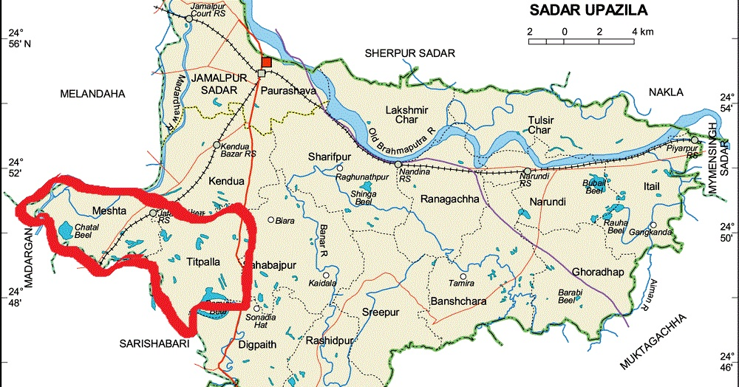

Table 1. Biosecurity scoring of the five farms

Principle | Total points | Farm 1 | Farm 2 | Farm 3 | Farm 4 | Farm 5
Isolation | 66 | 17 | 25 | 21 | 17 | 19
Good farm hygiene | 44 | 12 | 17 | 13 | 13 | 19
Flock health care and monitoring | 14 | 1 | 7 | 3 | 3 | 7
Good farm management practices | 17 | 7 | 13 | 10 | 11 | 15
Compliance with government regulations | 2 | 0 | 0 | 0 | 0 | 0
Total | 143 | 37 | 62 | 47 | 44 | 60
Percentage |  | 25.87% | 43.37% | 32.87% | 30.77% | 41.96%
Average point |  | 50
Average percentage |  | 34.97%

Table 2. Scores of five farms according to isolation principle

Topic | Standard value | Farm 1 | Farm 2 | Farm 3 | Farm 4 | Farm 5
- Location | 13 | 3 | 5 | 5 | 3 | 4
- Farm characteristics | 16 | 5 | 7 | 6 | 6 | 7
- Traffic on and off-farm | 20 | 3 | 6 | 4 | 6 | 5
- Pest management and others | 17 | 6 | 7 | 6 | 2 | 3
Total | 66 | 17 | 25 | 21 | 17 | 19
Percentage |  | 25.76% | 37.88% | 31.82% | 25.76% | 28.79%

Table 3. Scores of five farms according to good farm hygiene principle

Topic | Standard value | Farm 1 | Farm 2 | Farm 3 | Farm 4 | Farm 5
- House cleaning and disinfection | 27 | 12 | 17 | 13 | 13 | 19
- Personal hygiene and apparel | 17 | 0 | 0 | 0 | 0 | 0
Total | 44 | 12 | 17 | 13 | 13 | 19
Percentage |  | 27.27% | 38.64% | 29.55% | 29.55% | 43.18%

Table 4. Scores of five farms according to the later (3-5) principles

Principle | Standard value | Farm 1 | Farm 2 | Farm 3 | Farm 4 | Farm 5
- Flock health care and monitoring | 14 | 1 | 7 | 3 | 3 | 7
- Good farm management practices | 17 | 7 | 13 | 10 | 11 | 15
- Compliance with government regulations | 2 | 0 | 0 | 0 | 0 | 0
Total | 31 | 8 | 20 | 13 | 14 | 22
Percentage |  | 25.81% | 64.52% | 41.94% | 45.16% | 70.97%

Figure 2. South part of the shed. Besides this, there is a river

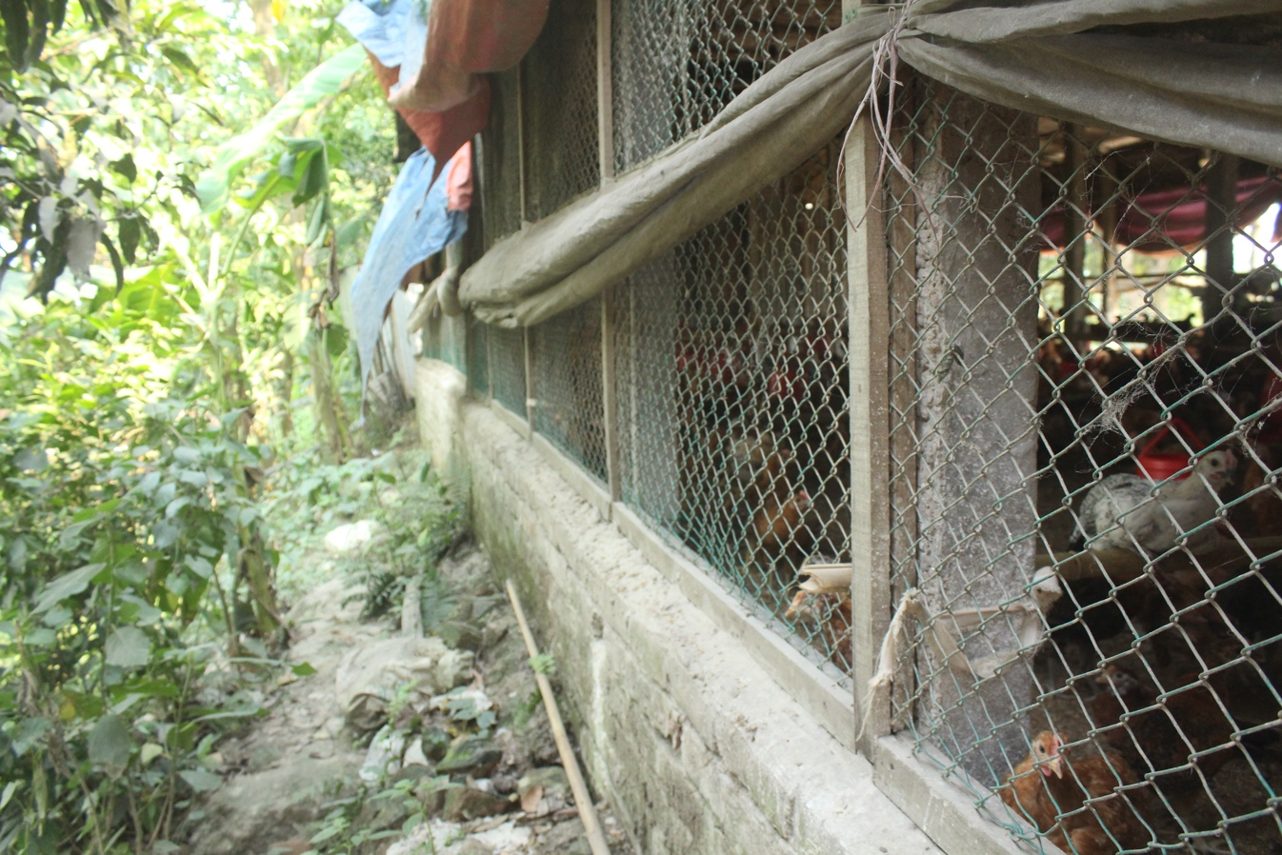

Figure 3. Local poultry around the shed
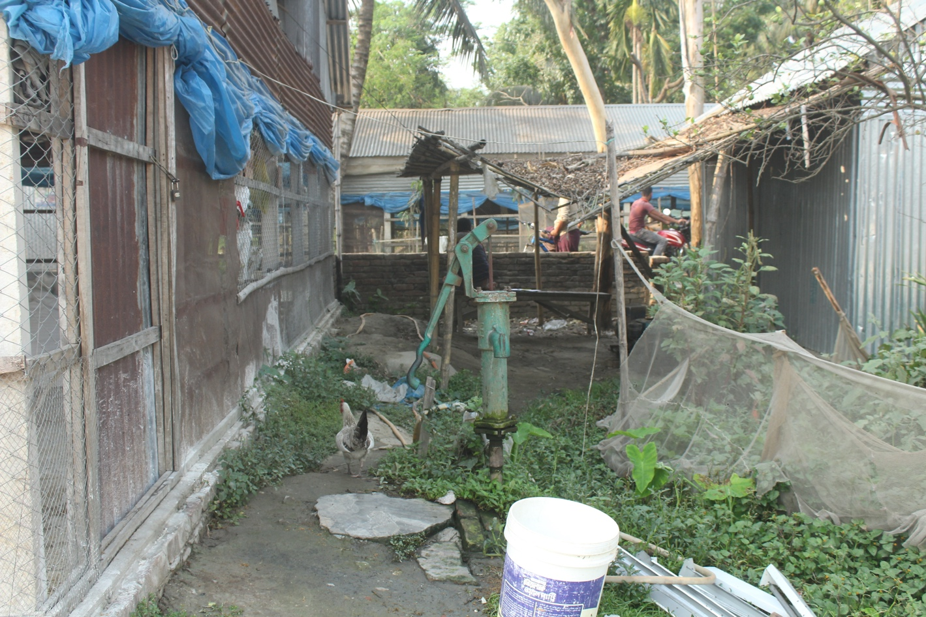

Figure 4. Pond adjacent to the shed with cow dung pile

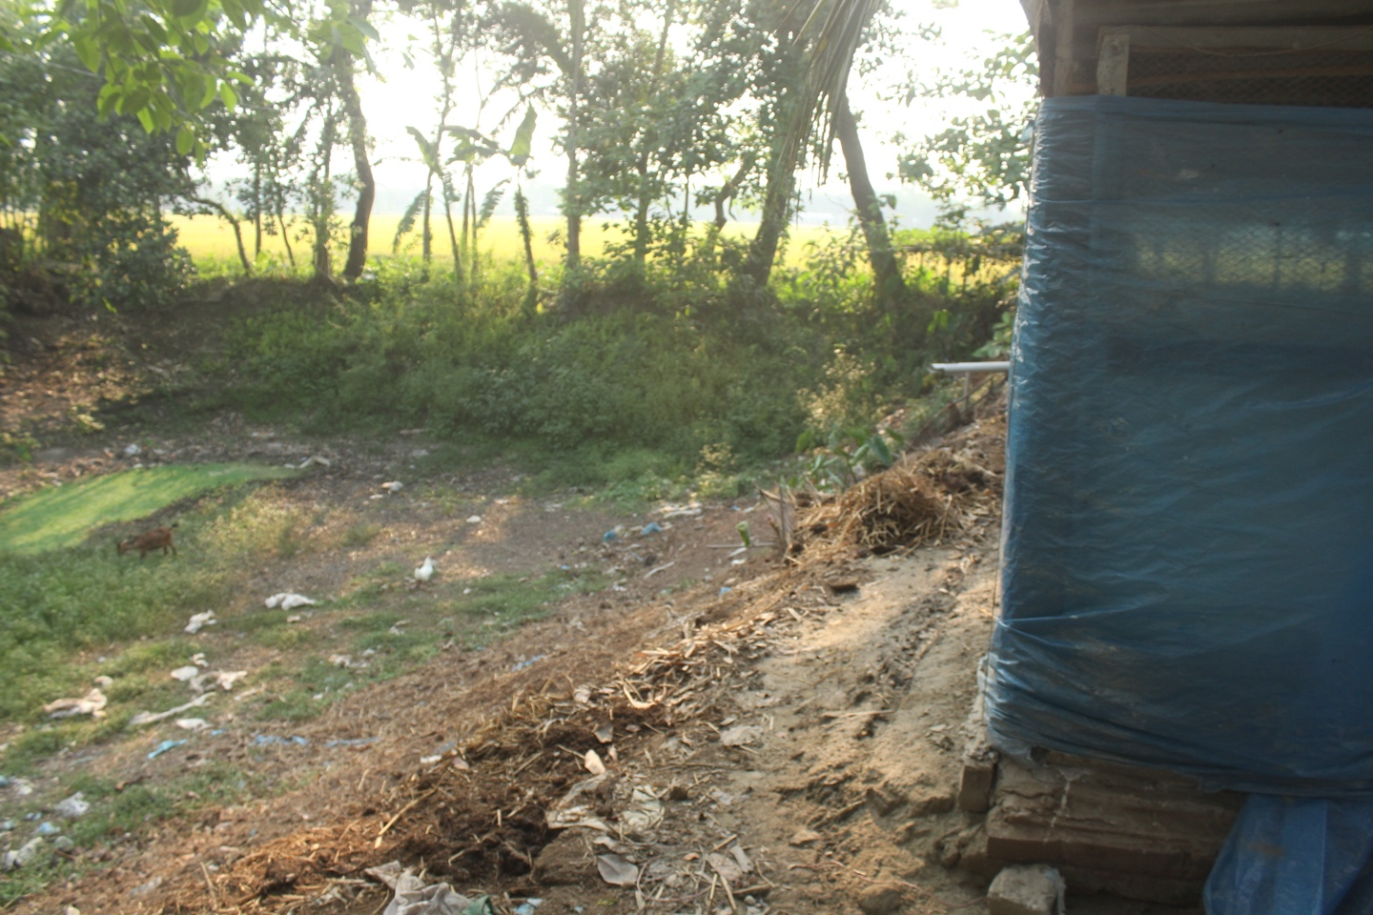

Figure 5. Used litter pile and cultivable land surrounding the farm
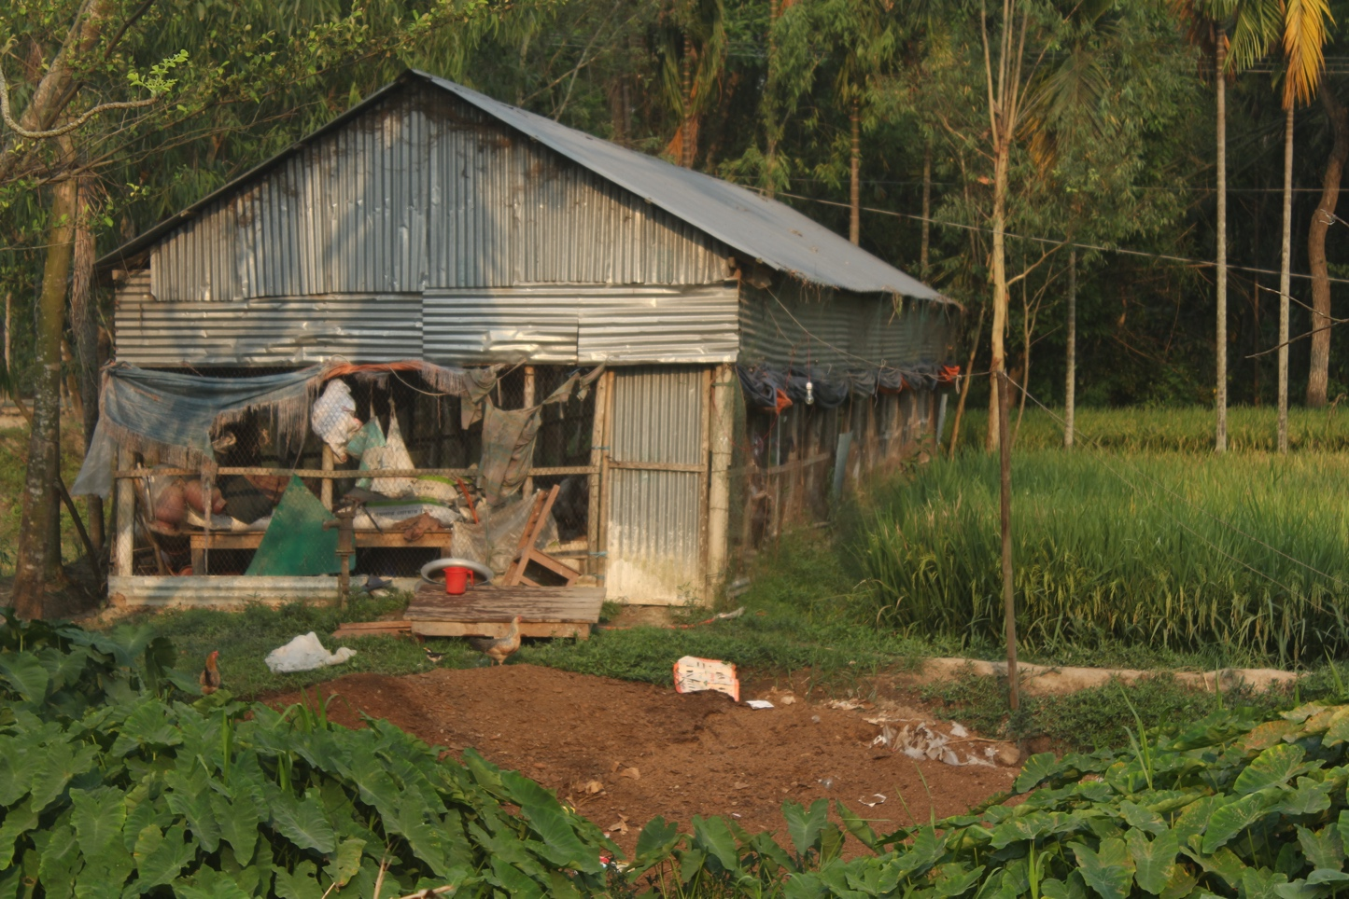

Figure 6. Tree adjacent to the shed

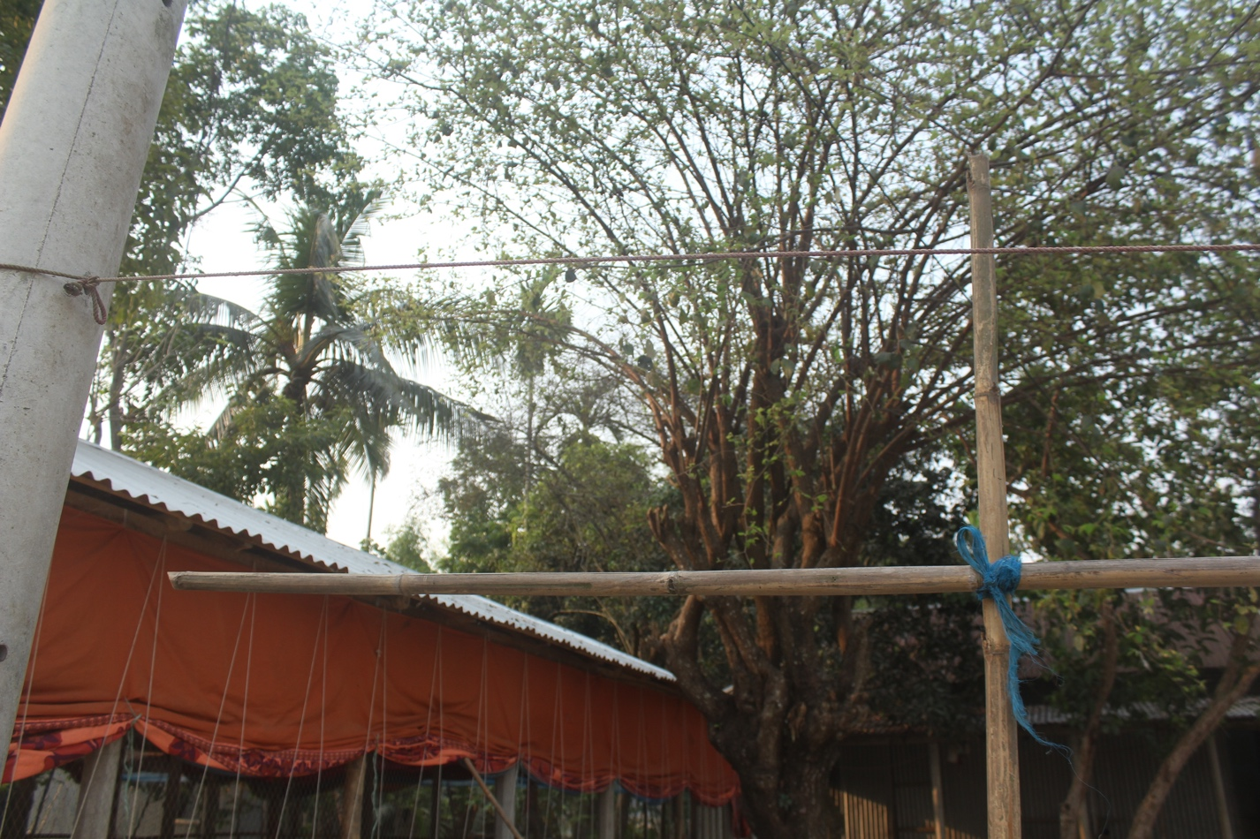

All five farms lack some of the most important parameters of biosecurity. A major issue was there were large trees adjacent to every poultry shed, providing a nest to wild birds. There was no foot bath at the entrance of the shed and farmers were not aware of this method. No farm was surrounded by a fence, which hampered the flock’s health by allowing other animals to come closer to the shed. Except for Farm 2, all the farms were adjacent to the home residence. Again, none of the farms had warning signs, so children were freely moving around the shed. Stray dogs were another major concern of all farms, which may bear different deadly pathogens. While transporting or marketing birds, vehicles could move freely without any wheel dip in the farm. Even visitors or other personnel don’t sign a logbook when visiting the farm. No records were kept of the previous flock and their diseases. Most of the farmers are reluctant to call a veterinary doctor if there is any disease outbreak or birds start to die. They start applying antibiotics on their own or by the concern of the dealers. As previously discussed, rodents were a major problem and point of farmer’s complaint. There was no safe disposal system of dead birds on any farm, which leads to disease spread among other birds. Used litter was not also treated before applying to the cultivable land or in a fishpond (Farm-5). This leads to public health danger. Even feed storage systems were vulnerable and very unhygienic on every farm. Trash piles were also found around all the farms including cow dung, used litter, and village garbage. The grass surrounding the shed was not also trimmed regularly.

Conclusion
Our results show that major and vital parameters of biosecurity are avoided by the broiler chicken farmers. For example, measures regarding the storage of used liter, foot baths, distance from residence, large trees, stray dogs, and backyard poultry farming are ignored. Furthermore, due to low biosecurity, birds are affected with different diseases and farmers are applying antibiotics without consulting with registered veterinary surgeons, which ultimately leads to public health risk. A major cause of this may be a lack of training. If they were being trained about some of these basic biosecurity parameters, they could have a higher profit. As per our knowledge, this is the first survey study of poultry farms at Jamalpur district. No similar work in this aspect was found in Bangladesh. Though only 5 farms were studied due to the COVID-19 pandemic, the findings of this study might help to make an overview of the status of broiler farm biosecurity and take proper steps to improve the biosecurity status of broiler farms in this region. Further studies should be conducted in this region.

References
- Simon P. Commercial egg and poultry meat production and consumption and poultry trade worldwide. In: 6th International poultry show and seminar, Dhaka, Bangladesh. 2009.
- DLS. Livestock Economy at a Glance. 2020;2020. Available from: http://dls.portal.gov.bd/sites/default/files/files/dls.portal.gov.bd/page/ee5f4621_fa3a_40ac_8bd9_898fb8ee4700/2020-07-22-19-34-e4cd5ed65f45419ee038e00b8939c1a0.pdf
- Hamid MA, Rahman MA, Ahmed S, Hossain KM. tatus of Poultry Industry in Bangladesh and the Role of Private Sector for its Development. Asian J Poult Sci [Internet]. 2017;(11: 1-13). Available from: https://scialert.net/abstract/?doi=ajpsaj.2017.1.13
- Astill J, Fraser E, Dara R, Sharif S. Detecting and predicting emerging disease in poultry with the implementation of new technologies and big data: A focus on avian influenza virus. Front Vet Sci. 2018;5(OCT).
- Greening SS., Mulqueen K., Rawdon TG., French NP., Gates MC. Estimating the level of disease risk and biosecurity on commercial poultry farms in New Zealand. N Z Vet J [Internet]. 2020;68(5):261–71. Available from: https://doi.org/10.1080/00480169.2020.1746208
- Bojesen AM, Nielsen SS, Bisgaard M. Prevalence and transmission of haemolytic Gallibacterium species in chicken production systems with different biosecurity levels. Avian Pathol. 2003;32(5):503–10.
- Untoo DM, Banday PDMT, Baba DIA, M.Ambreen D. Biosecurity for poultry farms [Internet]. Engormix. 2012. Available from: https://en.engormix.com/poultry-industry/articles/biosecurity-in-poultry-farm-t35526.htm
- Nespeca R, Vaillancourt JP, Morgan Morrow WE. Validation of a poultry biosecurity survey. Prev Vet Med. 1997;31(1–2):73–86.
- Sarrazin S, Cay AB, Laureyns J, Dewulf J. A survey on biosecurity and management practices in selected Belgian cattle farms. Prev Vet Med [Internet]. 2014;117(1):129–39. Available from: http://dx.doi.org/10.1016/j.prevetmed.2014.07.014
- Osimani A, Aquilanti L, Pasquini M, Clementi F. Prevalence and risk factors for thermotolerant species of Campylobacter in poultry meat at retail in Europe. Poult Sci. 2017;96(9):3382–91.
- RW Fraser, NT Williams LP, Cook J. Reducing Campylobacter and Salmonella infection: Two studies of the economic cost and attitude to adoption of on-farm biosecurity measures. Zoonoses Public Health. 2010;57(7–8):109–15.
- Sharkey KJ, Bowers RG, Morgan KL, Robinson SE, Christley RM. Epidemiological consequences of an incursion of highly pathogenic H5N1 avian influenza into the British poultry flock. Proc R Soc B Biol Sci. 2008;275(1630):19–28.
- Chickens HN, Kong H, Kung NY, Morris RS, Perkins NR, Sims LD, et al. Risk for Infection with Highly Pathogenic Influenza A Virus. Emerg Infect Dis. 2007;13(3).
- Nishiguchi A, Kobayashi S, Yamamoto T, Ouchi Y, Sugizaki T, Tsutsui T. Risk factors for the introduction of avian influenza virus into commercial layer chicken farms during the outbreaks caused by a low-pathogenic H5N2 virus in Japan in 2005. Zoonoses Public Health. 2007;54(9–10):337–43.
- Power C. The source and means of spread of the avian influenza virus in the Lower Fraser Valley of British Columbia during an outbreak in the winter of 2004. [Internet]. 2008. Available from: http://www.inspection.gc.ca/english/anima/heasan/disemala/avflu/2004rep/%0Aepie.shtml
- Dent JE, Kao RR, Kiss IZ, Hyder K, Arnold M. Contact structures in the poultry industry in Great Britain: Exploring transmission routes for a potential avian influenza virus epidemic. BMC Vet Res. 2008;4:1–14.
- Climate of Jamalpur [Internet]. besttimevisitors.com.ph. 2021 [cited 2021 May 2]. Available from: https://www.besttimetovisit.com.ph/bangladesh/jamalpur-221055/#Climate_Jamalpur
- Ministry of fisheries and livestock G of the PR of B. Biosecurity Guideline for the Commercial Poultry Industry. 2011;

Appendix

Questionnaires used for this study were based on the following:

Principle #1: ISOLATION.

- Location:

Parameters | Standard value
- Minimum distance between a poultry farm to the next poultry farm. | 200 M
- Minimum distance allowed of back yard poultry farm. | 200 M
- Minimum distance between a poultry farm to a processing plant. | 1 km
- Minimum distance between poultry farm to Live Birds Market. | 1 km
- Minimum distance between poultry farm to a residential area. | 500 M
- Minimum distance between a poultry farm to the nearest urban or village waste disposal facilities. | 1 km
- Minimum distance between a poultry farm to the nearest standing body of water (pond, lake, dam). | 200 M
- Minimum distance between a poultry farm to the nearest river with the possibility of flooding. | 1 km
- Minimum distance between a poultry farm to the nearest market garden or plantation that spread raw poultry manure (to be checked for existing legislation). | 200 M
- Minimum distance between farm fences to a poultry house. | 2 M
- Minimum distance between a poultry house to large trees that host wild birds. | 100 M
- Minimum distance between shower/washroom/toilet for the farmworkers and the poultry house residential area. | 10 M
- Minimum distance between farm and road.

- Farm characteristics:

Parameters | Standard value
- The farm should be directed in East-West. | Yes
- Farm must be surrounded by a protective fence. ( Minimum 2 M) | Yes
- Farm must have a lockable gate. | Yes
- Farm must have only one main gate entrance, in and out of the farm. | Yes
- Farm must have a 24-hour security guard at the main entrance or other strategic points of the farm. | Yes
- Farm must have warning signs at the gate and on the fence indicating that access is restricted. | Yes
- All sheds on the farm must be locked at all times. | Yes
- Sheds must be oriented with wind flow going from the younger to older groups. | Yes
- A minimum distance between sheds on the farm is maintained. | 40 M
- All sheds must have bird-proof nettings. | Yes
- All sheds on the farm must be closed, environment-controlled sheds. | Yes
- Flocks of different age groups (multi-age farms) are allowed on the same farm. | Yes
- Untreated water (non-filtered, non-chlorinated) not allowed for drinking or cooling at the farm. | Yes
- A safe dead bird disposal system (pit, incinerator, and composter) is present at the farm. | Yes
- A safe manure disposal system (pit, incinerator, and composter) is present at the farm. | Yes
- Height of the roof. | 1M

- Traffic on and off the farm:

Parameters | Standard value
- Farm vehicles are never to be taken off the farm. | Yes
- No lent or borrowed equipment from other poultry units or farms is allowed to be used at the farm. | Yes
- All visitors to the farm must sign a logbook. | Yes
- No visitors are permitted on the premises except authorized personnel. | Yes
- All visitors must be asked where they have been before coming on the farm, to ensure no previous contact with poultry over the last hours. | Yes
- All visitors and employees must have a shower and change clothes and footwear (farm clothes) before entering the farm. | Yes
- All vehicles coming onto the farm must be checked to see if they are clean. | Yes
- All vehicles must be washed with detergent and then disinfected (wheels, undercarriage, driver cabin, etc.) before entering the farm. | Yes
- All vehicles must drive through a wheel dip with an active disinfectant solution before entering the farm. | Yes
- No vehicles are allowed to drive from outside the farm into the poultry shed area. | Yes
- Vehicles must park no less than 30 meters of poultry sheds. | Yes
- Drivers are not allowed into poultry sheds. | Yes
- Farm employees are not allowed to ride between two or more units or farms in the feed or egg truck. | Yes
- No one except the farm manager, employees, service personnel, and veterinarians are permitted into poultry houses before load-out. | Yes
- Employees are assigned to their sheds and don’t visit other sheds unless they showered and change clothing. | Yes
- Load-out crews are not permitted to go anywhere else on the farm except for the house they are assigned to work in. | Yes
- Farm managers and employees never visit other farms. | Yes
- Farm managers and employees never visit other farms during disease outbreaks. | Yes
- Farm managers and employees never visit the live-side of the processing plant or wet market. | No
- When there are multiple ages of birds on the farm, the order of birds’ care must be from youngest to oldest or different employees caring for different ages. | Yes

- Pest management and others:

Parameters | Standard value
- Farm must have a rodent control plan. | Yes
- Bait boxes and traps must be regularly checked to be sure that the bait is fresh and to remove dead rodents. | Yes
- Rodent activity must be regularly checked, e.g., active holes near the foundations, chewed curtains and insulation, rodent droppings on sills and in entry-rooms. | Yes
- No trash and junk is allowed to pile up for 30 meters around the sheds and in the entry room. | Yes
- Grass and weeds must be trimmed around the house. | Yes
- Outside feed spills must be cleaned promptly. | Yes
- Dead birds must be removed promptly and placed in vermin-proof containers before disposal. | Yes
- The screening in the eaves of poultry houses must be weekly checked and repaired to prevent wild birds. | Yes
- Sheds must have concrete floor or slates and pads long the walls and at every entrance to the house. | Yes
- Regular spray for insect control, using approved insecticides must be applied at the farm. | Yes
- Farm must have an insect control plan for darkling beetles, lice, mites, and flies. | Yes
- Employees must be trained in the usage of insecticides and pest management. | Yes
- Farm must have wild birds control plan. | Yes
- Farm must have stray dogs and cats control plan. | Yes
- Pet dogs, cats, and birds (parrots/ pigeons) are not allowed on farms or to enter sheds. | Yes
- Other farms animals like cattle, goats, etc., are not allowed on farms. | Yes
- Other farms animals like cattle, goats, etc., are not allowed within 30 meters of poultry sheds. | Yes

Principle # 2: GOOD FARM HYGIENE.

- House Cleaning and Disinfection:

Parameters | Standard value
- Litter that is removed from poultry houses must be stored in a covered shed or covered with a plastic sheet. | Yes
- Used litter must be treated in an approved, properly managed composting facility before being sold out. | Yes
- Untreated litter should not be spread on fields adjacent to poultry houses. | Yes
- Used litter must not be stored near clean litter. | Yes
- When removing litter from poultry houses any spills in roadways and entrances to poultry houses must be cleaned up immediately. | Yes
- All equipment used during litter removal must be properly cleaned and disinfected after each use. | Yes
- After litter removal the poultry house must be thoroughly swept and clean from top to bottom. | Yes
- All rafters, sills, lighting fixtures, fan blades, motors, louvers, brooders, etc. must be blown off or wiped and clean. | Yes
- The entire facility, including curtains (inside and out), entry rooms, and equipment must be washed from top to bottom with a detergent spray. | Yes
- The entire facility must be disinfected using an approved product at the concentration and quantity recommended by the manufacturer. | Yes
- A suitable sprayer should be used for washing and disinfection. | Yes
- All feed pans, feed lines, and hoppers should be emptied before cleaning. | Yes
- All feed pans, cones, hoppers, and drinkers should be scraped, scrubbed, washed, and disinfected as per need. | Yes
- The feed bin, boot, and auger must be regularly cleaned and disinfected. | Yes
- Water lines should be cleaned, de-scaled, and sanitized between flocks. Water lines. | Yes
- Loose feathers and debris must be cleaned/ burnt up outside, around the house. | Yes
- After cleaning and final disinfection the shed should be allowed at least 2 weeks to dry out and remain empty. | Yes
- The shed must be re-bed using clean, dry, litter, which is free of any moldy smell and fumigate before use. | Yes
- Removable equipment like feed trays and jug waters should be cleaned and disinfected just before setting the house up for new birds. | Yes
- Litter must be insect-free. | Yes
- Staff should be trained about the correct use of disinfectants and spraying equipment. | Yes
- Any equipment such as vaccinators, debeakers, egg trays, etc., brought into the farm must be cleaned and disinfected. | Yes
- Feed stored not more than 7-8 days. | Yes
- Shed floor is cleaned daily. | Yes
- Feeder and waterer are cleaned daily. | Yes
- Water sanitizer is used. | Yes
- Farm premises and the surrounding of the shed are regularly cleaned. | Yes

- Personal Hygiene and Apparel:

Parameters | Standard value
- Vehicles that leave the farm must be cleaned and disinfected regularly, including the cabs and beds. | Yes
- All employees must wash, and change clothes and footwear before entering to work in the farm or poultry houses. | Yes
- Street clothes or shoes must never be worn in the poultry houses. | Yes
- Separate cap and pair of coveralls should be used for each house and/or each brooder and finisher unit. | Yes
- All caps and coveralls must be laundered regularly within the farm area, especially between flocks. | Yes
- Separate pair of boots or sandals must be used for each house and/or brooder and finisher unit. | Yes
- Boots or sandals must be cleaned and disinfected before and after use. | Yes
- Hands must be cleaned and disinfected (disinfectant cream/soap can be used) often and when moving between units. | Yes
- Dip pans (foot bath) with a daily refreshed solution should be placed at every poultry house entrance. | Yes
- All visitors who wish to enter poultry houses must wear clean, sanitized caps, coveralls, gloves, and footwear. | Yes
- All soiled, disposable apparel should be washed or disposed of on the farm when visitors leave. | Yes
- Farm employees should be regularly vaccinated against foodborne diseases and seasonal flu. | Yes
- Farm employees should be trained regularly about personal hygiene issues. | Yes
- Clean basin with running water, showers, and toilets must be available on every farm. | Yes
- Use protective clothes. | Yes
- Disinfectant spray at the entrance of every shed. | Yes
- Hand wash before entering the shed. | Yes

Principle # 3: FLOCK HEALTH CARE AND MONITORING

Parameters | Standard value
- The veterinarian should be called immediately when birds appear to be sick/In unusual condition. | Yes
- Sick or dead birds should be regularly examined by clinical, post mortem, and laboratory tests to determine if infectious agents may be responsible for the problem. | Yes
- Birds should routinely be bled and/or swabs taken for serological or diagnostic purposes. | Yes
- Birds should be vaccinated for agents known to have caused problems at the farm in the past. The vaccination program should be developed by the veterinarian. | Yes
- When using vaccines the manufacturer’s instructions must be followed. | Yes
- Antibiotics must be administered according to the dosage and treatment period listed on the label or according to the instructions of a veterinarian. | Yes
- Antibiotics must be used only when birds are sick, following instructions by veterinarians. | Yes
- Antibiotics should be withdrawn by the manufacturer’s instruction label. | Yes
- Expired vaccines or antibiotics are never to be used at the farm. | Yes
- Birds should be dewormed regularly, according to veterinary instruction. | Yes
- A regular flock monitoring program for the disease should be in place. | Yes
- Dead /sick birds should be sent to the laboratory in a proper, safe way for investigation as instructed by the veterinarian. | Yes
- A documented contingency plan should be ready in case of HPAI or other notifiable infectious disease outbreaks on the farm. | Yes
- A registered veterinarian must be responsible for the animal health of the farm. | Yes

Principle # 4: GOOD FARM MANAGEMENT PRACTICES

Parameters | Standard value
- A flock record must be kept for each shed. The record includes information of DOC origin, number of chicks placed, daily mortality (numbers and %), daily feed consumption, daily water consumption, weekly body weight, daily egg production, vaccinations, medications, vitamins administration, laboratory results, etc. | Yes
- Housing temperature is maintained according to guidelines prescribed by the breeding company. | Yes
- If birds look chilled, they must be supplied more heat without compromising air quality. | Yes
- Poultry houses must be ventilated according to breeding company recommendations. | Yes
- The air in the poultry houses must be suitable for human consumption (long term). | Yes
- Poultry houses should never be overstocked. | Yes
- Poultry houses must have sufficient eating and drinking space as prescribed by the breeding company. | Yes
- The lighting program must follow the prescribed by the breeding company. | Yes
- All farms should maintain all in & all-out systems. | Yes
- Dead birds must be disposed of safely on the farm (in a sealed pit, incineration, composting). | Yes
- The litter on the farm must be well managed and disposed properly. | Yes
- Dead birds are never to be stocked piled overnight before disposal and exposed to pests. | Yes
- Dead birds are never to be left inside the shed longer than 2- 5 hours. | Yes
- Feed should be sourced only from a trusted feed mill. | Yes
- Feed must be stored on-farm in sealed and dry containers with no access to rodents or wild birds and free of fungus and mold. | Yes
- After house depopulation no birds should be left behind inside or outside the house. | Yes
- The downtime between flocks should never be less than two weeks. | Yes

Principle # 5: COMPLIANCE WITH GOVERNMENT REGULATIONS

Parameters | Standard value
- All farms must join the government scheme for compulsory farm registration and upgrading to meet government minimum biosecurity standards. | Yes
- All farms should join the government compensation schemes for HPAI. | Yes

How to cite this article: Islam MK & Mahbub ASM. Assessment of Biosecurity Status of Broiler Farm at Jamalpur District. Global Biosecurity, 2022; 4(1).
Published: August 2022
Copyright: Copyright © 2022 The Author(s). This is an open-access article distributed under the terms of the Creative Commons Attribution 4.0 International License (CC-BY 4.0), which permits unrestricted use, distribution, and reproduction in any medium, provided the original author and source are credited. See http://creativecommons.org/licenses/by/4.0/ .
Global Biosecurity is a peer-reviewed open access journal published by University of New South Wales.

