RESEARCH ARTICLES
Predicting Forest Pest Threats in Australia: Are Risk Lists Worth the Paper they’re Written on?
Helen F Nahrung¹ & Angus J Carnegie²
¹ University of the Sunshine Coast, Australia
² New South Wales Department of Primary Industries, Australia

Abstract
We reviewed exotic insect species that are considered threats to Australia’s plantation, amenity, native forests and timber-in-service (“risk species”), comparing them to already-established non-native species. We examined biological and phylogenetic traits, border interceptions, origins and geographic distributions, to identify similarities between groups. Border interceptions of insect species considered an invasion risk were further analysed to identify their likely pathways. The two groups “risk species” and “established species” differed compositionally, with the dissimilarity possibly due to: (1) neither timber pests nor, to a lesser extent, exotic amenity tree host taxa being considered in industry or environmental biosecurity plans (e.g. explaining the under-representation of Bostrichidae in perceived risks compared to establishments and interceptions); (2) the importance of high-profile pests overseas (e.g. Monochamus spp., Lymantria spp.) inflating some groups over others; (3) unpredictability (“known unknowns”) (e.g. establishment of unexpected species such as Marchalina hellenica and Essigella californica); (4) identification of emerging pests or pathways that may differ from historical arrivals; and (5) surveillance — for insects at least — traditionally targeting more detectable taxa (possibly explaining the over-representation of moths and cerambycids in risk lists compared to establishments). The under-representation of Hemiptera on risk lists may reflect their low visibility as impact species outside Australia, their lower detectability, and hence, unpredictability. Risk and established species groups could be separated based on body size and geographic distribution, as well as in the frequency (proportion of species intercepted), but not number, of border interceptions. Risk species were often intercepted from their invaded range, and were largely associated with wood products and packaging and non-commercial pathways (mail, baggage, personal effects). Our study highlights common factors that might assist with developing risk lists — e.g. polyphagy, history of invasiveness, body size — and the fallibility of such lists. Improving general surveillance capacity and capability will increase the chance of detecting cryptic or unpredictable pests that are not effectively targeted in specific surveillance.

Keywords: invasion, biosecurity, exotic species, non-native species, surveillance

Introduction
Invasive species cost the Australian economy almost $AUD14B annually [1], as invasions continue worldwide with no evidence of saturation [2]. Australia has accumulated ~140 non-native forest insect species in native, amenity and plantation trees and timber, > 95% of which are invasive elsewhere [3] and many of which continue to move globally through trade and travel [4]. The globalised movement of goods and people inevitably leads to an increased risk of the arrival of additional invasive species [5], with commensurate requirements for their prevention and mitigation.
The Australian biosecurity system aims to minimise adverse impacts of exotic invasive pests and diseases on the economy, environment and community, whilst facilitating trade and the movement of people and commodities [6] and is estimated to provide an average return on investment of 30:1 [7]. Australia’s biosecurity system is among the strictest in the world [8]; the Australian Government’s Department of Agriculture, Water and the Environment (DAWE) is the lead agency for biosecurity in Australia, with partnerships across government, industry, the community, and other countries to help manage risks overseas, at the border, and within Australia [9]. The recent proposal to establish a National Forest Pest Surveillance Program aims specifically to reduce the risk of establishment and spread of exotic forest pests through targeted post-border surveillance strategies [10, 11]. Pest risk prioritisation for allocation of limited funds for surveillance is an important consideration for stakeholders [12], with formal pest risk analyses forming a mainstay for this prioritisation.
Typically, biosecurity pest risk analyses involve assessment at each step of the invasion process to identify the likelihood and consequence of a pest’s arrival, establishment, spread and impact. This provides a foundation for prevention and mitigation measures [13, 14], and facilitates the prioritisation of pre-border, border and post-border activities and response measures [15]. Accurate and up-to-date information on exotic pest threats, likely pathways, and potential impacts is required to develop pest and pathway risk assessments and ensure adequate biosecurity measures are in place [16]. Prevention of arrival and establishment is the most cost-beneficial outcome of biosecurity [17, 18], while effective management can provide a 13-fold benefit over the economic costs of damage [19]. In Australia, the management of three invasive forest insects alone (Hylotrupes bajulus, Marchalina hellenica and Cryptotermes brevis) has cost over $3M pa in eradication and containment measures since 2003 [16, 20].
Here we examine the exotic insects considered biosecurity threats to Australia’s forests, comparing them compositionally and biologically to those already established in Australia, and using border interception data to identify their potential pathways, commodity associations and origins. Our findings aim to inform stakeholders towards effective pest risk prioritisation regarding biosecurity policy, early detection and increased likelihood of eradicating potentially devastating invasive forest pests.

Materials & Methods
Construction of datasets
To compare perceived threats with pests that have already established, we constructed two datasets: the Risk dataset and the Establishment dataset. For insects in each dataset, we recorded the same attributes as used previously [4] (i.e. global distribution, body size, concealment, reproductive strategy, polyphagy, host-associated lifestages, native range, and impact/priority in forestry). We also recorded whether close (genus-level) relatives of each are present in Australia as native or invasive taxa. Each dataset was further classified into forest-relevant taxa (i.e. those specific to forest/amenity/timber hosts, not primarily associated with other industries such as horticulture) – see [3], and priority pests (PPs) as defined by those causing moderate to high impact in Australia [3, 16], or assessed as moderate to high risk in assessment processes (see below).

Risk dataset
Exotic insects listed as threats to Australian forests (defined here as plantation, amenity and native forest trees), as well as threats to timber-in-service were considered. Threats included those formally assessed nationally [21], in industry (plantation forestry and nursery) biosecurity plans [22-25], in environmental biosecurity prioritisation lists [26], in exotic forest-relevant insects listed as “regulated pests” in the Pest and Diseases Image Library (www.padil.gov.au), in exotic timber pest guides [27, 28], and forest-relevant insects on the Northern Australia Quarantine Strategy (NAQS) surveillance list (J. Walker, pers. comm.). We note that the assessment processes by which these species were included differed between sources, although several species were included in more than one source (see Supplementary data table 1). Relevant host plants were the same native, plantation and amenity genera, and timber, as used in [3]. We restricted our list to insects explicitly described or assessed as being of some threat to Australia rather than using records of all exotic insects associated with our forest hosts as these would number into the thousands (e.g. >400 exotic insect species recorded on eucalypts alone ([29; HFN unpubl.]). The risk dataset thus comprised of 74 insect species, 44 of which were primarily forest species, and 17 of which were designated as moderate or high priority pests (PPs); in total, 52 of these species had been formally risk-assessed through government [30], industry [22-25] and environmental biosecurity processes [26], while a further four were on the NAQS watch list (Supplementary data table 1).

Establishment dataset
We used the 135 non-native insect species established in Australia from [3, 4] to which we added four established non-native termite species (Cryptotermes brevis, C. cyanocephalus, C. domesticus, and C. dudleyi [31]). Of these 139 species, 70 were primarily forest pests, and 20 were considered to cause moderate–high impact (see 3; Supplementary data table 2).

Border interceptions
The number of border interceptions of species on each list were accessed from the Australia-wide DAWE border interception database (2003–2016), through a formal data-sharing deed with HFN. These interception data comprise air, sea and mail border detections made during inspection by biosecurity officers at ports of entry associated with international cargo, travellers, and mail. Available details included country of origin and commodity-association, which were categorised to geographic region and broad commodity classes (Table 1) for analyses.
We acknowledge the limitations of the border interception data including: a lack of information on relative inspection rates and import volumes; difficulties in accurately identifying different insect lifestages; lack of data on the number of insects found and their lifestage at the time of discovery; potential differences in inspection rates and methods between jurisdictions; and potential unreliability in country of origin records given multiple port stops. Intercepted insects were destroyed, and potential risk of any associated consignments were mitigated as part of usual biosecurity processes.

Table 1. Types of commodities on which interceptions were made and their classification into commodity classes.

Commodity class | Commodity description
Plant material | Fresh and dried fruit, vegetables, flowers, woven grasses, nursery stock, seeds, herbs and spices, grains
Wood products | Wooden articles that are the commodity e.g., timber, artefacts and ornaments, furniture, panels, personal effects (where wood is specified as material)
Wood packaging | Crates, pallets, dunnage, packing material (where wood is specified as material)
Machinery/vessel | Typically non-host material associated with cargo or vessels e.g., tyres, empty containers, ship or part of ship, tools, new and used vehicles, machinery and parts thereof
Other/unknown | Animal products (e.g., fish meal, meat meal), personal effects (where wood is not specified), slate, paper, plastic, cardboard; or no commodity recorded

Asian gypsy moth, Lymantria dispar, was not recorded in border interceptions at subspecies level, so subspecies was inferred based on origin (i.e. L. d. dispar from Europe or North America, L. d. japonica from Japan, L. d. asiatica from elsewhere in Asia). The single border interception of Euwallacea fornicatus was split between the two taxa in the risk list that it might have been (E. kuroshio and E. fornicatus), although there are two other species in the complex [32]. Finally, Cryptotermes brevis is formally listed as a high priority exotic pest for Australia [21, 25] but because it is established in several locations, albeit under control [31, 33], we included it in the establishment list, rather than the risk list.

Comparisons between risks and establishments
Taxonomic compositional differences between all, forestry-specific, and moderate–high priority lists of established species and risk species were visualised at the Order level using simple bar graphs, and at the family level by plotting the number of species in each family represented in each list.
Differences in established and risk taxa between the larger dataset based on the first six attributes above were quantified using analysis of similarity (ANOSIM) based on the index of association [34] and visualised using non-multidimensional scaling (nMDS) in Primer 7 (v.7.0.13, PRIMER-e), with those that contributed most strongly to group separation being identified with similarity percentage (SIMPER) [35]. To avoid any potential phylogenetic bias in the larger dataset, the same analysis was repeated for Coleoptera only, as one of the most important groups of invasive forest insects. Border interceptions were compared between risk and established species using chi-square tests, t-tests and regression analyses conducted in SPSS (IBM SPSS V26).

Border interceptions of risk species
Interception frequencies were compared between risk and established groups using chi-square and Mann-Whitney U-tests. Border interception data for the risk species only was examined further to identify taxonomic patterns, origins and commodities that they were associated with. Spearman rank correlation was used to examine relationships between the number of interceptions and numerical trait scores. These were further examined using ANOSIM and Mann-Whitney U-tests comparing trait ranks between binary groups “intercepted” and “not-intercepted”.

Results
Comparisons between risks and establishments
The broadest list (all native, amenity, plantation and timber-in-service insects) showed little taxonomic similarity between risk (n = 74) and established (n = 139) insects (Figure 1a), with Hemiptera extremely over-represented, and Lepidoptera under-represented, in establishments compared to risks. There were six families of insects with at least two species established that were not considered risks (Adelgidae, Aphididae, Cicadellidae, Diaspididae, Psyllidae and Tenthridinidae), and ten families considered risks for which no forestry representatives are established (Coreidae, Cossidae, Erebidae, Lasiocampidae, Pentatomidae, Pyralidae, Rhinotermitidae, Saturniidae, Thaumetopoeidae, Tortricidae), four of which have no invasive representatives in Australia at all (Rhinotermitidae, Thaumetopoeidae, Cossidae, Lasiocampidae – HFN, unpubl.). A similar percentage of species had native Australian congeners between the risk and established lists (32% and 27%, respectively; χ²₁ = 0.61, P=0.44) but significantly more non-native established species had invasive congeners in Australia than did risk species (60% vs 28% respectively; χ²₁=19.8, P<0.001).
Considering primarily forest insects, six families with two or more established species were unrepresented in the risk list (Adelgidae, Aphididae, Cicadellidae, Diaspididae, Psyllidae, Tenthridinidae) and six families appeared on the risk list which currently have no invasive forest species present (Cossidae, Lasiocampidae, Pyralidae, Rhinotermitidae, Thaumetopoeidae, Tortricidae) (Figure 1b). The comparison of exotic pests (PPs) of moderate–high priority to those documented causing moderate–high impact (Figure1c) illustrated general incongruence for all families except the Curculionidae; cerambycid beetles were over-represented by risk, with only one (Hylotrupes bajulus) established species causing economic impact so far. Similarly, there are not yet representatives of the Rhinotermitidae or Erebidae established in forestry or causing impact.
The two groups (risk species and established species) were separated based on their biological attributes for all three data subsets (ANOSIM: all: R = 0.49, P = 0.001; forestry: R= 0.19, P = 0.001; PPs: R = 0.31, P = 0.002 – only nMDS for the full dataset presented – Figure 2), with SIMPER showing that body size and global distribution were the strongest contributors (>70%) to group separation in all cases, with established species being smaller and having broader global distributions than risk species. When number of interceptions was added to the model, it replaced global distribution as a discriminating factor, with established species having higher numbers of interceptions than risk species.
The risk species that clustered most closely to the established species based on their six measured biological attributes are listed, along with their respective number of border interceptions, in Table 2.
The same group separation held for Coleoptera alone (ANOSIM: R = 0.18, P = 0.001) with the same attributes (body size, global distribution) responsible for group partitioning (Figure 3).
In addition to the five beetles in Table 2, Lyctus africanus (Bostrichidae) was identified in this analysis as a risk species of overlap, with 76 border detections.

Border interceptions of risk species and established species
There were 1,079 border interceptions between 2003 and 2016 of 28 of the 74 exotic species considered in our risk list, and 4,058 of 78 out of 139 established species. Significantly more established non-native species (56%) were intercepted than risk species (38%) (χ²₁=6.5, P=0.01). However, the mean number of interceptions per intercepted species did not differ between established (52.0 ± 12.6) and risk (38.6 ± 16.1) groups (t-test, t₁₀₄=0.58, P=0.56).
At family level, there was a linear relationship between the number of species intercepted and the number of species established (Figure 4A), with 5 of the 11 families with no established representatives also having no border interceptions among forest taxa. Aphids were an outlier in their over-representation in establishments compared with interceptions, and when removed the linear relationship became y = 0.7278x - 0.1949; R²=0.96, P<0.001. The relationship between the number of interceptions per intercepted species, and number of species established per family, was not significant (R²=0.07, P=0.1) (Figure 4B).
For the nine (of forty) families of overlap between the established and risk lists (comprising 60 and 47 species, respectively), the number of interceptions is shown in Table 3. In both groups, the Buprestidae had no interceptions, and Bostrichidae had the highest number of interceptions per species, but the Cerambycidae had substantially higher numbers of interceptions among the risk species than established species (driven by high numbers of Arhopalus ferus — see below for explanation). Interceptions of Curculionidae were most divergent between groups, with 200 times the number of interceptions of established species compared with risk species (Table 3).

Border interceptions of risk species
Within the risk species, those that were invasive elsewhere were more likely to be intercepted (59%) than those that were non-invasive (20%) (χ²₁=10.3, P<0.001), and 91% of interceptions were of species invasive elsewhere. However, of the 20 invasive species intercepted, half were intercepted at least once from their invaded range, while all but Dysmicoccus neobrevipes were intercepted at least once from their native range. Over 95% of interceptions of species from their invaded ranges were of only three species: Arhopalus ferus, Halymorpha halys, and Sinoxylon conigerum; when these were excluded, there were more interceptions from native range than invaded range, of invasive species (Figure 5). South America had the highest diversity among interceptions, while New Zealand had no diversity, with only A. ferus being intercepted from there.
Overall, there was no difference between intercepted and non-intercepted risk species based on their biological attributes (ANOSIM: R=0.02, P=0.213), however, the number of border interceptions was significantly correlated with invasiveness (number of adventive regions) and polyphagy (Spearman rank correlations: rho = 0.45, P<0.001; rho = 0.32, P = 0.006; although these two factors were also correlated: rho = 0.41, P <0.001). Intercepted species were found invasively in 1.6 regions, and non-intercepted species in only 0.5 (Mann-Whitney U-test, U = 857, P = 0.007) and intercepted species had a broader host range than non-intercepted species (Mann-Whitney U-test, U = 950, P<0.001).
All commodity types hosting forest risk species had similar numbers of species intercepted (11–16), with the greatest number of interceptions from commercial wood products and packaging. There were 230 interceptions with no specific commodity recorded, associated with non-commercial pathways (baggage, personal effects and mail) (Figure 6).
There were 485 interceptions of 9 of the 17 moderate–high priority insects between 2003 and 2016, 77% of which were Arhopalus ferus (Table 4). Queensland, Victoria and New South Wales accounted for 86% of all interceptions (Figure 7), with 20, 18 and 22 species each, respectively, and 96% of all HPP interceptions (7, 5, 8 HPP species, respectively).
High numbers of A. ferus from New Zealand is not unexpected, and import conditions are imposed specifically for this pest (www.biocon.agriculture.gov.au/biconweb4.0/). DAWE and the New Zealand Ministry for Primary Industries (NZ MPI) jointly recognise a A. ferus management plan for the export of wood products and movement of vessels from New Zealand to Australia. At particular times of the year, usually between October and April, adult flight activity of A. ferus is monitored by NZ MPI and after thresholds of adults captured are reached, any contamination of wooden products by adults is managed. Vessel movement is strictly monitored, and vessels are inspected en route by crew and again on-arrival by Australian biosecurity officers for the presence of adult A. ferus.

Discussion
We asked, “how similar are perceived forest risks to historical establishments?” using different diversity measures and data partitioning, to compare non-native forest insects established in Australia with those considered biosecurity threats, under the assumption that historical invasion patterns may assist with predicting future events [36, 37]. Overall, the risk list differed in ordinal and familial composition from the established list, and likewise when partitioned into forest-specific, and high priority pests, with the greatest congruence for Coleoptera at order level. Risk and established species groups could also be separated based on body size and geographic distribution, as well as in the frequency (proportion of species intercepted), but not number, of border interceptions.
We found that Hemiptera are under-represented on risk lists compared with establishments, while cerambycid beetles and Lepidoptera are considered more of a risk to forestry than they have proven historically. Australia has very high diversity among native fauna of Lepidoptera, and among the lowest ratio of non-native to native Lepidoptera species in the world [38]. This apparent lower establishment rate may, in part, be driven by competitive exclusion (e.g. 39), adaptation of native natural enemies (e.g. 40) and evolutionarily unfamiliar host plants [41], particularly in eucalypts [42]. Less than one-third of our established and risk taxa had native congeners in Australia, possibly reflecting that the majority of non-native insects are invasive on exotic hosts [3], and/or suggesting the presence of co-evolutionary barriers to establishment on native hosts [42]. Polyphagous insects are those most amenable to establishing on novel taxa [42, 43], and polyphagy was correlated with invasiveness (spread) and interceptions here, as in our previous studies [3, 4].
Although established species were more frequently intercepted than risk species, there was no clear relationship between the number of interceptions (used as a proxy of propagule pressure – e.g. 44) and establishments. In all, just 15% of intercepted species accounted for 81% of interceptions among the established and risk forest taxa in Australia. In contrast to established species, there was no group separation of intercepted and non-intercepted risk species, although the most important trait in separating established species (year of establishment) was not relevant for risk species. For established and risk taxa, interceptions were correlated with polyphagy and global distribution. As we found for established forest insects [4], the role of bridgehead populations in interceptions is likely behind the latter pattern, where the more regions in which a species is established, the more opportunities for movement exist. For example, 95% of interceptions of the three most-intercepted risk species, accounting for 70% of interceptions, were from their invaded ranges. Despite this, movement from the native range was also significant among the other invasive risk species, and Seebens et al. [45] cautioned against basing risk lists on species that are invasive elsewhere, arguing that emerging invaders commonly arise through increased accessibility of new source species pools in native ranges.
Mirroring first detections and interceptions of established insects, whereby pests from Asia were more likely to occur in Queensland [3, 4], more interceptions of risk insects also occurred in Queensland from Asia-Pacific regions than in other Australian states. The most common pathways associated with the global movement of forest insects are wood packaging materials (WPM) and live plants [46]. Both pathways are strictly regulated in Australia using different approaches based on the inherent differences between them, such as volume of trade, and capacity to inspect goods (DAWE pers. comm.). In this study, very few detections were made of risk insects on live plants, while wood products and WPM associated with commercial pathways were the most important source of interceptions of risk species. Krishnankutty et al. [47] suggested that risk associated with WPM may be independent of geographic origin; although detections were made in WPM from all regions in our study, the majority (79%) were from the Asia-Pacific region. Non-commercial pathways (baggage, personal effects and mail) were again an important source of border interceptions, as in our previous study [4].
The absence of interceptions of risk species of bark beetles suggests that Australia’s phytosanitary requirements, including the requirement for bark freedom through Australia’s adoption of ISPM 15 or equivalent measures for imported WPM and the acceptance of systems approaches (Canadian Sawn Wood Certification Program [48]) may be effective in reducing bark beetle movement.
Some studies have criticised the effectiveness of ISPM 15, for WPM in particular, (e.g. 47, 49, 50), however, interceptions of some borers associated with WPM may not necessarily indicate phytosanitary treatment failure. The scope of ISPM 15 (and most wood product phytosanitary treatments) is limited to mitigating the risk of pests of living trees and other organisms that may be present in the timber at the time of treatment, rather than ongoing protection from contaminating pests or other organisms [51]. A great number of interceptions in WPM (82%) and wood products (44%) were bostrichid borers that colonise dry wood or timber-in-service. Thus, a proportion of these infestations may have occurred after the phytosanitary treatments were applied. Bostrichids are not considered on risk lists compiled by the forest industry [25] (represented by growers only) as potential pests, despite some established species being of moderate impact [3].
The inclusion of timber-in-service pests on forestry pest lists in Australia is contentious, as they are not covered by the Emergency Plant Pest Response Deed (EPPRD) unless they impact living trees (Plant Health Australia, pers. comm.). Within the forest industry in Australia, only growers are signatories to the EPPRD, hence there is no clear avenue for cost-sharing during an incursion, and no identification of an affected party or industry for decision-making about detections of such insects [11]. Trait analyses suggested that three species of Bostrichidae may be of risk of establishing in Australia, all of which are frequently intercepted at the border, and collectively accounted for almost 500 post-quarantine detections between 2003 and 2016 (HFN unpubl.). This is consistent with observations that the Bostrichidae tend to be highly represented globally in interceptions [52] and in non-native establishments [53]. Nevertheless, two species of drywood termites are listed as high priority pests in the forest plantation biosecurity plan [25], and the attempted eradication of Hylotrupes bajulus was cost-shared among governments and the forest industry despite being primarily a timber-in-service pest [11, 16].
Trait similarity analysis also suggested that the ambrosia beetles Euwallacea fornicatus¹ and E. kuroshio may be at risk of establishing in Australia. Both were assessed as low risk to the plantation industry [25] as they are not pests of plantation species, but E. fornicatus and its associated fungus (Fusarium euwallaceae) were identified as significant risks to the environment [26]. There was only one interception of either Euwallacea species between 2003 and 2016. These species belong to a cryptic complex of at least four species [32, 54], one of which (E. perbrevis) is likely an established non-native species in Australia (Nahrung et al. in prep.) and in a forest context probably most likely to impact amenity trees. Some amenity trees are tangentially considered under the nursery and garden industry and environment biosecurity plans, but the incomplete overlap of host tree taxa may further partly explain some of the differences in risk and established species we found here.
Another potential reason behind the incongruence between insects identified as risks and insects that have historically established and caused impact in Australia’s forests may be because insects are often included on priority surveillance lists based on their detectability [55]. Along with pathway identification, and likelihood and consequences of establishment and spread, the ability to detect a pest is recommended as a consideration in biosecurity surveillance prioritisation [56]. Although it was not explicitly considered in the pest risk assessments here [25], historical inclusion of some risk species may have included this criterion. The ability to implement management activities, including delineating surveys, is dependent on effective detection methods, and the ability to trap is also associated with eradication success [57, 58]. This may partially explain the risk list weighting towards taxa that are easily trapped, such as beetles and moths, in risk lists compared with Hemiptera, which are difficult to predict [58]. Hemiptera may further be overlooked in risk assessments that use arrival rates/propagule pressure to predict risk because they are not as detected in border inspections [59, but see 52]. They are also more likely to be overlooked in passive surveillance such as public reporting/citizen science [60], which accounted for the second-highest number of forest insect detections in Australia [16].

¹ Since preparing the ms, E. fornicatus was detected in Western Australia, but its establishment status is still under consideration [https://www.outbreak.gov.au/current-responses-to-outbreaks/polyphagous-shot-hole-borer].

Pest risk prioritisation for allocation of limited funds for surveillance is an important consideration for policy makers, conservationists, and land managers [12]. Despite trade-offs associated with the inaccuracy of invasion predictions (e.g. 61), risk assessments are viewed as cost-effective means of reducing invasions and impacts [62, 63]. Lawson et al. [50] suggested that more effort should be put into refining forest pest lists and carrying out risk analyses for key pests through analysis of interception data, and the Australian plantation forest sector recently reviewed the plantation timber biosecurity plan and undertook risk assessment to identify exotic pest threats, in parallel with the advent of the National Forest Pest Surveillance Program: 58% of the species in our risk list analysed here were assessed under the new plan.
Pest species’ risk prioritisation is undertaken from an initial list of candidate species known to cause damage in forests overseas, and this alone may explain why high-profile groups dominate our risk list. In particular, cerambycid beetles (e.g. Monochamus spp.) and Lepidoptera (e.g. Lymantria spp.) are well-known forest pest species, while (with some exceptions) Hemiptera are not as prominent as high-impact species either as native or introduced pests overseas, and hence, are not necessarily placed on initial pest lists for risk assessment.
Traditional risk assessments — including those that generated our forestry risk list — involve expert consensus predictions of arrival, establishment, spread and impact of individual species [14]. Kean et al. [64] suggested that biosecurity risk analyses incorporating these risk indices with interception data as a proxy of propagule pressure may assist with prioritisation, however, interception data is subject to several limitations in its scope and utility, and it may merely provide greater predictability of historical establishments than contemporaneous ones [4, 59].
We compared the suite of established forest insects with the risk list assessed as above under the tenet that understanding historical invasion patterns in Australia may assist with predicting future events [36, 37], and while they differed, it is unclear what weight to place on this finding. We suggest that future risk analyses could incorporate: (i) climate-modelling to predict pest establishment and spread under current and projected climate scenarios [65]; (ii) greater emphasis on pathway assessment [14] and pathway management, over risk analysis based on specific pests [50]; and (iii) the connectivity of trade networks as another predictor of invasion [66].
However, risk lists will inevitably omit “unknowns” — organisms that are not pests in their native or invaded ranges (e.g. Essigella californica – [67]), have no prior invasion history [45], may be deliberately introduced (e.g. Marchalina hellenica – [68]), belong to cryptic complexes (e.g. Euwallacea fornicatus – [54]) or are undescribed or unknown in their country of origin prior to invasion (e.g. several species of eucalypt gall wasps – [69]). Because of this unpredictability and subsequent inability to be included in risk lists, such species may have a higher likelihood of slipping through border controls and escaping early detection [45]. Recognising risks more broadly (e.g. at the family or guild level) may assist to mitigate these issues. The ability to expect and respond to “known unknowns” is paramount, given that three out of four moderate–high impact species established in the last 20 years were not identified as high priority pests in risk assessments [16]. Considering that, on average, one new non-native forest insect establishes each year and almost one-fifth of these cause moderate–high impact [16], prevention of invasion is crucial as the most cost-beneficial outcome [17], with early detection similarly paramount.
Our study highlights factors that may assist with developing risk lists (e.g. polyphagy, history of invasiveness) but also illustrates the fallibility of such lists. Host and climate suitability mapping — the latter not routinely conducted — will improve forecasting; thorough pest risk assessments (e.g. 70) are not routinely conducted for forestry pests in Australia. Priority pest lists serve to focus national preparedness capability, including managing potential pathways to minimise the risk of introduction, ensure diagnostic capability and capacity, develop and implement national surveillance — including effective surveillance protocols — for early detection, and contingency plans in the event of an incursion, including ensuring capacity and capability to respond effectively (e.g. 71). Thus, while it is recognised that pests on risk lists are not the only species of biosecurity concern and risk lists are not foolproof, they serve to increase broader biosecurity awareness and capability. Increasing surveillance capacity (i.e. more eyes on the ground) is one avenue to increase the chance of detection of non-listed pests (e.g. “unknowns”), especially with limited resources for targeted surveillance, which often relies on ability of target pests to be captured. Increasing the capability and capacity of general surveillance, through which a high proportion of pests are detected [16], will serve to improve early detection of cryptic or unpredictable pest species.

Figure 1. Comparison between numbers of exotic forest insect species considered at risk of establishing in Australia (grey) with those already present (black) by Order (inset) and Family. (A) all species associated with forest hosts; (B) species affecting primarily forest hosts; (C) those considered of moderate–high priority (risk species) and to cause moderate–high impact (established species). Dotted line shows where equivalent representation would fall (adjusted for sample size). COL=Coleoptera; BLT=Blattodea; LEP=Lepidoptera; HEM=Hemiptera; HYM= Hymenoptera.

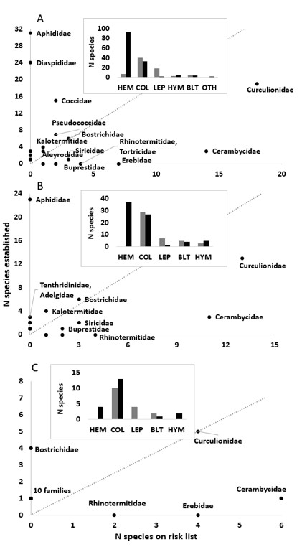

Figure 2. Non-metric multidimensional scaling ordination of all exotic forest-related insects at risk of establishing in Australia (grey) and those already established (black). LEP = Lepidoptera, COL = Coleoptera, HEM = Hemiptera, BLT = Blattodea, HYM = Hymenoptera, THYS = Thysanoptera.

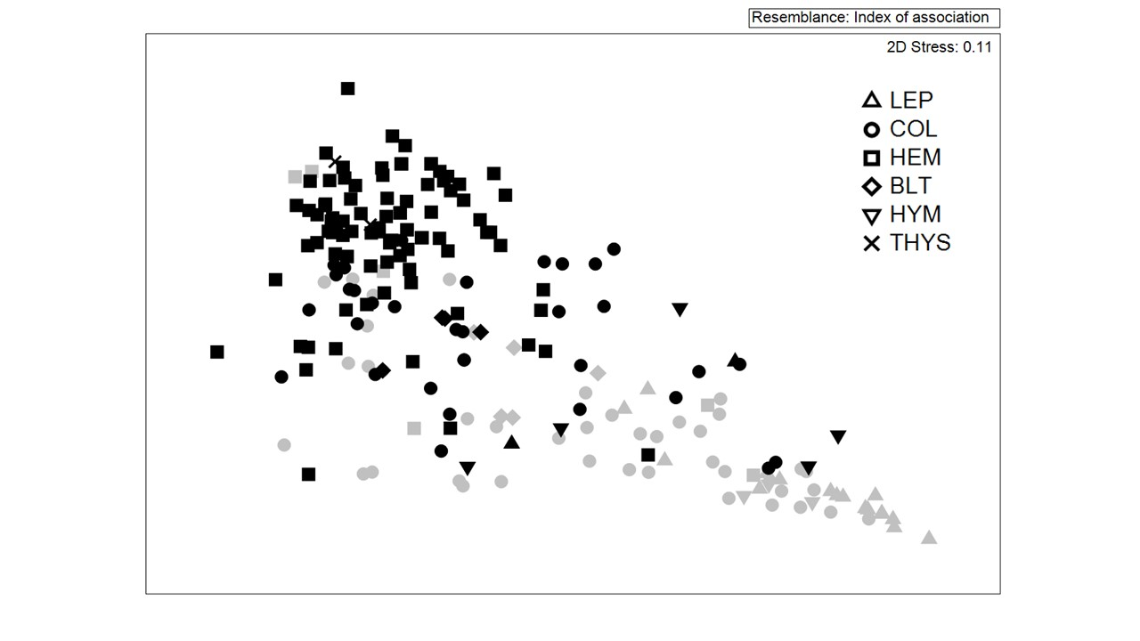

Table 2. The ten risk species most similar to established forest species based on their biological attributes, and the number of border interceptions of each.

Species | Order: Family | N interceptions
Aleurocanthus woglumi | Hemiptera: Aleyrodidae | 3
Coptotermes formosanus | Blattodea: Rhinotermitidae | 15
Coptotermes gestroi | Blattodea: Rhinotermitidae | 18
Dysmicoccus neobrevipes | Hemiptera: Pseudococcidae | 3
Euwallacea fornicatus* | Coleoptera: Curculionidae | 0.5
Euwallacea kuroshio* | Coleoptera: Curculionidae | 0.5
Lyctoxylon dentatum | Coleoptera: Bostrichidae | 19
Paracoccus marginatus | Hemiptera: Pseudococcidae | 0
Sinoxylon unidentatum | Coleoptera: Bostrichidae | 240
Xylosandrus compactus | Coleoptera: Curculionidae | 0

*one interception recorded as E. fornicatus may have been either species

Figure 3: Non-metric multidimensional scaling ordination (nMDS) of exotic forest Coleoptera at risk of establishing (grey) and already established (black).

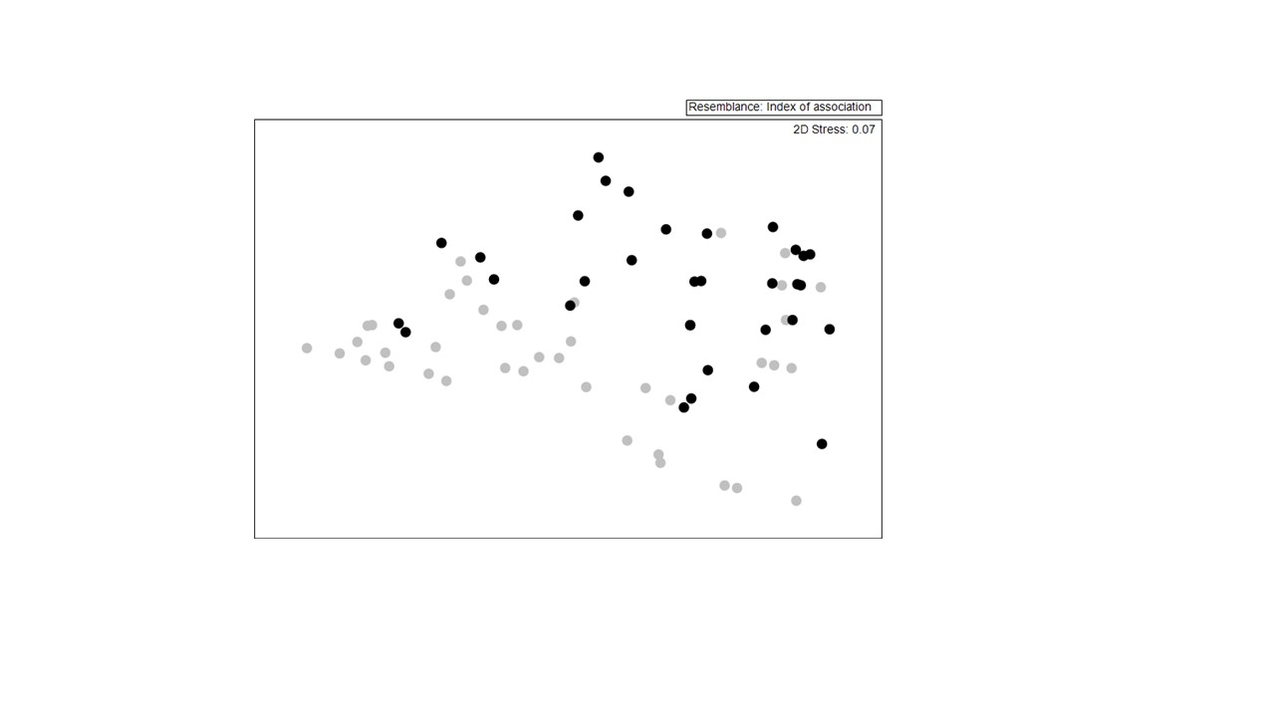

Figure 4. Relationships between border interceptions and establishments of forest species (risk + establishments combined; N=213 species) by family. (A) number of species intercepted and established per family; and (B) number of interceptions (per intercepted species) and number of species established per family.

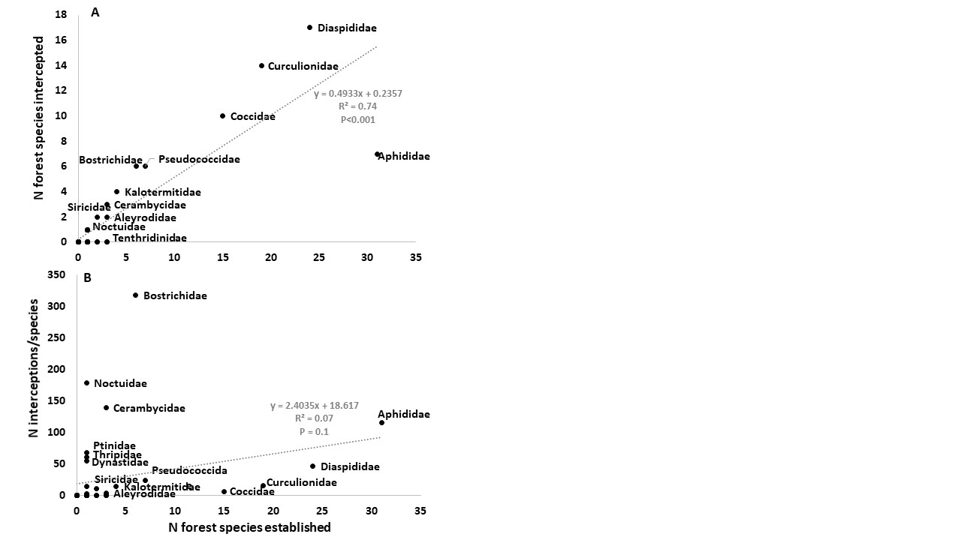
Table 3. Number of species and interceptions for nine families of forest insects established (Est) and at risk (Risk) of establishing in Australia.

Family | N species |  | N species intercepted (%) |  | Total interceptions |  | Interceptions per species
 | Est | Risk | Est | Risk | Est | Risk | Est | Risk
Aleyrodidae | 3 | 1 | 2 (67) | 1 (100) | 4 | 3 | 1.3 | 3.0
Bostrichidae | 6 | 3 | 6 (100) | 3 (100) | 1573 | 335 | 262.2 | 111.7
Buprestidae | 1 | 3 | 0 | 0 | 0 | 0 | 0 | 0
Cerambycidae | 3 | 14 | 3 (100) | 9 (64) | 16 | 402* | 5.3 | 28.7
Coccidae | 15 | 2 | 10 (67) | 0 | 60 | 0 | 4.0 | 0
Curculionidae | 19 | 18 | 14 (74) | 1 (6) | 224 | 1 | 11.8 | 0.1
Kalotermitidae | 4 | 1 | 4 (100) | 1 (100) | 45 | 12 | 11.3 | 12.0
Pseudococcidae | 7 | 2 | 6 (86) | 1 (50) | 139 | 3 | 19.9 | 1.5
Siricidae | 2 | 3 | 2 (100) | 3 (100) | 4 | 18 | 2 | 6

* 371 were a single species (Arhopalus ferus) – see Table 4

Figure 5. Number of interceptions of risk forest insect species in Australia from different regions, and the status of the species in that region. Numbers above bars indicate the number of species intercepted from each region. Inset is the same data with the top three species (accounting for 794 interceptions) removed.

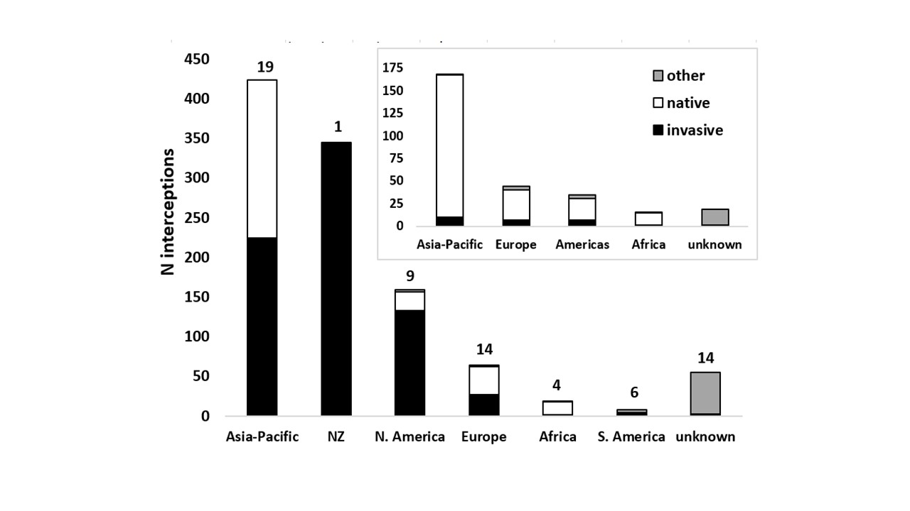

Figure 6. Number of interceptions of risk forest species of different orders on different commodity types in commercial (cargo) and non-commercial (baggage, mail, personal effects) between 2003 and 2016. The number in parentheses shows the number of species intercepted for each commodity type in total.

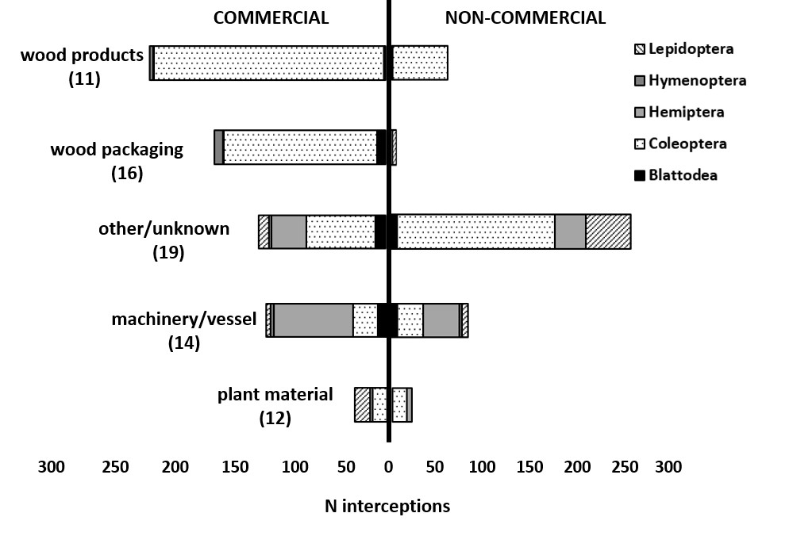

Table 4: Number of border interceptions of Australian plantation forestry’s highest priority pest risks between 2003 and 2016.

Species/group | Order: Family | N interceptions
Arhopalus ferus | Coleoptera: Cerambycidae | 371
Coptotermes (2 spp.) | Blattodea: Rhinotermitidae | 33
Dendroctonus (3 spp.) | Coleoptera: Curculionidae | 0
Lymantria (4 spp.) | Lepidoptera: Erebidae | 68
Monochamus (5 spp.) | Coleoptera: Cerambycidae | 12
Tomicus piniperda | Coleoptera: Curculionidae | 0

Figure 7. Number of interceptions at each Australian state/territory of Australian forestry risk pests according to shipment origin (top five origins only, N = 995 interceptions). *All interceptions from NZ were a single species, Arhopalus ferus, a species with specific mitigation in place.

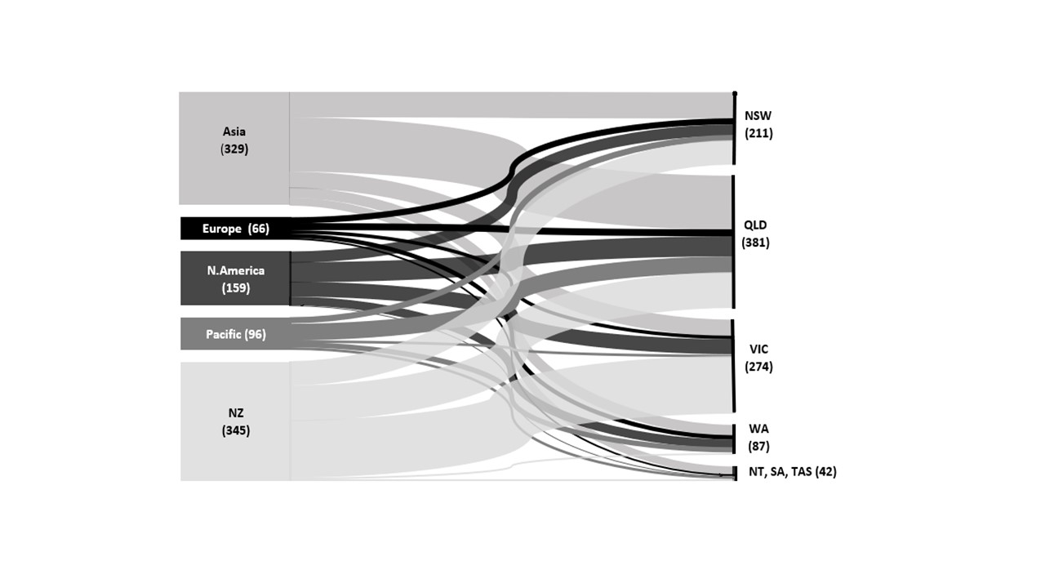
Acknowledgments
We thank staff at the Department of Agriculture, Water and the Environment, particularly Brendon Reading, for access to border interception data, James Walker for access to the NAQS pest list and Matthew Gordon and Chris Howard for critical comments on the manuscript. We also thank Rebecca Turner (Scion), Simon Lawson (University of the Sunshine Coast), and Francisco Tovar (Plant Health Australia) for additional comments on the manuscript.

Funding information
HFN was in receipt of an Advance Queensland Industry Fellowship through the Queensland Department of Innovation and Tourism Industry Development, supported by the University of the Sunshine Coast, Department of Agriculture and Fisheries, National Sirex Coordination Committee, Forest and Wood Products Australia, Plant Health Australia and HQPlantations Pty Ltd. AJC acknowledges support from Forestry Corporation of NSW.

Competing interests
The authors declare no competing interests.

References
- Hoffmann BD, Broadhurst LM. The economic cost of managing invasive species in Australia. NeoBiota. 2016; 31: 1-18.
- Seebens H, Blackburn TM, Dyer EE, Genovesi P, Hulme PE, Jeschke JM, Pagad S, Pysek P, Winter M, Arianoutsou M, Bacher S. No saturation in the accumulation of alien species worldwide. Nature Communications. 2017; 8:14435.
- Nahrung HF, Carnegie AJ. Non-native forest insects and pathogens in Australia: establishment, spread and impact. Frontiers in Forests and Global Change. 2020; 3: 37.
- Nahrung HF, Carnegie AJ. Border interceptions of forest insects established in Australia: intercepted invaders travel early and often. NeoBiota. 2021; 64: 69-86
- Hulme PE. Trade, transport and trouble: managing invasive species pathways in an era of globalization. Journal of Applied Ecology. 2009; 46: 10-18.
- Council of Australian Governments. Intergovernmental Agreement on Biosecurity. Available at: https://www.coag.gov.au/about-coag/agreements/intergovernmental-agreement-biosecurity-0; 2019.
- Dodd, A, Stoeckl N, Baumgartner J, Kompas T. Key Result Summary: Valuing Australia’s Biosecurity System. CEBRA, Melbourne; 2020.
- Eschen R; Britton K, Brockerhoff E, Burgess T, Dalley V, Epanchin-Niell RS, Gupta K, Hardy G, Huang Y, Kenis M, Kimani E. International variation in phytosanitary legislation and regulations governing importation of plants for planting. Environmental Science and Policy. 2015; 51: 228–237.
- Department of Agriculture, Water and the Environment - Commonwealth Biosecurity 2030, Commonwealth of Australia, Canberra, May. CC BY 4.0. 13pp; 2021.
- Department of Agriculture and Water Resources - National Plant Biosecurity Surveillance Strategy 2018–2023. Plant Health Australia, Canberra, ACT; 2018.
- Carnegie AJ, Tovar F, Collins S, Lawson SA, Nahrung HF. A coordinated, risk-based, national forest biosecurity surveillance program for Australia’s plantation, amenity, and native forests. Frontiers in Forests and Global Change. In press;
- Courtois P, Figuieres C, Mulier C, Weill J. A cost–benefit approach for prioritizing invasive species. Ecological Economics. 2018; 146: 607-620.
- MacLeod A. (2015) The relationship between biosecurity surveillance and risk analysis. In Jarrad F, Low-Choy S, Mengersen K (eds) Biosecurity Surveillance: Quantitative Approaches, CAB International. 2021; 109-122.
- Roy HE, Adriaens T, Aldridge DC, Bacher S, Bishop JDD, Blackburn TM, Branquart E, Brodie J, Carboneras C, Cook EJ, Copp GH, Dean HJ, Eilenberg J, Essl F, Gallardo B, Garcia M, García-Berthou E, Genovesi P, Hulme PE, Kenis M, Kerckhof F, Kettunen M, Minchin D, Nentwig W, Nieto A, Pergl J, Pescott O, Peyton J, Preda C, Rabitsch W, Roques A, Rorke S, Scalera R, Schindler S, Schönrogge K, Sewell J, Solarz W, Stewart A, Tricarico E, Vanderhoeven S, van der Velde G, Vilà M, Wood CA, Zenetos A. Invasive Alien Species - Prioritising prevention efforts through horizon scanning ENV.B.2/ETU/2014/0016. European Commission; 2015.
- Koch FH, Yemshanov D, Colunga-Garcia M, Magarey RD, Smith WD. Potential establishment of alien-invasive forest insect species in the United States: where and how many? Biological Invasions. 2011; 13: 969-85.
- Carnegie AJ, Nahrung HF. Post-border forest biosecurity in Australia: response to recent exotic detections, current surveillance and ongoing needs. Forests. 2019; 10: 336.
- Epanchin-Niell RS, Liebhold AM. Benefits of invasion prevention: effect of time lags, spread rates, and damage persistence Ecological Economics. 2015; 116: 146–153.
- Reaser JK, Burgiel SW, Kirkey J, Brantley KA, Veatch SD, Burgos-Rodríguez J. The early detection of and rapid response (EDRR) to invasive species: a conceptual framework and federal capacities assessment. Biological Invasions. 2020; 22: 1-19.
- Diagne C, Leroy B, Vaissière AC, Gozlan RE, Roiz D, Jarić I, Salles JM, Bradshaw CJ, Courchamp F. High and rising economic costs of biological invasions worldwide Nature. 2021; 592:571-6.
- Horwood M. West Indian drywood termite. PrimeFacts 826. New South Wales Department of Primary Industries; 2008.
- Department of Agriculture, Water and the Environment – National Priority Plant Pests www.agriculture.gov.au/pests-diseases-weeds/plant/national-priority-plant-pests-2019. Accessed 21/05/2021
- Plant Health Australia Ltd. Plantation Forest Biosecurity Plan. Version 1.0. Rep., Plant Health Aust., Canberra, ACT; 2007.
- Plant Health Australia Ltd. Industry Biosecurity Plan for the Nursery Industry (Version 3.0 – May 2013). Plant Health Australia, Canberra, ACT. 118pp; 2013.
- Plant Health Australia Ltd. Plantation Forest Biosecurity Plan; Version 2.0; Plant Health Australia: Canberra, Australia; 2013.
- Plant Health Australia Ltd. Plantation Forests Biosecurity Plan (Version 3.0 – 2020) Plant Health Australia, Canberra, ACT (draft) 2021.
- Australian Bureau of Agricultural Resource Economics and Sciences. The National Priority List of Exotic Environmental Pests, Weeds and Diseases: Information Paper (Version 2.0), ABARES report to client prepared for the Chief Environmental Biosecurity Officer, Department of Agriculture, Water and the Environment, Canberra, ACT. CC BY 4.0; 2021.
- Australian Quarantine Inspection Service. Forests and Timber: a field guide to exotic pests and diseases. The Australian Quarantine and Inspection Service and the National Office of Animal and Plant Health; 2000.
- Department of Agriculture and Water Resources - Importing timber and timber products – What’s inside? Department of Agriculture and Water Resources, Canberra; 2016.
- Mansfield S. New communities on eucalypts grown outside Australia. Frontiers in Plant Science. 2016; 29:1812.
- DAWE. National Priority Plant Pests https://www.awe.gov.au/biosecurity-trade/pests-diseases-weeds/plant/national-priority-plant-pests-2019. Accessed 21 July 2021.
- Evans TA, Forschler BT, Grace JK. Biology of invasive termites: a worldwide review. Annual Review of Entomology. 2013; 58: 455-474.
- Smith S, F Gomez D, A Beaver R, Hulcr J, I Cognato A. Reassessment of the species in the Euwallacea fornicatus (Coleoptera: Curculionidae: Scolytinae) complex after the rediscovery of the “lost” type specimen. Insects. 2019; 10:261.
- Peters BC. Infestations of Cryptotermes brevis (Walker) (Isoptera: Kalotermitidae) in Queensland, Australia 1. History, detection and identification. Australian Forestry. 1990; 53: 79-88.
- Clarke KR, Gorley RN. PRIMER v7: User Manual/Tutorial PRIMER-E: Plymouth. 2015.
- Clarke KR. Non-parametric multivariate analyses of changes in community structure. Austral Ecology. 1993; 18: 117–143.
- van Klinken RD, Panetta FD, Coutts S, Simon BK. Learning from the past to predict the future: an historical analysis of grass invasions in northern Australia. Biological Invasions. 2015; 17:565-79.
- Santini A, Liebhold A, Migliorini D, Woodward S. Tracing the role of human civilization in the globalization of plant pathogens. The ISME journal. 2018;12(3):647-52.
- Mally FR, Turner RM, Blake RE, Yamanaka T, Hoare RJB, Bertelsmeier C, Fenn-Moltu G, Brockerhoff EG, Roques A, Pureswaran DS, Nahrung HF, Liebhold AM. Moths and butterflies on alien shores – biogeography of global Lepidoptera invasions. Submitted to Journal of Biogeography. In review.
- Paini DR, Funderburk JE, Reitz SR. Competitive exclusion of a worldwide invasive pest by a native. Quantifying competition between two phytophagous insects on two host plant species. Journal of Animal Ecology. 2008; 77: 184-190.
- Tanaka S, Nishida T, Ohsaki N. Sequential rapid adaptation of indigenous parasitoid wasps to the invasive butterfly Pieris brassicae. Evolution. 2007; 61: 1791-1802.
- Bertheau C, Brockerhoff EG, Roux‐Morabito G, Lieutier F, Jactel H. Novel insect‐tree associations resulting from accidental and intentional biological ‘invasions’: a meta‐analysis of effects on insect fitness. Ecology Letters 2010; 13:506-15.
- Paine TD, Steinbauer MJ, Lawson SA. (2011). Native and exotic pests of Eucalyptus: a worldwide perspective. Annual Review of Entomology. 2011; 56: 181–201.
- Martin NA, Paynter Q. (2014) Predicting risk from adventive herbivores to New Zealand indigenous plants. New Zealand Entomologist. 2014; 37: 21-28.
- Brockerhoff EG, Kimberley M, Liebhold AM, Haack RA, Cavey JF. Predicting how altering propagule pressure changes establishment rates of biological invaders across species pools. Ecology. 2014; 95: 594–601.
- Seebens H, Blackburn TM, Dyer EE, Genovesi P, Hulme PE, Jeschke JM, Pagad S, Pyšek P, van Kleunen M, Winter M, Ansong M. Global rise in emerging alien species results from increased accessibility of new source pools. Proceedings of the National Academy of Sciences. 2018; 6;115:E2264-73.
- Meurisse N, Rassati D, Hurley BP, Brockerhoff EG, Haack RA. Common pathways by which non-native forest insects move internationally and domestically. Journal of Pest Science. 2019; 92:13-27.
- Krishnankutty S, Nadel H, Taylor AM, Wiemann MC, Wu Y, Lingafelter SW, Myers SW, Ray AM. Identification of tree genera used in the construction of solid wood-packaging materials that arrived at US ports infested with live wood-boring insects. Journal of Economic Entomology. 2020; 113: 1183-1194.
- Canadian Food Inspection Agency. Canadian sawn wood certification program https://inspection.canada.ca/plant-health/plant-pests-invasive-species/directives/date/d-17-04/eng/1546882362007/1546882362522 (accessed July 2021)
- Haack RA, Britton KO, Brockerhoff EG, Cavey JF, Garrett LJ, Kimberley M, Lowenstein F, Nuding A, Olson LJ, Turner J, Vasilaky KN. Effectiveness of the International Phytosanitary Standard ISPM No. 15 on reducing wood borer infestation rates in wood packaging material entering the United States. PloS One. 2014; 9:e96611.
- Lawson SA, Carnegie AJ, Cameron N, Wardlaw T, Venn TJ. Risk of exotic pests to the Australian forest industry. Australian Forestry. 2018; 81: 3–13.
- Food and Agriculture Organisation of the United Nations. International Plant Protection Convention. International Standard for Phytosanitary Measures 15: Regulation of wood packaging material in international trade. 2018.
- Turner R, Brockerhoff E, Bertelsmeier C, Blake R, Caton, B, James A, MacLeod A, Nahrung HF, Pawson S, Plank M, Pureswaran D, Seebens H, Yamanaka T, Liebhold A. (2021) Worldwide border interceptions provide a window into human-mediated global insect movement. Ecological Applications. 2021; 31(7): e02412.
- Liebhold AM, Turner R, Blake R, Bertelsmeier C, Brockerhoff E, Nahrung HF, Pureswaran D, Roques A, Seebens H, Yamanaka T. (2021) Invasion disharmony in the biogeography of native and non-native global Coleoptera. Diversity and Distributions. 2021; 11: 2050-2062.
- Rugman-Jones PF, Au M, Ebrahimi V, Eskalen A, Gillett CP, Honsberger D, Husein D, Wright MG, Yousuf F, Stouthamer R. One becomes two: second species of the Euwallacea fornicatus (Coleoptera: Curculionidae: Scolytinae) species complex is established on two Hawaiian Islands. PeerJ. 2020; 8:e9987.
- Wylie FR, Griffiths M, King J. Development of hazard site surveillance programs for forest invasive species: A case study from Brisbane, Australia. Australian Forestry 2008; 71: 119–235.
- Wylie FR, Speight MR. Insect pests in tropical forestry. CABI; 2012.
- Brockerhoff EG, Liebhold AM, Richardson B, Suckling DM. Eradication of invasive forest insects: Concepts, methods, costs and benefits. New Zealand Journal of Forest Science. 2010; 40: S117–S135.
- Tobin PC, Kean JM, Suckling DM, McCullough DG, Herms DA, Stringer LD. Determinants of successful arthropod eradication programs. Biological Invasions. 2014; 16: 401–414.
- Caley P, Ingram R, De Barro P. Entry of exotic insects into Australia: Does border interception count match incursion risk? Biological Invasions. 2015; 17: 1087–1094.
- Caley P, Welvaert M, Barry SC. Crowd surveillance: estimating citizen science reporting probabilities for insects of biosecurity concern. Journal of Pest Science. 2020; 93:543-50.
- Smith C, Lonsdale W, Fortune J. When to Ignore Advice: Invasion Predictions and Decision Theory. Biological Invasions 1999; 1: 89–96.
- Keller RP, Lodge DM, Finnoff DC. Risk assessment for invasive species produces net bioeconomic benefits. Proceedings of the National Academy of Sciences. 2007; 104: 203-207.
- Leung B, Roura‐Pascual N, Bacher S, Heikkilä J, Brotons L, Burgman MA, Dehnen‐Schmutz K, Essl F, Hulme PE, Richardson DM, Sol D. TEASIng apart alien species risk assessments: a framework for best practices. Ecology Letters. 2012; 15: 1475-1493.
- Kean JM, Phillips CB, McNeill MR. Surveillance for early detection: lottery or investment? In Froud KJ, Popay AI, Zydenbos SM (eds) Surveillance for Biosecurity: pre-border to pest management, 2008; pp 11-7.
- Kriticos DJ. Regional climate-matching to estimate current and future sources of biosecurity threats. Biological Invasions. 2012; 14:1533-1544.
- Chapman D, Purse BV, Roy HE, Bullock JM. Global trade networks determine the distribution of invasive non‐native species. Global Ecology and Biogeography. 2017; 26(8):907-17.
- Wharton TN, Kriticos DJ. The fundamental and realized niche of the Monterey Pine aphid, Essigella californica (Essig) (Hemiptera: Aphididae): implications for managing softwood plantations in Australia. Diversity and Distributions 2004; 10:253-62.
- Avtzis DN, Lubanga UK, Lefoe GK, Kwong RM, Eleftheriadou N, Andreadi A, Elms S, Shaw R, Kenis M. Prospects for classical biological control of Marchalina hellenica in Australia. BioControl. 2020; 65(4):413-23.
- Dittrich‐Schröder G, Hurley BP, Wingfield MJ, Nahrung HF, Slippers B. Invasive gall‐forming wasps that threaten non‐native plantation‐grown Eucalyptus: diversity and invasion patterns. Agricultural and Forest Entomology. 2020; 22(4):285-97.
- Carnegie AJ, Venn T, Lawson SA, Nagel M, Wardlaw T, Cameron NL, Last I. An analysis of pest risk and potential economic impact of pine wilt disease to Pinus plantations in Australia. Australian Forestry. 2018; 81:24-36
- Department of Agriculture. National Xylella Action Plan 2019–2029, Canberra, December 2019.

How to cite this article: Nahrung HF & Carnegie AJ. Predicting Forest Pest Threats in Australia: Are Risk Lists Worth the Paper they’re Written on? Global Biosecurity, 2022; 4(1).
Published: June 2022
Copyright: Copyright © 2022 The Author(s). This is an open-access article distributed under the terms of the Creative Commons Attribution 4.0 International License (CC-BY 4.0), which permits unrestricted use, distribution, and reproduction in any medium, provided the original author and source are credited. See http://creativecommons.org/licenses/by/4.0/ .
Global Biosecurity is a peer-reviewed open access journal published by University of New South Wales.

