RESEARCH ARTICLES
Greater Sydney SARS-CoV-2 Observations from the 16th of June to the 13th of July
Haley Stone¹, Samsung Lim¹, Mohana Kunasekaran¹ & Rick Nunes-Vaz²
¹ University of New South Wales
² Flinders University

Abstract
The Greater Sydney region is undergoing an outbreak of a COVID-19 Delta variant, which is much more transmissible than the variants we have observed in previous outbreaks in Australia. The aim of this report is to analyse the outbreak and the current impacts of the non-pharmaceutical interventions. While earlier results indicated that interventions were decreasing the growth rate, it has since been increasing with new hot spot clusters arising daily.
Keywords: Covid-19, coronavirus, SARS-CoV-2, epidemic, pandemic, infectious disease, Delta variant, Sydney

Introduction
The first case of the outbreak was reported on June 16, 2021; a driver for international flight crews. By June 23, when the stay-at-home order was announced for the Greater Sydney region, 36 COVID-19 cases were reported in the Bondi and eastern suburb cluster [1]. The strain identified in the initial reported case and the cases to follow was the Delta variant (B.1.617.2), which was first identified in India in October 2020 and has subsequently been detected in 98 countries [2]. The Delta variant is estimated to be 60% more transmissible than the Alpha variant (B.1.1.7), which is estimated to be 50% more transmissible than the dominant circulating strain of 2020 [3]. In the United Kingdom, the Delta variant accounts for 95% of the new cases, where 68% of the population is vaccinated [4].
Evidence supports that vaccination protects against the Delta variant, both against symptomatic infection and hospitalisations [5]. However, with only 9.3% of the entire country vaccinated, reliance must be put on non-pharmaceutical interventions to dampen the transmission of this variant [4]. The aim of this rapid report is to assess the current outbreak and analyse the impact of current intervention strategies.

Methods
A comprehensive line list was created by compiling data on COVID-19 reported cases, isolation status of the daily cases, hospitalisation/intensive care/ventilation requirements, age and gender information, tests, and reported clusters from New South Wales (NSW) Department of Health’s press releases and datasets [6-8].
An epidemic curve was plotted in order to describe the distribution of cases within the outbreak against the daily number of tests. Additionally, the daily cases were adjusted for testing by assuming the highest single day of

testing within the outbreak captured 95% of those reported that day. The daily cases were adjusted accordingly to this factor. Lastly, key dates relating to implementation of control measures were overlaid for clarity.
In addition to an epidemic curve, an age and gender chart was created to determine the age groups associated with high case count. Data reported through NSW health was monitored daily for age and gender distribution of cases and recorded within the linelist [7]. Doubling times for the outbreak was calculated to assess the current impact of interventions and was compared to previous outbreaks within Australia. The calculation involves measuring the amount of time it takes for the total reported case count to double in continual, sequential days. Prior to this report, Nunes-Vaz & MacIntyre (2021) analysed the doubling times early in the current outbreak as compared to COVID-19’s first wave in Australia and Melbourne’s outbreak in 2020 [9]. As explained in their report, doubling time changes are often indicators of intervention’s success or failure as deviations in viral infectivity is not likely [9].
Emerging hot spot analysis (EHSA) was completed to assess trends in spatial clustering of the delta variant cases in NSW, Australia. ESHA finds patterns throughout the outbreak and does not necessarily pick up an area with occurrences on a couple of days. Hot spots are classified as the following: new, consecutive, intensifying, persistent, diminishing, sporadic, and oscillating. These terms can be defined as the following: New, the most recent time step interval is hot for the first time; Consecutive, a single uninterrupted run of hot time step intervals, comprised of less than 90% of all intervals; Intensifying, at least 90% of the time step intervals are hot, and becoming hotter over time; Persistent, at least 90% of the time step intervals are hot, with no trend up or down; Diminishing, at least 90% of the time step intervals are hot, and becoming less hot over time; Sporadic, some of the time step intervals are hot; Oscillating, some of the time step intervals are hot, some are cold. EHSA was performed for the beginning of the outbreak (June 16) to three recent days in the outbreak (June 11, 12, and 13).

Greater Sydney Outbreak
As of July 13, 2021, a total of 864 confirmed COVID-19 cases were recorded during this outbreak (Figure 1). Of those cases 8.22% (n=71) have required hospitalisation, 2.31%(n=20) have required intensive care, 0.46% (n=4) have required ventilation, and 0.23%(n=2) have passed away. Contact tracing measures have indicated that local, house-hold contacts have so far accounted for 46.34% of the reported cases. However, cases that are unliked to any contact are rising at 27.55% of the reported cases in the past three days, as compared to the 3 days prior. Additionally, an estimated 34.0% (n=276) of the total cases and 26.51%(n=79) cases between July 10 and July 13 have not isolated at any point during their infectious period before confirmation. This presents difficulties when lockdown measures are not as stringent, and compliance to these measures is seemingly lower as compared to the first wave in Australia.
The number of daily tests has been fluctuating throughout the outbreak, with the peak of testing found on July 2, 2021. In Figure 1, daily cases were adjusted assuming 95% of cases were detected on July 2 to estimate the potential cases unidentified.
Figure 2 demonstrates the doubling time for the current outbreak as compared to past outbreaks in Australia. Initial readings saw a decrease in growth following the mandatory stay-at-home order for 6 local government areas (June 22) and greater Sydney (June 23) [9]. However, with a highly transmissible variant such as the Delta variant, growth rates increase rapidly, a trend that can be seen beginning on July 1, 2021. Therefore, to control or prevent the spread, more stringent lockdown measures and higher compliance to these measures are required.
Of the total cases per each age group, under 10 and 10 to 19 age groups have been impacted with 18.5% (n=59) and 26.9% (n=122) attributed to the current outbreak, respectively (Figure 3). Although most of this outbreak occurred during school holidays, 5 schools have reported cases in students or staff. With schools having reopened on July 10, the risk transmission in schools increasing is likely inevitable [10]. Currently, the mandatory mask usage for students is only from years 7 and above. However, much like in Australia, the UK is seeing a steep increase in the youth, especially amongst the school-going population. This highlights, at minimum, the need for mask usage in younger children, especially those in childcare and pre-school [11]. Additionally, Australian cases remain highest (40.8%) amongst the age groups 10 to 29, who are not eligible for vaccination according to the NSW vaccination policy [12]. While implementing prevention strategies on the most vulnerable has benefited the severity of the disease, transmission will remain high if ‘soft lockdown’ policies are still in place.
Figure 4 demonstrates the notable clusters found in the current epidemic. Hot spots initially arose in the eastern suburbs but have since spread to southwestern Sydney, with new hot spots arising in the Liverpool local government area on July 11. However, by July 12 the new Liverpool hotspot had become a consecutive hot spot with a new one having arisen in Burwood/Strathfield, demonstrating the rapid daily dissemination of cases across Sydney. With the current lockdown measures, the outbreak is not being contained and the virus may continually move from cluster to cluster along with those who continue to leave home for essential travel such as work, shops and medical appointments.

Conclusion
Evidence above indicates that by implementing non-pharmaceutical measures, the growth rate decreased. However, current measures may not be enough as travel for work is continuing and there is a broad definition of essential retail. New hot spots are emerging daily with an unfavourable trend in doubling time. In the absence of adequate vaccination supplies and low vaccination rates, controlling the outbreak will rely on the compliance with prevention strategies (e.g. hard lockdowns, school closures or mandatory mask usage for younger ages, testing, and contact tracing), which may need to be increased if doubling time continues to fall. Loss of epidemic control may also result if the outbreak becomes too large for current testing and tracing capacity.

Figure 1. Epicurve of current local reported NSW cases in relation to the number of daily COVID-19 tests performed and adjusted daily cases assuming peak of testing (July 2) captures 95% of the cases in the state.

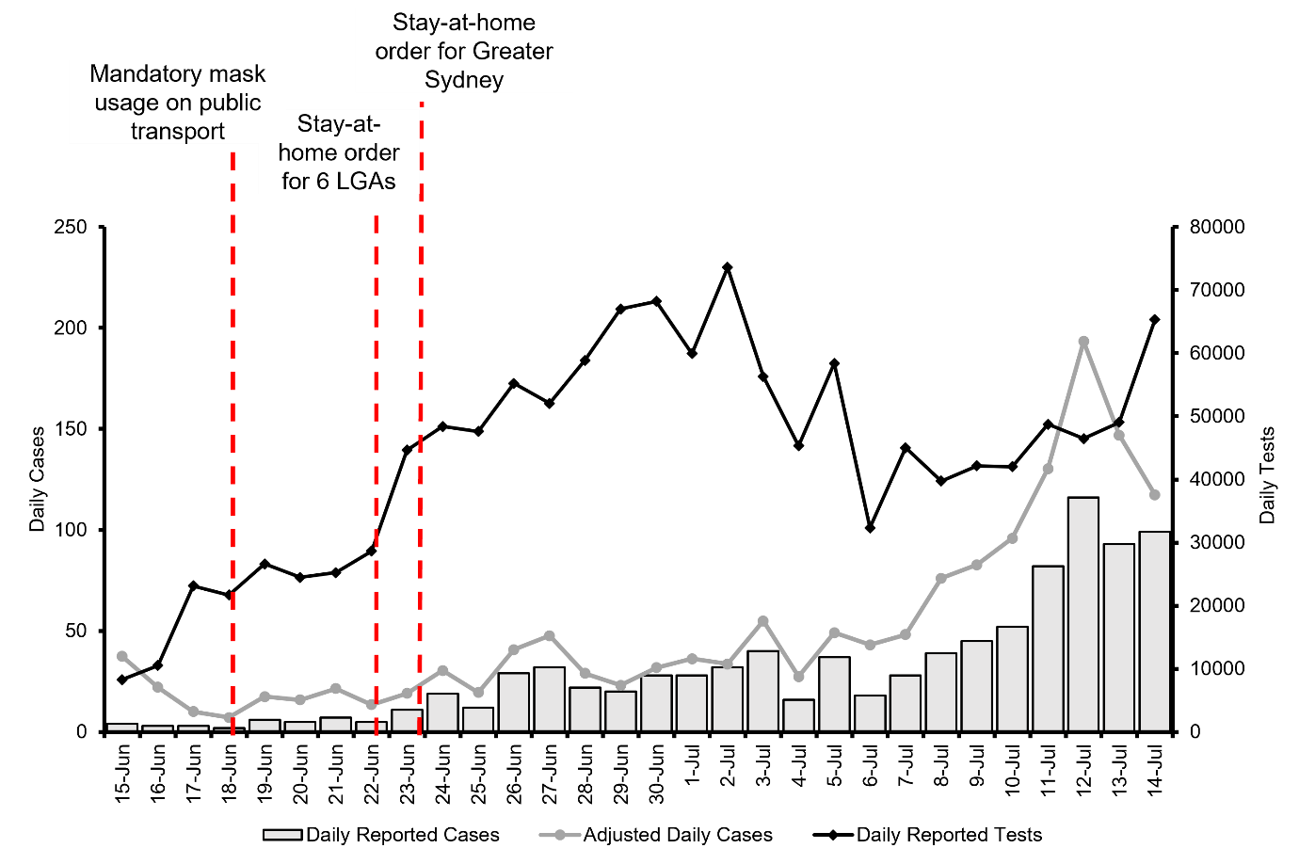

Figure 2. Doubling times for Sydney’s outbreak up to present time, as compared to the doubling times of the country’s first wave (grey) and Melbourne’s outbreak in 2020 (blue).

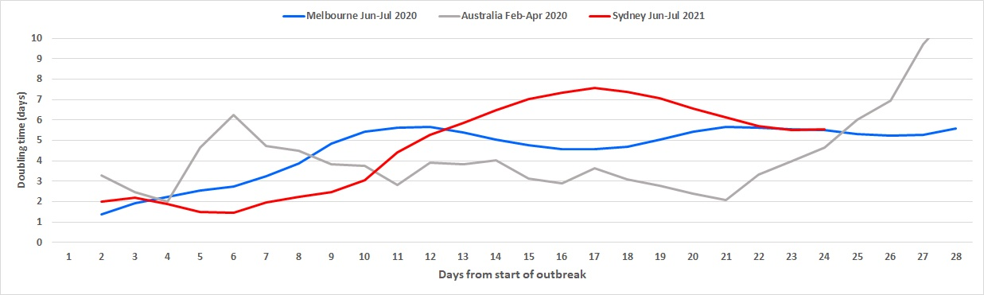

Figure 3. (A) Analysis of gender and age groups in current outbreak (June 16 to July 13, 2021), as compared to (B) all confirmed cases since 2020.

A | B
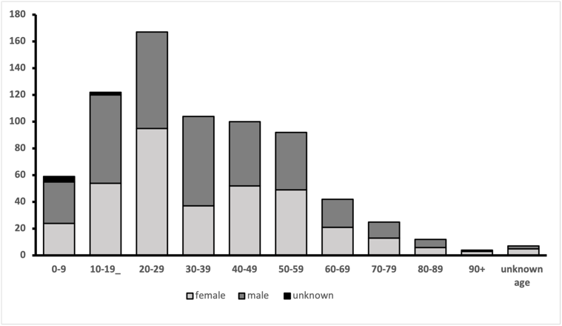 | 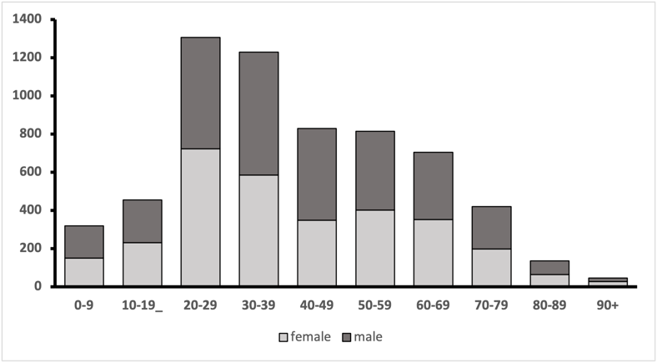

Figure 4. Emerging spatial cluster trends of COVID-19 cases in New South Wales between (A) June 12 to July 11, 2021 (B) June 12 to July 12, 2021 (C) June 12 to July 13, 202.

A | B | C
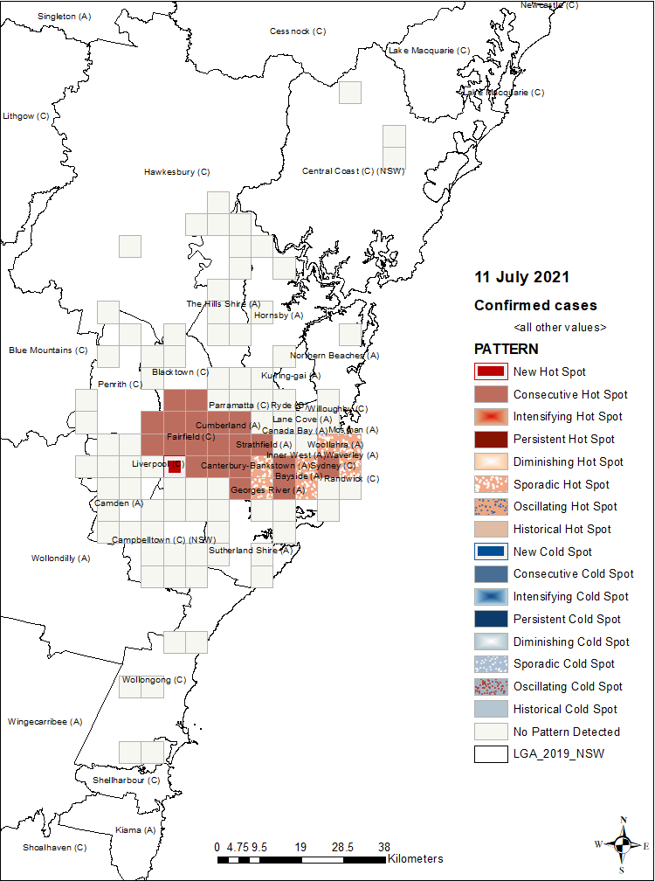 | 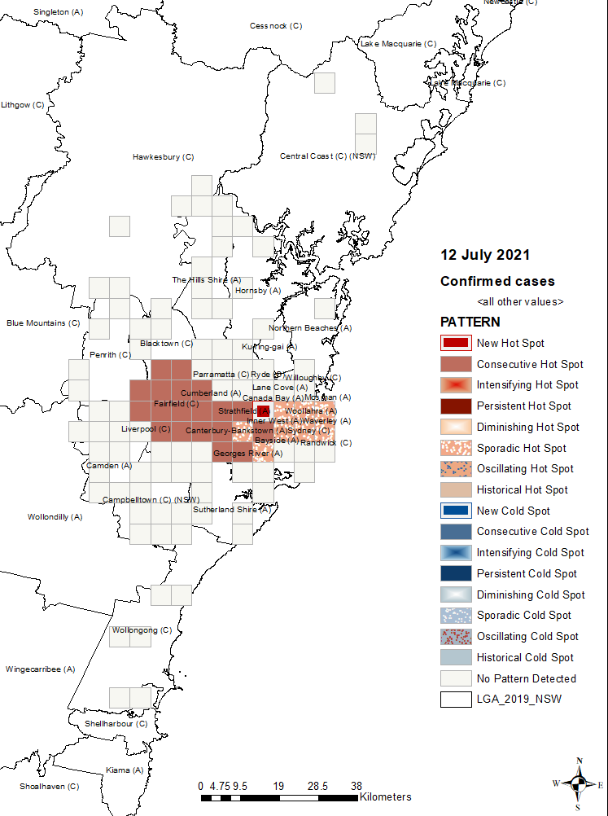 | 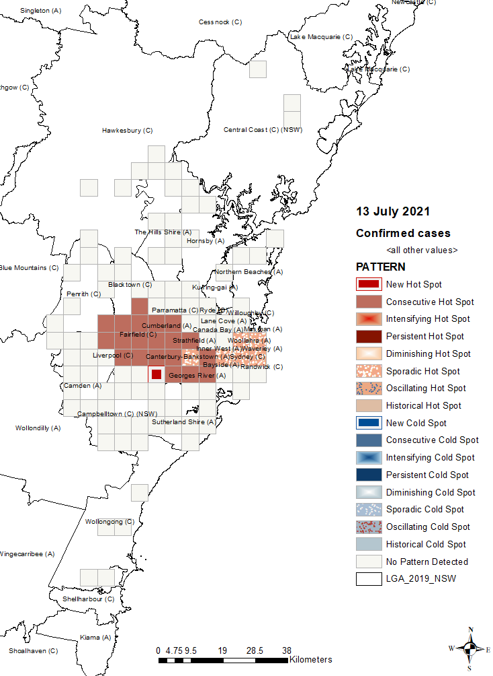

References

- NSW Health. COVID-19 (Coronavirus) statistics-24 June 2021. 2021; Available from: https://www.health.nsw.gov.au/news/Pages/20210624_00.aspx.
- The United Nations. COVID-19 Delta variant detected in 98 countries, continues to evolve and mutate, warns WHO. 2021; Available from: https://news.un.org/en/story/2021/07/1095252.
- Callaway, E., Delta coronavirus variant: scientists brace for impact. Nature.
- Our World in Data. Coronavirus (COVID-19) Vaccinations. 2021; Available from: https://ourworldindata.org/covid-vaccinations.
- Public Health England, Investigation of SARS-CoV-2 variants of concern: technical briefings. 2021.
- Data NSW. NSW COVID-19 cases data. 2021; Available from: https://data.nsw.gov.au/nsw-covid-19-data/cases.
- NSW Health. Find the facts about COVID-19. The latest case numbers, vaccination totals and statistics on coronavirus disease in NSW, including people who have tested positive for COVID-19 in the past 14 days. 2021; Available from: https://www.nsw.gov.au/covid-19/find-the-facts-about-covid-19.
- NSW Health. 2021 media releases from NSW Health. 2021; Available from: https://www.health.nsw.gov.au/news/Pages/2021-nsw-health.aspx.
- Nunes-Vaz, R. and C. Macintyre, Observations on the current outbreak of the SARS-CoV-2 Delta Variant in Sydney. Global Biosecurity, 2021. 3(1).
- NSW Education. Schools in Greater Sydney. 2021; Available from: https://education.nsw.gov.au/covid-19/advice-for-families/schools-in-greater-sydney1.
- Public Health England, National flu and COVID-19 surveillance reports, in National influenza and COVID-19 report, monitoring COVID-19 activity, seasonal flu and other seasonal respiratory illnesses. 2021.
- NSW Health. Who can get vaccinated for COVID-19? COVID-19 vaccines are safe and effective. Find out who can get vaccinated and where to get more information. 2021; Available from: https://www.health.gov.au/initiatives-and-programs/covid-19-vaccines/getting-vaccinated-for-covid-19/who-can-get-vaccinated-for-covid-19.

How to cite this article: Stone H, Lim S, Kunasekaran M & Nunes-Vaz R. Greater Sydney SARS-CoV-2 Observations from the 16th of June to the 13th of July. Global Biosecurity, 2021; 3(1).
Published: July 2021
Copyright: Copyright © 2021 The Author(s). This is an open-access article distributed under the terms of the Creative Commons Attribution 4.0 International License (CC-BY 4.0), which permits unrestricted use, distribution, and reproduction in any medium, provided the original author and source are credited. See http://creativecommons.org/licenses/by/4.0/ .
Global Biosecurity is a peer-reviewed open access journal published by University of New South Wales.

