RESEARCH ARTICLES
The effectiveness of non-pharmaceutical interventions on outbreaks of COVID-19 in aged care and long-term care facilities: A meta-analysis
Princy Poovanna Natolanda¹, Ashley Quigley¹, Aye Moa¹ & Chandini Raina MacIntyre¹
¹ Kirby Institute, University of New South Wales, Sydney, Australia

Abstract
A review on the use of non-pharmaceutical interventions (NPI) was conducted in long-term care facilities. The use of personal protective equipment, isolation and re-testing of COVID-19 were protective against the infection. Facilities which implemented NPIs prior to the outbreak had fewer COVID-19 outbreaks, odds ratio=0.70. Re-testing of asymptomatic people during outbreaks is crucial.
Key words: COVID-19, PPE, aged care facilities, long-term care facilities

Research Letter
Globally, high mortality rates of COVID-19 have occurred in older people, and the disease has disproportionately affected the residents of long-term care facilities (LTCFs) (1, 2). In the United States in May 2020, on average, 43% of the total COVID-19 deaths were reported from the LTCFs across the 40 states, 26 states reported a higher number, and 50% or more LTCF deaths were due to COVID-19 (3). The World Health Organisation (WHO) Europe estimates that 50% of COVID-19 related deaths in Europe also occurred among LTCF residents (4).
A systematic review of COVID-19 outbreaks in LTCFs was conducted between January 1, 2020 and June 30, 2020, as per PRISMA guidelines, and registered with Prospero (CRD42020196764). A meta-analysis was performed to compare COVID-19 cases in LTCFs which had applied COVID-19 non-pharmaceutical interventions (NPIs) to those with no reported NPIs. The odds ratio (OR) and 95% confidence interval (CI) were calculated. A p-value of < 0.05 was considered statistically significant. Forest plots were generated using the random-effects model. Review Manager Software, version 5.4 was used in the analysis (5). Studies were grouped by type of interventions applied such as assessment and restriction of visitors, personal protective equipment (PPE) use, hand hygiene, re-testing of people who had initially negative test results, and isolation or cohorting of residents. PPE use was defined as the use of masks or other types, such as gowns, gloves and eye protection. An analysis was performed by type of NPI applied as well as application of combined interventions either before or after the outbreak. Facilities that applied NPIs before the outbreak were grouped into pre-outbreak interventions, which included

the assessment of visitors and visitor restrictions (supplementary table S1, reference; 3, 6, 7, 12), assessment of residents for signs, and symptoms of COVID-19 (supplementary table S1, reference 1-3, 6), assessment of staff before the beginning of a shift (supplementary table S1, reference 3, 6, 7, 12, 1), mask use (supplementary table S1, reference 1, 2, 7, 12, 14), restriction on communal activities (supplementary table S1, reference 3, 14) and suspension of resident admissions in the facility (supplementary table S1, reference 6, 7).
A flow chart for study selection is shown in supplementary figure S1. We identified 542 published articles; 15 studies met the selection criteria (supplementary table S1) and 14 studies were included in the analyses. The mean age of the COVID-19 positive residents was 84.5 years, and 43.9 years for aged care workers (ACWs). The attack rate among residents in LTCFs are shown in the supplementary table S2. Of the 1,767 LTCF residents identified, the overall attack rate was 31.1% (550/1767) and the CFR was 24.9% (137/550). From studies that reported on asymptomatic infection (supplementary table S1, reference 1- 4, 6, 7, 9, 12- 14), of the 302 residents confirmed with COVID-19, over half (n=159) were asymptomatic. In addition, 44% (134/302) of the reported COVID-19 positive residents showed COVID-19 symptoms (Supplementary table S1, reference 1, 2, 3, 4, 6, 7, 12, 14, 13).
More than half (60%) of the facilities had applied NPIs before the emergence of COVID-19 cases in the facility (supplementary table S1, reference 1, 2, 3, 6, 7, 9, 12, 13). The probability of COVID-19 infection was reduced by 45% when ACWs used PPE. All other NPIs, except hand hygiene, were also protective (Figure 1). The odds of contracting COVID-19 in facilities that implemented intervention before the onset of outbreak (relative to facilities that applied interventions after the outbreak) was 0.70 (95% CI: 0.58-0.86) (Figure 1).
The majority of the studies used Reverse Transcription Polymerase Chain Reaction (RT-PCR) testing of residents (supplementary table S1, reference 1, 4-8, 10-15) and staff (supplementary table S1, reference 2, 6, 7, 13, 14) after the occurrence of an outbreak. In 36.2% (640/1767) of the outbreaks, retesting of all residents or negative residents/staff was conducted (supplementary table S1, reference 1, 4, 6, 7, 13, 10). Some LTCFs instituted either isolation of residents and cohorting of positive cases, or isolation of all residents and exposed ACWs (supplementary table S1, reference 2, 6, 7, 8, 10,11- 13, 15). In the aftermath of an outbreak, most LTCFs recommended RT-PCR testing to identify all infected staff and residents for early isolation (supplementary table S1, reference 1, 3, 4, 6, 9, 11, 12 14, 15). Six of these facilities also advocated for repeated testing of all residents, irrespective of symptoms (supplementary table S1, reference 1, 4, 6, 7, 10, 13).
We found that asymptomatic cases plausibly contribute the widespread transmission of COVID-19 in the facilities, and therefore re-testing of undiagnosed cases is essential during outbreaks. Overall, findings from our review support the use of PPE, isolation and re-testing in aged care settings during outbreaks, as well as routine use of NPIs prior to outbreaks occurring.

Figure 1. Forest plot of overall interventions used in LTCFs.

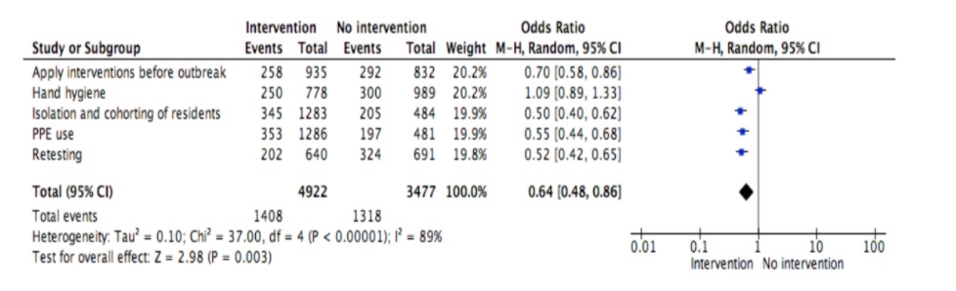

LTCFs, long-term care facilities; PPE, Personal protective equipment.

References
- Girvan G, Roy A. Nursing homes & assisted living facilities account for 42% of COVID-19 deaths.Available at: https://freopp.org/the-covid-19-nursing-home-crisis-by-the-numbers-3a47433c3f70. Accessed 12 Apr, 2021.
- MacCharles T. 82% of Canadaʼs COVID‐19 deaths have been in long‐term care, new data reveals. The Star. May 7, 2020.Available at: https://www.thestar.com/politics/federal/2020/05/07/82-of-canadas-covid-19-deaths-have-been-in-long-term-care.html. Accessed Feb 28, 2021.
- Lau‐Ng R, Caruso LB, Perls TT. COVID‐19 deaths in long term care facilities‐a critical piece of the pandemic puzzle. Journal of the American Geriatrics Society. 2020.
- Associated Press. WHO Europe: up to half of deaths in care homes.Available at: https://www.voanews.com/covid-19-pandemic/who-europe-half-deaths-care-homes. Accessed Feb 28, 2021.

- Collaboration C. Review manager (RevMan version 5.4). 2014.

Funding
No funding was supported for this study.

Acknowledgement
CRM is supported by a NHMRC Principal Research Fellowship, grant number 1137582.

Competing interest
None declared.

Supplementary Materials

Table S1. Geographic distribution and demographic characteristics of LTCF residents and staff from 15 studies.

Author/  year | Country | Settings | Total number of residents (N) | Index Case | Mean age of all residents (year) | Total number of residents tested for COVID-19 (n) | Laboratory-confirmed COVID-19 cases (Residents, n) | Male COVID-19 Residents (%) | Female COVID-19 Residents (%) | Total number of staff (N) | Mean age of all staff (year) | Total number of staff tested for COVID-19 (n) | Laboratory-confirmed COVID-19 cases (Staff, n)
Arons et al. 2020 (1) | USA | SNF | 89 | ACW | NR | 76 | 57 | NR | NR | 138 | NR | 57 | 26
Balestrini et al. 2020 (2) | UK | LTCF | 286 | ACW | NR | 98 (CCE) | 13 | 89 (CCE) | 11 (CCE) | 275 (CCE) | NR | 150 (CCE) | 1 (CCE)
 |  |  |  |  |  | NR (STE) |  |  |  | 215 (STE) |  | 105 (STE) | 15 (STE)
 |  |  |  |  |  | 0 (TM) |  |  |  | 250 (TM) |  | 26 (TM) | 2 (TM)
Blackman et al. 2020 (3) | NR | SNF | 150 bed | ACW | NR | 11 | 11 | NR | NR | NR | NR | NR | 26
Blain et al. 2020 (4) | NR | NH | 79 | NR | NR | 79 | 38 | NR | NR | 34 | NR | 34 | 8
Bouza et al. 2020 (5) | Spain | NH | 79 | NR | NR | 62 | 58 | NR | NR | 44 | NR | 44 | 6
Dora et al. 2020 (6) | USA | LTSNF | 99 | R | NR | NR | 19 | 100 | 0 | 136 | NR | NR | 8
Goldberg et al. 2020 (7) | USA | SNF | 97 | ACW | NR | 97 | 82 | NR | NR | 146 | 45 | 97 | 36
Kim 2020 (8) | South Korea | LTCH | 142 | ACW | NR | NR | 0 | NR | NR | 85 | NR | NR | 1
Kimball et al. 2020 (9) | USA | LTSNF | 82 | ACW | NR | 76 | 23 | 31 | 70 | NR | NR | NR | NR
Lee, et al. 2020 (10) | South Korea | LTCH | 193 | ACW | 82 | 0 | 0 | NR | NR | 123 | 66 | NR | 2
McMichael et al. 2020 (11) | USA | SNF | 130 | R | NR | 118 | 101 | 31.7 | 68 | 170 | NR | NR | 50
Patel et al. 2020 (12) | USA | SNF | 127 | R | NR | 126 | 35 | 31 | 69 | 120 | NR | 42 | 19
Roxby et al. 2020 (13) | USA | IALF | 83 | R | 86 | 80 | 6 | NR | NR | 62 | 40 | 62 | 2
Sacco et al. 2020 (14) | France | NH | 87 | R | 87 | 87 | 41 | NR | NR | 92 | NR | 70 | 22
Stall et al. 2020 (15) | Canada | NH | 126 bed | NR | NR | NR | 89 | NR | NR | NR | NR | NR | 47

USA-United States of America, UK- United Kingdom.
SNF-Skilled Nursing Facility, NH- Nursing Homes, LTSNF- Long term Skilled Nursing Facility, LTCF- Long term Care Facility, LTCH- Long Term Care Hospital, IALF - Independent and Assisted Living Facility.
R- residents, ACW- aged care workers, CCE- Chalfont Centre for Epilepsy, STE- St. Elisabeth, TM- The Meath Epilepsy Facility, NR -not reported.

Table S2. Attack rate and case fatality rate among ACF residents

Author/year | Resident population (N) | COVID-19 cases (n) | COVID-19 deaths (n) | Attack rate (%) | Case fatality rate (%)
Arons et al. 2020 (1) | 89 | 57 | 15 | 64 | 26.3
Balestrini et al. 2020 (2) | 286 | 13 | 2 | 4.5 | 15.3
Blackman et al. 2020 (3) | 150 | 11 | 4 | 7.3 | 36.4
Blain et al. 2020 (4) | 79 | 38 | 12 | 48 | 31.5
Bouza et al. 2020 (5) | 79 | 58 | 12 | 73.4 | 20.6
Dora et al. 2020 (6) | 99 | 19 | 1 | 19 | 5.3
Goldberg et al. 2020 (7) | 97 | 82 | 24 | 84.5 | 29.2
Kim, 2020 (8) | 142 | 0 | 0 | 0 | 0
Lee et al. 2020 (10) | 193 | 0 | 0 | 0 | 0
McMichael et al. 2020 (11) | 130 | 101 | 34 | 77.6 | 33.6
Patel et al. 2020 (12) | 127 | 35 | 10 | 27.5 | 28.5
Roxby et al. 2020 (13) | 83 | 6 | 0 | 7.2 | 0
Sacco et al. 2020 (14) | 87 | 41 | 11 | 47.2 | 26.8
Stall et al. 2020 (15) | 126 | 89 | 12 | 70.6 | 13.4
All studies | 1767 | 550 | 137 | 31.1 | 24.9

References of included studies (Tables S1 and S2)
- Arons MM, Hatfield KM, Reddy SC, Kimball A, James A, Jacobs JR, et al. Presymptomatic SARS-CoV-2 infections and transmission in a skilled nursing facility. New England journal of medicine. 2020.
- Balestrini S, Koepp MJ, Gandhi S, Rickman H, Shin GY, Houlihan C, et al. Clinical outcomes of SARS-CoV-2 pandemic in long-term care facilities for people with epilepsy: observational study. medRxiv. 2020.
- Blackman C, Farber S, Feifer RA, Mor V, White EM. An Illustration of SARS‐CoV‐2 Dissemination Within a Skilled Nursing Facility Using Heat Maps. Journal of the American Geriatrics Society.
- Blain H, Rolland Y, Tuaillon E, Giacosa N, Albrand M, Jaussent A, et al. Efficacy of a Test-Retest Strategy in Residents and Health Care Personnel of a Nursing Home Facing a COVID-19 Outbreak. Journal of the American Medical Directors Association. 2020;21(7):933-6.
- Bouza E, Pérez-Granda MJ, Escribano P, Fernández-del Rey R, Pastor I, Moure Z, et al. Outbreak of COVID-19 in a nursing home in Madrid. The Journal of Infection. 2020.
- Dora AV, Winnett A, Jatt LP, Davar K, Watanabe M, Sohn L, et al. Universal and serial laboratory testing for SARS-CoV-2 at a long-term care skilled nursing facility for veterans—Los Angeles, California, 2020. Morbidity and Mortality Weekly Report. 2020;69(21):651.
- Goldberg SA, Lennerz J, Klompas M, Mark E, Pierce VM, Thompson RW, et al. Presymptomatic transmission of SARS-CoV-2 amongst residents and staff at a skilled nursing facility: results of real-time PCR and serologic testing. Clinical Infectious Diseases. 2020.
- Kim T. Improving Preparedness for and Response to Coronavirus Disease 19 (COVID-19) in Long-Term Care Hospitals in the Korea. Infection & Chemotherapy. 2020;52.
- Kimball A, Hatfield KM, Arons M, James A, Taylor J, Spicer K, et al. Asymptomatic and presymptomatic SARS-CoV-2 infections in residents of a long-term care skilled nursing facility—King County, Washington, March 2020. Morbidity and Mortality Weekly Report. 2020;69(13):377.
- Lee SH, Son H, Peck KR. Can post-exposure prophylaxis for COVID-19 be considered as one of outbreak response strategies in long-term care hospitals? International Journal of Antimicrobial Agents. 2020:105988.
- McMichael TM, Currie DW, Clark S, Pogosjans S, Kay M, Schwartz NG, et al. Epidemiology of Covid-19 in a long-term care facility in King County, Washington. New England Journal of Medicine. 2020;382(21):2005-11.
- Patel MC, Chaisson LH, Borgetti S, Burdsall D, Chugh RK, Hoff CR, et al. Asymptomatic SARS-CoV-2 infection and COVID-19 mortality during an outbreak investigation in a skilled nursing facility. Clinical Infectious Diseases. 2020.
- Roxby AC, Greninger AL, Hatfield KM, Lynch JB, Dellit TH, James A, et al. Outbreak investigation of COVID-19 among residents and staff of an independent and assisted living community for older adults in Seattle, Washington. JAMA Internal Medicine. 2020.
- Sacco G, Foucault G, Briere O, Annweiler C. COVID-19 in seniors: Findings and lessons from mass screening in a nursing home. Maturitas. 2020;141:46-52.
- Stall NM, Farquharson C, Fan‐Lun C, Wiesenfeld L, Loftus CA, Kain D, et al. A Hospital Partnership with a Nursing Home Experiencing a COVID‐19 Outbreak: Description of a Multi‐Phase Emergency Response in Toronto, Canada. Journal of the American Geriatrics Society. 2020.

Table S3. List of abbreviations

Term | Abbreviation
ACF | Aged care facility
ACW | Aged care worker
CCE | Chalfont Centre for Epilepsy
CFR | Case fatality rate
COVID-19 | Corona Virus Disease-2019
IALF | Independent and Assisted Living Facility
HH | Hand hygiene
MERS | Middle East Respiratory Syndrome
LTCF | Long Term Care Facility
LTCH | Long Term Care Hospital
LTSNF | Long Term Skilled Nursing Facility
NR | Not reported
NH | Nursing Homes
PPE | Personal protective equipment
PR | COVID-19 positive residents
R | Residents
RT-PCR | Reverse Transcription Polymerase Chain Reaction
SARS-COV-2 | Severe Acute Respiratory Syndrome-Corona Virus-2
SNF | Skilled Nursing Facility
STE | St. Elisabeth
TM | The Meath Epilepsy Facility

Figure S1. Flow chart for database search and study selection.

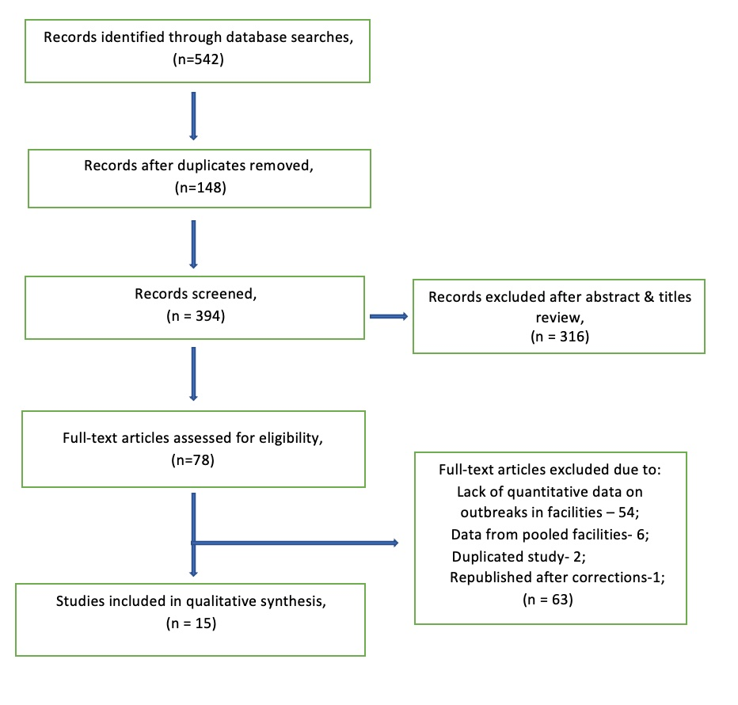

How to cite this article: Natolanda PP, Quigley A, Moa A & MacIntyre CR. The effectiveness of non-pharmaceutical interventions on outbreaks of COVID-19 in aged care and long-term care facilities: A meta-analysis. Global Biosecurity, 2021; 3(1).
Published: July 2021
Copyright: Copyright © 2021 The Author(s). This is an open-access article distributed under the terms of the Creative Commons Attribution 4.0 International License (CC-BY 4.0), which permits unrestricted use, distribution, and reproduction in any medium, provided the original author and source are credited. See http://creativecommons.org/licenses/by/4.0/ .
Global Biosecurity is a peer-reviewed open access journal published by University of New South Wales.

