RAPID REPORTS AND PERSPEECTIVES FROM THE FIELD
Using the Bradford-Hill criteria to assess causality in the association between CHADOX1 NCOV-19 vaccine and prothrombotic immune thrombocytopenia
C Raina MacIntyre¹
¹ Biosecurity Program, The Kirby Institute for Infection and Immunity, UNSW Sydney
Abstract
The Bradford-Hill criteria are accepted criteria for assessing causality of an association. Here, the criteria were applied to the association between the CHADOX1 NCOV-19 vaccine and vaccine induced thrombotic immune thrombocytopenia (VITT). All criteria for causation are met, with consistency, specificity, temporality and biological plausibility being very clearly met. Strength of association is met, but more data are required to establish the precise estimate of the association, as case ascertainment may be variable between countries, resulting in varied estimates of incidence rates from 25 to 0.5 per 100,000. (2, 4) The application of the modified Bradford-Hill criteria to VITT following CHADOX1 NCOV- vaccine strongly supports a causal relationship.
Key words: Thrombosis, VITT, HITT, heparin, COVID-19, vaccine, Astrazeneca, CHADOX1 NCOV vaccine, thrombocytopenia

An association between the CHADOX1 NCOV-19 vaccine and prothrombotic immune thrombocytopenia has been reported from several countries, at reported rates ranging from 1/25,000 to 1/600,000 (1, 2). The European Medicine Agency (EMA) concluded that there is a signal for disseminated intravascular coagulation, cerebral venous sinus thrombosis (CVST) and haemorrhagic stroke following CHADOX1 NCOV-19 vaccine (3). The EMA concluded on 7 April 2021 that the association was likely, with a rate of about 1/200,000 doses (4).
The thrombocytopenia and thrombosis syndrome is distinct from common clotting disorders such as deep venous thrombosis or pulmonary embolism, and includes the combination of thrombocytopenia and thrombosis in unusual sites, such as CVST, splanchnic vein thrombosis and arterial thrombosis (5, 6). It appears to be an immune-mediated phenomenon, starting at 4-14 days but up to as long as 20 days after vaccination, and is more common in females and adults under the age of 60 years. The syndrome is similar to heparin-induced thrombocytopenia (HIT) or heparin-induced thrombocytopenia with thrombosis (HITT), but occurs without the use of heparin (3). It is important to ascertain causation for the association, not just for vaccine safety, but for patient safety in the event of thrombosis. Heparin, which would normally be given to patients presenting with thrombosis, is contraindicated. The syndrome is more serious and more likely to be fatal than common thrombosis, and has been termed vaccine-induced thrombotic thrombocytopaenia (VITT) (5, 6). Whilst the EMA concluded an association between CHADOX1 NCOV-19 vaccine and VITT was likely (4), they did not report any assessment of causation using formal criteria.
The Bradford-Hill criteria are an accepted method for assessing causation (7). The World Health Organization (WHO) suggests a set of modified Bradford-Hill criteria for assessing causality of adverse events following immunisation (Box 1) (8). Here, I demonstrate the application of the modified Bradford-Hill criteria to assess the association between CHADOX1 NCOV-19 vaccine and VITT.

Box 1. Modified Bradford Hill Criteria for adverse events following immunization {(WHO)., 2001 #1663}
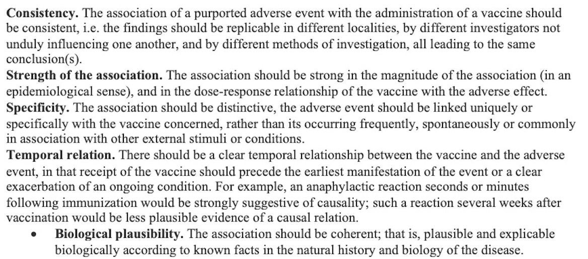

Consistency
The syndrome has been reported independently in at least seven countries including Germany, Norway and the United Kingdom (2, 3). The consistency of reports has prompted the European Medicines Agency to review the association and conclude there is a signal for a HIT or HITT-like syndrome (3).

Strength of the association
The rate of general thrombotic disorders does not appear increased in people who are vaccinated (3). However, the rate of HITT-like syndrome appears increased. The rate of CVST reported from Germany was 31 from 2.7 million vaccinations, which is a rate of 11.5 per million, compared to a reported general community incidence of 3 to 5 per million (9, 10). CVST appears to be 2.2 to 3.8 times higher than the reported community incidence. More data are needed to determine the overall risk of HITT-like syndrome following vaccination with greater certainty. However, the EMA concluded the association is real, with 62 cases of CVST and 24 of splanchnic vein thrombosis in Europe following 25 million vaccinations.

Specificity
The syndrome itself is specific, associated with thrombocytopenia and thrombosis, in many cases with antibodies to platelet factor 4 (PF4), which is also seen in HITT (11). This has not been seen following other COVID-19 vaccines in common use, the mRNA vaccines (12). Very specific manifestations of VITT are CVST and splanchnic vein thrombosis with a high case fatality rate (5, 6).

Temporal relationship
Reports of the syndrome show a clear temporal relationship within 4 to 20 days after vaccination, most commonly within 14 days (2, 11). This has been observed across different case series (5, 6).

Biological plausibility
Two possible mechanisms of action are through the adenoviral vector, or through the expression of SARS-COV-2 spike protein. The European Medicines Agency concluded that the construct used in the CHADOX1 NCOV-19 vaccine encoding for the spike protein is less likely to impact on thrombosis than the viral vector (3). The adenovirus 5 vector (Ad 5) is associated with thrombocytopenia in animals and humans, increased von Willebrand factor antigen, as well as activation of platelets and the coagulation cascade (3, 13-15). Studies of Ad 5 suggests a biologically plausible mechanism for thrombocytopenia and thrombosis (13). The CHADOX1 NCOV-19 vaccine uses a chimpanzee adenovirus (ChAdOx1). A ChAd vector was used in an Ebola vaccine ChAd3-EBO-Z – phase 1 and 2 trials showed a transient thrombocytopenia in some vaccinated subjects (16-18). It is postulated that the ChAdOx1 virus may bind directly to platelets or to PF4 (11). However, the dose of adenovirus in the vaccine is very small, and an alternative hypothesis is that free DNA in the vaccine may form multimolecular complexes with PF4 (5), which can bind to antibodies from patients with HITT and also induce antibodies against PF4–heparin in a mouse model (19). A study comparing the immunogenic epitopes of PF4 and SARS-CoV-2 spike protein found that it is unlikely that the immune response to the spike protein induces VITT (20).

Conclusion
In summary, all criteria for causation are met, with consistency, specificity, temporality and biological plausibility being very clearly met. Strength of association is met, but more data required to establish the precise estimate of the association, as case ascertainment may be variable between countries, resulting in varied estimates of incidence rates from 25 to 0.5 per 100,000 (2, 4). The application of the modified Bradford-Hill criteria to VITT following CHADOX1 NCOV- vaccine strongly supports a causal relationship.

References
- Pai MG, A; Ivers, N; et al. Vaccine-Induced Prothrombotic Immune Thrombocytopenia (VIPIT) Following AstraZeneca COVID-19 Vaccination. Science Table. Canada: COVID-19 Advisory for Ontario; 2021. https://covid19-sciencetable.ca/sciencebrief/vaccine-induced-prothrombotic-immune-thrombocytopenia-vipit-following-astrazeneca-covid-19-vaccination/
- Vogel G, Kupferschmidt K. Side effect worry grows for AstraZeneca vaccine. Science. 2021;372(6537):14.
- European Medicines Agency. Signal assessment report on embolic and thrombotic events (SMQ) with COVID-19 Vaccine (ChAdOx1-S [recombinant]) – COVID-19 Vaccine AstraZeneca (Other viral vaccines). Pharmacovigilance Risk Assessment Committee (PRAC): European Medicines Agency; 2021. https://www.ema.europa.eu/en/documents/prac-recommendation/signal-assessment-report-embolic-thrombotic-events-smq-covid-19-vaccine-chadox1-s-recombinant-covid_en.pdf
- European Medicines Agency. AstraZeneca’s COVID-19 vaccine: EMA finds possible link to very rare cases of unusual blood clots with low blood platelets The Netherlands: European Medicines Agency; 2021. https://www.ema.europa.eu/en/news/astrazenecas-covid-19-vaccine-ema-finds-possible-link-very-rare-cases-unusual-blood-clots-low-blood
- Greinacher A, Thiele T, Warkentin TE, Weisser K, Kyrle PA, Eichinger S. Thrombotic Thrombocytopenia after ChAdOx1 nCov-19 Vaccination. N Engl J Med. 2021. DOI: 10.1056/NEJMoa2104840
- Schultz NH, Sørvoll IH, Michelsen AE, Munthe LA, Lund-Johansen F, Ahlen MT, et al. Thrombosis and Thrombocytopenia after ChAdOx1 nCoV-19 Vaccination. N Engl J Med. 2021. DOI: 10.1056/NEJMoa2104882
- Hill AB. The environment and disease: association or causation? Proc R Soc Med. 1965;58(5):295-300.
- WHO. Causality assessment of adverse events following immunization. Geneva: WHO; 2001. https://www.who.int/vaccine_safety/causality/en/
- Bousser MG. Cerebral venous thrombosis: diagnosis and management. J Neurol. 2000;247(4):252-8.
- Saposnik G, Barinagarrementeria F, Brown RD, Jr., Bushnell CD, Cucchiara B, Cushman M, et al. Diagnosis and management of cerebral venous thrombosis: a statement for healthcare professionals from the American Heart Association/American Stroke Association. Stroke. 2011;42(4):1158-92.
- Andreas G, Thomas T, Theodore EW, Karin W, Paul K, Sabine E. A Prothrombotic Thrombocytopenic Disorder Resembling Heparin-Induced Thrombocytopenia Following Coronavirus-19 Vaccination. Research Square. 2021.
- Chapin-Bardales J, Gee J, Myers T. Reactogenicity Following Receipt of mRNA-Based COVID-19 Vaccines. JAMA. 2021.
- Stone D, Liu Y, Shayakhmetov D, Li ZY, Ni S, Lieber A. Adenovirus-platelet interaction in blood causes virus sequestration to the reticuloendothelial system of the liver. J Virol. 2007;81(9):4866-71.
- Othman M, Labelle A, Mazzetti I, Elbatarny HS, Lillicrap D. Adenovirus-induced thrombocytopenia: the role of von Willebrand factor and P-selectin in mediating accelerated platelet clearance. Blood. 2007;109(7):2832-9.
- Rasheed MA, Alsaud AE, Razzaq S, Fadul A, Yassin MA. Cerebral Venous Thrombosis in a Patient with Immune Thrombocytopenia, an Apparent Paradox. Case Rep Oncol. 2020;13(2):588-94.
- De Santis O, Audran R, Pothin E, Warpelin-Decrausaz L, Vallotton L, Wuerzner G, et al. Safety and immunogenicity of a chimpanzee adenovirus-vectored Ebola vaccine in healthy adults: a randomised, double-blind, placebo-controlled, dose-finding, phase 1/2a study. Lancet Infect Dis. 2016;16(3):311-20.
- Tapia MD, Sow SO, Lyke KE, Haidara FC, Diallo F, Doumbia M, et al. Use of ChAd3-EBO-Z Ebola virus vaccine in Malian and US adults, and boosting of Malian adults with MVA-BN-Filo: a phase 1, single-blind, randomised trial, a phase 1b, open-label and double-blind, dose-escalation trial, and a nested, randomised, double-blind, placebo-controlled trial. Lancet Infect Dis. 2016;16(1):31-42.
- Tapia MD, Sow SO, Mbaye KD, Thiongane A, Ndiaye BP, Ndour CT, et al. Safety, reactogenicity, and immunogenicity of a chimpanzee adenovirus vectored Ebola vaccine in children in Africa: a randomised, observer-blind, placebo-controlled, phase 2 trial. The Lancet Infectious Diseases. 2020;20(6):719-30.
- Jaax ME, Krauel K, Marschall T, Brandt S, Gansler J, Fürll B, et al. Complex formation with nucleic acids and aptamers alters the antigenic properties of platelet factor 4. Blood. 2013;122(2):272-81.
- Greinacher, A; Selleng, K; Mayerle, J, et al. Research Square. 2021.DOI:10.21203/rs.3.rs-404769/v1

How to cite this article: MacIntyre CR. Using the Bradford-Hill criteria to assess causality in the association between CHADOX1 NCOV-19 vaccine and prothrombotic immune thrombocytopenia. Global Biosecurity, 2021; 3(1).

Published: April 2021
Copyright: Copyright © 2021 The Author(s). This is an open-access article distributed under the terms of the Creative Commons Attribution 4.0 International License (CC-BY 4.0), which permits unrestricted use, distribution, and reproduction in any medium, provided the original author and source are credited. See http://creativecommons.org/licenses/by/4.0/ .
Global Biosecurity is a peer-reviewed open access journal published by University of New South Wales.

