Feedback from operational stakeholders who manage or respond to outbreaks is that they are often too busy to review literature or obtain relevant background information to assist them with acute response. Unlike a traditional analytical outbreak investigation report, Watching Briefs are intended as a rapid resource for public health or other first responders in the field on topical, serious or current outbreaks, and provide a digest of relevant information including key features of an outbreak, comparison with past outbreaks and a literature review. They can be completed by responders to an outbreak, or by anyone interested in or following an outbreak using public or open source data, including news reports.

Watching brief

Title | Report on COVID-19 in India
Authors | Babitha Suseelan Bhargavi
Date of first report of the outbreak | India’s first confirmed case of COVID-19 was reported on January 27, 2020 in the state of Kerala, India (1).
Disease or outbreak | SARS‐CoV‐2 (COVID-19, coronavirus disease 2019; previously 2019‐nCoV)
Origin (country, city, region) | The first reported cases were in December 2019 in Wuhan, Hubei Province, China with “pneumonia of unknown aetiology” presentation (2). Subsequent research has shown possible origins in November 2019 or earlier, with reports of serological evidence of infection in Europe and the United States by December 2019 (3).
Suspected Source (specify food source, zoonotic or human origin or other) | Human to human aerosol transmission is responsible for the pandemic. Research suggests a zoonotic origin, however, the Centers for Disease Control and Prevention (CDC) states an absence of evidence in ongoing zoonotic spread of COVID-19 (4). Other theories of origin include accidental release from a laboratory (5).
Date of outbreak beginning | The first confirmed case of SARS-COV-2 in India was reported on January 30, 2020 in the Thrissur district of Kerala in a returning student from Wuhan, China (1).
Date outbreak declared over | The pandemic is ongoing in India.
Affected countries & regions | In India (from 30/01/2020 to 31/05/2021) there were 28,047,534 diagnosed cases in total (Figure 1 & 2).  The total number of reported SARS CoV-2 cases by state, 2020 to 2021 (6):  - Andaman and Nicobar Islands (6,984)  2. Andhra Pradesh (1,685,142)  3. Arunachal Pradesh (26,950)  4. Assam (406,868)  5. Bihar (705,648)  6. Chandigarh (59,922)  7. Chhattisgarh (969,300)  8. Dadra and Nagar Haveli and Daman and Diu (10,256)  9. Delhi (1,425,592)  10. Goa (155,064)  11. Gujarat (807,488)  12. Haryana (755,389)  13. Himachal Pradesh (189,465)  14. Jammu and Kashmir (288,940)  15. Jharkhand (336,943)  16. Karnataka (2,587,827)  17. Kerala (2,514,279)  18. Ladakh (18,497)  19. Lakshadweep (7,928)  20. Madhya Pradesh (778,825)  21. Maharashtra (5,731,815)  22. Manipur (49,882)  23. Meghalaya (35,190)  24. Mizoram (12,087)  25. Nagaland (21,563)  26. Odisha (756,684)  27. Puducherry (103,826)  28. Punjab (565,415)  29. Rajasthan (938,460)  30. Sikkim (15,171)  31. Tamil Nadu (2,068,580)  32. Telangana (575,827)  33. Tripura (51,133)  34. Uttarakhand (328,338)  35. Uttar Pradesh (1,690,016)  36. West Bengal (1,366,240)  Figure 1. The reported SARS CoV-2 outbreak cases by state, 30/01/2020 -31/05/2021. Source: Government of India, M., 2021. MoHFW | Home. [online] mohfw.gov.in. Available at: https://www.mohfw.gov.in/  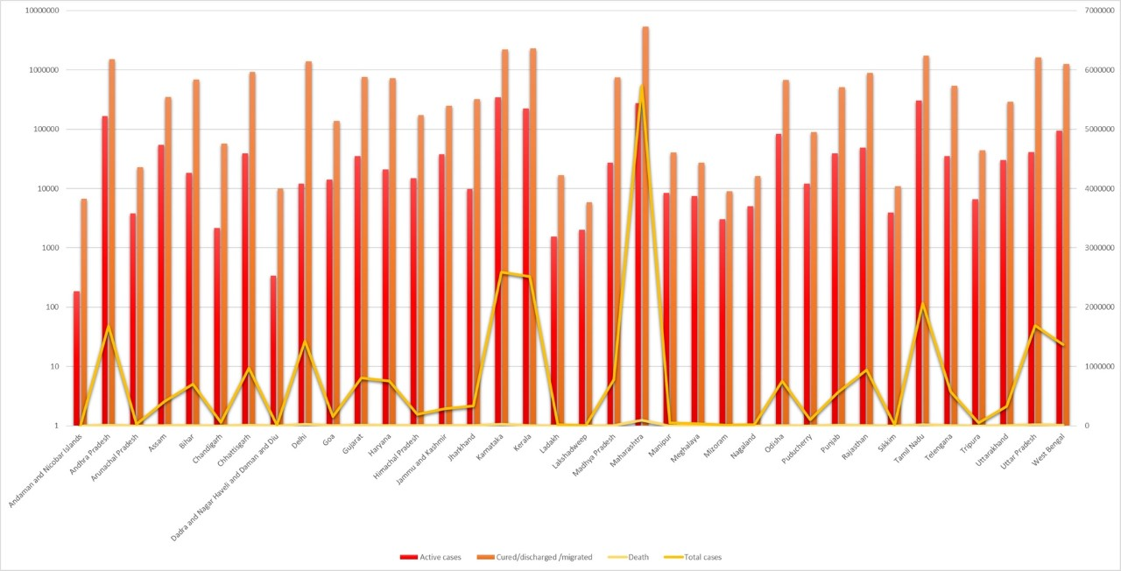  Figure 2. The total number of reported SARS CoV-2 cases by state, 30/01/2020 31/05/2021. Source: Government of India, M., 2021. MoHFW | Home. [online] mohfw.gov.in. Available at: https://www.mohfw.gov.in/  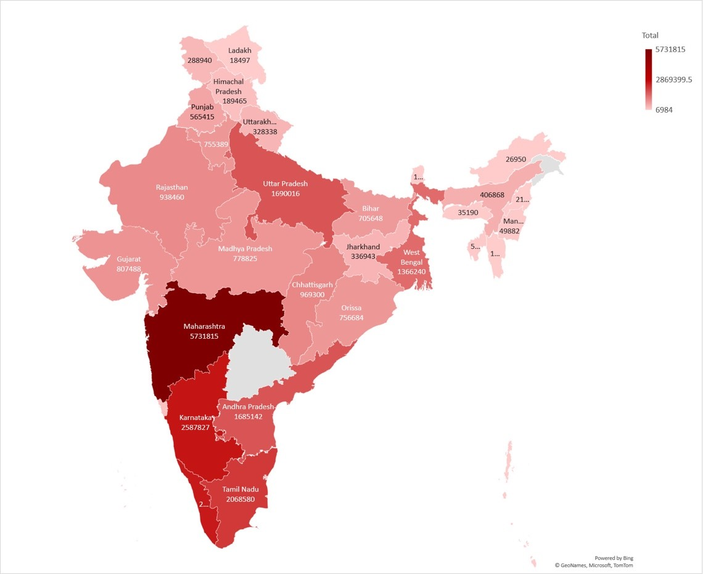
Number of cases (specify at what date if ongoing) | The total number of confirmed cases as of May 31, 2021 is 28,047,534, of which 2,026,092 were active cases. The number of recovered cases is 25,692,342, which includes cumulative cured/discharges/migrated cases, and the total number of deaths in India due to COVID-19 is 329,100. The highest number of COVID-19 cases to date is recorded in Maharashtra with 5,731,815 (6).
Clinical features | COVID-19 presents with severe respiratory symptoms including fever, cough and shortness of breath. The temperature ranges from mild to moderate (37.3°C to 39°C) (7). Sore throat, headache, fatigue, diarrhoea and chest tightness are less common, but gastrointestinal presentations may be more common with the B.1.617.1 variant (8). Conjunctivitis is rare but reported in India (9). Recent studies indicated that non-respiratory symptoms like diarrhoea manifest as part of initial presentation (10). Atypical presentations included delirium, low-grade hyperpyrexia and abdominal pain (11).  In paediatric COVID-19 cases, a retrospective study of 341 patients aged 0-14 years showed only mild to moderate clinical symptoms. About 318 patients (93.3%) demonstrated mild symptoms like fever and cough without any abnormal findings of pneumonia in imaging, to moderate symptoms of respiratory tract with indication of pneumonia in imaging. About 0.6% had severe onset of respiratory distress with acute hypoxia, while 0.3% of cases developed critical complications like respiratory failure and shock. About 20 (5.9%) paediatric cases were asymptomatic. Of these cases, 136 showed clinical features of fever (37.3-40 °C), lacrimation, stuffy nose, sneezing, sore throat, dyspnea, headache, physical discomfort, diarrhea, conjunctivitis, dizziness, myalgia, fatigue, nausea and vomiting (12).
Mode of transmission (dominant mode and other documented modes) | The most significant mode of transmission is respiratory, through aerosols. COVID-19 may also be transmitted through large droplets, contact or fomites, although these are less likely (13). Aerosol transmission was observed in contaminated indoor environments, with the virus persisting 3 hours in aerosols or for about 48-72 hours on steel/plastic surfaces (14,15). The World health Organization initially denied airborne transmission but has since acknowledged this mode of transmission (15).
Demographics of cases | As per June 2021 statistics from the Integrated Disease Programme (IDSP), COVID-19 cases in children below 10 years of age constituted only 3.36% of cumulative cases. There has been an increased proportion of COVID-19 cases in the age group of 10-20 years, accounting for 2,328,584 (8.4%) cases. About 60.95% of diagnosed COVID-19 cases were in the age group of 21-50 years and 22.71% in the age group 51-70 years. About 4.58 % of affected cases were from the age group of above 70 years.  The percentage of confirmed cases were higher in males, with 60.70% compared to females with 39.20%, while about 0.10% were mentioned as non-specified. The distribution of cases was 12.39% in rural areas, 29.54% in urban areas, and 58.06% was mentioned to be from non-specific areas (16).
Case fatality rate | In the initial period of the pandemic, the CFR was 3% or even higher. The CFR further declined to 1.7%; which is lower than the world average rate, and may be explained by the younger age structure of the population (17).
Complications | Frequently reported complications of COVID-19 infection include coagulopathy, venous thromboembolism, sepsis, septic shock, massive pulmonary embolism and acute respiratory distress syndrome (ARDS). It is seen that complications from septic shock can often lead to multiorgan failure. COVID-19 infection can result in cardiovascular complications like acute pericarditis, left ventricular dysfunction and acute myocardial injury. Critically ill patients exhibited laryngeal oedema and laryngitis (18).  The analysis of pregnant COVID-19 patients showed complications like ARDS and septicaemia. However, the risk of vertical transmission remains controversial. In India, mucormycosis in the lungs (black lung disease) and rhino-cerebral disease has been reported, and is thought to be due to overuse of corticosteroids and the high prevalence of diabetes (19).
Available prevention | Active prevention of COVID-19 infection is through vaccination, mandatory usage of face masks, physical distancing of 6 feet, strict abiding to respiratory etiquettes, and practising hand hygiene measures like hand washing with soap and use of alcohol-based hand sanitiser. These interventions and preventive measures were aimed at reducing the risks/threats of transmission, thereby instilling COVID-19 appropriate behaviour and fostering a healthy environment. A nation-wide lockdown was implemented by the Indian government on March 22, 2020 to prevent the spread of COVID-19 infection (20).  Covaxin is India’s first locally-made vaccine. Three vaccines have received approval to date, which includes Covishield, Covaxin and Sputnik V. Both Covishield and Covaxin were granted “emergency-use approval” by the drug regulatory agency and primary vaccination-programme. Sputnik V vaccine was made available by May 18, 2021 (21). Covovax is the newest addition and is under Phase III trial awaiting approval. The Indian government commenced administering COVID-19 vaccines on January 16, 2021. As per available data, the percentage of the population that is fully vaccinated is about 3.0%. The total vaccine doses administered were 21,20,66,614. The current vaccination status of the Indian population is 16,76,17,477 first doses and 4,44,49,137 second doses as of 30 May (22).  A vaccination drive was launched on January 16, with the first phase of vaccination targeting health and frontline workers. The second phase of the vaccination campaign was initiated in two sessions - for individuals above 60 years of age and individuals over 45 years with comorbidities. Vaccination registrations have opened for individuals between the age of 18-44 years since May 1, 2021 (23).
Available treatment | Diverse treatment modalities have been used in COVID-19 management. The Indian Council of Medical Research ICMR-National Institute of Virology, Pune and the Central Drugs Standard Control Organization authorized the use of antiviral medications like lopinavir/ritonavir combination for treating symptomatic COVID-19 individuals in India. This was in accordance with the studies exhibiting the readapted use of these therapeutic drugs against severe acute respiratory syndrome (SARS) and Middle East respiratory syndrome (MERS) coronavirus (CoV) (24). Other recently tried drugs in diabetic patients co-infected with COVID-19 include antimalarial drugs like chloroquine and hydroxychloroquine (HCQ), despite no evidence of efficacy against COVID-19 (25). A novel approach that emerged was the use of convalescent plasma (CP), or immune plasma collected from the recovered patients that were transfused to COVID-19 positive individuals as a part of postexposure prophylaxis. However, convalescent plasma therapy does not result in a reduction of the mortality or disease progression rate (26). Supportive medical care, including antipyretic, analgesic, oxygen and mechanical ventilatory support, is required in cases of severely ill patients (27). India has suffered shortages of oxygen, which may be life saving in cases that may not otherwise require ventilation.  There are various clinical trials and research in progress globally for COVID-19 treatments. The United Kingdom, South Korea, Taiwan, India, Singapore, Israel, European Union, United States and Japan have approved Remdesivir for treating individuals hospitalized with COVID-19, despite a lack of strong evidence for efficacy. Camostat Mesilate and Nafamostat are being evaluated in clinical trials by the University of Tokyo. Clinical trials are currently underway for evaluation of the combination of Darunavir/Cobicistat against SARS-Cov-2 (28). Clinical trials have demonstrated potential benefit for Sofosbuvir, Galidesivir and Tenofovir against the RNA-dependent RNA polymerase (RdRp) of the newly emerged coronavirus strain. Methylprednisolone and dexamethasone have been advocated as an adjunctive treatment in severe acute respiratory distress syndrome (ARDS) cases, but should not be used for mild to moderate cases. Ivermectin had been approved by South Africa, Zimbabwe, Slovakia, Czech Republic, Mexico, and India for prophylactic usage by healthcare personnel owing to some studies showing potential benefit (29,30).
Comparison with past outbreaks | No past outbreaks of COVID-19 have been documented in India. Research studies have shown the existence of seasonal variants - human coronavirus 229E (HCoV-229E), HCoV-OC43, HCoV-NL63, Human coronavirus HKU1 – and zoonotic beta-coronaviruses severe acute respiratory syndrome (SARS)-associated coronavirus (SARS-CoV) and Middle East respiratory syndrome-related coronavirus (MERS-CoV). HCoV-229E and HCoV-OC43 were identified during mid-1960s; that caused common cold and showed global presentation (31). The two strains were collectively named by the International Committee for the Nomenclature of Viruses (ICNV) as Human respiratory virus in the year 2009 (32). Human coronavirus HKU1 was first reported in January, 2004 in Hong Kong and is known to cause upper respiratory disease that may progress to pneumonia and bronchiolitis (33). The SARS-CoV outbreaks were reported on April 16, 2003 in Asia and caused severe  pneumonia with a high case fatality rate (34). In 2004, HCoV-NL63 emerged in the Netherlands, which caused bronchitis in children and those that were immunocompromised (35). MERS-CoV emerged in 2012 and spread through travel to over 21 countries including middle eastern countries, United states, Bangladesh, South Korea, China, Thailand and Philippines (36).  As per Ministry of Health, India, samples from eighteen Indian states showed three different variants in circulation, mainly the B.1.1.7 variant, B.1.351 variant and P.1 variant. A newly emerged variant of concern in Maharashtra includes the B1617 variant, which has three variations - B1617.1 (Kappa), B1617.2 (Delta) and B1617.3. The Delta is dominant in many parts of India and has the mutations E484Q and L452R (37).
Unusual features | The emergence of multiple variants of concern between September 2020 and June 2021 independently in different parts of the world is also puzzling, with some evidence that mutations may arise in immunocompromised hosts (38).  Recent research revealed a high degree of community transmission in India (9). During the initial period of pandemic up until March 2020, the effective reproduction number (R) was 3.2 and then gradually dropped. As per recent research, the basic reproduction number (R0) values for metropolitan cities in India were 1.297 for Delhi and 1.405 for Tamil Nadu, thus indicating variations between different populations. The R0 of COVID-19 in India is 1.379, suggesting a growing epidemic (39). However, the Delta variant, which emerged in India, is thought to be even more transmissible than the Alpha (UK) variant, which was initially present in India (40).  An unusual feature is the susceptibility of children to COVID-19-induced inflammatory processes appearing post-infection. This is referred to as Paediatric multisystem syndrome temporally associated with SARS-CoV-2 (PIMS-TS) or multisystem inflammatory syndrome in children (MIS-C). There is a striking increase observed in the number of PMIS-TS cases reported in Asia as well as in European countries, including United Kingdom, Spain, France, and Italy. About three deaths and over 102 cases were reported in May 2020, from New York (41). The clinical and laboratory features are similar to Kawasaki disease. The documented case reports showed acute presentation with hyperinflammatory syndrome causing multi-system failure and shock in children (42).
Critical analysis | India confirmed its first COVID-19 infection in Kerala, a southwestern coastal state. The first documented COVID-19 positive case was reported in the Emergency Department in General Hospital, Thrissur, Kerala (1). The first stage of transmission was noted among individuals with travel-related history where the COVID-19 infection was imported into India. At this point, the number of individuals affected were relatively low, but testing rates were also low. The second stage involved local transmission and stage three was widespread community transmission. According to the Indian Council of Medical Research (ICMR), India is now at stage two of COVID-19 transmission (43). This is highly debatable as there have been reports of cluster outbreaks and community events that could have led to potential community transmission. Hindustan Times and The Print reported cluster outbreaks in Washim, Karnal and Dharamsala, as well as in community events like the Tablighi Jamaat congregation in Delhi causing a sudden spike in COVID-19 cases and multiple cluster outbreaks (44,45). In April, the situation significantly shifted, with India recording almost 6.6 million cases in April alone, bringing the overall number of cases to 18.76 million. According to data from the Ministry of Health, there were 386,452 new coronavirus infections recorded on April 30, 2021, the highest increase in a single-day listed globally. With this, the overall case load had reached 18,762,976. Rapid surges were reported in states like Maharashtra, Chhattisgarh, Delhi, Punjab, Chandigarh, Gujarat and Rajasthan during the month of April. Delhi had seen an unprecedented rise in COVID-19, exceeding Mumbai in daily number of COVID-19 cases (46).  The severe epidemic has caused medical oxygen supply shortages in several states of India. Acute shortages of oxygen supply had been recorded in Delhi. Karnataka, West Bengal, Tamil Nadu, Kerala and Punjab also faced scarcities of oxygen. Immediate efforts were taken by the Indian Government to alleviate the shortfall. By invoking the Disaster Management Act, 2005, the Central Government had taken over the right to provide oxygen to states depending on their demand. The act also mandates that state governments assure continuous production and supply of medical oxygen, as well as its transportation across state lines. Healthcare institutions typically utilise 15% of the oxygen supply, and in April, approximately 90% of India's oxygen supply was redirected for medical usage. Furthermore, the government authorised funding for the installation of 551 specialised “Pressure Swing Adsorption (PSO) Medical Oxygen Generation Plants”. In addition, “Green corridor” was established by Indian Railway for express transport of oxygen, along with “Oxygen-Express Ferries” launched by the Navy, to deliver oxygen to the island territories of India. But there still exists short-comings in public health infrastructure, and shortages of workforce and medical supplies with regard to individual states (47).  In India, the case fatality rate (CFR) was 3.3% in females and 2.9% in males. The age-specific CFR rate was highest among females of the age group of 40-49 years at 3.2% (48). This is in contrary to the global trend, but could reflect older adults being unable to access clinical care and therefore not being counted in official statistics. Similar analyses in countries such as the United States, China, and Italy have found that men had a higher mortality rate. This disparity may be attributable to a lower frequency of smoking in women, and men acquiring co-morbid conditions at a young age.  India’s goal is to vaccinate 300 million susceptible individuals by July 2021, requiring 650 million doses. The main reason for vaccination shortage was the unanticipated second wave in February 2021, triggering a surge in COVID-19 cases. The Serum Institute of India (SII) had offered 100 million doses on December 2020, but a delayed procurement agreement and inability to enhance production led to vaccine crisis. Additionally, the paucity of vaccination was exacerbated by the export rate, as India, the largest vaccine manufacturer in the world, committed to supplying much of Asia and Africa. India had already exported 65 million doses by April, causing the daily average of vaccination administration to fall below 1.6 million in May (49). The vaccine export has been since been completely halted by the government of India, resulting in shortages in many countries depending on Indian supply. India is likely to experience vaccine shortage in the medium term.  India is currently the second-worst COVID-19 affected country in the world, but given substantial under-reporting of cases, it may be the worst. There was a national lockdown on March 25, 2020. Initially, the high incidence states included Maharashtra, Delhi and Madhya Pradesh, with infection spreading swiftly across to the country since then (45). Government authorities endorsed mandatory mask-usage, strict nation-wide lock down and social distancing in March 2020. According to ICMR task force, a country wide lockdown from 23 March 2020, throughout April and May was imperative to halt cases. They assessed a reduction of cases by 16 May 2020. On 10 February, at the commencement of the second wave, India reported a daily average of roughly 22,000 cases over the next 50 days. However, during the next ten days, the number of cases increased dramatically, reaching an average of 89,800 every day. On April 18, 2021, the greatest single-day increase of cases was observed in Maharashtra, peaking to 68,631 cases. The state accounted for 30.55% of mortality in India. Among the containment measures, the "Mumbai model" was implemented by Municipal Corporation of Greater Mumbai (MCGM)/ Brihan Mumbai Municipal Corporation (BMC). Requirements for in-patient hospitalization is analysed by a panel of doctors to determine if admission is warranted. BMC implemented a decentralized strategy for efficient distribution of logistics and health infrastructure in 24 wards in Mumbai. Despite widespread calls to close COVID-19 care centres and closures in other cities such as Delhi, Municipal commissioner Iqbal Singh Chahal kept them open (50). This provided some resilience as the second wave occurred. Furthermore, comprehensive planning by accurate resource maps and demand estimates by BMC necessitated expanding the oxygen capacity. Additional cryogenic tankers were installed in majority of hospitals to boost oxygen storage capacity. BMC started “Walk-in Covid Care Centres” in early 2021 in densely populated slum areas for persons who were symptomatic but not tested positive for COVID-19. Medical attention was provided for those testing positive. This model may have saved the lives of 22,000 individuals (50).
Key questions | - How can the shortage of COVID-19 vaccines be addressed?  - What strategies can best achieve rapid mass vaccination?  - How can genomic surveillance be expanded to better understand the new variants in India?  - What research can be done to estimate the magnitude of under-ascertainment of cases and deaths?  - How can better epidemiological data be obtained from the largely privatised health system of India?  - The Indian government’s funding in public health interventions and preventive care is lower when compared to developed countries. What are the crucial gaps to be identified for enforcing a robust healthcare system?
References | - Andrews MA, Areekal B, Rajesh KR, Krishnan J, Suryakala R, Krishnan B, Muraly CP, Santhosh PV. First confirmed case of COVID-19 infection in India: A case report. The Indian Journal of Medical Research. 2020 May;151(5):490.  - Yang J, Zheng Y, Gou X, Pu K, Chen Z, Guo Q, Ji R, Wang H, Wang Y, Zhou Y. Prevalence of comorbidities in the novel Wuhan coronavirus (COVID-19) infection: a systematic review and meta-analysis. International journal of infectious diseases. 2020 Mar 12.  - Basavaraju SV, Patton ME, Grimm K, Rasheed MA, Lester S, Mills L, Stumpf M, Freeman B, Tamin A, Harcourt J, Schiffer J. Serologic testing of US blood donations to identify SARS-CoV-2-reactive antibodies: December 2019-January 2020. Clin. infect. dis. 2020.  - Csiszar A, Jakab F, Valencak TG, Lanszki Z, Tóth GE, Kemenesi G, Tarantini S, Fazekas-Pongor V, Ungvari Z. Companion animals likely do not spread COVID-19 but may get infected themselves. GeroScience. 2020 Aug 7:1-8.  - Science News. 2021. Here are answers to 3 persistent questions about the coronavirus’s origins [Internet]. Science News. 2021 [cited June 2021]. Available from: https://www.sciencenews.org/article/coronavirus-covid-origins-questions-wuhan-lab-leak-nature  - Government of India, M., 2021. MoHFW | Home. [online] Mohfw.gov.in. Available at: https://www.mohfw.gov.in/ [Accessed May 2021].  - Wan S, Xiang Y, Fang W, Zheng Y, Li B, Hu Y, Lang C, Huang D, Sun Q, Xiong Y, Huang X. Clinical features and treatment of COVID‐19 patients in northeast Chongqing. Journal of medical virology. 2020 Mar 21.  - Williams H, Hutchinson D, Stone H. Watching Brief: The evolution and impact of COVID-19 variants B.1.1.7, B.1.351, P.1 and B.1.617. Global Biosecurity. 2021;3(1):None. DOI: http://doi.org/10.31646/gbio.112  - Ghosh A, Nundy S, Mallick TK. How India is dealing with COVID-19 pandemic. Sensors International. 2020 Jan 1;1:100021.  - Mardani R, Vasmehjani AA, Zali F, Gholami A, Nasab SD, Kaghazian H, Kaviani M, Ahmadi N. Laboratory parameters in detection of COVID-19 patients with positive RT-PCR; a diagnostic accuracy study. Archives of Academic Emergency Medicine. 2020;8(1).  - Perrotta F, Corbi G, Mazzeo G, Boccia M, Aronne L, D’Agnano V, Komici K, Mazzarella G, Parrella R, Bianco A. COVID-19 and the elderly: insights into pathogenesis and clinical decision-making. Aging clinical and experimental research. 2020 Jun 16:1-0.  - Guo CX, He L, Yin JY, Meng XG, Tan W, Yang GP, Bo T, Liu JP, Lin XJ, Chen X. Epidemiological and clinical features of pediatric COVID-19. BMC medicine. 2020 Dec;18(1):1-7.  - Greenhalgh T, Jimenez JL, Prather KA, Tufekci Z, Fisman D, Schooley R. Ten scientific reasons in support of airborne transmission of SARS-CoV-2. The Lancet. 2021 May 1;397(10285):1603-5.  - Rahman HS, Aziz MS, Hussein RH, Othman HH, Omer SH, Khalid ES, Abdulrahman NA, Amin K, Abdullah R. The transmission modes and sources of COVID-19: A systematic review. International Journal of Surgery Open. 2020 Sep 11.  - World Health Organization. Modes of transmission of virus causing COVID-19: implications for IPC precaution recommendations: scientific brief, 27 March 2020. World Health Organization; 2020.  - 12. Government of India M. Dashboard: National Centre for Disease Control (NCDC) [Internet]. Ncdc.gov.in. 2021 [cited June 2021]. Available from: https://ncdc.gov.in/dashboard.php  - Philip M, Ray D, Subramanian S. Decoding India's low COVID-19 case fatality rate. Journal of Human Development and Capabilities. 2020 Dec 24:1-25.  - Azer SA. COVID-19: Pathophysiology, diagnosis, complications and Investigational therapeutics. New Microbes and New Infections. 2020 Aug 5:100738.  - Nehara HR, Puri I, Singhal V, Sunil IH, Bishnoi BR, Sirohi P. Rhinocerebral mucormycosis in COVID-19 patient with diabetes a deadly trio: Case series from the north-western part of India. Indian Journal of Medical Microbiology. 2021 May 26.  - Controller of Publications., G., 2021. SOP On Preventive Measures In Markets To Contain Spread Of COVID-19. [online] Mohfw.gov.in. Available at: <https://www.mohfw.gov.in/pdf/30NovSOPonpreventivemeasuresinmarketstocontainspreadofCOVID19.pdf> [Accessed January 2021].  - Thiagarajan K. Covid-19: India is at centre of global vaccine manufacturing, but opacity threatens public trust.  - Ministry of Health and Family Welfare. Government of India. 2021 [cited May 2021]. Available from: https://www.mohfw.gov.in/pdf/CumulativeCovidVaccinationCoverageReport31May2021.pdf  - The Hindu. 2021. Coronavirus | 18-44 age group may get COVID-19 jabs only through private facilities [Internet]. The Hindu. 2021 [cited May 2021]. Available from: https://www.thehindu.com/news/national/coronavirus-18-44-age-group-may-get-covid-19-jabs-only-through-private-facilities/article34407310.ece  - Bhatnagar T, Murhekar MV, Soneja M, Gupta N, Giri S, Wig N, Gangakhedkar R. Lopinavir/ritonavir combination therapy amongst symptomatic coronavirus disease 2019 patients in India: Protocol for restricted public health emergency use. Indian Journal of Medical Research. 2020 Feb 1;151(2):184.  - Singh AK, Singh A, Shaikh A, Singh R, Misra A. Chloroquine and hydroxychloroquine in the treatment of COVID-19 with or without diabetes: A systematic search and a narrative review with a special reference to India and other developing countries. Diabetes & Metabolic Syndrome: Clinical Research & Reviews. 2020 Mar 26.  - Agarwal A, Mukherjee A, Kumar G, Chatterjee P, Bhatnagar T, Malhotra P, Latha B, Bundas S, Kumar V, Dosi R, Khambholja JK. Convalescent plasma in the management of moderate COVID-19 in India: An open-label parallel-arm phase II multicentre randomized controlled trial (PLACID Trial). MedRxiv. 2020 Jan 1.  - Cheke RS, Shinde S, Ambhore J, Adhao V, Cheke D. Coronavirus: Hotspot on coronavirus disease 2019 in India. Indian Journal of Medical Sciences. 2020 Apr 30;72(1):29.  - Scavone C, Brusco S, Bertini M, Sportiello L, Rafaniello C, Zoccoli A, Berrino L, Racagni G, Rossi F, Capuano A. Current pharmacological treatments for COVID‐19: what's next? British journal of pharmacology. 2020 Nov;177(21):4813-24.  - Elfiky AA. Ribavirin, Remdesivir, Sofosbuvir, Galidesivir, and Tenofovir against SARS-CoV-2 RNA dependent RNA polymerase (RdRp): A molecular docking study. Life sciences. 2020 Jul 15;253:117592.  - Yousefi B, Valizadeh S, Ghaffari H, Vahedi A, Karbalaei M, Eslami M. A global treatment for coronaviruses including COVID‐19. Journal of cellular physiology. 2020 Dec;235(12):9133-42.  - Van Der Hoek L, Pyrc K, Jebbink MF, Vermeulen-Oost W, Berkhout RJ, Wolthers KC, Wertheim-van Dillen PM, Kaandorp J, Spaargaren J, Berkhout B. Identification of a new human coronavirus. Nature medicine. 2004 Apr;10(4):368-73.  - Woo, P. C. Y.; Lau, S. K. P.; Chu, C.-m.; Chan, K.-h.; Tsoi, H.-w.; Huang, Y.; Wong, B. H. L.; Poon, R. W. S.; Cai, J. J.; Luk, W.-k.; Poon, L. L. M.; Wong, S. S. Y.; Guan, Y.; Peiris, J. S. M.; Yuen, K.-y. (2004). "Characterization and Complete Genome Sequence of a Novel Coronavirus, Coronavirus HKU1, from Patients with Pneumonia". Journal of Virology. 79 (2): 884–95. doi:10.1128/JVI.79.2.884-895.2005. PMC 538593. PMID 15613317.  - Centers for Disease Control and Prevention. Remembering SARS: A Deadly Puzzle and the Efforts to Solve It.”(nd).  - Abdul-Rasool S, Fielding BC. Understanding human coronavirus HCoV-NL63. The open virology journal. 2010;4:76.  - World Health Organization. Middle East respiratory syndrome coronavirus (MERS-CoV).  - Wang Y, Wang Y, Chen Y, Qin Q. Unique epidemiological and clinical features of the emerging 2019 novel coronavirus pneumonia (COVID‐19) implicate special control measures. Journal of medical virology. 2020 Jun;92(6):568-76.  - Pattabiraman C, Prasad P, George AK, Sreenivas D, Rasheed R, Reddy NV, Desai A, Vasanthapuram R. Importation, circulation, and emergence of variants of SARS-CoV-2 in the South Indian State of Karnataka. Wellcome Open Research. 2021 May 13;6(110):110.  - Kemp SA, Collier DA, Datir RP, Ferreira IA, Gayed S, Jahun A, Hosmillo M, Rees-Spear C, Mlcochova P, Lumb IU, Roberts DJ. SARS-CoV-2 evolution during treatment of chronic infection. Nature. 2021 Apr;592(7853):277-82.  - Marimuthu S, Joy M, Malavika B, Nadaraj A, Asirvatham ES, Jeyaseelan L. Modelling of reproduction number for COVID-19 in India and high incidence states. Clinical Epidemiology and Global Health. 2020 Jan 1;9:57-61.  - Adam D. What scientists know about new, fast-spreading coronavirus variants. Nature. 2021 May 24.  - The New York Times. 2020. New Inflammatory Condition in Children Probably Linked to Coronavirus, Study Finds (Published 2020) [Internet]. Nytimes.com. 2020 [cited 2021]. Available from: https://www.nytimes.com/2020/05/13/health/coronavirus-children-kawasaki-pmis.html  - Pouletty M, Borocco C, Ouldali N, Caseris M, Basmaci R, Lachaume N, Bensaid P, Pichard S, Kouider H, Morelle G, Craiu I. Paediatric multisystem inflammatory syndrome temporally associated with SARS-CoV-2 mimicking Kawasaki disease (Kawa-COVID-19): a multicentre cohort. Annals of the rheumatic diseases. 2020 Aug 1;79(8):999-1006.  - Ray D, Salvatore M, Bhattacharyya R, Wang L, Du J, Mohammed S, Purkayastha S, Halder A, Rix A, Barker D, Kleinsasser M. Predictions, role of interventions and effects of a historic national lockdown in India’s response to the COVID-19 pandemic: data science call to arms. Harvard data science review. 2020;2020(Suppl 1).  - Hindustan Times. 2021. Washim, Karnal, Dharamsala: What recent cluster outbreaks of Covid-19 mean [Internet]. Hindustan Times. 2021 [cited May 2021]. Available from: https://www.hindustantimes.com/india-news/washim-karnal-dharamsala-what-recent-cluster-outbreaks-of-covid-19-mean-101614918096683.html  - The Print. 2021. The four stages of Covid-19 transmission & why India maintains it is not yet in stage 3 [Internet]. 2021 [cited May 2021]. Available from: https://theprint.in/health/the-four-stages-of-covid-19-transmission-why-india-maintains-it-is-not-yet-in-stage-3/395349/  - The New Indian Express. 2021. India records new daily high of 3,86,452 fresh COVID-19 cases [Internet]. The New Indian Express. 2021 [cited June 2021]. Available from: https://www.newindianexpress.com/nation/2021/apr/30/india-records-new-daily-high-of-386452-fresh-covid-19cases-2296786.html  - Hindustan Times. 2021. Covid Crisis: 7 steps India took to ramp up oxygen supply amid shortage [Internet]. Hindustan Times. 2021 [cited June 2021]. Available from: https://www.hindustantimes.com/india-news/covid-crisis-7-steps-india-took-to-ramp-up-oxygen-supply-amid-shortage-101619427560949.html  - Kushwaha S, Khanna P, Rajagopal V, Kiran T. Biological attributes of age and gender variations in Indian COVID-19 cases: A retrospective data analysis. Clinical Epidemiology and Global Health. 2021 May 28:100788.  - The Financial Express. 2021. Why India is facing vaccine shortage [Internet]. The Financial Express. 2021 [cited May 2021]. Available from: https://www.financialexpress.com/lifestyle/health/covid-19-why-india-is-facing-vaccine-shortage/2248748/  - India Today. 2021. Mumbai Covid Model: The city sets an example on how to fight the virus effectively [Internet]. India Today. 2021 [cited May 2021]. Available from: https://www.indiatoday.in/magazine/up-front/story/20210524-mumbai-covid-model-the-city-sets-an-example-on-how-to-fight-the-virus-effectively-1802466-2021-05-1

