RESEARCH ARTICLES
The global epidemiology of Hepatitis A outbreaks 2016-2018 and the utility of EpiWATCH as a rapid epidemic intelligence service
Dyah Ayu Shinta Lesmanawati¹, Dillon C Adam¹, Elmira Hooshmand¹, Aye Moa¹, Mohana Priya Kunasekaran¹ & Chandini Raina MacIntyre¹
¹ Kirby Institute, University of New South Wales

Abstract
Hepatitis A (Hep A) can cause sporadic or epidemic disease and has been frequently linked to contamination of the global food chain. Global surveillance data on Hep A is unavailable, and in some countries, reporting is incomplete or not timely, either because of the lack of human resources or sensitivities around reporting. The use of vast open-source data such as news-feeds and social media however can overcome barriers to surveillance and provide timely data on global epidemics. In this study we use EpiWATCH, a semi-automated outbreak scanning service, to review the global epidemiology of Hep A reports from 2016-2018. We reviewed the EpiWATCH Outbreak Alerts database for reports on Hep A dated between August 1, 2016, to April 31, 2018, which was then analysed by outbreak clusters, location, and time. Of 5098 total entries in the database, a total of 169 non-duplicate Hep A outbreak reports were found and included for descriptive analysis. The majority of outbreak reports (68.6%; N=116/169) originated from the United States of America (USA). The largest Hep A outbreaks were multi-country outbreaks in the European region, and multistate outbreaks in USA and Australia. Homelessness (mainly in USA outbreaks) was the predominant risk factor (40.2%), followed by foodborne outbreaks (26.6%) and outbreaks in men who have sex with men (6.5%). Using EpiWATCH, we found that the emergence of outbreaks in homeless people has dominated the epidemiology of Hep A in the USA and this appears a relatively new phenomenon over the study period. Epidemic intelligence systems such as EpiWATCH are a useful proxy for global surveillance of Hep A outbreaks and using open-source data can provide epidemic intelligence and outbreak alerts where global data is unavailable.
Keywords: Hepatitis A, Surveillance, Outbreaks, Epidemiology, Epidemic Intelligence

Introduction
Hepatitis A (Hep A) is a common cause of global foodborne outbreaks [1]. The virus belongs to the Hepatovirus genus within the family Picornaviridae [2] and infects human liver cells, leading to acute inflammation of liver tissue, which sometimes results in fulminant liver failure [3, 4]. Outbreaks of Hep A infection can be sporadic or epidemic in nature, sometimes with cyclic recurrences [5]. Humans are the only reservoir for the virus, and transmission involves direct contact through the faecal-oral route, usually through contaminated water or food [6]. A safe and effective vaccine exists, which has impacted the global epidemiology of Hep A infections since 1991 [7], and universal childhood vaccination programs have reduced incidence rates significantly [8, 9]. For example, in the United States of America (USA), Hep A infection has declined substantially since 1995 when the vaccination was first approved for individuals at risk, and recommendations later expanded to include universal childhood vaccination [8].
Outbreaks of Hep A continue to cause significant public health problems worldwide which include significant socio-economic consequences [10]. The World Health Organization (WHO) estimates that there are 1.5 million cases of Hepatitis A virus (HAV) infections every year worldwide, with low socio-economic profiles and lack of access to clean drinking water being the primary contributing factor to incidence and endemicity. In high endemic areas (parts of Africa and Asia), almost all infections occur in children [7]. Although developed countries such as USA and Australia are considered low-risk areas [11] outbreaks continue to occur, and common causes include imported foods such as frozen fruit and seafood [12]. Outbreaks among high-risk groups such as travellers and men who have sex with men (MSM) also continue to occur in countries with high socio-economic profiles despite vaccine recommendations for these groups [12-14].
Recently, studies have characterized Hep A transmission patterns using molecular epidemiology approaches [15]. When combined with reliable epidemiologic data, laboratory data can be used to identify transmission networks and confirm the source of exposure during common-source outbreaks, facilitating prompt and effective public health response. Historically, genotype IA has been the most common genotype circulating in North and South America [16]. During 2013–2018, Hep A genotype IB predominated in the USA [16], while increasing numbers of the previously rare genotype IIIA (in the USA at least) have been observed in recent years [16].
There is no global surveillance of Hep A and it is not part of routine surveillance in many countries [17, 18], however, the use of open source data and epidemic intelligence systems such as EpiWATCH [19] could provide insights into the global epidemiological picture of Hep A [20]. This study aimed to describe the epidemiology of global Hep A outbreaks between 2016-2018 using data from EpiWATCH.

Method
Surveillance data on reported Hep A outbreaks was obtained from EpiWATCH, an open source epidemic observatory established by the Australian National Health and Medical Research Council’s (NHMRC) Centre for Research Excellence’s (CRE) Integrated Systems for Epidemic Response (ISER) in 2016 [19]. The sources of EpiWatch range from google news alerts and news releases from public health agencies such as the WHO and Tephinet. We reviewed the EpiWATCH Outbreak Alerts database for the disease keywords ‘Hep A’, ‘HAV’, ‘Hepatitis A’ and ‘hepatitis’. Entries dated between August 1, 2016, to April 31, 2018 were included for analysis. News items that were not related to infectious disease outbreaks and duplicates of similar events were excluded. We grouped all reports according to the outbreak clusters by location and time. Reports were further analysed for details of the outbreaks, including location, size, dates and risk factors. Additional descriptive analysis of the outbreak was conducted on the three largest Hep A outbreaks within the study time frame using peer-reviewed articles and other open source data.

Results
Between 1 August 2016 and 31 April 2018, there was a total of 5,098 reports in EpiWATCH, of which 180 entries (3.5 %) were specific to Hep A. Reports were excluded due to duplication, leaving a total of 169 entries related to 48 outbreaks for analysis. The majority of reports (68.6%, N=116/169) were from USA, followed by Europe (16.0% N=27/169), and Australia (4.7%, N=8/169). Figure I shows the number of reported cases by countries or regions during the study period within EpiWATCH.
The numbers of Hep A reports by month are shown in Figure 2. The highest number of Hep A news reports were in September 2017 and April 2018, with a total number of 24 and 17 respectively. Different risk factors of the outbreaks were ascertained in different countries, with homelessness being the most frequent (40.2% of the number of entries). Figure 3 illustrates the proportion of Hep A risk factors associated with the reported outbreaks.

Epidemiology of largest Outbreaks
The largest Hep A outbreaks were multi-country outbreaks in the European region, and multistate outbreaks in USA and Australia. These are described below.

Outbreaks in Europe
A total of 10,083 confirmed cases were reported from the European Union (Figure 4). The cases were primarily linked to MSM (8,884/20,083; 88.1%). The most predominant risk factor was sexual contact through MSM. Only 340 cases of foodborne associated Hep A infection were reported in EpiWATCH.

Multi-state Outbreaks in the USA
The USA has experienced ongoing multistate outbreaks of Hep A since August 2016, primarily among homeless populations (17,544/28,499; 61.5%). Michigan was the first state to report Hep A cases in August 2016, and seven additional states, California, Kentucky, Utah, Indiana, West Virginia, Colorado, and Wyoming, have since reported cases during the study period (Figure 4b).
The point source of this multistate outbreak is still unknown. No link to common sources of food or beverages has been found between cases; however, patterns were identified in transmission within homeless populations and people who inject with drugs (PWID), although only one outbreak associated with PWID was reported in EpiWATCH (in Ohio with 47 cases). Hep A is rarely fatal, but a massive number of deaths in this outbreak have an association with acute liver failure or fulminant Hep.

Outbreaks in Australia
There were five clusters of Hep A outbreaks in Australia during the study period (Figure 4c). The first cluster was related to a foodborne outbreak in Sydney with 12 cases and three hospitalisations. Another outbreak was related to MSM in Victoria with 72 cases. The infection is believed to be spread by travellers from Europe or the USA who are MSM. There were 18 other cases of MSM that were also reported in Sydney. There were no reported outbreaks among homeless populations or PWID in Australia. A second foodborne outbreak was reported in Melbourne, Victoria with 68 cases and one death. However, there was insufficient information about the cause of death.

Discussion
In general, Hep A is considered a major foodborne disease transmitted via the fecal-oral route [1]. Recent cases in Australia, Europe, India, Chile, and Canada have been related to the consumption of food imported from other countries. In India, emerging cases have been related to the consumption of contaminated drinks imported from overseas [21]. However, using the EpiWATCH database we find that in recent years, formerly minor risk factors for Hep A have become increasingly common.

Figure 1. Number of Outbreak Reports by Country or Region between 1 August 2016 and 31 April 2018
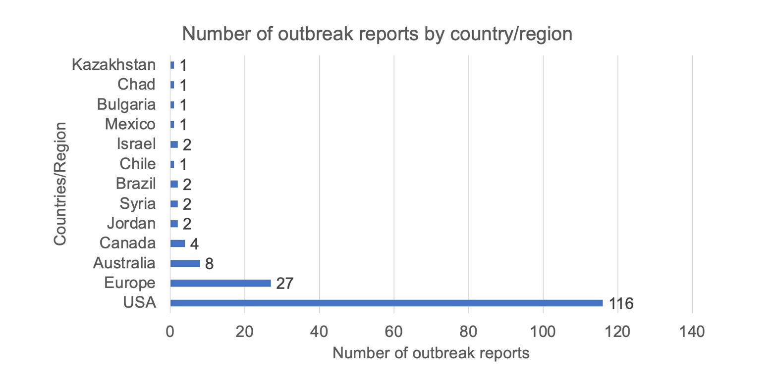

Figure 2. Number of Outbreak Reports by Month and Year between 1 August 2016 and 31 April 2018
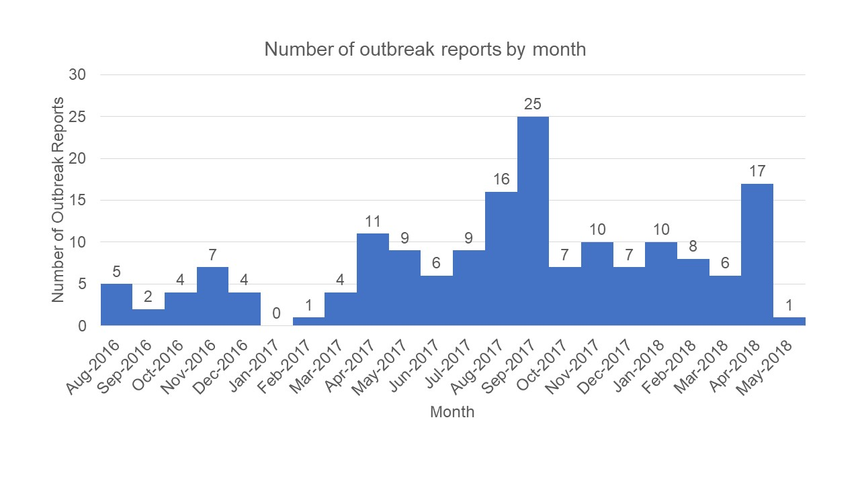

Figure 3. Risk-factors associated with reported outbreaks
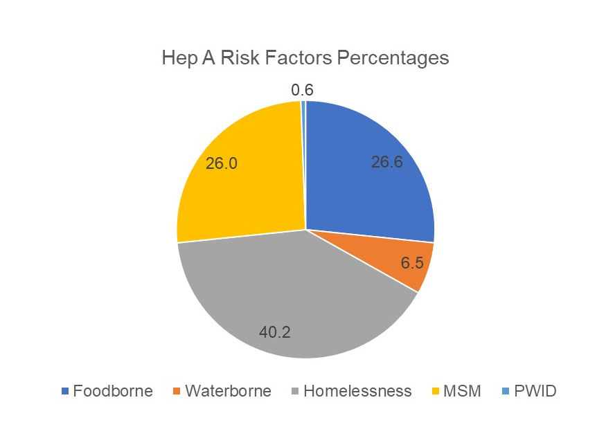

Figure 4. Locations Affected by Hep A Outbreaks in three regions a. Europe, b. USA, c. Australia
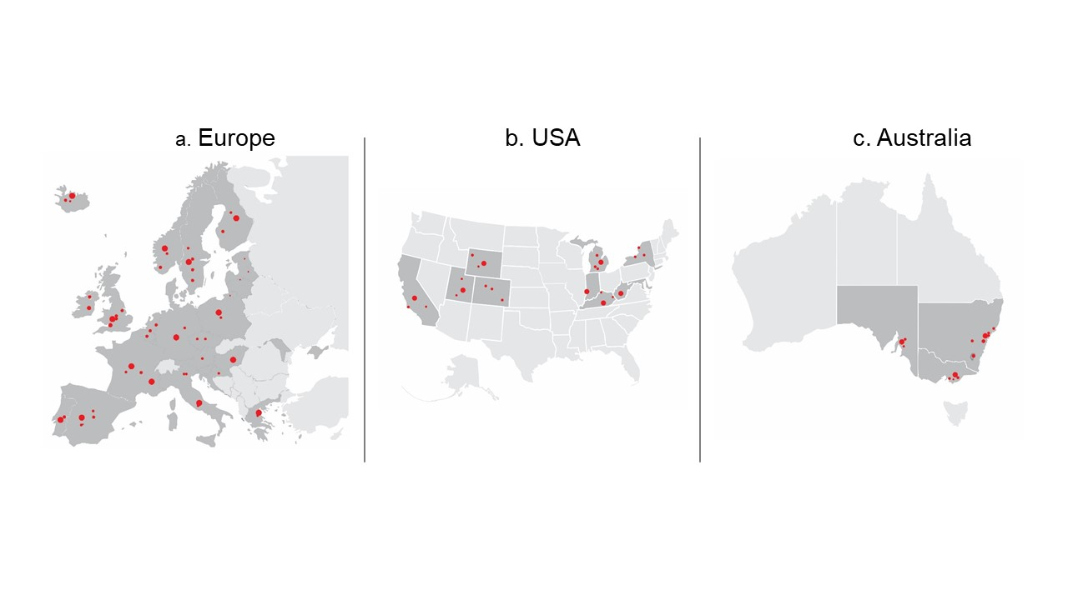
Legend: a. Countries Affected by Hep A outbreaks in Europe, b. States Affected by Hep A Outbreak in USA, c. States Affected by Hep A Outbreak in Australia

In the EU, most Hep A cases have a strong association with MSM [13]. The Madrid Lesbian, Gay, Bisexual, and Transgender (LGBT) World Pride Festival held from 23 June to 2 July 2017 during the study period is believed to be the tipping point at which the spread of Hep A began to accelerate and move into other European countries and regions around the world, such as Asia, America and Australia. The outbreak in Australia was also concentrated among those who identify as MSM. From the two outbreak clusters that occurred during the study period, one of them occurred in the LGBT community and was linked to the Madrid LGBT World Pride Festival [13].
Unlike Europe however, the majority of Hep A cases in USA have occurred among the homeless populations [25]. Cases among the homeless in Europe have occurred, however not on the scale seen in the USA. Hep A transmission in homeless populations most likely results from poor environmental conditions, such as overcrowded living environments, lack of access to hygienic facilities, and inadequate facilities for clean food storage and preparation [26], which facilitate the transmission of Hep A. For example, in California, those that are homeless do not have access to 24-hour toilets, with public toilets available only during certain hours, forcing the homeless to defecate and urinate outside, sometimes putting their waste into plastic bags that they then discard [27]. Feces and urine pose the highest risk for spreading Hep A [28]. The homeless may also inject drugs and lack access to health care services [26]. This has resulted in a large number of cases occurring among homeless populations, prompting the U.S. government to target this group with new control measures. For example, a change in the Hep A immunisation policy for high-risk populations during this outbreak resulted in a surge of demand and caused a shortage of the vaccine supply, leaving it difficult for public health practitioners to combat the outbreak effectively.
These outbreaks identified by EpiWATCH have also been characterised by high rates of hospitalization and deaths. In the USA in particular, there have been approximately 55 deaths since the first Hep A case reported in Michigan in August 2016 [14], and the highest hospitalisation rate ranged from 47.7% to 80.1%. Hep A is rarely fatal, and research indicates that the magnitude of hospitalisations and fatalities during the Hep A outbreak in the USA resulted from co-infection with Hepatitis B or C [23]. Outcomes for Hep A among homeless persons are considerably worse due to the increased potential for co-infection with Hepatitis C and B [23]. Studies have shown that fatality rates among cases co-infected with Hep B were up to 5.6 times higher compared to patients without co-infection [29]. This changing and unique burden of disease has implications for future Hep A prevention and control policy worldwide.
Formal surveillance systems, such as those used by the US Centers for Disease Control and Prevention (CDC), the European CDC, and the WHO, depend on both biological and clinical data, including laboratories, doctors and hospitals records [30]. The official publishers collect data at set intervals, typically with one to two weeks lag-time from the actual event to reporting. The CDC, for example, publishes national and regional data from these surveillance systems weekly [31]. The development of timelier internet-based infectious disease surveillance systems therefore could enhance infectious disease control and prevention efforts. Internet-based surveillance systems can collect data at an earlier time than traditional systems, which are characterised by complex structures that complicate information delivery [4]. Reports by health providers to governments are often delayed until there is a confirmed diagnosis [32]. However, it appears that news related to the disease event may appear on the internet beforehand. The global and timely approach provided by EpiWATCH may compliment traditional local systems and could play a vital role against future Hep A epidemics considering the lack of a global surveillance system. This has the potential to allow significant advances in the control of emerging cases, through identification in global trends [21].
The potential application of EpiWATCH as an internet-based system is not restricted only to surveillance. It can also serve as tools for resource management and allocation [33]. Real-time Hep A estimation would enable public health officials and professionals to respond to the epidemic adequately [30]. With a lead time of a few weeks, public health officials could create a more effective rapid response. If a region experiences a sharp increase of Hep A cases, additional resources may be assigned to that region to manage the event. This can include identifying the source of the outbreak, providing extra treatment capacity, and raising population awareness for educational purposes [30]. Internet-based surveillance however does not replace traditional surveillance systems; rather it can act as an low-cost passive extension that requires minimal resources to run [34].
Finally, this study has a number of limitations. First, internet-based surveillance systems are limited to the news items posted on the internet and can be driven by media bias. Ascertainment bias also could appear where outbreaks in low-income countries may not be reported as frequently as in high-income countries, as there are more internet and media consumers in wealthier nations [35]. Additionally, EpiWATCH only captures English language reports and is limited to finding outbreaks reported in other languages. Thus, the extent of outbreaks may not be reported or captured in low-income, non-English speaking countries with limited media or internet penetration. Unpublished data from EpiWATCH indicates that almost 30% of outbreak reports are from the USA, a high-income, English speaking country with high media and internet penetration, even in rural areas. Furthermore, EpiWATCH is a semi-autonomous system which utilises a human workforce for report confirmation or rejection from the database. This may introduce additional levels of bias and affect the accuracy of analysis. Another limitation of this study is its short duration (21 months). Longer time frames may provide a different global picture of epidemiology. Nonetheless, this study includes baseline information about how EpiWATCH can capture a major outbreak worldwide.

Conclusion
Homelessness has emerged as high-risk factors for Hep A infection, however primary risk-factors may differ around the world, for example MSM in Europe and Australia. The increased risk of hospitalisation and death among these groups due to potential co-infection with Hep Band C indicates a changing burden of disease that necessitates new policy considerations. EpiWATCH is a useful resource that may critically supplement traditional outbreak surveillance systems, especially in areas with a large number of internet users. The system allows for real-time and retrospective analysis of outbreaks that may be useful during outbreak responses and control efforts, and research respectively. The capacity of EpiWATCH to provide information about disease outbreaks in real-time makes this new approach a promising option that could enhance traditional approaches to surveillance.

Funding information
CR MacIntyre is supported by a NHMRC Principal Research Fellowship, grant number 1137582.

Competing interests
All authors have no conflict of interests to declare.

References
- AJ Z. Hepatitis Viruses. In: S B, editor. Medical Microbiology. 4. University of Texas Medical Branch at Galveston: Galveston (TX); 1996.
- Hartley DM, Nelson NP, Arthur RR, Barboza P, Collier N, Lightfoot N, Linge JP, van der Goot E, Mawudeku A, Madoff LC, Vaillant L. An overview of internet biosurveillance. Clinical Microbiology and Infection 2013;19:1006-1013. DOI: 10.1111/1469-0691.12273
- Barboza P, Vaillant L, Mawudeku A, Nelson NP, Hartley DM, Madoff LC, Linge JP, Collier N, Brownstein JS, Yangarber R, Astagneau P. Evaluation of epidemic intelligence systems integrated in the early alerting and reporting project for the detection of A/H5N1 influenza events. PLoS One 2013;8:e57252. DOI: 10.1371/journal.pone.0057252
- Milinovich GJ, Williams GM, Clements AC, Hu W. Internet-based surveillance systems for monitoring emerging infectious diseases. The Lancet infectious diseases 2014;14:160-168. DOI: 10.1016/S1473-3099(13)70244-5
- World Health Organisation. Epidemic intelligence - systematic event detection [Internet] Geneva: WHO; 2016 [Available from: http://www.who.int/csr/alertresponse/epidemicintelligence/en/.] Accessed 10 April 2020.
- Boulos MNK, Sanfilippo AP, Corley CD, Wheeler S. Social Web mining and exploitation for serious applications: Technosocial Predictive Analytics and related technologies for public health, environmental and national security surveillance. Computer methods and programs in biomedicine 2010;100:16-23. DOI: 10.1016/j.cmpb.2010.02.007
- Nelson NP, Murphy TV. Hepatitis A: the changing epidemiology of hepatitis A. Clinical liver disease 2013;2:227-230. DOI: 10.1002/cld.230
- Wasley A, Fiore A, Bell BP. Hepatitis A in the era of vaccination. Epidemiologic reviews 2006;28:101-111. DOI: 10.1093/epirev/mxj009
- Hadler SC, Webster HM, Erben JJ, Swanson JE, Maynard JE. Hepatitis A in Day-Care Centers: A Community-Wide Assessment. The New England Journal of Medicine. 1980;302:1222-1227. DOI: 10.1056/NEJM198005293022203
- Choi J, Cho Y, Shim E, Woo H. Web-based infectious disease surveillance systems and public health perspectives: a systematic review. BMC public health 2016;16:1238. DOI: 10.1186/s12889-016-3893-0
- Jayasundara D, Hui BB, Regan DG, Heywood AE, MacIntyre CR, Wood JG. Modelling the decline and future of hepatitis A transmission in Australia. Journal of viral hepatitis 2019;26:199-207. DOI: 10.1111/jvh.13018
- NSW Health. Hepatitis A linked to imported frozen pomegranate: NSW Health 2018, June 18 [Available from: https://www.health.nsw.gov.au/Infectious/alerts/Pages/hep-A-pomegranate.aspx.] Accessed 14 April 2020.
- World Health Organization(WHO). Hepatitis A outbreaks mostly affecting men who have sex with men–European Region and the Americas & June 2017(Available from:https://www.who.int/csr/don/07-june-2017-hepatitis-a/en/) Aceessed 9 April 2020.
- Center for Disease Control and Prevention (CDC). Outbreaks of hepatitis A in multiple states among people who are homeless and people who use drugs 2017 [Available from: https://www.cdc.gov/hepatitis/outbreaks/2017March-HepatitisA.htm.] Accessed 10 April 2020.
- Pettersson JHO, Myking S, Elshaug H, Bygdås KI, Stene-Johansen K. Molecular epidemiology of hepatitis B virus infection in Norway. BMC Infectious Diseases 2019;19:236. DOI:10.1186/s12879-019-3868-8
- Foster MA, Hofmeister MG, Kupronis BA, Lin Y, Xia GL, Yin S, Teshale E. Increase in hepatitis A virus infections—United States, 2013–2018. Morbidity and Mortality Weekly Report 2019;68:413. DOI: 10.15585/mmwr.mm6818a2
- Anema A, Kluberg S, Wilson K, Hogg RS, Khan K, Hay SI, Tatem AJ, Brownstein JS.. Digital surveillance for enhanced detection and response to outbreaks. The Lancet Infectious diseases 2014;14:1035. DOI: 10.1016/S1473-3099(14)70953-3
- Chunara R, Andrews JR, Brownstein JS. Social and news media enable estimation of epidemiological patterns early in the 2010 Haitian cholera outbreak. The American journal of tropical medicine and hygiene 2012;86:39-45. DOI: 10.4269/ajtmh.2012.11-0597
- School of Public Health and Community Medicine UNSW Sydney. Epi-watch Outbreak Alerts 2016 [Available from: https://sphcm.med.unsw.edu.au/centres-units/centre-research-excellence-epidemic-response/epi-watch-outbreak-alerts]. Accessed 8 June 2018.
- Yan SJ, Chughtai AA, Macintyre CR. Utility and potential of rapid epidemic intelligence from internet-based sources. International journal of infectious diseases 2017;63:77-87. DOI: 10.1016/j.ijid.2017.07.020
- School of Public Health and Community Medicine UNSW Sydney. Epi-watch [Internet]. 2019 [Available from: https://iser.med.unsw.edu.au/epi-watch.] Accessed 10 April 2020.
- Lugoboni F, Quaglio G, Civitelli P, Mezzelani P. Bloodborne viral hepatitis infections among drug users: the role of vaccination. Int J Environ Res Public Health 2009;6:400-413. DOI: 10.3390/ijerph6010400
- Cooksley W. What did we learn from the Shanghai hepatitis A epidemic? Journal of viral hepatitis 2000;7:1-3. DOI: 10.1046/j.1365-2893.2000.00021.x
- Latash J, Dorsinville M, Del Rosso P, Antwi M, Reddy V, Waechter H, Lawler J, Boss H, Kurpiel P, Backenson PB, Gonzalez C. Notes from the Field: Increase in Reported Hepatitis A Infections Among Men Who Have Sex with Men-New York City, January-August 2017. Morbidity and Mortality Weekly Report 2017;66:999-1000. DOI: 10.15585/mmwr.mm6637a7
- Sheridan J. Unexpected Hepatitis A Outbreaks Spread Throughout the U.S. The Disease Daily [Internet]. 2017 [Available from: https://www.diseasedaily.org/tags/united-states ] Accessed 10 June 2018.
- Syed NA, Hearing SD, Shaw IS, Probert CS, Brooklyn TN, Caul EO, Barry RE, Sarangi J. Outbreak of hepatitis A in the injecting drug user and homeless populations in Bristol: control by a targeted vaccination programme and possible parenteral transmission. European journal of gastroenterology & hepatology 2003;15:901-906. DOI: 10.1097/01.meg.0000059164.46867.77
- The Gaurdian. California city confiscates toilets from homeless residents – forcing them to use buckets 2019, [Available from: https://www.theguardian.com/us-news/2017/sep/08/anaheim-homeless-toilets-confiscated-public-health-crisis.] Accessed 8 April 2020.
- O’Neil J. Issues Leading to the Recent Outbreaks of Hepatitis A. The Journal for Nurse Practitioners 2018;14:639-644. DOI: 10.1016/j.nurpra.2018.08.018
- Reiss G, Keeffe E. Hepatitis vaccination in patients with chronic liver disease. Alimentary pharmacology & therapeutics 2004;19:715-727. DOI: 10.1111/j.1365-2036.2004.01906.x
- Ginsberg J, Mohebbi MH, Patel RS, Brammer L, Smolinski MS, Brilliant L. Detecting influenza epidemics using search engine query data. Nature 2009;457:1012. DOI: 10.1038/nature07634
- Center for Disease Control and Prevention. Global Disease Detection Operations Center: Event-based Surveillance 2016 [Available from: https://www.cdc.gov/globalhealth/healthprotection/gddopscenter/how.html.] Accessed 10 June 2018
- Chairulfatah A, Setiabudi D, Agoes R, van Sprundel M, Colebunders R. Hospital based clinical surveillance for dengue haemorrhagic fever in Bandung, Indonesia 1994–1995. Acta tropica 2001;80:111-115. DOI: /10.1016/S0001-706X(01)00180-2
- Dugas AF, Hsieh Y-H, Levin SR, Pines JM, Mareiniss DP, Mohareb A, Gaydos CA, Perl TM, Rothman RE. Google Flu Trends: correlation with emergency department influenza rates and crowding metrics. Clinical infectious diseases. 2012;54:463-469. DOI: 10.1093/cid/cir883
- Chan E, Sahai V, Conrad C, Brownstein J. Web search query data to monitor dengue epidemics: a new model for dengue surveillance. In 10th Annual Conference 2011 Building the Future of Public Health Surveillance. International Society for Disease Surveillance. 2011, pp17. DOI: 10.3402/ehtj.v4i0.11122
- Barclay E. Predicting the next pandemic. Lancet 2008. 372:1025-1026. DOI: 10.1016/S0140-6736(08)61425-7

How to cite this article: Lesmanawati DAS, Adam DC, Hooshmand E, Moa A, Kunasekaran MP & MacIntyre CR. The global epidemiology of Hepatitis A outbreaks 2016-2018 and the utility of EpiWATCH as a rapid epidemic intelligence service. Global Biosecurity, 2020; 1(3).
Published: March 2021
Copyright: Copyright © 2021 The Author(s). This is an open-access article distributed under the terms of the Creative Commons Attribution 4.0 International License (CC-BY 4.0), which permits unrestricted use, distribution, and reproduction in any medium, provided the original author and source are credited. See http://creativecommons.org/licenses/by/4.0/ .
Global Biosecurity is a peer-reviewed open access journal published by University of New South Wales.

